Find the network issue (30’)

In this exercise, you will have to discover the resources in the s2s resource group. The following architecture has been deployed:

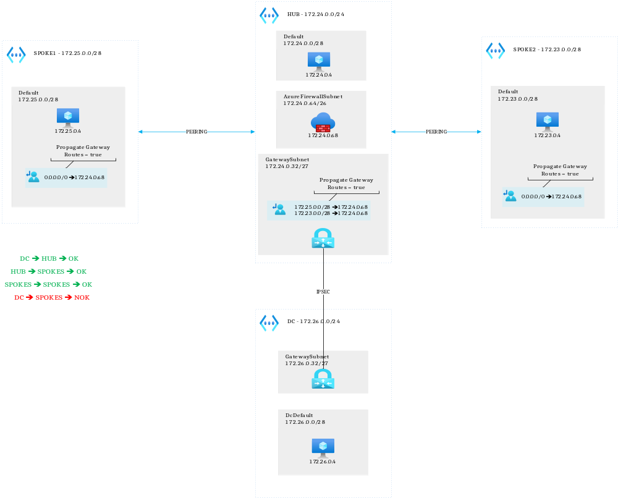
The problem is that the virtual machines from the simulated on-premises data center cannot connect to the spokes (and vice versa). All the other connections work.
Before changing anything, verify that the other connections work well by trying to use remote desktop when connecting to other machines.
The problem could come from:
- Invalid routing
- Invalid firewall configuration
- Invalid NSG rules
- Invalid peering configuration
- Invalid VPN gateway configuration

You have 30 minutes to restore connectivity between the on-premises VM and at least one spoke.

Virtual machines username/password:

stephaneey
@1StrongPwd

