Playing with Azure Policy (25’)

In this exercise, you must create a policy that automatically ensures that TLS 1.2 is enforced for Azure Storage Accounts.

To achieve this, you’ll need the following components:
- Azure Policy
To test your Policy, you’ll need:
- Your resource group
- A storage account

To verify that your policy is working, any created/updated storage account should show the following configuration:

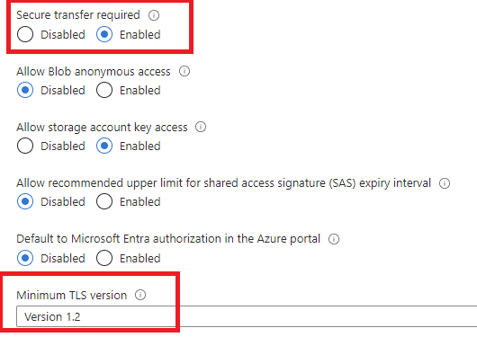

To test it further, make sure to disable TLS on an existing Storage Account. The policy should re-enable it.

Tips:
- Make sure to assign the policy to your resource group only (to not interfere with others)
- Make sure to grant the correct role to the policy engine.

