Deploy a Storage Account and a container with Bicep (30’)

In this exercise, you must:
- Deploy a storage account and a container

The result should look like this:

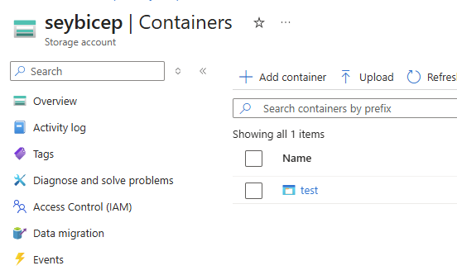

Constraint You must use bicep modules.

