Deploy a virtual machine using ARM (45’)

In this exercise, you must:
- Deploy a virtual machine using ARM. You can start from this documentation https://learn.microsoft.com/en-us/azure/virtual-machines/windows/ps-template
Additionally, you must:

- Enable the Windows Server Web role
- You must open port 80

Once deployed, you should be able to perform a GET request against default web site hosted on IIS.

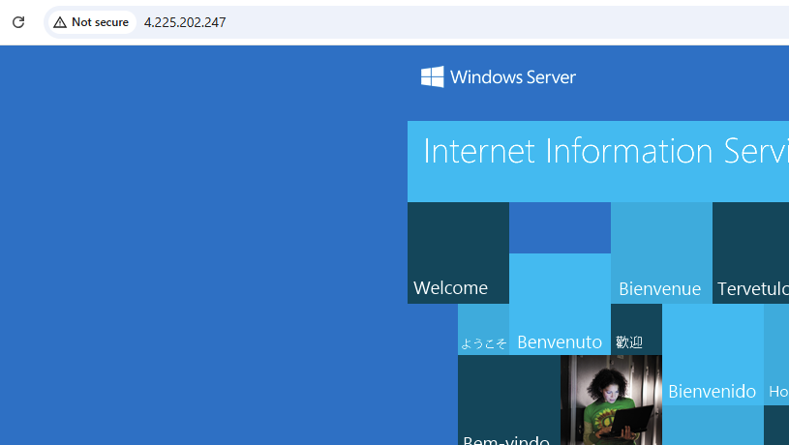
Or even better:
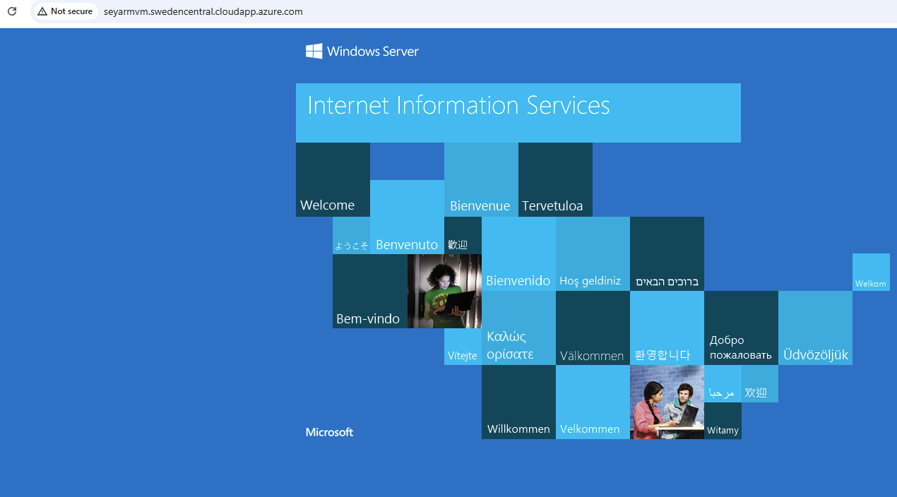

Make sure to deploy the VM in your own resource group.

