Setup alert rules and handle alerts with Logic Apps (40’)

In this exercise, you must monitor the number of messages landing in a deadletter queue and call Logic Apps to handle deadlettered messages. To achieve this, you’ll need

- To create a basic service bus
- Create a queue named “aqueue”
- To setup an alert rule that checks deadletter queues
- To create a Logic App that will handle the alerts
- To create an action group that will be used by the alert rule to trigger the logic apps

Things that will help you:

- Create new messages in the queue “aqueue” using the service bus explorer available from within the Azure Portal.

Once ready:
- Tell me that you’re ready, I will use my command line tool to make sure messages are deadlettered.

If your alert rule is correctly setup, you should see it firing when the deadletter queue has messages and resolved once emptied:

Alert in resolved state

Similarly, you should see that your Logic App has executed:
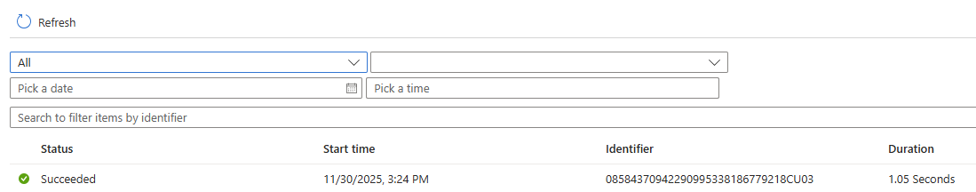
Logic App execution

