Setup your ASR between Sweden Central and France Central (60’)

To achieve your objective, you will need:

- A starting virtual machine in Sweden Central
- To enable the disaster recovery features of the source VM

Constraints:

- You must setup the initial virtual machine, virtual network, NSG with Azure CLI
- You must enable the Web Server role on the source VM (you can do that manually when logged in to the VM):
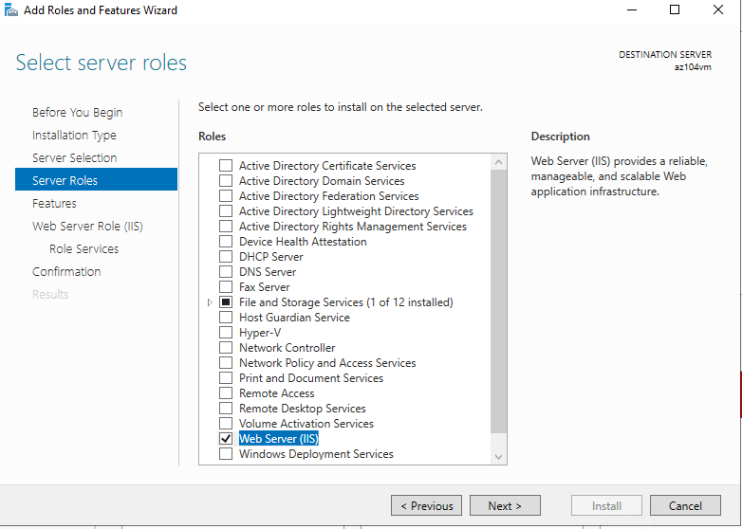
- You must be able to browse the default web site on port 80 from Internet
- You can configure replication using the portal
- You must run the failover and connect to the default web site of the replicated machine.

