 | User’s manual  Version 3.3 February 2016-04-01  S. Humbel,  iSm2, Aix-Marseille University  France  For HuLiS 3.3
Native english teachers (or students): if you like the program but not the manual, send me corrections
(use the http://www.hulis.free.fr:download:HuLiS_Manuel_3_3_en.doc file for corrections)
Overview
HuLiS is a Java applet that targets at the calculation of electronic structures within the Huckel framework. In addition to the standard simple Hückel method, HuLiS implements the calculation of mesomerism (i.e the user can build Lewis structures, and evaluate the weights of Lewis structures).
Mesomerism is written as a linear combination of Lewis structures, and coefficients are also calculated.
HuLiS is freely available a standalone applet (to download from the web site : http://www.hulis.free.fr). We also propose an “on-line” version that runs from the web site http://www.hulis.free.fr. Last, an HTML5 exists for mobiles and tablets (see m.hulis.free.fr).
This manual describes the standalone applet. Some features are removed in the “on-line” version because the required access to the user’s computer is blocked for security reasons (undo/redo, a robotized tutorial, file handling).

When you download HuLiS you are requested to fill a form that tells us where HuLiS is used. It can be skipped, but we appreciate if you do so.

In the same spirit, when you start HuLiS the first time, our privacy policy is explained, and you can let HuLiS send us some informations such as how many times you use HuLiS, which version of HuLiS you are using, which country you are using it from, etc. This choice can be modified later with the preference panel.

Nota : HuLiS’ interface is in English, but the for some langages (Italian, French Arabic) depending of the OS. This choice can be changed in the appropriate menu.

Areas
Nota: Flying over a button with the mouse display an help. The taskbar also gives indications on how to use HuLiS.
The HuLiS window is divided into 5 areas (Figure 1).

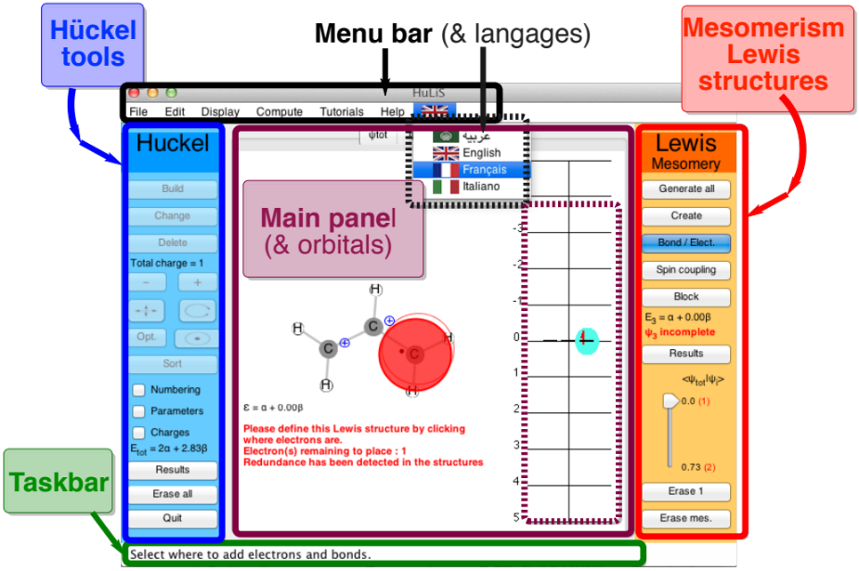
Figure 1 : Areas is HuLiS (in grey are buttons that are not relevant in the context)

Taskbar
Instant help (depends on the button in use). This area targets mainly at beginners.

Menu Bar

<File>
Open/save molecules & mesomeric structures (if any). The file format is that of Gaussian + NBO (see on the right here and examples in the library available for download from the website).
Preferences are here also: privacy, number of digits in outputs can be adjusted here. Molecular Orbitals scale factor for drawings, molecule drawing preferences, Lewis preferences, etc.

<Edition>
undo/redo + paste
paste can use several format
Gaussian type of file ( here opposite)==>
Or simply XYZ coordinates of atoms (without the number of atoms)
Format xyz
C -0.07609 0.04372 0.01551
From gaussian output – in Å
1 6 0 -0.07609 0.04372 0.01551
From Gamess output– in au (Bohr)
C 6.0 -3.42021 0.00000 0.00000
The molecule is automatically rotated along the xy plan. The initial orientation can be retrieved (see the results panel for Lewis).

Gaussian type
%mem=256MB
#P HF 6-31G(d) pop=nboread

! File generated by the HuLiS Formamide
5
0 1
C -0.07609 0.04372 0.01551
N -0.14415 0.23841 1.36154
H 0.94569 0.18721 -0.38447
H -1.03167 0.13229 1.83720
H 0.67219 0.48469 1.90309
S -1.02185 -0.25586 -0.69336

$nbo nrt $end
$NRTSTR ! Trust factor = 90.90% (HLP)
STR! HuLiS Wgt = 65.40% (HLP) S1
LONE 2 1 6 2 END
BOND D 1 6 S 1 2 S 1 3 S 2 4 S 2 5 END
END
$END

<Display> just zooms for the main panel.
<Compute> expert mode and choice of the Lewis calculation method : HL-CI or HL-P (default). The expert mode gives the opportunity to define a singlet coupling of two electrons in principle at long range (a green bond is drawn).
<Tutorial> One robot is defined, it builds a molecule, and shows the orbitals
<Help> events log (for debug), and the « About …»
<Langage - flags>
Nota: The menu bar has fewer options in the “on-line” version to match security requirements.

Main panel
Here are thumbnails for the molecule (ψ_{tot}) and the Lewis’ structures (ψ₁, ψ₂, …). For each, the Molecular Orbital (MO) energetic diagram is drawn.
When the mouse flies over an atom or a bond, the corresponding parameters are displayed. The MO are drawn by a clic on the energetic level.
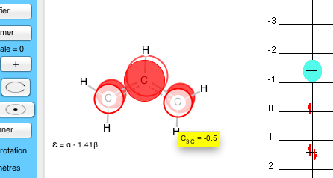
In the standalone version, the content of this panel can be saved as a vectorial picture (.svg) for a better quality:
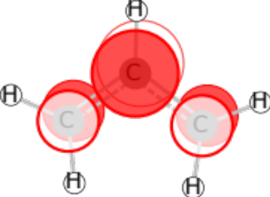
This image comes from a conversion ffrom .svg to .pdf (using Inkscape). The pdf is then inserted in word, and saved as a pdf to put on the web site.
A second clic erases the MO (bascule). When a MO is on the screen coefficients are displayed if the mouse flies over atoms.
The scale factor for the MO drawing can be changed in Preferences (Zoom MO - slider).

Hückel tools
In the left part (blue) are the tools to build the molecule for simple Hückel calculations. Results display panel is as neat as we could.
Nota : As Huckel calculations have delocalized π bonds (“delocalized structure”), these are not drawn for Hückel calculations. Bonds are rather drawn with dashes with a dash density that is proportional to π bond indices.
- Build, Change, Delete : tools to build the molecule’s connectivity.

"Build" creates a sp² (1 électron) Carbon. The appropriate valence is completed by H atoms.
"Change" modifies sp² Carbons into other atoms. When this button is selected, a clic on an atom (or a bond) open a small panel with compatible choices. Default parameters are proposed (built-in), with a reasonable choice of atoms (these parameters are from Van-Catledge ‘s paper []). All values can be modified. A Xx generic atom is also available. Atomic integral, h_{x}, number of neighbours (n_{neighb}), number of π electron (n_{e-}) and symbol Xx can be changed.
"Delete" delete an object atom or bond and correct the valency if necessary.
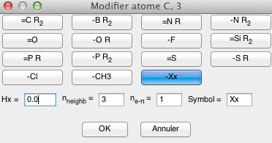(a)

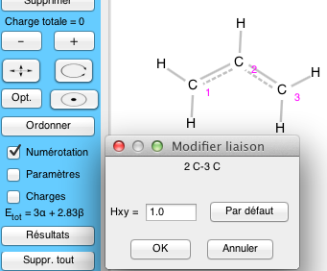(b)
Figure 2 : Change the parameters: for an atom (a) or for a bond (b).

- [ – ] & [ + ] increase/decrease the total charge.
- Move, Rotate, Optimize, Center to correct the display of the molecule.
- Sort sort the atoms. The applet waits for either all atoms are selected or that the button is deselected). Atoms are sorted in the order they have been selected.
- Three small buttons ("radio") Numbering Parameters Charges
To display (or not) the corresponding stuff.
- Results open a pop up panel (light blue background) with Hückel results.
- Erase all erase the molecule and reinitialize HuLiS.
- Quit (standalone only) Quit HuLiS.

Mesomery / Lewis Structures
The right hand-side part (orange) provides tools to build Lewis structures and see the corresponding results.
As elsewhere in HuLiS, when the mouse flies over a button, an explanation is displayed (yellow little panel). When selected a larger explanation is written in the taskbar.
Nota: consistent with the principle of localization (in Lewis structures), and a contrario to the delocalized electronic structures, π bonds and lone pairs are explicitly displayed in Lewis structures. The interaction between these structures gives rise to π delocalization (mesomerism). HuLiS computes the coefficients of this interaction, hence the weights of each structure.
Nota bis: HuLiS targets at a good matching between the delocalized envision (Hückel) and the localized one (Lewis). Two strategies are available:
- Wave function matching, or Hückel-Lewis-Projection (HL-P); it is the most accurate approach and the default one. However, it can require many computations. Large systems and/or systems with many Lewis structures might heat the cpu of your computer.[]
- Energetic matching, or Hückel-Lewis-Configuration-Interaction (HL-CI); faster but less accurate, it is a physically interesting approach where the interaction between localized states (Lewis structures) is accounted, for via an effective Hamiltonian.[]
The corresponding papers can be asked (and obtained) upon email request.
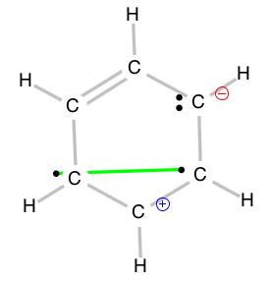
- Generate all
Creates all the Lewis structures that have 0 or 1 charge separation (1 +/– but not 1st neighbour), and biradicals if requested in the pref panel. Biradicals are singlet coupled – shown as a green bond (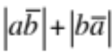). A structure can thus be both zwitterionic (+/–) and a biradical: → → →
- Create to define a new 1 Lewis structure (new thumbnail)
It copies the skeleton of the molecule in ψ (a new thumbnail). Charges displayed correspond to the π effective charge (Z^{eff}) for each atom as defined in the Hückel framework. The Lewis structure is to be completed with bonds, and odd or pairs of electron - use the “Bond/Electr” button.
- Bond/Electr to define bonds and electron dots of the Lewis structure
On an atom, it modifies the number of electron as 1 –> 2 –> 0 –> 1 etc.
On a bond, its π bonding indice is modified as single –> double –> single –> etc (there are no triple bond on HuLiS).
The charge is updated at each clic.
HuLiS checks for redundancy in Lewis structures. In HL-CI the weight is shared among the redundant structures. In HL-P, the weights are not computed when redundancy is encountered. A flag is put on the redundant structure(s).
Results open a pop up panel (light orange background) with mesomeric results.
Example for acrolein

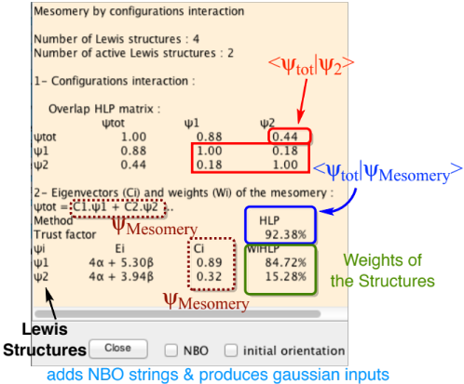
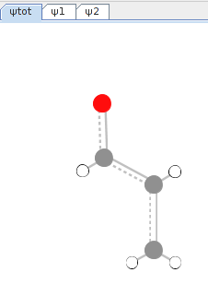 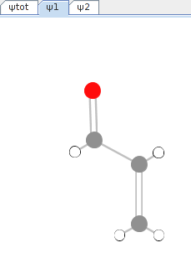 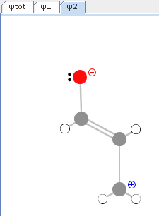
(a) (b) (c)
Delocalized (a) and mesomeric (b) (c) structures .

Figure 3 : Popup of Lewis results for acrolein. Here, 2 mesomeric structures are active among the set. Only HL-P is active. When HL-CI also activated, The effective Hamiltonian of the Configuration Interaction is also written.
Nota : the trust factor, (trust rank) (τ) corresponds to the overlap between the mesomeric wavefunction and Hückel’s (τ = <Ψ_{Hückel} | Ψ_{mesom.}>). It is written as %.

In version before HuLiS 3.2, τ was calculated differently.
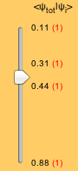 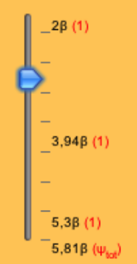
(a) (b)
Figure 4 : with the slider one selects structures (a) per overlap (see text) or (b) per energies (HL-CI only).

- Slider

To select part of the Lewis structures. Structures are ordered vertically using their overlap with the Hückel wave function, from smallest overlap (top) to the largest (bottom). The overlap value is indicated in black. The red number in parenthesis indicates how many structures have the same overlap with the Hückel wave function. The blue arrow indicates the threshold.
When overlaps are not computed we use the energy of the structures from the highest in energy (top) to the lowest (bottom).
Nota : The energy difference between the delocalized wavefunction (Hückel level) and the lowest Lewis give the resonance energy (at the Hückel level, in terms of β).

- Erase 1 Delete the resonance structure of the current thumbnail.
- Erase mes. Delete all resonance structures. Returns to Hückel calculations.
Remarks
1. To read Hückel results of a specific Lewis structure:
Select its thumbnail
Clic on “Results” of the Hückel (blue) area. This opens a blue-background popup. Note that the Hamiltonien matrix has zeros along single bonds. This is the way electrons are localized in HuLiS. Charges & indices are also here.
Localized orbitales can be viewed with a clik on the orbital level (main panel).
2. Biradical structures are singlet coupled.
A green bond is drawn. Only 1 (one) spin coupling can be defined. So a max of 3 unpaired electrons are allowed. The expert mode, adds a button labelled "Spin coupling" to define which 2 electrons are coupled. Only useful for 3 electrons cases.
3. Chemical bond, Valence Bond covalent vs ionics.
The chemical bond between A — B describes how two electrons are paired in a bonding orbital. This holds for π bonds. If the orbital π =1/√2 (p_{A}+p_{B}) is bioccupied, the standard π bond (a black line) includes :
- Covalent bonding (A• – •B)
- AND Ionics
  - A(–) (+)B when p_{A} si bioccupied
  - A(+) (–)B when p_{B} si bioccupied
Adding ionics structures to such a standard π bond would introduce redundancy. Redundancy should be avoided. It is a good practice to remove structures with a negative weight.
The green bond only introduces the covalent part. Ionics can (must) be added there. Only one green bond can be set in HuLiS.

F.A. Van-Catledge A Pariser-Parr-Pople-based set of Hueckel molecular orbital parameters, J. Org. Chem. 1980, 45, 4801-4802. (http://pubs.acs.org/doi/abs/10.1021/jo01311a060)
Y. Carissan, D. Hagebaum-Reignier, N. Goudard, S. Humbel Hückel-Lewis-Projection Method: A “Weights Watcher” for Mesomeric Structures: J. Phys. Chem. A. 2008, 112 (50), 13256–13262
S. Humbel Getting the Weights of Lewis Structures out of Hückel Theory: Hückel–Lewis Configuration Interaction (HL-CI) J. Chem. Educ. 2007 84 , 1056-1061

