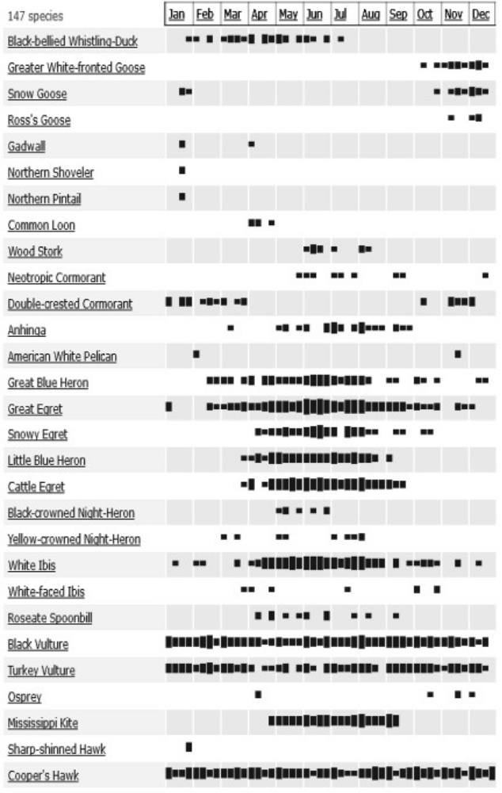
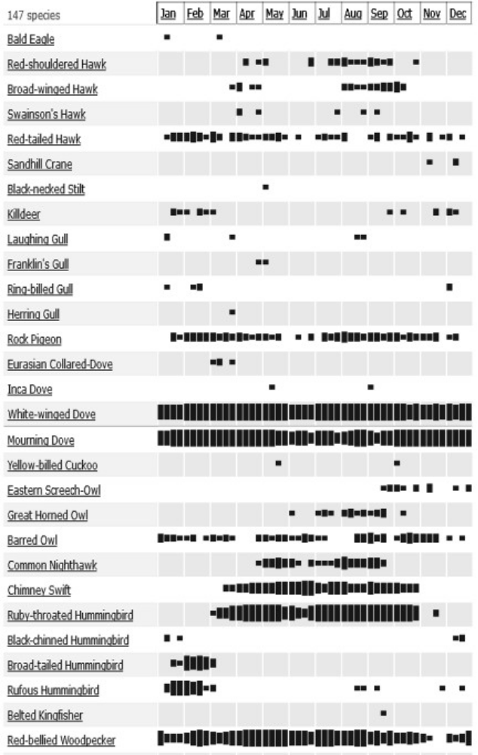
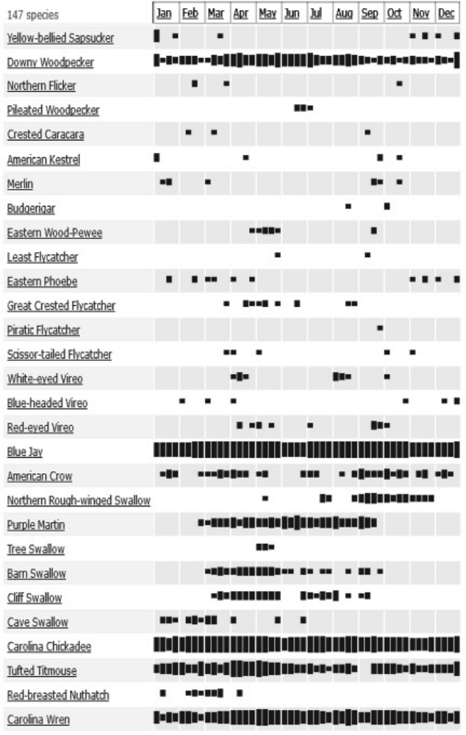
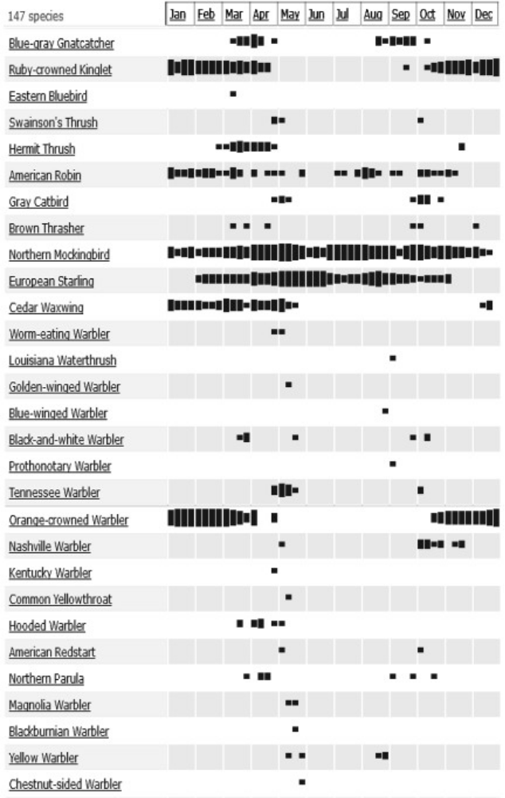
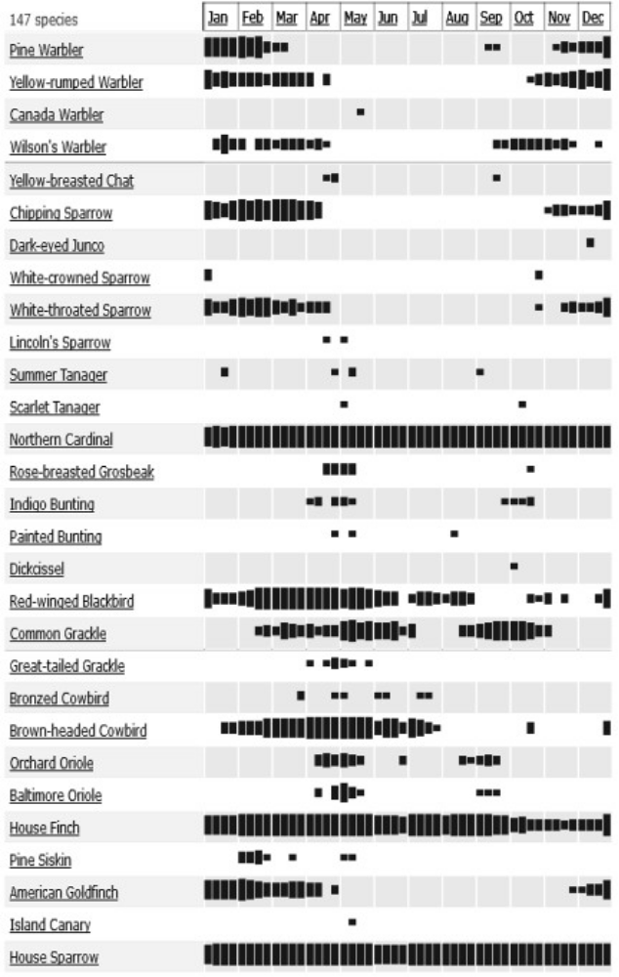
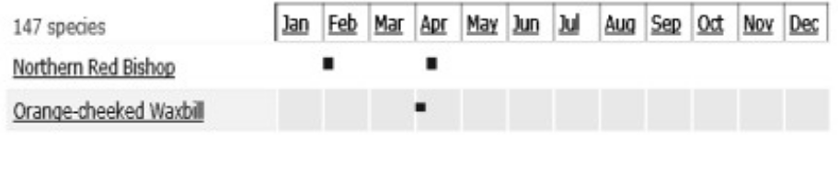

Garden Birds Checklist
1910 Oceania Court
Houston/Katy TX

From survey 2012 to 2014 (garden)
2015 to 2016 (overhead)
Garden Visitors 99
Sky Birds 48
Total Species 147 seen from the garden

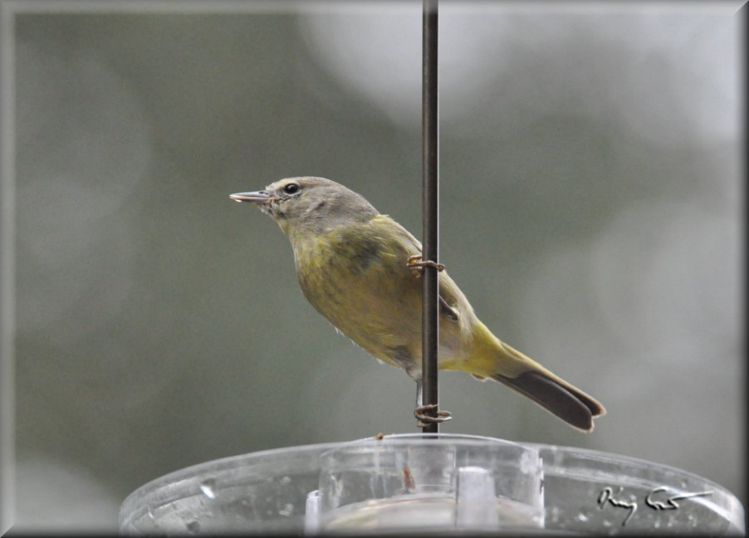

Kevin Smith 2016

