Onyx — Project Overview
  - Onyx · multi-process OS on Raspberry Pi 4

1. In one sentence
Onyx is a small multi-process operating system for the Raspberry Pi 4 (AArch64), built on top of Circle (rsta2/circle), which serves as its HAL and driver stack. It loads ELF programs from the SD card and runs them as applications isolated from one another, each in its own page table. The whole thing is driven by the Onyx desktop — a compositor, a menu bar, a dock, a terminal, a file manager — and some ninety applications and services (sdcard/apps), from an office suite and a web browser to emulators. Our own code is under the MIT licence (LICENSING.md).
It runs on real Raspberry Pi 4 hardware (not just in emulation).
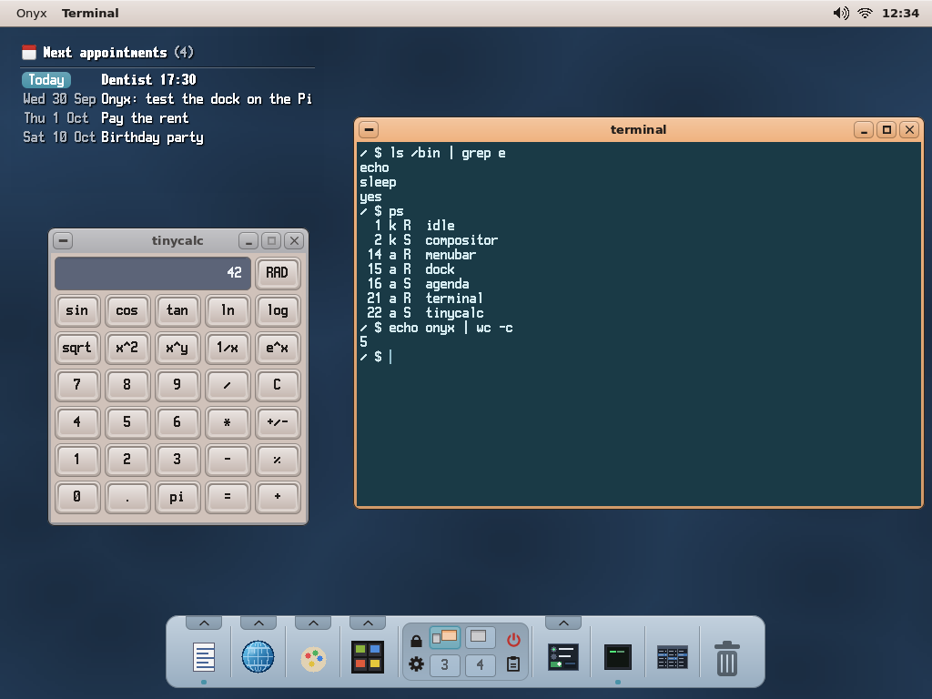 The Onyx desktop, a modernised CDE: the menu bar, the agenda on the Voronoi wallpaper, a calculator behind (grey frame), the terminal in front (its frame in the theme's colour), the dock with its Internet drawer open. (The real apps, run on a PC by the desktop simulator.)

2. Philosophy: "own the top, reuse the bottom"
Circle is a single-process, single-address-space, cooperative bare-metal framework ("your application is the system"). Onyx keeps the bottom half of Circle (which is excellent) and replaces its "operating system" half:
Layer | Decision | Detail
Reset → EL1, MMU activation, GIC, C++ constructors | Keep Circle | Our entry point is main(); everything below it is already done.
64 KB page allocator (palloc/pfree) | Keep — it's our frame allocator | CMemorySystem::Get().
GIC-400, timer, mailbox, EMMC+FatFs, USB, Ethernet, framebuffer | Reuse | This is the whole point of building on Circle.
CScheduler/CTask scheduler | Rewrite the implementation, keep the API | See kernel internals.
Per-process page tables, context switching, exception vectors, address spaces | Write from scratch | Doesn't exist in Circle.
Practical consequence: we link the kernel against Circle's already-compiled static libraries (libcircle.a, libfs, libusb, …) rather than copying its sources.

3. Main features
- Per-process isolation via the MMU. Each application has its own L2/L3 page table (64 KB granule), tagged by ASID. One application cannot see another's memory.
- Protected apps (EL0). Applications run at EL0, the unprivileged level, and call the kernel by system calls (svc): they are isolated from one another and from the kernel and the hardware. An app that crashes is killed; the system goes on. See §5.
- Stable fixed-address ABI (kapi). Each application sees a table of function pointers at a fixed virtual address (14 GB), mapped read-only; each entry is a small stub that makes the system call. Applications call the kernel through this table → an application binary keeps working without recompilation when the kernel changes (append-only contract, current ABI version: 74).
- Threads, app cores, RAM volume. An app may run threads (mutexes, events, a futex, "real time" priority), take a whole CPU core for its own code (the emulators, Doom), and keep files in memory on RAM:.
- The GPU. The VideoCore VI's 3D unit (V3D) is driven by the kernel for the apps: 3D (the N64 and GameCube emulators, the BASIC's 3D), and the compositing of layers (user/gpucomp: Paint's blend modes, Jet Browser).
- Full graphical desktop. 32-bit software compositor, window manager, toolkit of kernel-drawn widgets (buttons, checkboxes, sliders, text fields, scroll bars, icons…), windows with themeable decoration, wallpaper, mouse cursor.
- Onyx shell. A menu bar (the active app's menus, the clock, the Wi-Fi and volume menus), a dock (drawers of apps, workspaces), notifications, a shared clipboard with a history, an interactive terminal with pipes and redirection (|, >, >>, <), a column file browser, a Control Panel, a first-run wizard (Setup), and some sixty command-line tools in /bin.
- Application catalog (User guide §12). Office: Letters (word processor, PDF export), Spreadsheet, Slides (presentations), Cardfile (a small database), Ledger (accounting), Calendar, PDF Viewer (MuPDF), RTF reader, Archiver. Internet: Jet Browser, Mail, IRC, Courier (HTTP client), Lisa (an AI chat). Media: Paint, Photos, the Media Player (music and video), Screenshot, Koton (a music studio with plugins), FM Tracker. Emulators: Game Boy / Color, GBA, NES, SNES, N64, GameCube, with a Game Library. Games (Doom on Freedoom, Tetris, Solitaire, FreeCell, Invaders, Arkanoid…), a BASIC with its editor (QBasic), the Package Manager, a Task Manager, demos.
- USB input devices. Keyboard and mouse (HID), USB gamepads and MIDI keyboards, with keyboard layouts loaded from the card (US, UK, DE, FR, BE, ES, IT, Dvorak).
- Networking (WLAN). TCP/IP stack + on-board Wi-Fi (BCM4343 / wpa_supplicant), on core 3 (netcore=1, the shipped card) or core 0; TCP sockets exposed to apps through the ABI, TLS in user space, NTP clock synchronisation, and remote access: a telnet shell, VNC, a window-level remote desktop for Windows (rdpd + Onyx Remote), an FTP server.
- Packages. Every app is a signed package of the onyx-packages repository: pkg, the Package Manager and an update daemon keep a card up to date.
- A modern web browser. Jet Browser (jet), on WebKit (the engine of Safari): its own port to Onyx — http:// and https://, JavaScript compiled by JavaScriptCore's JIT, the page assembled by the Pi's GPU, <video> and <audio> (VP9, AV1, Opus; YouTube plays), one page per window, three processes (the window, the page, the network): the WebKit port.

4. The architecture at a glance
┌──────────────────────────────────────────────────────────────────┐
│ Applications (ELF EL0, isolated by ASID) │
│ menubar · dock · terminal · fileviewer · writer · jet · bin … │
│ │ call the kernel through kapi.h (inline wrappers) │
├───────┼──────────────────────────────────────────────────────────┤
│ ▼ kapi table at 14 GB (read-only) → stubs: svc #0 │ ← stable contract
╞═══════╪══════════════════ EL0 / EL1 ═════════════════════════════╡
│ ONYX KERNEL (EL1) │
│ • mm/ per-process address spaces, MMU, ASID │
│ • sched/ preemptive scheduler (replaces Circle's) │
│ • arch/ VBAR_EL1 vectors, trap frame, EL0 entry/exit │
│ • proc/ ELF64 loader │
│ • sys/ kapi impl., system calls, handles, streams, threads,│
│ network, sound, app cores, GPU (V3D), RAM: volume │
│ • gui/ GImage (software renderer), compositor+WM, cursor │
├──────────────────────────────────────────────────────────────────┤
│ CIRCLE (HAL + drivers; our fork, a few patches: docs/05) │
│ palloc · GIC · timer · EMMC+FatFs · USB · WLAN · TCP/IP · fb │
├──────────────────────────────────────────────────────────────────┤
│ Raspberry Pi 4 (BCM2711, 4× Cortex-A72, ARMv8-A) │
└──────────────────────────────────────────────────────────────────┘

5. The execution model: apps at EL0
The most structurally defining architectural decision. Since kapi v74 (2026-10-02):
- Applications run at EL0, each in its own page table tagged by ASID; the kernel's memory, the devices and the other apps' pages are out of their reach (EL1-only mappings).
- They call the kernel through the kapi table at a fixed address, as before — but in an app that table points at small stubs (mov x8, #slot; svc #0; ret): every kapi is a system call, its pointers checked, its handles per process. memcpy / memset and the event pump run in the app itself (no system call). Existing binaries kept working unchanged.
- A fault in an app kills that app (a notice on the desktop, a line in kmsg), never the machine.
- History: the project first ran apps at EL1 with direct calls ("Option C", ARCHITECTURE.md §11–§12: apps isolated from one another but not from the kernel); the move to EL0 was done in steps (EL0-PROTECTED-MODE.md) and the EL1 mode removed.

6. Scheduling: preemptive applications, non-preemptive kernel
A 100 Hz timer tick gives each task a time slice (20 ms); when it expires, the kernel preempts the application and runs the next task. An application stuck in a loop that never yields no longer freezes the system: the cursor, the desktop and the other apps stay responsive, and taskman can stop it (the spin app tests this).
An IRQ taken while an app runs (at EL0) arrives on that task's own kernel stack, with the app's full register and FP state saved there; when the slice is over the kernel yields right there, like a voluntary switch.
Only application code is preempted: an app inside a kapi_* call, and the kernel's own threads, are not (the kernel is non-preemptive, the classic Unix model); its long operations (file reads and writes, SD-card waits) yield between pieces. Tasks still also switch voluntarily (yield, msleep, present, wait, …), and a dynamic priority keeps CPU hogs from starving the tasks that yield (the network, the sound). Details in Kernel internals (§ "Preemptive scheduling").
An application may run threads (kapi v67): more tasks in its own address space, with mutexes, events and barriers, and calls posted to its event pump — a thread waits on the network while the window stays responsive. The process ends with its main thread; killing it kills them all. The scheduler's task list has no fixed limit.

7. Target hardware
- Raspberry Pi 4 (BCM2711, 4× Cortex-A72, ARMv8-A) — primary target.
- HDMI output (32 bpp framebuffer, 1024×768 by default, configurable).
- USB keyboard + mouse.
- Optional serial console (GPIO14/15, 115200 8N1) for the boot log and exception dumps.
- The four cores, used asymmetrically by design (not a symmetric SMP kernel): core 0 runs the kernel, the scheduler, the desktop and every process; core 1 the sound producer (and, on a hang, the crash record); cores 2 and 3 are app cores, each lent whole to one app for its own code (an emulator's machine, Doom's engine); with netcore=1 core 3 runs the network stack instead. Nothing of the kernel, Circle's drivers or FatFs has to be multi-core safe. (docs/02 §12, §14, §11.)
- The RPi 5 is not supported yet (I/O behind the RP1 chip via PCIe — heavier bring-up; the plan: PI5-PORT.md).

8. Repository structure
README.md what Onyx is, how to build / stage / test, where the docs are
ARCHITECTURE.md the original design + build manifest (historical record)
docs/ THIS documentation (overview, internals, dev/user guides, plans)
kernel/ the Onyx kernel (see docs/02-KERNEL-INTERNALS.md)
user/ the userland: apps (Apps/<name>/), wtk toolkit, libraries, /bin tools
(bin/), runtime (crt0.S, user.ld, libc/), the media library (av/)
sdcard/ ready-to-flash files for an RPi 4 (firmware, config, apps, /bin, samples)
sdcard_lite/ the minimal card (the required packages), the rest from the repository
third_party/ vendored libraries (FreeType, MuPDF, FFmpeg, ICU, Skia, curl, …)
tools/ host scripts and tests (packages, screenshots, desktop simulator, …)
pc/ the Windows builds (Koton, the emulators, Onyx Remote)
circle/ Circle, as a git submodule (the fork stephaneweg/circle, branch onyx)
Legacy docs. ARCHITECTURE.md is the historical design record (its banner says what changed since); where it contradicts this documentation, docs/ is authoritative. Its §11–§12 remain the reference for why the first execution model ("Option C", apps at EL1) was chosen; apps run at EL0 since kapi v74 (§5).

9. Further reading
Document | For whom | Contents
02 — Kernel Internals | anyone who wants to understand the kernel | boot, memory/MMU, scheduling, exceptions, ABI, GUI, streams
03 — Developer Guide | anyone who wants to build/compile/extend | toolchain, build, app model, extending the ABI, conventions, debugging
04 — User Guide | anyone who wants to use it | SD card, desktop, terminal, files, applications, customization
05 — Circle Changes | anyone touching circle/ | the patches of our Circle fork vs upstream Step51
08 — Jet Browser, the WebKit port | the browser | the port of WebKit to Onyx: its status, the patch series, how to build
EL0 protected mode | the execution model | how apps moved to EL0, the design
Licensing | distributors | the licences of everything Onyx contains
Handoff | the next session | where the work stands, the next tasks

10. Quick genesis (milestones)
- Taking control of main() on top of Circle's sysinit; serial console.
- Replacement scheduler ("shadow" header for CScheduler).
- VBAR_EL1 vectors, trap frame, system-call path.
- Per-process page tables (CAddressSpace), TTBR0/ASID switching.
- ELF64 loader → process.
- Framebuffer (C2DGraphics) + GImage rendering core (ported from the author's FreeBASIC SimpleOS).
- Compositor + window manager; two animated demos running simultaneously.
- Switch to Option C (EL1 apps + direct call) then fixed-table ABI.
- Onyx desktop (panel + applist), stream/stdio subsystem, terminal + /bin, file manager.
- Modal dialogs, themes, app-drawn wallpaper, PID management, keyboard layouts, theme editor (ABI v16).
- Networking: WLAN bring-up + TCP/IP on the primary core, TCP socket calls (ABI v21), an IRC client, a /bin/net tool, and NTP clock sync.
- The modernised CDE desktop (v64: menu bar, dock, workspaces), the wtk toolkit; the preemptive scheduler; sound on core 1, app cores 2–3 (v51), the GPU (v52); Jet Browser (WebKit); the office suite, the emulators, Koton; threads (v67); the network on core 3; the RAM: volume (v71); the packages.
- Every app at EL0 (v73–v74, 2026-10): system calls through the same table, per-process handles, every kapi pointer checked; a fault kills the app, not the machine.

