Onyx — Project Overview
  - Onyx · multi-process OS on Raspberry Pi 4
A note on the name. Onyx is the name of the OS, its kernel, and its GUI. The repository folder is historically named Zircon/ (a legacy name; unrelated to Google/Fuchsia's Zircon microkernel or to LK). Onyx is a homemade operating system, written from scratch, that builds on the Circle bare-metal framework as its hardware abstraction layer.

1. In one sentence
Onyx is a small multi-process operating system for the Raspberry Pi 4 (AArch64), built on top of Circle (rsta2/circle), which serves as its HAL and driver stack. It loads ELF programs from the SD card and runs them as applications isolated from one another, each in its own page table. The whole thing is driven by the Onyx desktop made up of a software compositor, a taskbar, a launcher, a terminal, a file manager, and about thirty applications.
It runs on real Raspberry Pi 4 hardware (not just in emulation).
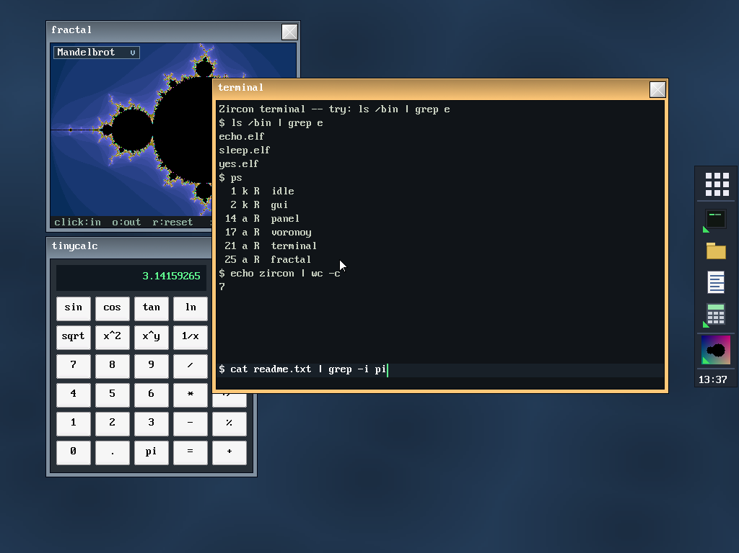 The Onyx desktop: panel/launcher on the edge, composited windows (fractal browser, active terminal, calculator), Voronoi wallpaper. (Simulated screenshot, rendered from the real skins/font/icons.)

2. Philosophy: "own the top, reuse the bottom"
Circle is a single-process, single-address-space, cooperative bare-metal framework ("your application is the system"). Onyx keeps the bottom half of Circle (which is excellent) and replaces its "operating system" half:
Layer | Decision | Detail
Reset → EL1, MMU activation, GIC, C++ constructors | Keep Circle | Our entry point is main(); everything below it is already done.
64 KB page allocator (palloc/pfree) | Keep — it's our frame allocator | CMemorySystem::Get().
GIC-400, timer, mailbox, EMMC+FatFs, USB, Ethernet, framebuffer | Reuse | This is the whole point of building on Circle.
CScheduler/CTask scheduler | Rewrite the implementation, keep the API | See kernel internals.
Per-process page tables, context switching, exception vectors, address spaces | Write from scratch | Doesn't exist in Circle.
Practical consequence: we link the kernel against Circle's already-compiled static libraries (libcircle.a, libfs, libusb, …) rather than copying its sources.

3. Main features
- Per-process isolation via the MMU. Each application has its own L2/L3 page table (64 KB granule), tagged by ASID. One application cannot see another's memory.
- "Option C" execution model. Applications run in EL1 (privileged) and call the kernel's functions directly (no SVC trap in the common path). The trade-off: apps are isolated from one another, but not from the kernel. See §5.
- Stable fixed-address ABI (kapi). The kernel publishes a table of function pointers at a fixed virtual address, mapped read-only into each application. Applications call the kernel through this table → an application binary keeps working without recompilation when the kernel changes (append-only contract, current ABI version: 17).
- Full graphical desktop. 32-bit software compositor, window manager, toolkit of kernel-drawn widgets (buttons, checkboxes, sliders, text fields, scroll bars, icons…), windows with themeable decoration, wallpaper, mouse cursor.
- Onyx shell. Panel/launcher (panel), app list, interactive terminal with pipes and redirection (|, >, >>, <), file manager, and a collection of command-line tools in /bin.
- Application catalog. Text editor, spreadsheet, scientific calculator, drawing program, fractal browser, calendar, task manager, theme editor, and many games (Tetris, Snake, 2048, Minesweeper, Sokoban, Pong, Game of Life, SameGame).
- USB input devices. Keyboard and mouse (HID), with hot-swappable keyboard layout switching (US, UK, DE, FR, ES, IT, Dvorak).

4. The architecture at a glance
┌──────────────────────────────────────────────────────────────────┐
│ Applications (ELF EL1, isolated by ASID) │
│ panel · applist · terminal · filer · tinypad · games · /bin/* │
│ │ call the kernel through kapi.h (inline wrappers) │
├───────┼──────────────────────────────────────────────────────────┤
│ ▼ kapi ABI table (at 14 GB, read-only in every app) │ ← stable contract
├──────────────────────────────────────────────────────────────────┤
│ ONYX KERNEL (EL1) │
│ • mm/ per-process address spaces, MMU, ASID │
│ • sched/ cooperative scheduler (replaces Circle's) │
│ • arch/ VBAR_EL1 exception vectors, trap frame │
│ • proc/ ELF64 loader │
│ • sys/ kapi impl., stream/stdio, debug console │
│ • gui/ GImage (software renderer), compositor+WM, skins, │
│ modal dialogs │
├──────────────────────────────────────────────────────────────────┤
│ CIRCLE (HAL + drivers, reused as-is) │
│ palloc · GIC · timer · EMMC+FatFs · USB HID · framebuffer 2D │
├──────────────────────────────────────────────────────────────────┤
│ Raspberry Pi 4 (BCM2711, 4× Cortex-A72, ARMv8-A) │
└──────────────────────────────────────────────────────────────────┘

5. The "Option C" execution model
This is the most structurally defining architectural decision. After prototyping EL0 processes + system calls (SVC), the project switched to Option C:
- Applications run in EL1 (the same privilege level as the kernel), each in its own page table tagged by ASID.
- They call the kernel's functions directly via the kapi ABI table — no system trap in the normal path.
- Isolation: applications are isolated from one another (a distinct ASID/TTBR0 per app; an app cannot address another's pages). The kernel is not protected: an EL1 app can technically touch the kernel's memory. This is the accepted trade-off in exchange for the ergonomics of direct calls.
- The EL0/SVC machinery (vectors, system-call dispatch) still exists but is inert; it could be reused if one wanted true EL0 applications isolated from the kernel.

6. Scheduling: cooperative (on hardware)
Although the kernel was initially designed to be preemptive (100 Hz tick), the port to hardware showed that preemption from the IRQ does not work in Circle's model: threads run in EL1t (with SP_EL0), while the IRQ handler runs in EL1h (with SP_EL1). A context switch from the IRQ would swap SP_EL1, not the thread's stack.
→ Scheduling is therefore cooperative. Tasks switch when they call yield, msleep, present, wait, etc. — exactly like Circle's original scheduler. Graphical applications naturally yield on each frame (via present/msleep), which gives the illusion of parallelism. Details in Kernel internals.

7. Target hardware
- Raspberry Pi 4 (BCM2711, 4× Cortex-A72, ARMv8-A) — primary target.
- HDMI output (32 bpp framebuffer, 1024×768 by default, configurable).
- USB keyboard + mouse.
- Optional serial console (GPIO14/15, 115200 8N1) for the boot log and exception dumps.
- The RPi 5 is deferred (I/O behind the proprietary RP1 chip via PCIe — heavier bring-up). Multi-core (SMP) is also deferred.

8. Repository structure
ARCHITECTURE.md original design + build manifest (historical, partly dated)
README.md summary (partly dated: describes the "2 demos" state)
docs/ THIS documentation (overview, internals, dev/user guides)
kernel/ the Onyx kernel (see docs/02-KERNEL-INTERNALS.md)
user/ the userland: apps (*.c), runtime (crt0.S, user.ld), /bin tools
sdcard/ ready-to-flash files for an RPi 4 (firmware, config, apps, /bin)
tools/ host scripts (BMP icon generation)
circle/ upstream Circle clone (not committed; cloned separately)
Beware of legacy docs. ARCHITECTURE.md, README.md, kernel/README.md, and sdcard/README.md describe older states of the project (EL0 processes, preemptive scheduling, 640×480, "two demos"). Where they contradict this documentation, these documents here (docs/) are authoritative for the current state. ARCHITECTURE.md §11–§12 nevertheless remains the best reference for why Option C and cooperative scheduling were chosen.

9. Further reading
Document | For whom | Contents
02 — Kernel Internals | anyone who wants to understand the kernel | boot, memory/MMU, scheduling, exceptions, ABI, GUI, streams
03 — Developer Guide | anyone who wants to build/compile/extend | toolchain, build, app model, extending the ABI, conventions, debugging
04 — User Guide | anyone who wants to use it | SD card, desktop, terminal, files, applications, customization

10. Quick genesis (milestones)
- Taking control of main() on top of Circle's sysinit; serial console.
- Replacement scheduler ("shadow" header for CScheduler).
- VBAR_EL1 vectors, trap frame, system-call path.
- Per-process page tables (CAddressSpace), TTBR0/ASID switching.
- ELF64 loader → process.
- Framebuffer (C2DGraphics) + GImage rendering core (ported from the author's FreeBASIC SimpleOS).
- Compositor + window manager; two animated demos running simultaneously.
- Switch to Option C (EL1 apps + direct call) then fixed-table ABI.
- Onyx desktop (panel + applist), stream/stdio subsystem, terminal + /bin, file manager.
- Modal dialogs, themes, app-drawn wallpaper, PID management, keyboard layouts, theme editor (ABI v16).

