Onyx — User Guide
  - Onyx · multi-process OS on Raspberry Pi 4
This guide explains how to prepare, boot and use Onyx: the desktop, the terminal, the file manager, the command-line tools, customization, and the application catalog.

Contents
- What you need
- Preparing the SD card
- Boot configuration
- First boot
- The Onyx desktop
- Working with windows
- The terminal and the shell
- The /bin tools
- The file manager
- Keyboard and layouts
- Customizing the appearance
- Application catalog
- Troubleshooting

1. What you need
- A Raspberry Pi 4.
- A microSD card formatted as FAT32.
- An HDMI display (micro-HDMI on the Pi 4 side).
- A USB keyboard and a USB mouse (standard HID).
- (Optional) a serial adapter on GPIO14 (TXD) / GPIO15 (RXD), 115200 8N1, 3.3 V, to view the boot log and error messages.

2. Preparing the SD card
Copy all the contents of the sdcard/ folder to the root of a FAT32 card, then insert it into the Pi 4 and power on.
Card contents:
Item | Role
start4.elf, fixup4.dat, bcm2711-rpi-4-b.dtb, armstub8-rpi4.bin | GPU firmware + device tree + Pi 4 ARM stub
config.txt, cmdline.txt | boot configuration (see §3)
kernel8-rpi4.img | the Onyx kernel
apps/<name>.app/main.elf | the applications (one per .app folder)
apps/autostart.txt | apps launched automatically at boot
apps/quicklaunch.txt | apps pinned to the panel
bin/<tool>.elf | the terminal command-line tools
skins/theme.txt | window theme colors
skins/ (wings.bmp, cursor…) | graphic skin
To regenerate the contents from sources: cd kernel && make stage (see the developer guide).

3. Boot configuration

config.txt
Selects 64-bit mode and the kernel image for the Pi 4:
arm_64bit=1
kernel_address=0x80000
initial_turbo=0
enable_uart=1 # reliable serial console + removes the rainbow splash
disable_splash=1
[pi4]
armstub=armstub8-rpi4.bin
kernel=kernel8-rpi4.img
max_framebuffers=2

cmdline.txt
Parameters read at boot:
width=1024 height=768 keymap=FR
- width / height: framebuffer resolution (default 1024×768).
- keymap: keyboard layout at boot — US, UK, DE, FR, ES, IT, DV (Dvorak). Can be changed later on the fly (see §10).

4. First boot
On power-on:
- The firmware loads kernel8-rpi4.img.
- The kernel initializes the display, the SD card and USB, then briefly shows a boot log.
- The apps in apps/autostart.txt launch. By default:
  - voronoy paints the wallpaper (Voronoi pattern) and then exits;
  - panel starts the desktop (the bar/launcher).
You then get a desktop with a wallpaper and a panel (on the right edge with the shipped configuration).
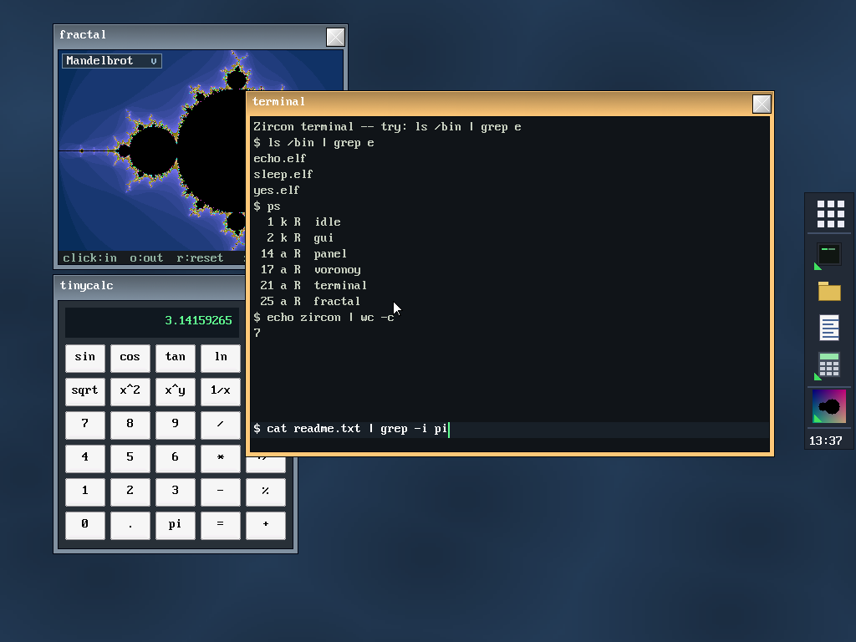 The desktop at startup: Voronoi wallpaper, panel on the right edge, and a few windows (fractal explorer, terminal, calculator).

5. The Onyx desktop
The "Onyx" desktop is made of two cooperating apps: the panel (panel) and the app list (applist).

The panel (panel)
A borderless bar, pinned to an edge of the screen (right with the shipped configuration; configurable via SD:apps/panel.app/config.ini, key position: 1=left, 2=top, 3=right, 4=bottom). It re-centers itself on its edge. It contains, in order:
- The "apps" button (9-square glyph): opens/closes the app list.
- The quicklaunch: the pinned icons listed in SD:apps/quicklaunch.txt (by default: terminal, filer, tinypad, tinycalc). A click launches the app (or brings it to the foreground if it is already open).
- The taskbar: the icons of the open apps (not pinned). A click brings the window to the foreground. An open app carries a small badge (triangle).
- The clock: updated every minute.

The app list (applist)
Clicking the "apps" button opens a scrolling grid of all the installed applications (any SD:apps/<name>.app/ folder). Click an icon to launch the app; the list then closes. Use the scrollbar if the grid overflows.
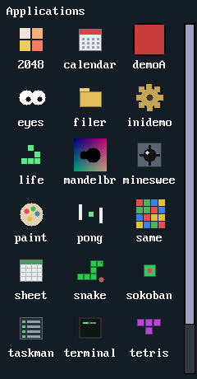 The app list (scrolling grid, opened from the panel's "apps" button).

Launching, closing, switching
- Launch: via the quicklaunch, the applist, the terminal (run <name>) or the file manager.
- Close: the × box on the title bar (normal windows), or via the task manager (taskman) / kill.
- Toggle: the "apps" button and certain icons use a toggle mechanism (a second click closes the launched app).

6. Working with windows
- Move: drag the title bar.
- Close: click the × box at the top right.
- Foreground / focus: click inside a window — it comes to the top and becomes active (chrome tinted differently). Inactive ones have a more muted tint.
- Borderless windows (panel, app list, certain gadgets) cannot be moved or closed with the mouse: they are managed by the desktop or close themselves.
- Mouse: left-click, right-click (depending on the app — e.g. flag in Minesweeper, eraser in Paint) and drag (paint, move, drag a slider).

7. The terminal and the shell
Launch terminal (pinned to the panel by default). It is a console where you type commands, executed by programs in SD:/bin/.
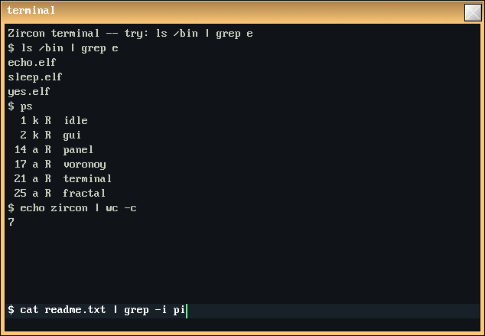 The terminal: a pipe (ls /bin | grep e), ps, and echo zircon | wc -c.

The prompt and the current working directory
- The prompt shows the current working directory followed by $ (e.g. SD:/ $). The terminal has a current working directory (cwd); relative paths given to commands are resolved against it.
- Type a command then press Enter. Backspace deletes the last character; Page Up/Down scroll through the output history (scrollback, 100 lines).

Built-in commands (builtins)
Three commands are executed by the terminal itself (they change its own state), not by a program in /bin:
Command | Effect
cd [path] | changes the current working directory (no argument: SD:/). The cwd is inherited by commands launched afterwards.
pwd | prints the current working directory.
clear | clears the screen (empties the scrollback).

Launching a program
Any other command xxx is resolved to SD:/bin/xxx.elf and executed as a process; its arguments, if any, follow the name (grep pattern, cp a b). A command that cannot be found prints xxx: command not found. To launch a graphical application from the terminal, use run <name> (see §8).

Pipes and redirections
The terminal composes commands in the Unix style:
Syntax | Effect
a | b | c | pipe: the stdout of each stage feeds the stdin of the next (up to 6 stages).
cmd > file | redirects the stdout of the last stage to file (created / overwritten).
cmd >> file | same, but appends to the end of file.
cmd < file | the input (stdin) of the first stage comes from file.
Path resolution. Redirection files are resolved by the kernel against the current working directory: a relative path (notes.txt) targets <cwd>/notes.txt, an absolute path (SD:/notes.txt) is taken as-is.
Default input and output. Without <, the first stage reads what you type: each line confirmed with Enter is sent to its stdin, and Ctrl-D signals end of input (EOF). Without >, the last stage displays its output in the scrollback.
Examples (with the cwd being SD:/ here):
pwd # prints: SD:/
cd apps # changes the current working directory (-> SD:/apps)
ls # list the current working directory
ls /bin | grep e # keep only the tools whose name contains "e"
cat SD:/notes.txt # display a file
echo bonjour > a.txt # write "bonjour" to <cwd>/a.txt
echo encore >> a.txt # append a line to a.txt
cat a.txt | wc # count lines / words / bytes
grep pi < a.txt # read a.txt, print only the lines containing "pi"
ps # list the processes
run mandelbrot # launch a graphical application
Under the hood. The terminal splits the line on |, creates a memory pipe (pipe) between each stage — and a file stream for </> —, then launches (spawn) each SD:/bin/<cmd>.elf with its (stdin, stdout) pair. The stages run concurrently (cooperatively); the terminal continuously drains the final output pipe (non-blocking read) and displays it, then waits for each process to finish. The details of streams and the process model are in Kernel internals §9.

8. The /bin tools
Command-line programs shipped in SD:/bin/, executed by the terminal and composable via pipes (§7). The relative paths they receive are resolved against the terminal's current working directory.
Files and directories
Tool | Usage | Description
ls | ls [path] | Lists a directory (default: the current working directory). One entry per line; folders get a trailing /.
cat | cat [file…] | Prints the file(s) to stdout; with no argument, copies stdin→stdout (useful at the end of a pipe).
cp | cp <src> <dst> | Copies a file (by stream: any size).
mv | mv <src> <dst> | Renames / moves a file or folder (same volume).
rm | rm <path…> | Deletes files (or empty folders); accepts multiple paths.
mkdir | mkdir <path…> | Creates one or more directories.
touch | touch <path…> | Creates empty files if they do not exist (no timestamp).
Text and streams
Tool | Usage | Description
echo | echo <text> | Writes its arguments followed by a newline.
grep | grep <pattern> | Reads stdin, prints only the lines containing <pattern> (substring, case-sensitive; only the first word is used as the pattern).
wc | wc | Counts and prints "lines words bytes" of stdin.
page | page | Copies stdin→stdout (the actual paging is the terminal's scrollback via Page Up/Down); handy as the end of a pipe.
Processes, launching, keyboard
Tool | Usage | Description
ps | ps | Lists the processes in columns PID K S NAME — K: a (app) / k (kernel); S: R (ready), S (sleeping), B (blocked), N (new).
kill | kill <pid> [--force|-f] | Terminates a process by PID (seen with ps). By default: clean shutdown (the app terminates itself); --force/-f: immediate stop. Kernel tasks and the terminal itself are protected.
run | run <app|path> [args] | Launches an application: run mandelbrot = SD:apps/mandelbrot.app/main.elf; a name containing / is taken as an explicit ELF path; the following arguments are passed as argv (e.g. run tinypad SD:/notes.txt).
keyb | keyb [XX] | With no argument: shows the current layout + the list. keyb FR: switches to the layout (US, UK, DE, FR, ES, IT, DV).

9. The file manager
Launch filer (pinned by default). It browses the SD card.
- Navigate: up/down arrow keys to select, Enter or Space to enter a folder, .. or Backspace to go up. Page Up/Down scroll.
- Open: double-click (or Enter) on an entry.
  - Text files (.txt, .ini, .md, .log, .cfg, .conf, .csv, .c, .h, .sh) → opened in tinypad.
  - .elf files → executed.
- Operations (shortcuts shown at the top):
  - d: delete the selection (with confirmation).
  - r: rename (pre-filled with the current name).
  - n: new folder (type the name then Enter).
Folders are shown in brackets and in blue; files show their size on the right.
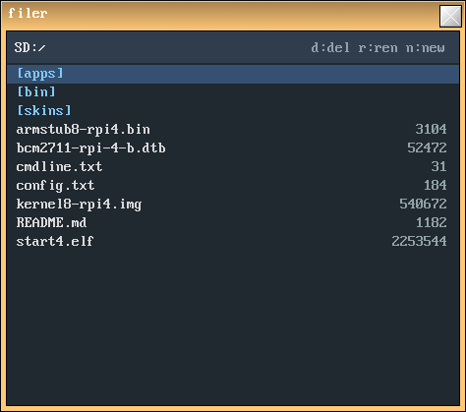 The file manager: folders in blue, files with their size, d/r/n shortcuts at the top.

10. Keyboard and layouts
The layout at boot comes from keymap= in cmdline.txt. To change it on the fly:
- At the command line: keyb FR (or US, UK, DE, ES, IT, DV). keyb alone shows the current layout and the list.
- Graphically: the theme editor (theme) offers a dropdown of layouts, applied live.

11. Customizing the appearance

The theme editor (theme)
The theme app lets you change live:
- the active chrome tint (foreground window),
- the inactive chrome tint (background windows),
- the title text color,
- the wallpaper color,
- the keyboard layout.
Click a color swatch to open the picker, choose the layout from the dropdown, then Apply (applies and persists by writing SD:skins/theme.txt + the voronoy config, and repaints the wallpaper) or Discard (cancels).

Manual theme editing
SD:skins/theme.txt (0xRRGGBB colors, re-read at boot):
active = 0xFFC878 # active window chrome (border + title)
inactive = 0x8090A0 # background windows
text = 0xFFFFFF # title text color
The window skin (wings.bmp) is grayscale; these tints are multiplied into it.

Startup and pinned apps
- SD:apps/autostart.txt: one app per line, launched at boot (folder name without .app). By default voronoy then panel.
- SD:apps/quicklaunch.txt: the apps pinned to the panel (top→bottom).

Wallpaper
At boot, voronoy draws a Voronoi pattern in the shared background buffer. Its color/density are set in SD:apps/voronoy.app/config.ini (and via the theme editor). The wallpaper persists after voronoy exits.

12. Application catalog
Tip: most games restart with r.

Gallery
A few applications (simulated screenshots, rendered from the real skins/font/icons by tools/screenshot/render.py):
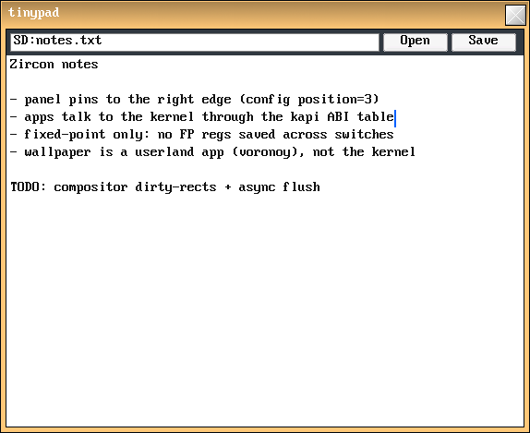 | 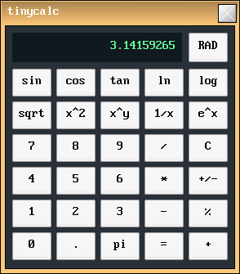 | 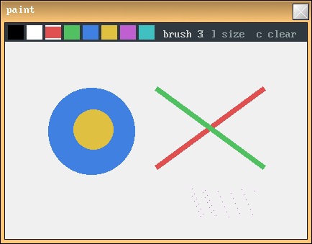
tinypad — text editor | tinycalc — calculator | paint — drawing
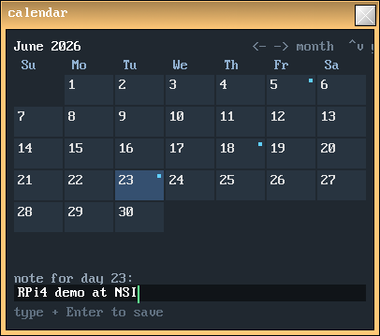 | 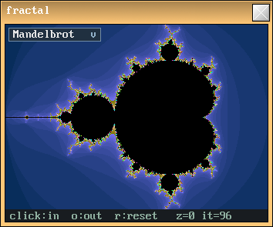 | 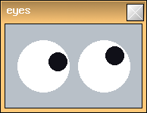
calendar — calendar + notes | mandelbrot — fractal explorer | eyes — gadget
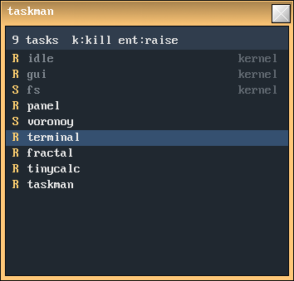 | 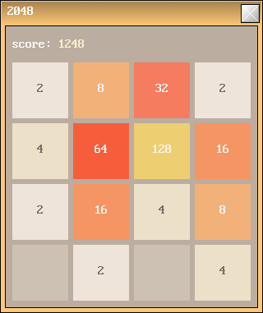 | 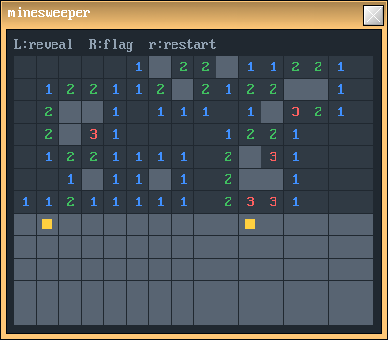
taskman — task manager | 2048 — tile game | minesweeper — minesweeper

Productivity and tools
App | Description and controls
tinypad | Text editor. Click the area to edit; arrows/Home/End/Page to navigate; Open/Save open file dialogs (loads/saves the whole file).
tinycalc | Scientific calculator (fixed-point). Buttons + keyboard (+ - * / ( ) ^ =), square root, trigonometric/exp/log functions.
sheet | Mini spreadsheet 8×16. Click a cell, type a value or a formula (=A1+B2*2, refs A1…H16, + - * / ( )); Enter/arrows confirm and move.
paint | Drawing. Palette of 8 colors at the top; drag to paint, right-click-drag to erase; [/] brush size; c clears; s saves SD:/paint.bmp.
calendar | Calendar + notes. Left/right arrows = month, up/down = year; click a day, type a note, Enter to save (agenda.txt in the app's folder).
filer | File manager (see §9).
terminal | Terminal/shell (see §7).
taskman | Task manager. Arrows to select; Enter brings the window to the foreground; k/Delete kills the app (except kernel tasks); r refreshes.
theme | Theme editor (see §11).
eyes | Gadget: two eyes whose pupils follow the mouse.
mandelbrot | Fractal explorer (Mandelbrot, Julia, Burning Ship, Tricorn via the dropdown). Click = zoom in (re-centers); o = zoom out; r = reset.
inidemo | Demonstration of the .ini reader (displays values from config.ini).
voronoy | Wallpaper generator (launched at boot; no window).

Games
Game | Goal and controls
tetris | Stack the pieces. Arrows: left/right/rotate/drop; Space: instant drop; r: restart.
snake | Eat to grow. Arrows: steer (no U-turn); r: restart.
2048 | Merge the tiles. Arrows: slide the whole board; r: restart.
minesweeper | Minesweeper. Left-click: reveal; right-click: flag; r: restart.
sokoban | Push each box onto a target. Arrows: move/push; r: restart the level; n: next level. (levels in levels.txt)
pong | Two players. Left: W/S; right: up/down arrows; first to 9; r: reset.
life | Game of Life. Click/drag: (de)populate cells; Space: run/pause; s: one step; c: clear; r: random.
same | SameGame. Click a group of ≥2 same colors to destroy it (collapse); r: new board.

Demos (technical examples)
Demo | Shows
demoA | Bouncing box (direct framebuffer access + file reading).
demoB | Animated color field (multitasking).
demoC | Fire effect; "Color" button to cycle the palette.
demoD | Widget gallery (label, textbox, checkbox, button, slider, progress bar).
demoE | Multi-line textarea + scrolling view with scrollbars.
demoF | Small borderless launcher (buttons A–E that launch the other demos).

13. Troubleshooting
- Nothing on screen / it freezes at boot. Check that all the files from sdcard/ are at the root of a FAT32 card, that config.txt correctly targets [pi4] and that kernel8-rpi4.img is present. Connect the serial (115200) to read the log.
- Black screen after launching an app, with green text. The app exited (or faulted): the debug console took over and shows the log. Note the message; in case of a fault, the ELR address helps locate the problem (cf. developer guide).
- Keyboard in the wrong layout. Set keymap= in cmdline.txt, or use keyb XX / the theme editor on the fly.
- Wrong resolution. Adjust width=/height= in cmdline.txt.
- An app stops responding. Since scheduling is cooperative, an app that never yields can freeze the system. If possible, kill it via taskman or kill; otherwise, restart.
- No mouse/keyboard. Check that they are standard USB HID devices and that they are plugged in at startup (hot-plug is handled, but the initial connection is the most reliable).

