**Name:** Darcy Eyres **Date:** September 11, 2021

**Summary:**

* Planned flight: CYYJ YYJ V495 HUH Hold (15) CYXX.RNAV Z 07 with miss (15) and back to CYYJ via V495.
* This document was prepared as part of planning for my IFR flight test.
* Walk though flight planning checklist in Foreflight as context for the planning and briefing.

**1. Minimum visibility to depart?**

As per the CAP GEN, take-off visibility is governed by visibility based on 1) RVR, 2) ground visibility if no RVR, or if it is fluctuating above and below, and 3) Pilot in command. For flight planning purposes takeoff minima are either ½ SM (RVR2600) or * for spec vis. Spec vis is based on the aircraft category – A 1SM, B – 1.5SM, C/D – 2SM. Category A are those with an approach speed <=90kts, B 91-120, C 121-140, D-141-165. A good example of * SPEC VIS is CYCD Nanaimo.

Victoria has 3 departure procedures – CYYJ5 is a vectored SID and CLOAK6 and MB8 are both pilot nav SIDs. All of the SIDs have a 1/2SM RVR2600 visibility requirement which at this time looks like we’ll have.

**2. Required climb gradient?**

The climb gradient is dependent upon the runway departing from. For example, for the CYYJ5 SID, runway 09 has no listed climb gradient. Where as RWY 14 has a minimum climb gradient of 420 ft/nm for 800’ ASL. Things to watch out for:

1. For all departures there is an expectation of 1) 35’ or greater beyond the departure end of the runway. 2) no turns before 400’ AGL, 3) A climb gradient of at least 200’/nm to the Minimum Enroute Altitude (MEA).
2. Climb gradients are NOT ft/min. In order to understand ft/min you need to look at the table often included with SIDs, or calculate it. For example, 420’/nm x 90 KIAS/60 seconds = 630’/min.
3. In a Cessna 172, often we’ll climb at 74 KIAS to 400’ AGL and then transition to a cruise climb at 90 KIAS giving us **700-1000’/min**. Have a look at POH maximum rate of climb to understand performance – sea level, fully loaded, at 20 degrees celsius, shows only 710 FPM. Watch out, because at a higher elevation airport like Cranbrook for example, or on a hot day, or with a heavier load you might find it hard to meet the climb gradient. Just pay attention because you are accountable to ensure obstacle avoidance during departure.

**3. When would you turn on course?**

Not until cleared by ATC, and in all cases not below 400’ AGL. Specifics of the navigation are documented with each SID. For example, CYYJ5 is a vectored SID. Departing 027, 089, or 135 all show three dots on the diagram. So that means take off on the appropriate RWY direction and maintain this, contact VIC TERM as noted above 1000’ and ATC will assign a new heading. We cannot make a turn on course until cleared by terminal.

The CLOAK6 and the MB8 departures are pilot navigation. With this type of SID we follow the vertical and lateral navigation as outlined in the SID. For the MB8 departure off 27 with a Vancouver transition, we track to MB, OB from MB 306 and intersect INBD 221 YVR. These are all done on our own unless we are instructed differently. The instruction with the pilot nav SIDs is to contact VIC TRML passing 1000’.

**APPROACH at CYXX:**

**1. What approach?**

For RWY07 our choices are 1) ILS RWY 07 – ILS, LOC, or circling or 2) RNAV (GNSS) Z Rwy 07 – LPV, LNAV/VNAV, LNAV, circling. For the categories without vertical guidance CDA calculations have been done and added to each chart.

For the flight test, we’re planning on a RNAV Z RWY 07 to LNAV minima (MDA = 760 ASL). We plan to go missed.

**2. Define how you would stepdown on the approach?**

Step downs are inherently less stable, so let’s review the plan for executing the constant descent angle (CDA) method since this gives us better stability. Many of the approach charts include CDA information if standard – CYXX ILS07 does, but many do not, so best to know how to do these calculations for yourself. I’ve also created an excel spreadsheet to make these calculations where this info is not provided – e.g. US approach charts.



We can always do the math to figure out the angle and the Top of Descent distance, which I’ll do here for future reference.

**Descent angle:** tan-1 (2nd func on iphone) = descent / (nm x 6070 ft/nm). so tan-1 [1775/5.6x6070]=2.99 degrees. In this case the plate tells us we have a ~ standard 3 degree approach. If we fly that perfectly, the TCH 50’ means that we’ll be 50’ high as we go over the threshold of the runway.

**Descent rate:** we need 300’/nm in this case, and let’s assume we’re configured for 90 KIAS. 300’/nm x 90 kts GS/60 minutes = 300 x 1.5 = 450’/min. Notice that the chart shows a little higher rate at 480 ft/min. Using the 1 in 60 rule, 1 degree of descent gets you 100’/nm. So if the descent angle was 4 then 400 x 1.5 = 600’/min at 90 KIAS. If you were in a faster approach aircraft like a Cirrus SR22 at 120 Kts GS then for a standard approach 300 x 120/60 = 600’/min descent.

**TOD:** Using the CDA table, we can see where we need to start descending. For example, if we are at 3000’ as we are being vectored in for the RNAV Z 07, then we’ll need to start a descent 3.4nm from LERIM. If we were at 4,000’ then we would start our descent at MISAR, which is 6.7nm from LERIM. NOTE: Watch out, because when you are in the plane the GARMIN 530 will report distance to a waypoint, not distance to the MDA.

**DIVING:** Another way to descent would be to drop quickly, say 1000’/min to get down to the minimum altitudes for each of the fixes. The disadvantage is that this approach is less stabilized so a CDA is preferable. Current flight test standards discourage this kind of descent.

1. **How do you ensure protected airspace on the full procedure?**

Where there is a published procedure turn on the approach plate, such as for the ILS07, the important thing is to stay on the protected side, and also within any noted distances. For the ILS07 at CYXX this means SW of FAC and within 8nm of the XX NDB. The RNAV Z 07 does not have a PT. We do need to check that the GPS is in LPV mode at least 2nm from the FAWP/FAF depending on the approach type.

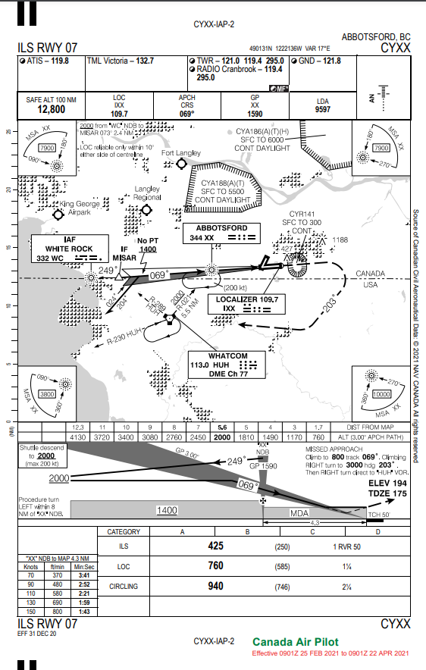

**4. Is an RVR approach ban a possibility for RNAV Z 07? If so, when would it come into effect?**

Generally, each approach plate has an advisory visibility depending on the aircraft category. For CYXX the RNAV Z has an advisory visibility of 1SM / RVR50. If the METAR is better than that it is likely that you’ll be able to see one of the required visual references and be able to land with the approach.

But sometimes the visibility is low enough that an approach ban comes into play and you’re not even allowed to start the approach unless there are some factors in play as noted below. For example, if low visibility procedures are in effect, then we are not even allowed to commence the approach. There are different rules for GA, commercial (.75 the advisory vis), and commercial ops spec (.5 advisory vis). See the CAP for the exact values for each category.

In Canada, instrument approaches are governed by RVR (runway visibility range). Below is the GA requirement and the commercial operator visibility (because we are in a Victoria flying club plane).

|  |  |
| --- | --- |
|  |  |

An RVR report takes precedence over a runway visibility report or a ground visibility report, and a runway visibility report takes precedence over a ground visibility report. Ground visibility will only impose an approach ban at aerodromes south of 60°N latitude. If no RVR, runway visibility, or ground visibility is reported, there are no criteria to impose an approach ban. (This concept is similar to the present Subpart 602 of the CARs approach ban, where if there is no RVR reported; there is no criterion to impose an approach ban). An RVR report is the only visibility report that can impose an approach ban applicable to helicopters. The following exceptions to the above prohibitions apply to all aircraft:

* when the visibility report is below the required value and the aircraft has passed the FAF inbound
* the pilot-in-command has informed the appropriate ATC unit that the aircraft is on a training flight and that the pilot-in-command intends to initiate a missed approach procedure at or above the DA(H) or the minimum descent altitude, as appropriate.
* the RVR is varying between distances less than and greater than the minimum RVR;
* the ground visibility is varying between distances less than and greater than the minimum visibility;
* a localized meteorological phenomenon is affecting the ground visibility to the extent that the visibility on the approach to the runway of intended approach and along that runway, as observed by the pilot in flight and reported immediately to ATS, if available, is equal to or greater than the visibility specified in the CAP for the instrument approach procedure conducted; or
* the approach is conducted in accordance with an Ops Spec issued in accordance with subparts 703, 704 or 705 of the CARs.

No pilot shall commence a non-precision approach, an APV, or a CAT I precision approach to an airport where low-visibility procedures are in effect. Low visibility procedures are associated with CAT III operations. They are specified for an airport in the Canada Air Pilot and restrict aircraft and vehicle operations on the movement area of the airport when the runway visual range is less than 1,200 feet.

The CAP advisory visibility for RNAV Z 07 to LNAV minima is 1 ¼ miles. If the RVR is less than 5000’ or it is fluctuating above and below this value, then if the GND vis is less than 1 mile, then an approach ban comes into play and we are not allowed to start the approach unless one of the conditions above is met. Since we plan to execute a missed approach, the approach ban will not come into play.

1. **Cold temperature corrections.**

Pressure altimeters are calibrated to indicate true conditions under ISA conditions. This means sea level pressure of 29.92” of mercury and, 15 degrees Celsius. If the temperature is greater than this the altimeter will show altitudes which are higher than actual. And if the temperature is colder, then the true altitude will be lower than what is shown. Given that we are already approaching within 200’ AGL on the ILS this could be super dangerous for us.

As a general rule this is considered to be 0°C or, when MDAs/DAs are 1 000 ft HAA or higher, it begins at 10°C. From the AIM the following table can be used

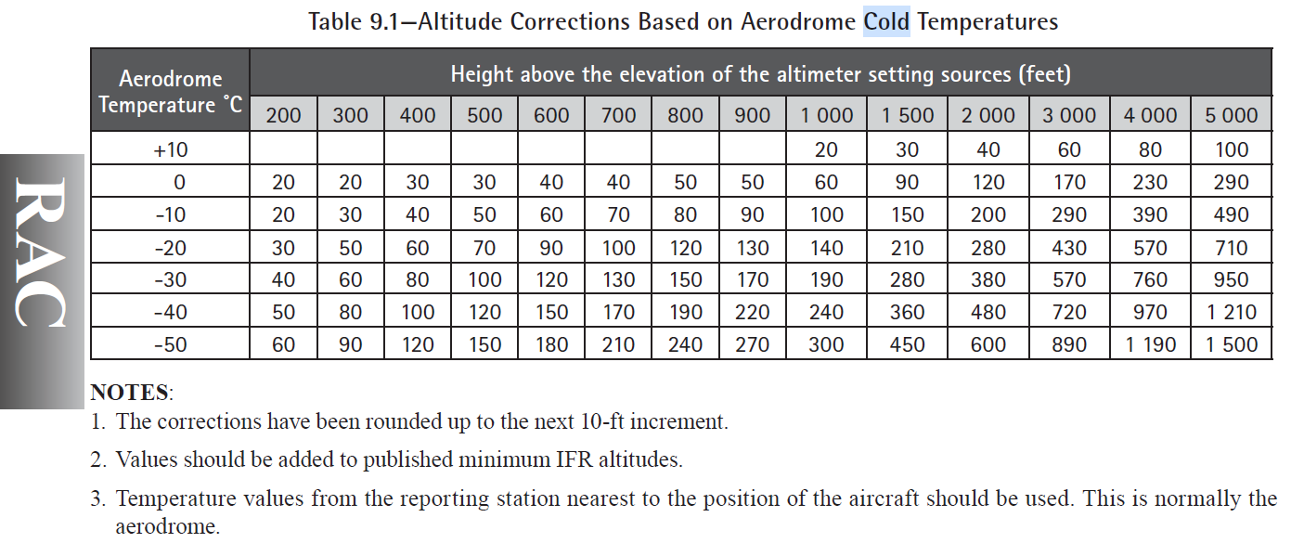

Something noted in the AIM is that ATC assigned vectoring altitudes assigned by ATC are temperature compensated and we should not apply an additional correction. If we would like to apply cold weather correction on say a FP, then we should advise ATC.

An excel spreadsheet has been prepared so that these calculations can be quickly done for any approach plate. Below is the example for CYXX RNAV Z 07 at -10, 0, and 10 degrees Celsius.







Key learning – as the temperatures get lower and the height above the altimeter setting sources get higher, the cold weather correction can be significant. For example, at -50 degrees Celsius and 5000’ above the source, the correction is 1,500’. If you are in IMC then you cannot see just how close you may be coming to obstructions.

**6. If we wanted to utilize CYXX as our legal IFR alternate, then what are the minimums ceiling and visibility required?**

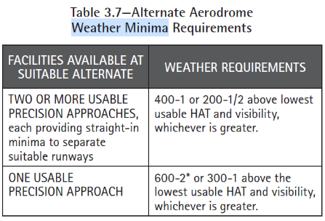The tables below are from the AIM. There are similar tables in the CAP GEN.

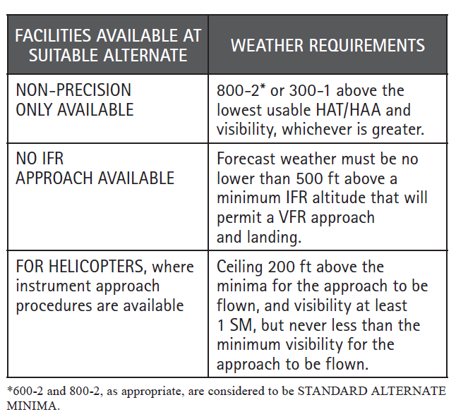 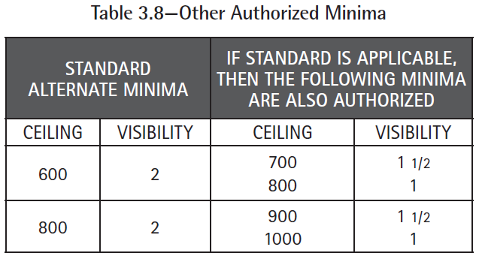

* CYXX has a TAF, but if it did not and we only had a GFA then the following rules would apply – 1) No cloud lower than 1000’ above the lowest usable HAA/HAT. 2) No cumulonimbus, 3) Visibility of >= 3SM. Note that GFA is MSL so need to consider terrain to get the AGL.
* If an airport has only an advisory forecast, then we can have no weather lower than 500’ above the lowest HAT, and we need >= 3SM visibility.

For CYXX only 7/25 have approaches ILS07, RNP 7/25 (we don’t have equipment/cert for this) and RNAV Z 07 (non-precision). There are no approaches for 1/19. So in this case we have 1 useable precision approach – ie wind, NOTAMS etc are all OK. So we need:

a) 600’ HAA/HAT and 2SM visibility

b) 300’ HAA/HAT added onto the TAF value and 1 SM added onto the TAF visibility. On the ILS 07 plate HAA is 250’ and recommended visibility is 1SM. So added this is 550-2.

The greater of 600-2 and 550-2 gives us 600-2 as the minima, which is standard. So we can also use the sliding scale in table 3.8 above so that we could also use 700-1 ½ or 800-1.

Remember that for altitudes > 20’ U need to round up to the next 100’ elevation. For example, 736’ would round up to 800’.

At the time I am typing this the TAF is P6SM visibility and BKN020, OVC040. So, no problem to use CYXX as our legal alternate.

**7. If we wanted to utilize CYYJ as our legal IFR alternate, then what are the minimums ceiling and visibility required?**

* Can only take credit for a single precision approach as the RNAV ones are not going to count as less than 100nm.
* So using ILS09 we’d be 600-2 or 300-1 HAT/HAA which is 250-1 or in total 550-2. We use the higher so 600-2 would be our alternate requirements and we could use the sliding scale.