SRM IST-RAMAPURAM

SUBJECT CODE:18CSC206J

SUBJECT NAME: SOFTWARE ENGINEERING AND PROJECT MANAGEMENT

YEAR/SEMESTER: 2nd/ 3rd
SECTION: ‘I’

TOPIC: ONLINE RAILWAY RESERVATION

PROJECT BY: Stephanie Grace Stanly

 | S.no | Date | Content | Page No | Signature
 | 1 |  | Problem Statements  - –Identify the Software Project  - - Create Business Case  - –Arrive at a problem statement
 | 2 |  | Stakeholders & Process Models  - – Identifying Stakeholders  - – User story  - - Identify the Appropriate Process Model  - - Arrive at a Problem Statement  - - Comparative Study with Agile
 | 3 |  | Identifying The Requirements From Problem Statement  - – Requirements Elicitation  - – Feasibility Study  - – Functional Requirements  - - Non-Functional Requirements  - – System Requirements
 | 4 |  | Project Plan and Project Eﬀort Based On Resources  - – Project Plan  - - Identify Job Roles and Responsibilities
 | 5 |  | Project Eﬀort Based On Resources  - - Work Breakdown Structure  - – Risk Analysis
 | 6 |  | Estimation of Project Metric’s  6.1.1 - Function Point Analysis | COCOMO Model
 | 7 |  | Design  7.1.1 - System Architecture

 | 8 |  | Modeling Uml Use Case Diagrams & Capturing Use Case Scenarios  - - Use case diagrams  - – Identifying Actors  - – Use Case  - - Association between Actors and Use Cases  - - Use Case Relationships  - – Include Relationship  - - Extend Relationship  - – Generalization Relationship
 | 9 |  | E-R modeling from the Problem Statements  - - Entity Relationship Model  - - Entity Set and Relationship Set  - - Attributes of Entity  - -Keys  - – Weak Entity
 | 10 |  | Identifying Domain Classes From The Problem Statements  - – Domain Class  - – Using Generalization  - – Using Subclasses
 | 11 |  | State chart& Activity Modeling  - – State chart Diagrams  - -State  - -Transition  - -Action  - – Activity Diagrams  - -Components of an Activity Diagram
 | 12 |  | Modeling UML Class Diagram & Sequence Diagrams  - – Class diagram  - -Class  - -Relationships  - – Sequence diagram  - -Object  - - Life-line bar
 | 13 |  | Modeling Data Flow Diagram  - - Data Flow Diagram  - - Context diagram and leveling DFD
 | 14 |  | Implementation  - - Addition of New requirement  - - Addition of New Issue
 | 15 |  | Estimation of Test Coverage Metrics &Structural Complexity  - - Control Flow Graph  - - McCabe's Cyclomatic Complexity  - - Optimum Value of Cyclomatic Complexity
 | 16 |  | Designing Test Suites  - - SoftwareTesting  - - Testing Frameworks  - - Master Test Plan  - - Manual Testing
 | 17 |  | Deployment Report
 | 18 |  | Conclusion
 | 19 |  | References
Project Completed In The Session 2019-2020

1.1 PROBLEM STATEMENTS

1.1.1 Identify the Software Project

Online Railway Reservation

This project will give us the information about the railway reservation. This system is basically concerned with the reservation and cancellation of railway tickets to the passengers. To be more specific, our system is limited in such a way that a train starting from a particular source will have a single destination.
The basic functions being performed by our system are reservation and cancellation.
Customer can find the proper and correct information about the railway and shows the:
- It reserves and cancels seats for passengers.
- It contains information about trains.
- It contains information about seat availability.
- Railway time table.
- Train ticket booking.
- Reservation possibilities.

1.1.2 CREATE BUSINESS CASE
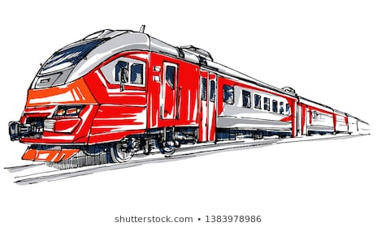

DATE
SUBMITTED BY | Stephanie Grace Stanly
TITLE / ROLE | ONLINE RAILWAY RESERVATION

THE PROJECT
In bullet points, describe the problem this project aims to solve or the opportunity it aims to develop.
- This project aims to focus on booking of trains both local and express.
- It helps to overcome the problem of standing in queues for buying up of the same ticket that one can buy online.
- It saves time and energy.
THE HISTORY
In bullet points, describe the current situation.
- The current situation deals with standing in queues for hours.
- The seats allotted by random order and one cannot choose the seat that one prefer.
- Only list can tell us about the current situation of our seat availability.
LIMITATIONS
List what could prevent the success of the project, such as the need for expensive equipment, bad weather, lack of special training, etc.
- Large number of servers are required by the online booking platform to book large number of tickets within seconds.
- Due to bad weather connectivity can be lost between the user and the platform.
APPROACH
List what is needed to complete the project.
- User information such as name, age, sex.etc.
- Distance between the stations should be noted to calculate the total amount of fare.
- Trains availability and information is needed.
- Availability of seats is required.

BENEFITS
In bullet points, list the benefits that this project will bring to the organization.
- It helps to overcome the problem of standing in queues for buying up of the same ticket that one can buy online.
- It saves time and energy.
- User can book the ticket on spot.
- User can choose their own seats according to their preferences.
- User can always check the seat availability.
DISCLAIMER

Any articles, templates, or information provided by Smart sheet on the website are for reference only. While we strive to keep the information up to date and correct, we make no representations or warranties of any kind, express or implied, about the completeness, accuracy, reliability, suitability, or availability with respect to the website or the information, articles, templates, or related graphics contained on the website. Any reliance you place on such information is therefore strictly at your own risk.

1.1.3 Problem Statement
Online Railway Reservation

Session 1: Project Description

- The main objective of this project shows that this system is basically concerned with the reservation and cancellation of railway tickets to the passengers.
- Users can book their seats according to their preferences.
- It contains information about seat availability.
- The current situation deals with standing in queues for hours.
- This project aims to focus on booking of trains both local and express.
- It helps to overcome the problem of standing in queues for buying up of the same ticket that one can buy online.
- It saves time and energy.

2.1.1 STAKEHOLDERS

- One of the most important stakeholders for online railway reservation can be railway station staff.
- Stakeholders also include railway conductors.
- Railway department administration and people working for it helps to solve some major problems.
- System engineers also play a key role in online railway reservation.
- Indian government has a major impact on railways and therefore is considered a very important stakeholder.
- For booking online a strong mobile and internet service provider is needed so as to successfully implement the project. The mobile and internet service provider has an influence over the other stakeholders as with a proper internet connectivity customers cannot book the tickets.
- Net banking or E-wallet is also important and solve potential problems and helps the customer to pay for their tickets from anywhere they want.
- The most important and the end users are the passengers who have the power to make the project succeed without whose involvement everything would collapse.

2.1.2 USER STORY

S no. | User Story | Success criteria | Owner | Point & Status
1 | As a User  I have an ardent desire to safeguard my company from all type of threats and want to monitor all the activities | Good result is obtained | User | Moderate
2 | As a Developer:  I want to conduct meeting every day so that I can develop the application also have a work-oriented space | Application is created | Developer  - Stephanie Grace Stanly | Moderate

2.2.2 Session 2

Problem Constraints

- It helps to overcome the problem of standing in queues for buying up of the same ticket that one can buy online.
- It saves time and energy.
- User can book the ticket on the spot.
- User can choose their own seats according to their preferences.
- User can always check the seat availability.
- Large numbers of servers are required by the online booking platform to book large number of tickets within seconds.
- Due to bad weather connectivity can be lost between the user and the platform.
- The main objective of this project shows that this system is basically concerned with the reservation and cancellation of railway tickets to the passengers.
- Users can book their seats according to their preferences.
- It contains information about seat availability.

2.2.3 COMPARATIVE STUDY WITH AGILE

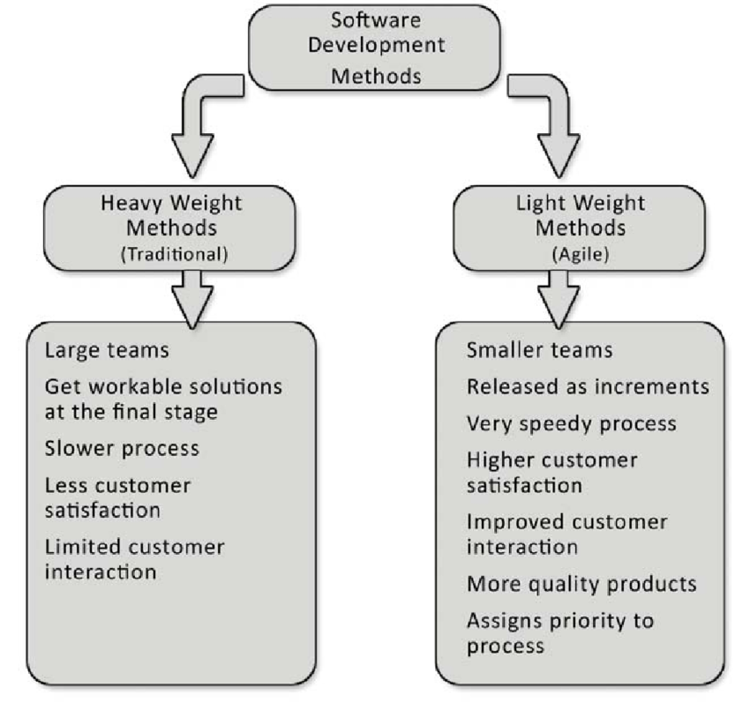

3.1 REQUIREMENTS

There are 4 types of requirement for our project to be successful
1. SYSTEM REQUIREMENT
The system needs the ability to do the following things given below as the requirements:
- User management of railway reservation services.
- Reservations and seat management of railway reservation service.
- Transactions of railway reservation services.
- Ticket display management of railway reservation service.

Now, this system has intended in such a way that it takes fewer resources to work out properly. The development of this project needs the following hardware and software requirements.

Software Requirement:
- Language / Packages : Turbo C++
- Version : Turbo C++ 3.1
- Operating systems : Windows 10
- Communication protocol : HTTP Protocol

Hardware Requirement:
- Processor Clock speed : Premium IV with 800MHz
- RAM :412 MB
- Hard disk capacity : 10 GB

2. FUNCTIONAL REQUIREMENT

- USER SATISFACTION-
This system is such that it stands up to the user expectations.

- ERROR HANDLING-
Responds to the user errors and undesired situations has been taken care to ensure that the system operate without any halting.

- USER FRIENDLY-
The system is so easy that even a native user can use this to book tickets online.

- DESIGN CONSTRAINTS-
There are a number of factors in the client’s environment that may restrict the choice of a designer. Such factors includes standards that must be followed, resources limits , operating environment, reliability and security requirements and policies that may have an impact on the design.

3. NON FUNCTIONAL REQUIREMENT
- SECURITY-
- The user’s back-end information shall only be accessible to authorized management.
- User information is completely secured.
- USEABLITY-
- The system must be quickly accessible by both user and railway management.
- The system must be intuitive and simple in the way it displays all the relevant information.
- The time table must be easily displayed to the user.
- RELIABLITY-
- The system must give accurate seat status to the user continuously.
- Any enquiries are taken care by the regular confirming of the actual levels with the levels displayed in the system.
- The system must successfully book any seat given by the user and provide estimation and booked status in relevance with the newly updated entities.
- PERFORMANCE-
- All the functions of the system must be available to the user any time the system is turned on.
- The calculation performed by the system must comply according to the distance between the origin stations to the destination station, which is set by the user according to his or her requirement.
- IMPLEMENTATION-
- A basic system user interface is built.
- The programming is done in C++.
- A basic database is implemented.
- INTERFACING-
- The system must offer an easy and simple way of viewing the current system.
- The system must be able to deliver a great user experience.

Schedule Resource & Budget Constraints

- No high budget tools are required.
- Main Component is Wi-Fi adapter.

Software Requirement:
- Language / Packages : Turbo C++
- Version : Turbo C++ 3.1
- Operating systems : Windows 10
- Communication protocol : HTTP Protocol

Hardware Requirement:
- Processor Clock speed : Premium IV with 800MHz
- RAM :412 MB
- Hard disk capacity : 10 GB

Documentation Tools:
- Microsoft word 2016

4.1.1 PROJECT PLANNING

Deadlines
S.no | Task | Date
1 | Problem Statements | Start Date - 24-12-2020 End Date - 31-12-2020
2 | Stakeholders & Process Models | Start Date - 31-12-2020 End Date - 07-01-2020
3 | Identifying the Requirements from Problem Statements | Start Date - 07-01-2020 End Date - 14-01-2020
4 | Project Plan | Start Date - 14-01-2020 End Date - 21-01-2020
5 | Project Effort Based on Resources | Start Date - 21-01-2020 End Date - 28-01-2020
6 | Estimation of Project Metrics | Start Date - 28-01-2020 End Date - 04-02-2020
7 | Modeling UML Use Case Diagrams and Capturing Use Case  Scenarios | Start Date - 04-02-2020 End Date - 11-02-2020
8 | E-R Modeling from the Problem Statements | Start Date - 11-02-2020 End Date - 18-02-2020
9 | Identifying Domain Classes from the Problem Statements | Start Date - 18-02-2020 End Date - 25-03-2020
10 | Statechart and Activity Modeling | Start Date - 25-03-2020 End Date - 03-03-2020
11 | Modeling UML Class Diagrams and Sequence diagrams | Start Date - 03-03-2020 End Date - 10-03-2020
12 | Modeling Data Flow Diagrams | Start Date - 10-03-2020 End Date - 17-03-2020
13 | Implementation | Start Date - 17-03-2020 End Date - 24-03-2020
14 | Estimation of Test Coverage Metrics and Structural  Complexity | Start Date - 24-03-2020 End Date - 30-03-2020
15 | Designing Test Suites | Start Date - 30-03-2020 End Date - 03-04-2020
16 | Deployment Report | Start Date - 03-04-2020 End Date - 10-04-2020

4.1.2 ROLES AND RESPONSIBILITES

- Subject Matter Experts (SME): Stephanie
- Product Owner : Stephanie
- Project Manager (PM) : Stephanie
- Technical Lead : Stephanie
- Software Developers : Stephanie
- Software Tester : Stephanie
- User Acceptance Testers : Stephanie

5.1.1 Work Breakdown Structure

WBS OUTLINE

- Online Railway Reservation
- Train Timetable
  - View Timetable
  - Confirm Train Information
- User
  - Name
  - Age
  - Gender
- Reserve
  - Coach
  - Seats
  - Confirm reservation
- Fare
  - Fare Details
  - Payment options
  - Confirm payment
- Ticket
  - Print Ticket

5.1.2 RISK ANALYSIS-SWOT ANALYSIS

STRENGTHS-
- Easy to use User Interface
- It helps to overcome the problem of standing in queues for buying up of the same ticket that one can buy online.
- This system is basically concerned with the reservation and cancellation of railway tickets to the passengers.
- It saves time and energy.
- User can book the ticket on the spot.
- It contains information about seat availability.

WEAKNESS-
- Large numbers of servers are required by the online booking platform to book large number of tickets within seconds.
- Due to bad weather connectivity can be lost between the user and the platform.
- Unable to attract the audience with less Internet experience or daily usage.
OPPORTUNITIES-
- Helps in development of railways in the country.
- Helps in increasing the average GDP of the country.
- Increased mobile and internet users in the middle class section of the country.

THREATS-
- Fluctuations in currency and its exchange rates.
- Irrational market response or reaction from the user.
- Fluctuated seasonal demands of the customer.
- Less Reliability on online payment options.

FUNCTION POINT ANALYSIS
6.1.1 COCOMO MODEL

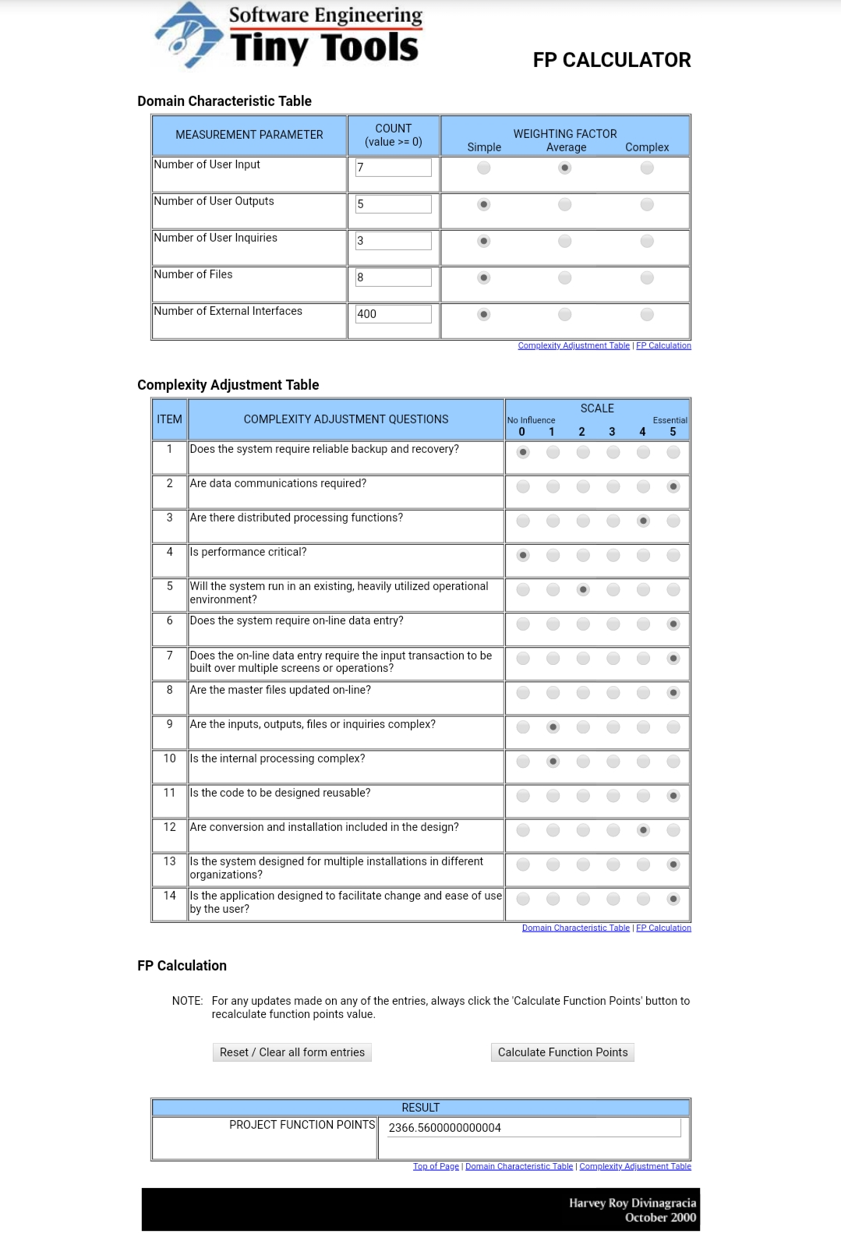

7.1.1 System Architecture

1218 Wang Zongjiang / Physics Procedia 33 ( 2012 ) 1217 – 1223

Figure 1 System architecture
The database layer The database is used to hold data, including user registration information, ticket
ordering information, ticket information and all of the other information.
The application service layer The application service layer is the core of this three-layer structure,
the system functions and business logic are handled in this layer. In this layer, the system's business logic
is encapsulated, the application service interfaces is provided for the user interface layer and the system
modules between the function calls. The application service layer also updates data in the database,
according to the service request of the top layer.
The user interface layer The user interface layer is a program that runs on a remote user computer. It
displays the provided services by the server to the user. When the user selects a service, this program
sends request to the server. When the server returns the processed result, this program shows it to the
user.
1218 Wang Zongjiang / Physics Procedia 33 ( 2012 ) 1217 – 1223

Figure 1 System architecture
The database layer The database is used to hold data, including user registration information, ticket
ordering information, ticket information and all of the other information.
The application service layer The application service layer is the core of this three-layer structure,
the system functions and business logic are handled in this layer. In this layer, the system's business logic
is encapsulated, the application service interfaces is provided for the user interface layer and the system
modules between the function calls. The application service layer also updates data in the database,
according to the service request of the top layer.
The user interface layer The user interface layer is a program that runs on a remote user computer. It
displays the provided services by the server to the user. When the user selects a service, this program
sends request to the server. When the server returns the processed result, this program shows it to the
user.
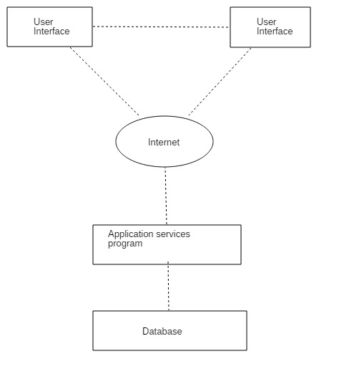

Figure 1 System architecture
The database layer The database is used to hold data, including user registration information, ticket
ordering information, ticket information and all of the other information.
The application service layer The application service layer is the core of this three-layer structure,
the system functions and business logic are handled in this layer. In this layer, the system's business logic
is encapsulated, the application service interfaces is provided for the user interface layer and the system
modules between the function calls. The application service layer also updates data in the database,
according to the service request of the top layer.
The user interface layer The user interface layer is a program that runs on a remote user computer. It
displays the provided services by the server to the user. When the user selects a service, this program
sends request to the server. When the server returns the processed result, this program shows it to the
user.

SYSTEM ARCHITECTURE DESCRIPTION

- The database is used to hold data, including user registration information, ticket ordering information, ticket information and all of the other information.
- The application service layer is the core of this three-layer structure, the system functions and business logic are handled in this layer. In this layer, the system's business logic is encapsulated, the application service interfaces is provided for the user interface layer and the system modules between the function calls.
- The user interface layer is a program that runs on a remote user computer. It displays the provided services by the server to the user. When the user selects a service, this program sends request to the server. When the server returns the processed result, this program shows it to the user.
8.1.1 USE CASE DIAGRAM

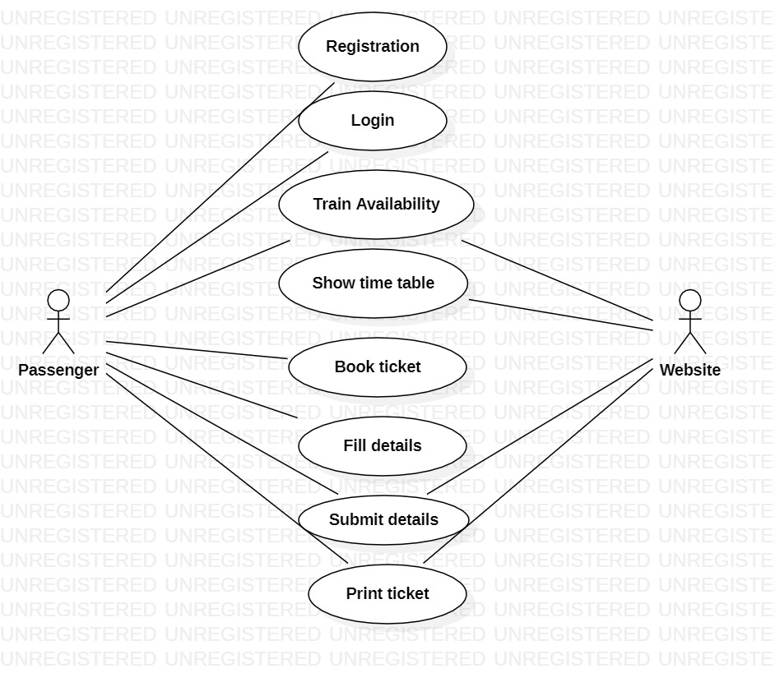

S.No | 8.2.1 Association between actor and use case
1 | Actors In Project |  | - Passenger  - Website
2 | Use Case In Project |  | - Registration  - Login  - Train Availability  - Show Time Table  - Book Ticket  - Fill Details  - Submit Details  - Print Ticket
3 | Association between Actors & Use Case |  | - Passenger: - The Passenger must be able to enter the data and perform a booking operation.  - Website: - Website will provide all the task associated with Booking operations
8.2.2 USECASE RELATIONSHIP
1 |  | Relationship  8.2.2.1 Include Relationship  8.2.2.2 Extend Relationship |  | - Passenger is performing include relationship  - Website will perform extend relationship
8.2.3 Generalization Relationship
1 |  | Generalization Relationship |  | All the actors have to go through the login use case module first and a her successful login they will be redirected to their dashboard which include all the sub routine class belonging to the particular actor with history viewer and account seeing enabled with pinging feature

9.1.1 Entity Relationship Diagram

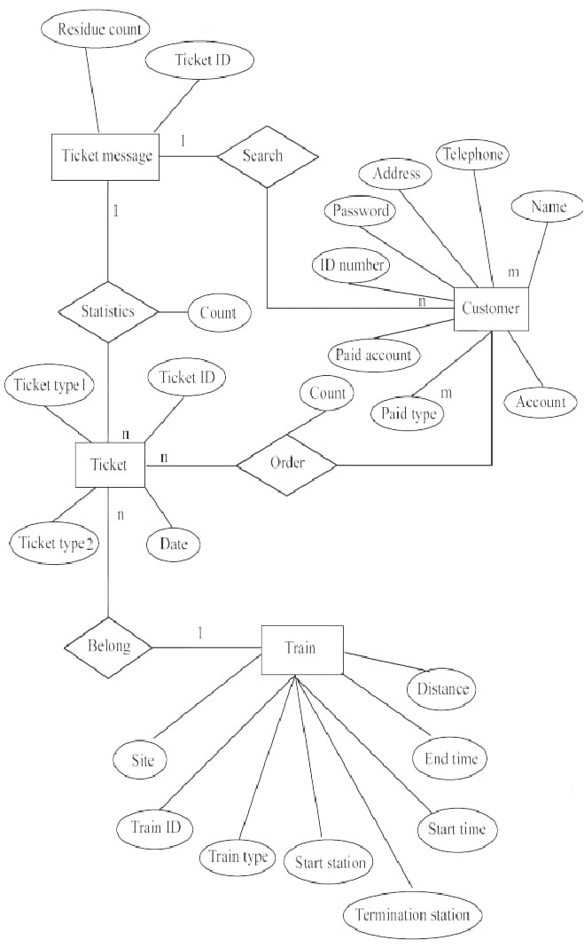

S. No | 9.1.2 ENTITY SET AND RELATIONSHIP SET
1 | Entity Set  &  Relationship Set |  | 1:- Entity Set  System Administrator  - Network administrator  - Network Designer  Technical Team  - User Actions  - Network  - Tools Other  - users  2:- Relationship Set  System Administrator:-System administrator access the feedback section and assign role to technical team. The software up gradation is done by the system administration only.  Network Administrator : - Network administrator access the network area tools and monitor the network. The  Other role sunder network category is assigned by network administrator.  Network Designer : - Network designer access the analyzing tools of network class. The alteration in  The network design is done by the network designer.  Technical Team:-Technical team upgrade and degrade the software on the basis of feedback and report sanctioned by the system administrator.
9.1.3 ATTRIBUTES OF ENTITY
1 |  | Attributes of Entity  9.1.3.1 Keys  9.1.3.2 Weak  Entity | - Keys:-Customer-id will be used as the primary key.  - Candidate Key:-User-Id, Name, Email-id  - Weak Entity:-Network tool is available only when network is available.
10.1.1 CLASS DIAGRAM

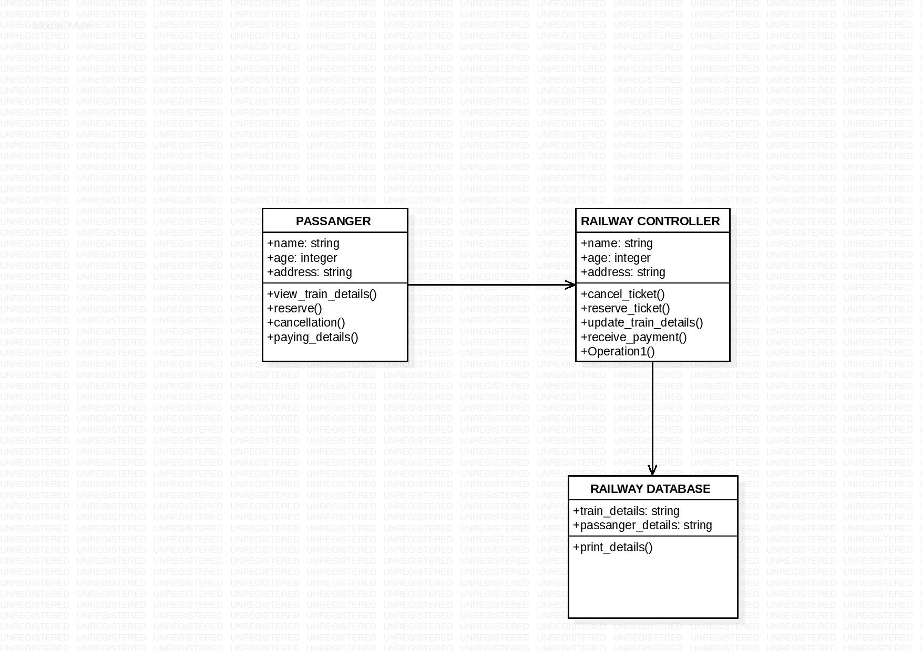

CLASS DIAGRAM DESCRIPTION
10.1.2  Generalization | Generalization is the process of extracting shared characteristics from two or more classes and combining them into a generalized super class.  Shared characteristics can be attributes, associations, or methods.  Generalized Class Example in Online Railway Reservation : -  - Passenger  - Railway Controller  - Railway Database  Des
10.1.3 Sub-Class | - Train Details  - Reserve  - Cancellation  - Payment  - Print Details  stem Administrator

11.1.1 STATECHART DIAGRAM

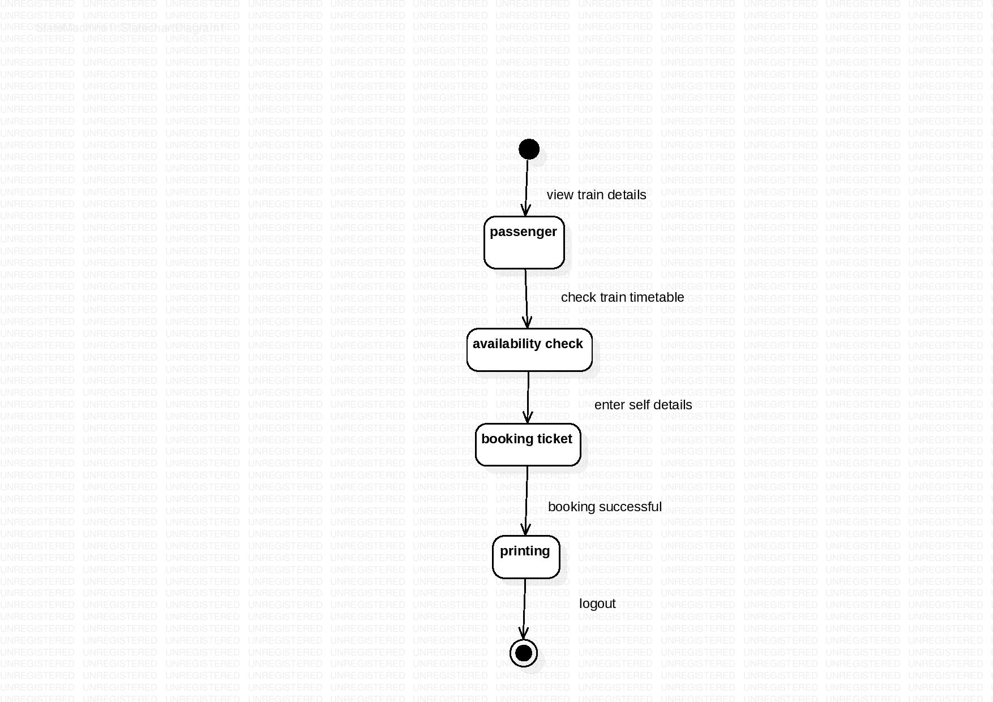

STATECHART DESCRIPTION
11.1.2 States | States In Online Railway Reservation Are : -  - Passenger : This state generate the details of the passenger  - Seat availability : This state show all the available seats as preferred by the passenger  - Booking Ticket : This state takes the input of the passenger details wishing to travel.  - Printing: This state allows the passenger to take print of their train ticket as preferred by him.
11.1.3 Transitions | .

11.1.5 ACTIVITY DIAGRAM

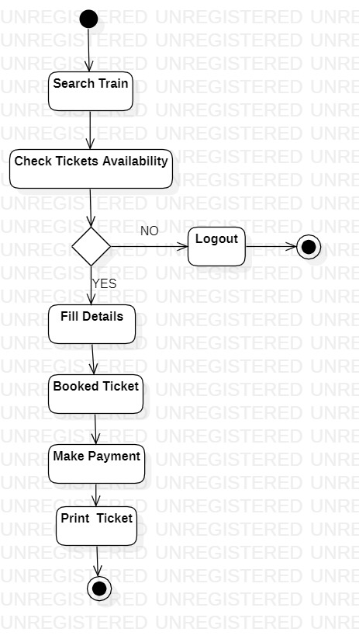

ACTIVITY DIAGRAM DESCRIPTION
11.1.6 Components of an Activity Diagram | Component of Activity Diagram Used In Project : -  - Decision Node :-A conditional branch in the ﬂow that is represented by a diamond. It includes a single input and two or more outputs.  - Control ﬂows :-Another name for the connectors that show the ﬂow between steps in the diagram.  - Start node:-Symbolizes the beginning of the activity. The start node is represented by a black circle.  - End node:-Represents the ﬁnal step in the activity .The end node is represented by an outlined black circle.

12.1.4 SEQUENCE DIAGRAM

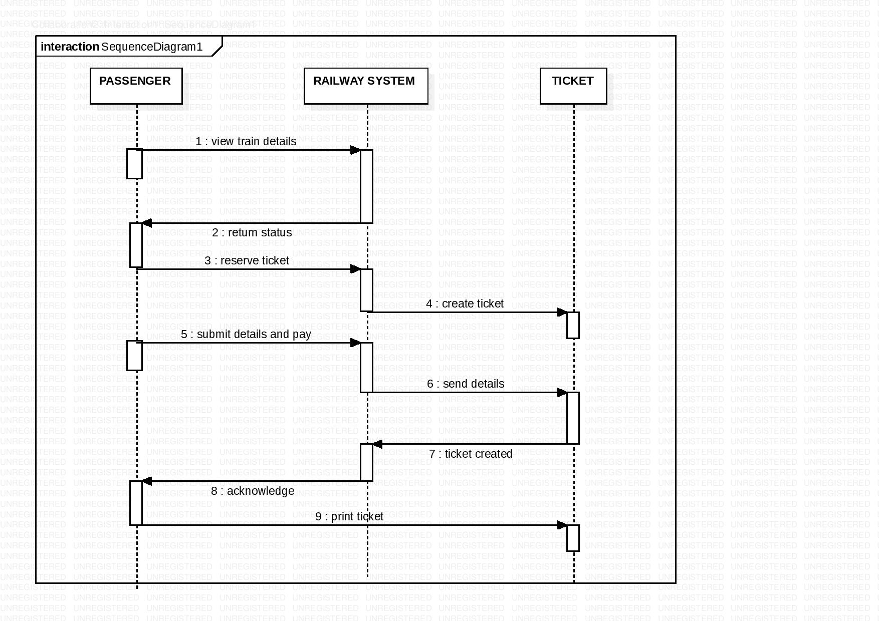

Sequence Diagram Description

This is the sequence diagram of online railway reservation, here passenger requests to system for getting train details as per their requirements. The railway system shows the status of available train . Passenger will reserve ticket and submit payment details.
System will generate the ticket as preferred by the passenger.

13.1.1 DATA FLOW DIAGRAM

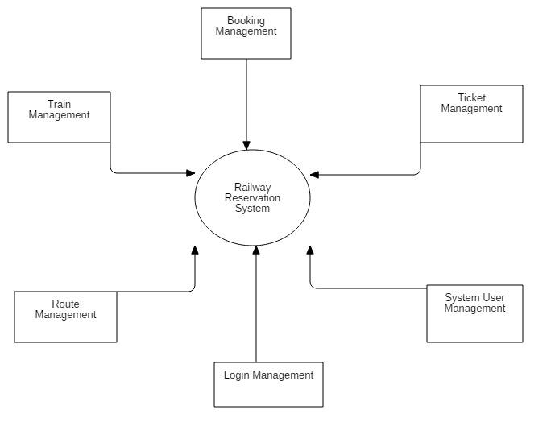

Dataflow Diagram Description
The ﬂow of data in "Online Railway Reservation " is shown by the data ﬂow diagram above. It begins from the login system where the connection is established and the data ﬂow is between the Passenger database and System Management. It normally consists of overall application dataflow and processes of the Railway Reservation process. It contains all of the user flow and their entities such all the flow of Trains, Booking, Ticket, Train Schedule, Train Route, Customer, Payment. This diagram has been used for the visualization of data processing and structured design of the Railway Reservation process and working flow.

DESIGNING TEST SUITES SOFTWARE TESTING

The process, to evaluate the functionality of a software application with an intent to find whether the developed software met the specified requirements or not and to identify the defects to ensure that the product is defect-free in order to produce the quality product; For our software testing involves testing the machine learning model against as many cars and brand as possible and check for their mean squared error and showed be as low as possible. Other checks may involve checking the UI aspects of the same to ensure a smoother use experience. Testing is done to find information critical decisions about the
Project or product that are made on basis of that information.

TESTING FRAMEWORKS
Testing frameworks that can be incorporated to ensure the trusted and expected response from the software include-
- White Box Testing
White Box Testing is based on application’s internal code structure. In white box testing, an internal perspective of the system, as well as programming skills, is used to design test cases. This testing is usually done at the unit level. White Box Testing sometimes called glass box testing is test case design method that uses control structure of procedure design to derive test cases. Using White Box testing methods derives cases that:-

- Guarantee that all individual paths within module have been exercise at least once.
- Exercise all logical decisions on their true & false sides.
- Exercise all loops at their boundaries & within their optional bound.
- Exercise internal data to ensure there validity.

- Black Box Testing
Black Box Testing is a software testing method in which testers evaluate the functionality of the software under test without looking at the internal code structure. Black Box Testing also called behavior testing focuses on functional requirement of software.
Black Box testing enables the software engineer to derive the set I/p condition that will fully exercise all functional requirement of program. Black box testing attempt to find in following categories:-
- Incorrect or missing function.
- Interface error.
- Error in data structure or external database access.
- Behavior or performance error.
- Initialization & termination error.

- Master Test Plan
The Master Test plan for the given piece of software would to use an automation testing tool such as python’s selenium library to construct the code that would automatically test all the UI aspects and also run the main code and log the result and at any point where it would encounter some error, then it shall reflect the same. Hence it is a very accurate and time optimised approach toward testing the software. Master Test Plan contains all the test scenarios and risks prone areas of the application. MTP includes test scenarios to be executed in all the phases of testing that run during the complete lifecycle of the application development.
- Manual Testing
Manual testing is the process of testing software by hand to learn more about it, to find what is and isn’t working. This usually includes verifying all the features specified in requirements documents, but often also includes the testers trying the software with the perspective of their end user’s in mind.

DEPLOYMENT REPORT

The deployment report or documentation might include training materials for new users and test plans to verify a successful deployment that can be reused when updating the software after the initial deployment. The pilot deployment gives you the opportunity to implement your planned solution but change it, if needed.
- PASSENGER INPUT-
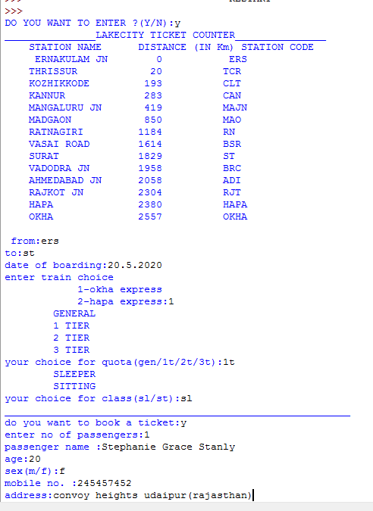

- Time table is displayed
- Passenger enters destination, date of boarding, train, tier and seat choices.
- Confirmation for booking the tickets.
- Number of passengers as well as details of each passenger is taken
- PASSENGER TICKET GENERATION-
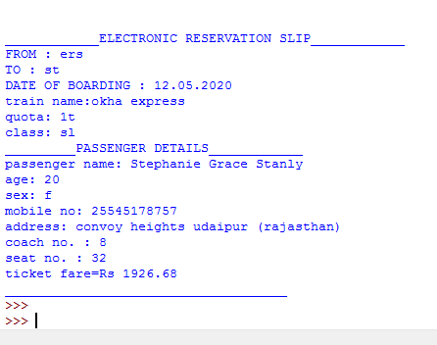

- Destination, Date, train as well as quota and class details are printed in the generated ticket.
- Passenger Details is printed in the ticket.
- Coach and seat number allotted to the passenger is printed.
- Total ticket fare is calculated and printed on the generated ticket.

CONCLUSION

Thus, putting all the aspects of professional approach to formulating a software design plan to its testing into place, software is constructed which holds the ability to provide a reliable means to book your railway tickets easily and efficiently.
It is a transparent, reliable as well as less time consuming approach to book your ticket in the most well organised manner. Thus, it can be considered as a credible and sustainable methodology for buying up of tickets.

REFERENCES

- Software project management insights - www.wrike.com
- Deeper insights- 1.myindiantourism.com
2. indianrailways.info
- Other Particulars- 1. Wikipedia.com
2. Encyclopedia.com

