Results_Outline_Jeff

Stephanie Bland

January 25, 2018

## Part A: Model Realism - [Show that new models are realistic (Show our setup is good)]

Figures:

* Fig 1a: Von Bert curves

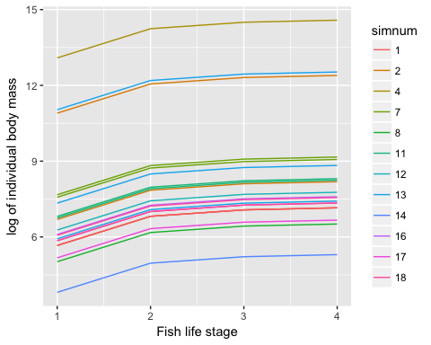

Figure 1 Von-Bertalanffy curves for surviving fish in several simulated food webs. Each colour represents a different food web.

* Fig 1b: Allometric Ratios are invariant

## Loading required package: grid

## `stat_bin()` using `bins = 30`. Pick better value with `binwidth`.  
## `stat_bin()` using `bins = 30`. Pick better value with `binwidth`.  
## `stat_bin()` using `bins = 30`. Pick better value with `binwidth`.  
## `stat_bin()` using `bins = 30`. Pick better value with `binwidth`.

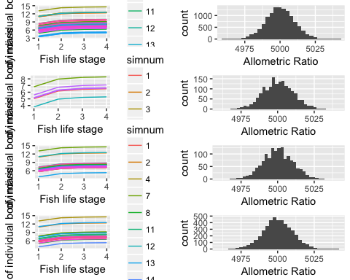

Figure 2 A histogram of the allometric ratios for all the surviving adult fish life stages.

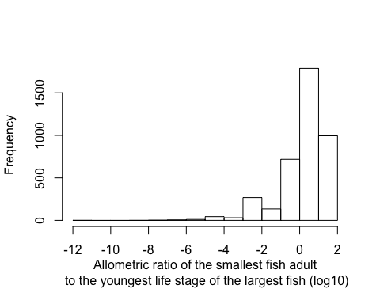

Supplementary Figure 3 A histogram of the logged allometric ratios between the oldest life stage of the smallest fish species and the youngest life stage of the largest fish species for any model.

# Logic for text:

Our model produces realistic fish species. (broken down in two parts: first part says that adults have a realistic size range, and second part says that life histories are realistic in terms of growth for each species and overlap between species within a web.) Since we are using an allometric trophic network model, mass is unitless and all that matters is the relative ratios of predator to prey within the same model. You can not compare mass across simulations. We already know that adult fish have realistic weight ranges because our model produces adults with the same lognormal distribution for body mass as Tonin's model. Fish extinctions are equally probable across the lognormal distribution of allometric ratios, so fish species are not disproportionately skewed by size range in any of our models (fig 2b).

The growth curves for new life stages are also realistic. Individual fish species follow the von-Bertalanffy function defined in the methods. Fish also have realistic body size ranges for their growth, as there is a large overlap between the size ranges for species within each web (fig 2a). Webs have an overlap between all the fish species size ranges 69.55% percent of the time.

# Text (Alternate version, says the same thing as above):

Our model produces realistic von-Bertalanffy growth curves (fig 2a). Since we are using an allometric trophic network model, mass is unitless and all that matters is the relative ratios of predator to prey within the same model. You can not compare mass across simulations. However, fish species within simulations tend to be in the same size range, as the weight range for fish species often overlap each other. The youngest life stage of the largest fish species is smaller than the oldest life stage of the youngest fish 69.55% percent of the time. The growth curves for any given species are also realistic, as we defined the curve to follow a von-Bertalanffy growth function. Our model produces fish species with realistic allometric ratios (fig 2b), and fish extinctions are equally probable across the lognormal distribution of allometric ratios, so our model is not favouring fish of any particular body mass.

## Part B: General simulation Output (Start looking at time series results, and compare model types

Figures: Fig 2: Time Series for a linked Model 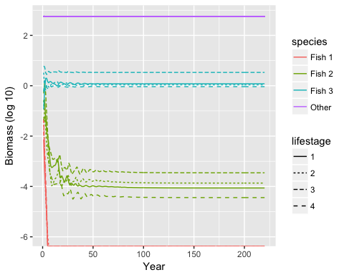

Fig 3: Hist of number of surviving species (a=0,1,2,3; b=none,all) 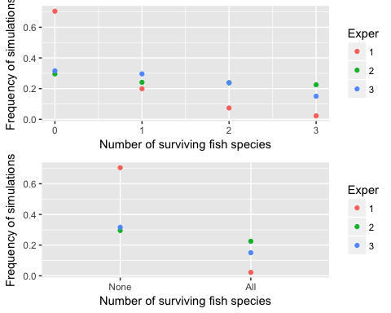

Fig 4a: CV of tot biomass against Model type 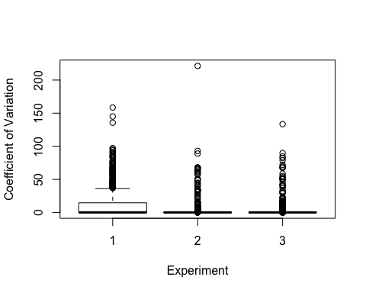

Fig 4b: CV of fish biomass against Model type

* (Maybe, if time permits) - A comparison plot of time series for diff sims and models in supplementary

# Text:

80.2% of our simulations met the criteria for the first part of the analysis, meaning fish stabilized in at least one of the experiments. 24.275% of our simulations met the second criteria, where at least one fish must stabilize in every experiment. It was anticipated that some simulations would never stabilize, given that we placed minimal constraints on food webs during the web creation stage. Thus, some of the webs would invariably end up being completely biologically unrealistic. This process of weeding out unstable webs might seem unintuitive at first, but it mimics what we observe in nature. Just as natural landscapes are eventually populated by stable ecosystems after a long process of species invasions and extinctions. A typical time series of the simulation for a food web that eventually stabilizes is illustrated in figure 4.

Our models can be broken down into two steps: adding in new life stages and then linking them with life histories. One of the goals of this paper is to identify how much each step affects the output of our model. Adding in new life stages reduces the CV of the total biomass, so new life stages stabilize the model (fig 6). Since we can treat new, unlinked, life stages as individual species, this essentially equivalent to saying that an ecosystem with more diverse fish species is more stable. None of our model types differ in terms of CV for total fish biomass (fig 7). This trend is further backed up by the frequency of the consecutive number of surviving fish species in each model (fig 5). The models with new life stages are far more likely to have at least one fish species survive, as well as having every fish species survive. The difference between the linked model and unlinked model is more subtle. Linking the life histories seems to steepen the probability of consecutive extinctions, meaning that if one sp

## Part C: Output for linked model

Figures:

* Fig 5: Life History correlation plots

Text:

### Discussion:

The general trend is that adding in new life stages is far more important than linking them together.

Why would more diversity be better:

-cite Hutchinson less competition -better niche filling -Along the same lines of fungii/disease being able to spread between phylogenetically similar plant species, predators will be able to share the same prey (I'm not sure if this should relax mortality of rare species and give them a "break" or increase mortality for all similar species) (Donoghue Yale Lecture - Charles Darwin the tree of life, ~50 minutes in)