Results

Stephanie Bland

November 27, 2017

Experiments:

1st Experiment: Extended nicheweb + Lifehistory

2nd Experiment: Extended nicheweb

3rd Experiment: Original Nicheweb

## First Paragraph: Overall description, general overview

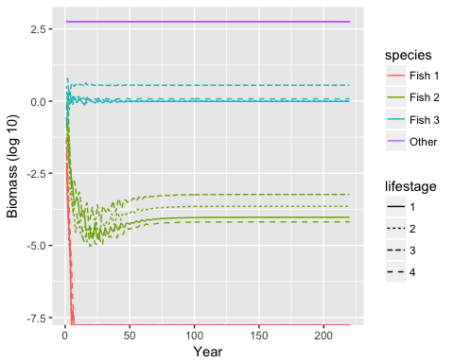

Figure 1 A typical time series for experiment 1. This shows the logged biomass at the end of each year cycle for each fish life stage along with the combined biomass of the rest of the ecosystem.

77% of our simulations met the criteria for the first part of the analysis, meaning fish stabilized in at least one of the experiments. 24.25% of our simulations met the second criteria, where at least one fish must stabilize in every experiment. It was anticipated that some simulations would never stablize, given that we placed minimal constraints on food webs during the web creation stage. Thus, some of the webs would invariably end up being completely biologically unrealistic. This process of weeding out unstable webs might seem unintuitive at first, but it mimics what we observe in nature. Just as natural landscapes are eventually populated by stable ecosystems after a long process of species invasions and extinctions. A typical time series of the simulation for a food web that eventually stabilizes is illustrated in figure 1.

## Second Paragraph: Number of extinctions

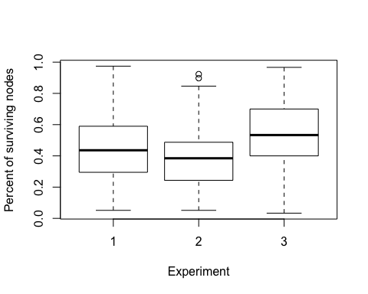

Figure 2 Boxplot of the percent of surviving nodes in each experiment.

The mean percent of surviving nodes is shown in figure 2. Experiment 3 has a slightly higher percentage of surviving nodes. This indicates that the new fish life stages we added are probably more likely to go extinct than an average node. Alternatively through, it could also be true that the new lifestages are not more likely to go extinct, but the presence of them destabilizes other species instead so other species are more likely to go extinct when new nodes are added. Experiment 1 and 2 have a similar percent of surviving nodes.

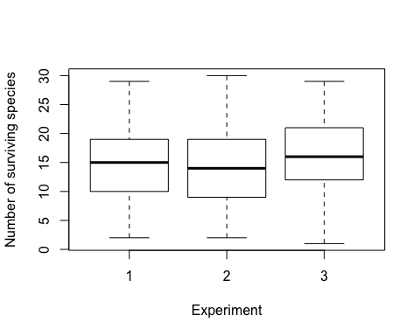

Figure 3 Boxplot of the number of surviving species in each experiment.

There is no significant effect on the number of surviving species (fig 3). "this figure seems not needed. You can add this information in to the previous paragraph. Also, focus on number of surviving species because those are the ones we are interested in" -> this figure is the one about the number of surviving species. The previous figure (fig 2) is about the percent of surviving nodes.

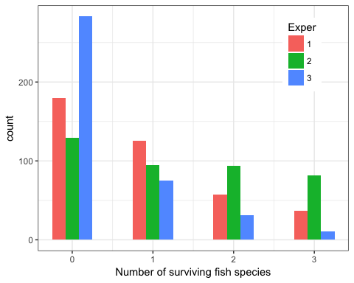

Figure 5 Histogram of the number of surviving fish in each experiment.

A histogram of the number of surviving fish species is shown in figure 5. The original web has the most extinctions and fewest surviving species. Adding in life stages increases the probability of survival, but linking them together decreases it yet again.

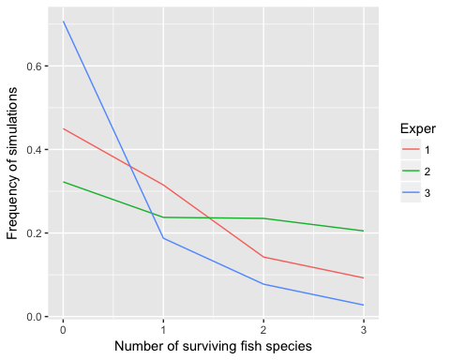

Figure 6 The frequency of fish surviving in each experiment.

## Third Paragraph: Stability -> Coefficient variation (CV)

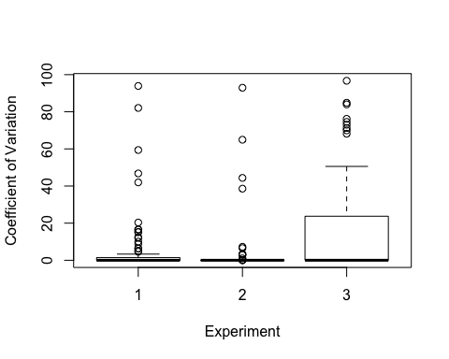

Figure 6 The coefficient of variation for the total biomass in each experiment

The variability in total biomass is higher in experiment 3 than in the other two (fig 6). This could be because life histories stabilize the ecosystem, but it might also be because there are more extinctions in the first two experiments. These figures are created with a subset of data where at least some fish persist in all the experiments, so we know it's not just a relic of having more webs that stabilize to total extinction.

There is no apparent pattern in the CV for the total fish biomass.

|  |  |  |
| --- | --- | --- |
| Exper | mean(Fish_ratio) | var(Fish_ratio) |
| 1 | 0.0217494 | 0.0022258 |
| 2 | 0.0295442 | 0.0040400 |
| 3 | 0.0345259 | 0.0110228 |

The fish to total biomass ratios for each experiment is shown in table 1. The basic nicheweb in experiment 3 seems to have a slightly higher proportion of fish biomass, but it doesn't appear to be significant.

## End paragraph: Von-Bertalanffy

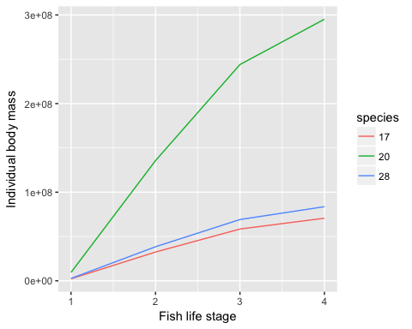

Figure 8 The von-Bertalanffy curve displaying the growth of three different fish species in the same food web simulation

Our model produces realistic life histories for our fish species (fig 8). Fish start off as juveniles with a small body weight and follow a von-Bertalanffy growth curve as they mature.

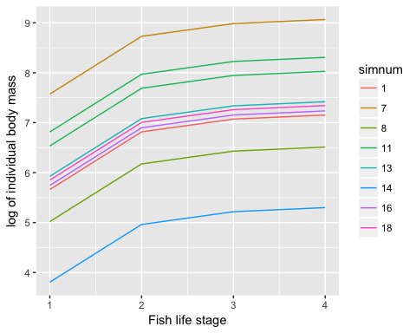

Figure 9 Von-Bertalanffy curves for surviving fish in several simulated food webs. Each colour represents a different food web.

The fish for any given food web simulation often end up having similar body mass. This is because we only assign life histories to the three largest species in the food web, which will have similar trophic levels and body masses.

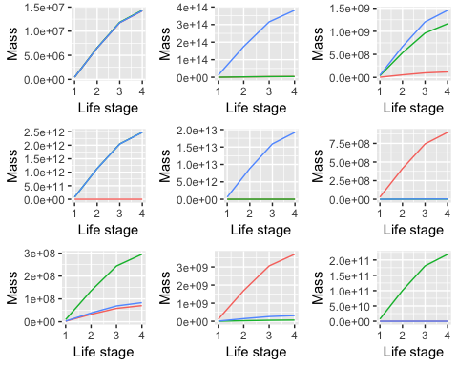

Figure 10 The von-Bertalanffy plots for the surviving fish species in nine different simulations.

Figure 10 shows von-Bertalanffy growth curves for all the surviving fish species across several simulations.

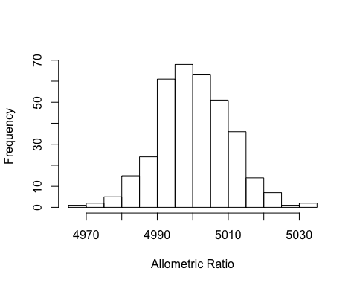

Figure 11 A histogram of the allometric ratios for all the surviving adult fish life stages.

Figure 11 shows the distribution of the predator prey body mass ratios for the adult fish species that persist in our simulations. This distribution is similar to the initial log normal random distribution that we assigned the species, so extinctions occur relatively randomly with respect to allometric ratio.

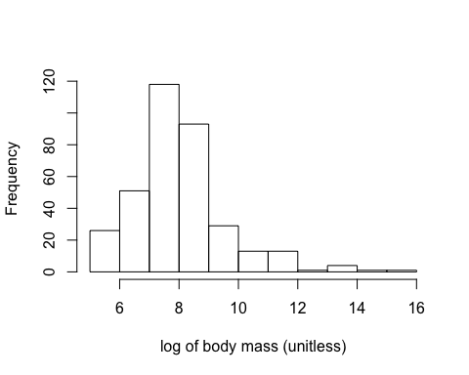

Figure 12 A histogram of the logged adult body mass for all the surviving fish life stages.

The absolute mass of most surviving fish species are in the 10E8 range, with a few extreme outliers. This isn't a major concern because we are using an allometric network model, where the most important feature are the relative body sizes of predator and prey species. So mass is unitless, and is only meaningful in relation to the other species in that particular simulation. These histograms show the mass of fish species across several different simulations. The only other feature that is affected by body mass is the metabolic rate.

"You say body mass only matters in relative terms, compared with other species, but is the ratio of fish/invertebrate realistic?" -> Yeah, so this is why I was looking at allometric ratios in figure 11. We set the parameters for the initial allometric ratio, so if it's not realistic we can modify it very easily. I'm not quite sure if you were referring to the ratio of individual body mass here (allometric ratio for predator/prey) or the biomass, but I thought I addressed both.

## Life History Correlations

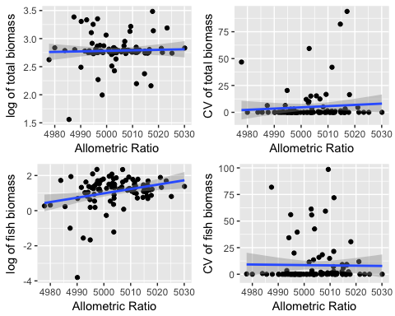

Figure 13 The mean and CV of fish and total biomass with respect to the largest fish species' allometric ratio. The lines shows the fit of a linear model.

Figure 13 shows the effect of the largest fish's allometric ratios on the biomass. The CV of biomass is invariant with allometric ratio. There seems to be a trend of more extreme CV values in total biomass for a larger allometric ratio, but we might not have enough data. Total biomass seems to be relatively unaffected by allometric ratio. Fish biomass increases with a larger allometric ratio, although this might just be because individuals need less food since their per unit mass metabolic rate is lower.

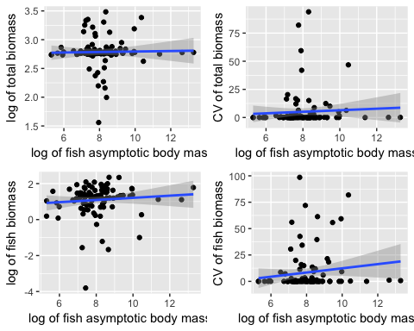

Figure 14 The mean and CV of fish and total biomass with respect to the largest fish species' asymptotic body mass. The lines shows the fit of a linear model.

Figure 14 shows the fish and total ecosystem biomass as a function of the asymptotic body mass of the largest fish species. It also shows the CV of the fish and total biomass after the ecosystem has stabilized. The only apparent trend appears to be that the CV of fish biomass increases with a larger asymptotic individual body mass.

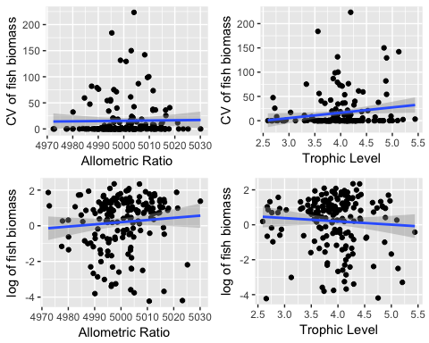

Figure 15 The CV and mean of fish biomass is plotted against the life history traits of adult allometric ratio and trophic level. These are plotted on a species level basis, so rather than using the largest fish species's traits to predict total fish biomass, we look at the relationship between a species' biomass and its life history traits. The lines shows the fit of a linear model.

[note, not to be published: this last figure seems to repeat some earlier plots, namely CV/allometric ratio, but it's really entirely new - these plots have more data points because instead of going by the largest fish species allometric ratio/asymptotic body mass, it includes pseudoreplicates for each web so every species is plotted against its CV/mean]

Figure 15 shows the correlation between each fish species life history trait against its mean and CV biomass. The main trend here seems to be that the CV of a fish's biomass tends to increase with its trophic level, so the higher up a fish is in the food chain, the more it will experience large population fluctuations. This may be because each consecutive step in the food chain adds variance to the biomass.

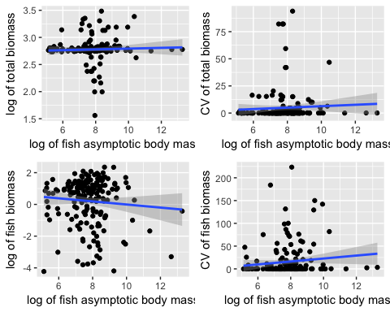

Figure 16 The CV and mean of fish and total biomass is plotted against the asymptotic body mass of individual fish species. These are plotted on a species level basis, so rather than using the largest fish species's traits to predict total fish biomass, we look at the relationship between a species' biomass and its life history traits. The lines shows the fit of a linear model.

The asymptotic body mass of individual fish species does not have a strong effect on the total biomass (fig 16). Fish biomass seems to decrease for larger fish species (fig 16), which seemingly contradicts our earlier result from figure 14. The difference between these two figures is that figure 14 plots the total fish biomass against the asymptotic body size of the largest fish in the ecosystem, while figure 16 plots it on a species level basis. So maybe the smaller fish species are the fish that increase the biomass. So they would increase the total fish biomass in figure 14 without getting the credit for it. The CV of fish biomass increases for larger fish species (fig 16).

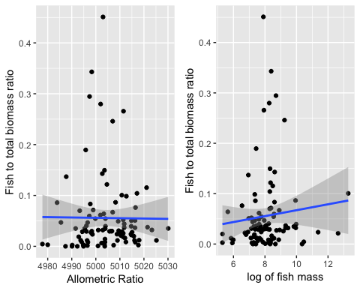

Figure 17 The Fish to total biomass ratio with respect to the allometric ratio and log of the fish mass for the largest adult fish species. The lines shows the fit of a linear model.

Figure 17 shows the fish to total species biomass ratio as a function of the two main life history traits: allometric ratio and adult fish aysmptotic body mass.