Results_Outline_Jeff

Stephanie Bland

December 04, 2017

## Part A: Model Realism - [Show that new models are realistic (Show our setup is good)]

Figures:

* Fig 1a: Von Bert curves 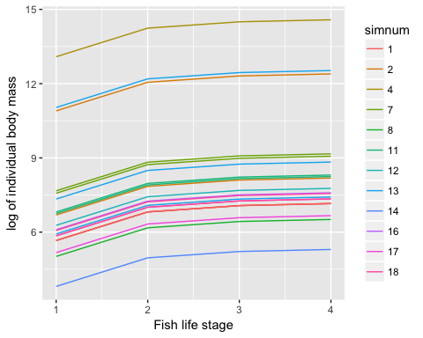
* Fig 1b: Allometric Ratios are invariant

## Loading required package: grid

## `stat_bin()` using `bins = 30`. Pick better value with `binwidth`.  
## `stat_bin()` using `bins = 30`. Pick better value with `binwidth`.  
## `stat_bin()` using `bins = 30`. Pick better value with `binwidth`.  
## `stat_bin()` using `bins = 30`. Pick better value with `binwidth`.

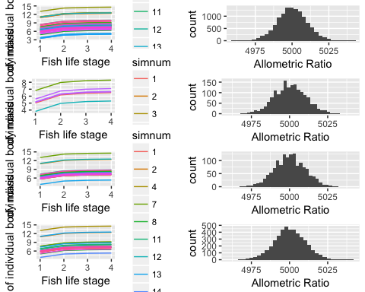

Figure 3 A histogram of the allometric ratios for all the surviving adult fish life stages.

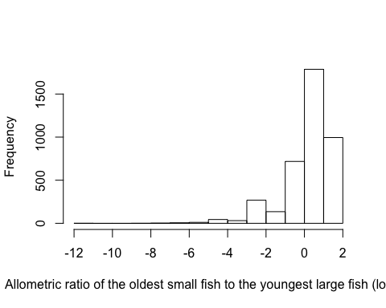

# Logic for text:

Our model produces realistic life histories for fish species. Since we are using an allometric trophic network model, mass is unitless and all that matters is the relative ratios of predator to prey within the same model. You can not compare mass across simulations. We already know that adult fish have realistic weight ranges because our model produces adults with the same lognormal distribution for body mass as Tonin's model. Fish extinctions are equally probable across the lognormal distribution of allometric ratios, so fish species are not disproportionately skewed by size range in any of our models (fig 3b).

The growth curves for new life stages are also realistic. Individual fish species have realistic growth curves as they are defined to follow the von-Bertalanffy function defined in the methods. Fish also have realistic body size ranges for their growth, as there is a large overlap between the size ranges for species within each web (fig 3a). Webs have an overlap between all the fish species size ranges 69.55% percent of the time.

# Text (Alternate version, says the same thing as above):

Our model produces realistic von-Bertalanffy growth curves (fig 3a). Since we are using an allometric trophic network model, mass is unitless and all that matters is the relative ratios of predator to prey within the same model. You can not compare mass across simulations. However, fish species within simulations tend to be in the same size range, as the weight range for fish species often overlap each other. The youngest life stage of the largest fish species is smaller than the oldest life stage of the youngest fish 69.55% percent of the time. The growth curves for any given species are also realistic, as we defined the curve to follow a von-Bertalanffy growth function. Our model produces fish species with realistic allometric ratios (fig 3b), and fish extinctions are equally probably across the lognormal distribution of allometric ratios, so our model is not favouring fish of any particular body mass.

## Part B: General simulation Output (Start looking at time series results, and compare model types

Figures: Fig 2: Time Series for a linked Model 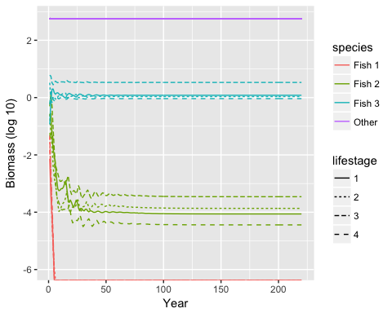

Fig 3: Hist of number of surviving species (a=0,1,2,3; b=none,all)

## Loading required package: grid

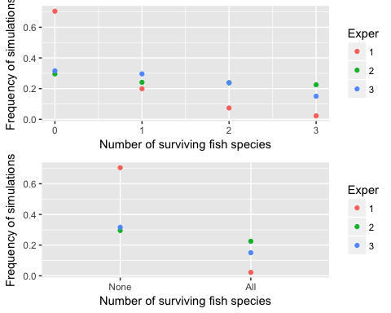

Figure 4 The frequency of fish surviving in each experiment.

Fig 4a: CV of tot biomass against Model type 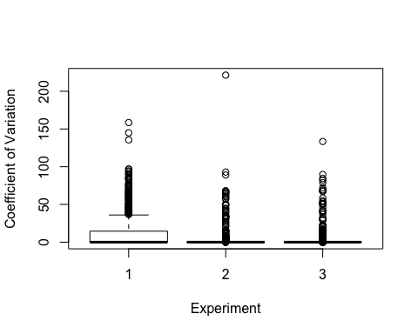

Fig 4b: CV of fish biomass against Model type

* (Maybe, if time permits) - A comparison plot of time series for diff sims and models in supplementary

Text: 80.2% of our simulations met the criteria for the first part of the analysis, meaning fish stabilized in at least one of the experiments. 24.275% of our simulations met the second criteria, where at least one fish must stabilize in every experiment. It was anticipated that some simulations would never stablize, given that we placed minimal constraints on food webs during the web creation stage. Thus, some of the webs would invariably end up being completely biologically unrealistic. This process of weeding out unstable webs might seem unintuitive at first, but it mimics what we observe in nature. Just as natural landscapes are eventually populated by stable ecosystems after a long process of species invasions and extinctions. A typical time series of the simulation for a food web that eventually stabilizes is illustrated in figure 3.

## Part C: Output for linked model

Figures:

* Fig 5: Life History correlation plots

Text: