Complex food webs

1 Methods

1.1 Model structure

We studied the impact of fishing at high trophic levels and subjected these systems to only one basic scenario: the managed one with fixed exploitation effort.
Following William & Martinez (2000, 2008), food webs were simulated using the Original Niche Model (ONM) which has two input parameters: the number of species S and the connectance C = L/S² (Martinez 1991), where L is the number of trophic links. In the ONM, a uniformly random "niche value" (0 ≤ n_{i} ≤ 1) is assigned to each species. Consumer i eats only prey species whose niche values are contained within a range r_{i}, whose center c_{i} is less than the predator’s niche value n_{i}. The niche center c_{i} is randomly chosen from a uniform distribution between r_{i}/2 and min(n_{i}, 1−r_{i}/2). The niche range is calculated as follows: r_{i} = xn_{i}, where x is a random variable defined on [0,1] with a beta-distributed probability density function p(x)=β(1−x)β−1 with β=1/(2C)−1.
To be able to compare the food webs obtained from the ONM, we used 17 structural network properties (William & Martinez 2000, 2008, Dunne et al. 2002, 2008): Top, Int, Bas are the proportions of species that are respectively without predators (top), with both predators and preys (intermediate), and without preys (basal); Can, Herb, Omn and Loop are the fractions of species that are cannibals, herbivore (only basal preys), omnivores (i.e. feeding on multiple trophic levels) and involved in loops (apart from cannibalism); ChLen, ChSD and ChNum, the mean length, standard deviation of length and log number of the food chains; TL, the mean trophic level; MaxSim, the mean of the maximum trophic similarity of each species; VulSD, GenSD and LinkSD are the normalized standard deviations of vulnerability (number of predators), generality (number of preys) and total links; Path is the mean shortest food-chain length betwenn two species and Clust is the clustering coefficient (Watts & Strogatz 1998).
The population dynamics within the food webs were simulated using the Allometric - Trophic-Network model:
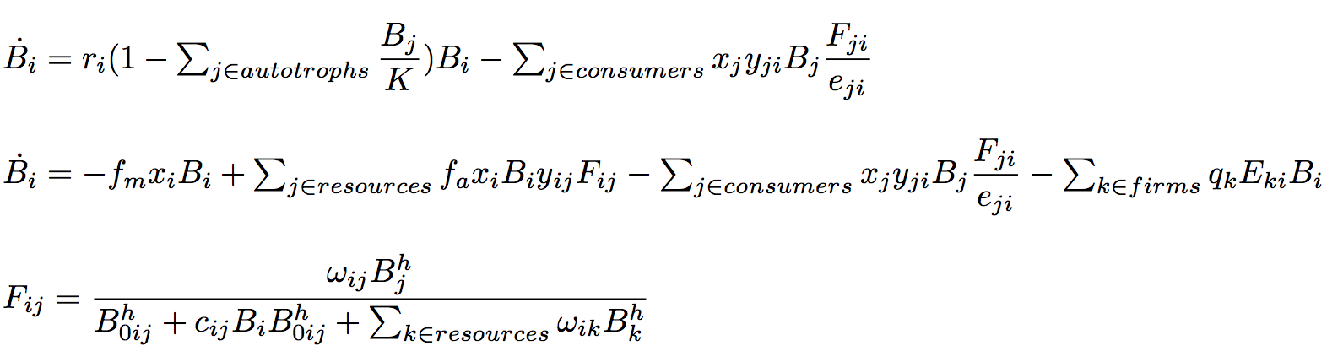
Eq. 1 and 2 describe the changes in the biomass densities of, respectively, an autotroph and an heterotroph species. In these equations, r_{i} is intrinsic growth-rate of basal species i, K is the carrying capacity shared by all the basal species, x_{i} is i’s metabolic rate (x_{basal} = 0, Brose et al. 2006) and y_{ij} is the maximum consumption rate of i eating j, e_{ij} is i’s assimilation efficiency when consuming j. f_{m} is the fraction of assimilated carbon respired by maintenance of basic bodily functions and f_{a} is the fraction of assimilated carbon used for production of consumers’ biomass under activity. We used a weak Holling-type III functional response (eq. 3). B_{0ij} is the half-saturation density of i eating j, h is the Hill exponent, c_{ij} is the predator interference and ω_{ij} is i’s relative inverse attack rate (i.e. i’s preference towards j).

1.2 Parameterization

We used the above model to explore the managed scenario with a fixed exploitation rate. We explored the effects of fishing only one or several species at a time, the effects of body size by adding stochasticity in the allometric allocation of metabolic rates x_{i}, and of the structural properties of the food webs.
Table 1 describes the values and units of the ecological parameters. In order to use a consistent parameterization, most of the values are from the study of Lake Constance (Boit et al. in prep.). The food webs were simulated for S = 30 species and C = 15% of connectance (S = 24 and C = 18% in Lake Constance). Basal species intrinsic growth rates were varied between 0.6 d⁻¹ and 1.6 d⁻¹ (Boit et al. in prep.) using a normal distribution with a mean of 1.1 and a standard deviation of 0.18.

Name | Description | Unit | Value
S | Number of species | - | 30
C | Connectance | - | 0.15
K | Carrying capacity of basal species | µgC/L | 540
r_{i} | Basal species growth rate | d ⁻¹ | 0.6 - 1.6
A | Allometric scaling exponent for invertebrate / fish species | - | 0.15 / 0.11
y_{ij} | Maximum grazing rate of consumer i relative to its metabolic rate | d ⁻¹ | 10
e_{ij} | Assimilation efficiency for carnivores / herbivores | - | 0.85 / 0.45
ω_{ij} | Relative inverse attack rate | - | 1 / Σ i's resources
p_{ij} | Fraction of resource species shared between i and j | - | # (i’s res. ∩ j’s res.) / # i’s res.
h | Hill exponent | - | 1.2
B_{ini} | Initial biomasses | µgC/L | 0.02 - 20
B_{0ij} | Half-saturation density of j when consumed by i | µgC/L | 1.5 - 150
c_{ij} | Predator interference for i consuming j | L/(µgC) | 1E-10 - 1
Table 1: List of ecological parameters and their description. The parameters not listed were varied across the simulations (see Methods). Data from the Lake Constance study (Boit et al. in prep.)

For each food web, the metabolic rates of non-basal species (x_{basal}=0, Brose et al. 2006) were calculated using species trophic levels TL_{i}. We used two definitions of trophic levels: on the one hand, T1_{i} is the length of the shortest path from species i to a basal species. On the second hand, T2 = (Id − Q)⁻¹ · 1 (Levine 1980), where Q is the weighted niche web matrix: Q(i,j)=1/preys(i) if i eats j, and equals 0 if not. We took the mean over these two definitions: TL=(T1+T2)/2. The basal species body-masses were set to unity as a reference. The body-masses of predators were calculated using the average predator-prey body-mass ratios, Z: M_{i}=Z^{TLi}−1. Z was sampled from a log-normal distribution, with a distinction between fishes and invertebrates (mean=5000 & SD=100 for ectotherm vertebrates, mean=100 & SD=100 for invertebrates; Brose et al. 2006). Species with trophic levels lower than 3 were always considered as invertebrates, whereas a species with a trophic level greater than 3 had 60% of probability to be a fish. Finally, the metabolic rates follow negative power-law relationships with the species body-masses x_{i} = 0.314 M_{i} ^{−0.15} for invertebrates and x_{i} = 0.88 M_{i} ^{−0.11} for ectotherm vertebrates (Brose et al. 2006, Boit et al. in prep.).

For each feeding link, the half-saturation density B_{0ij} when i eats j, and the predator interference coefficient c_{ij} were assigned according to the i‘s and j‘s nature. The several possibilities were based on the Lake Constance’s food web analysis. (Boit et al. in prep.) See fig. for the values.
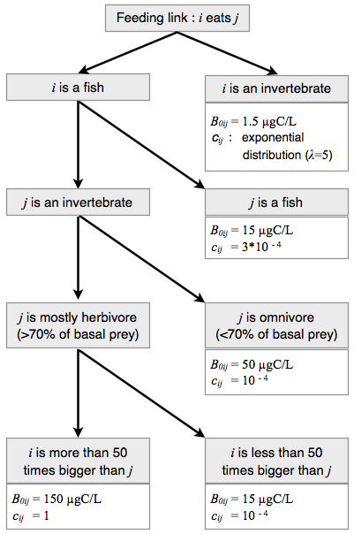
1.3 Protocol

If unspecified, collections of biomass densities were chosen from a uniform distribution in the ranges 0.02-20 μgC/L. Before every simulation with economic exploitation of a species, we let the system evolve without harvesting over 5000 time steps, in order to model the arrival of a new fishing economy in a stable ecosystem. Between 3% and 50% of the species go extinct during this first period (extinction threshold was set at 10⁻⁶ μgC/L), due to the instability of the initial conditions. We only selected webs for which the final networks, after 5000 time steps, were still connected, with at least 70% of persistant species and a minimum of three fish species. As the effort was always fixed, we set the catchability to 1% and then considered the effort as the effective percentage of extracted biomass.
For each food web, the species to harvest were selected among the three fish species with the highest TL_{i}/x_{i}, in order to select big fishes at high trophic levels. We compared three scenarios: each time, only one of the three selected species was harvested. For each species, we draw a comparison with the one-species logistic-growth model. Its carrying capacity K was estimated as its biomass without exploitation, and the intrinsic growth rate calculated from the species metabolic rate: r = x(y−1).The percentage of extracted biomass was varied between 0% and 100%.

We analyzed ??? food webs with a mean number of species of 25.5 (SD=2.0) and a mean connectance of 15.8% (SD=1.2%). Each time, the 17 structural properties of the web were calculated, and also the metabolic rate of the harvested species, their trophic levels, if they are top, intermediate, herbivore and/or cannibal species. Finally, we calculate the local structural properties of the web: vulnerability, generality and connectivity of the harvested species, of its preys and of its predators.
We conducted ??? simulations, each lasting 5000 time steps. Our analyses focused the means of the biomasses during the last 400 of the 5000 time steps. Among our simulations, no large, slow oscillations emerged which might have motivated analyses of more than 400 time steps. All simulations were performed in Matlab version 6.5 and 7.10 using ode45 for ODEs with the default settings.

