**CST1340 Information in Organisation**

**Group Coursework Report**

**Group Members:**

|  |  |  |  |
| --- | --- | --- | --- |
| **#** | **MISIS Number** | **Full Name** | **Program** |
| 1 | M00976018 | Abdiel Dixon | BSc IT |
| 2 | M00979216 | Mariyam Salim | BSc IT |
| 3 | M00979606 | Rajavi Mhatre | BSc IT |
| 4 | M00978236 | Stephanie Sunil | BSc IT |

**SECTION 1 – HTML**

**First page of the website – HOME page:**

**Main Navigation Bar:**

Displayed using<div> tag as a parent container and <a> tag.

**Logo of the bookshop:**

Displayed using <img> tag.

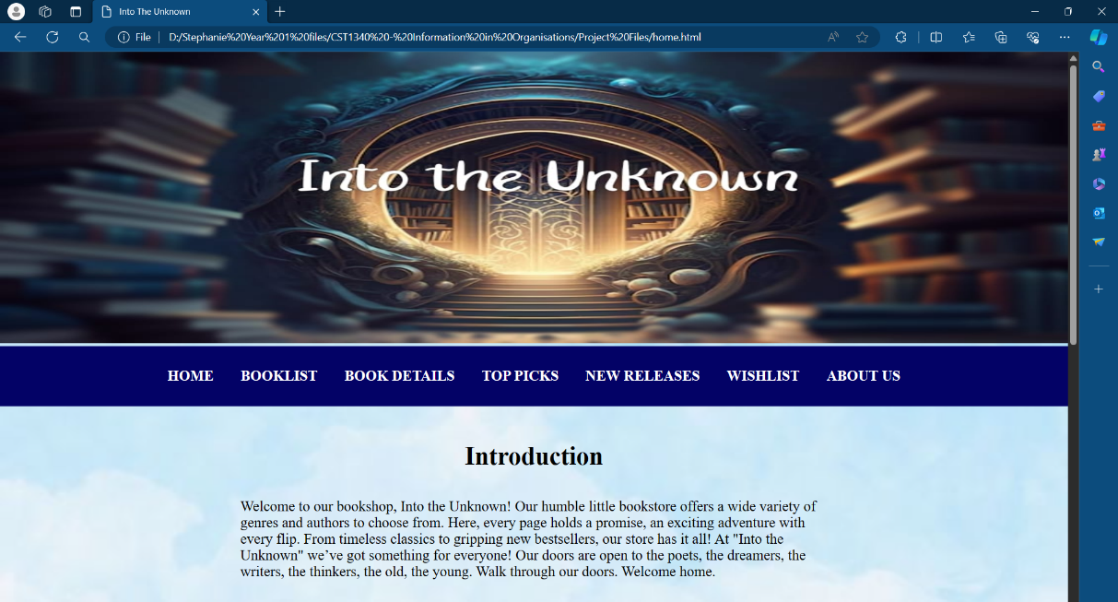

**Heading 1: Introduction**

Displayed using<h2> tag.

**Content for Introduction:** General information about bookshop displayed using<p> tag.

**Background:**

Displayed using CSS styling. Applied on body section of website using “background-image” property.

**Heading 2: Main Genres**

Displayed using<h4> tag.

**Heading 3: Schedule**

Displayed using<h2> tag.

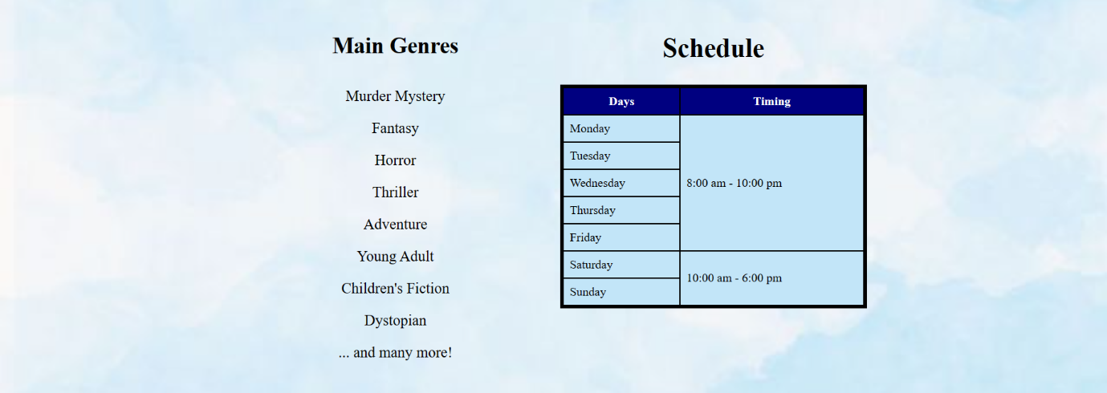

**Content for Schedule:** Schedule Table displayed using <table> tag and styled using CSS.

**Content for Main Genres:**

Genres are displayed using <ul> tag and <li> tags.

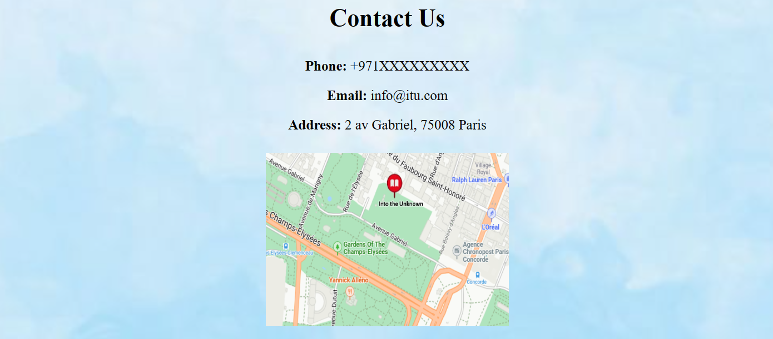

**Heading 4: Contact Us**

Displayed using<h2> tag.

**Content for Contact Us:** Contact information was displayed using three <p> tags and <img> tag for the location and it was styled using CSS.

**Code for “Home” page:**

**DOCTYPE declaration** as HTML5 document.

**<html>** opening tag defining the language as English.

**<head>** section of HTML document.

**<link>** tag used to style website using external CSS.

**<meta>** tags to specify the document's character encoding and viewport settings.

**<title>** tag to define “Into The Unknown” as title that appears on the tab.

**<body>** section of HTML document.

first**<div>** tag to display logo using **<img>** tag.

Second **<div>** tag to display the main navigation bar using **<a>** tag for each page and **<br>** to add a line break before the next section.

**<div>** tag to create another section with the class “center” for styling.

**<h2>** tag displays the heading “Introduction”.

**<p>** tag to display content for the introduction.

Next **<div>** tag is to create a main section to contain 2 other sections side by side.

**<div>** tag with the class “center” to align the section to the center.

The next **<div>** tag is a child container of the main section **<div>** and contains the heading “Main Genres” and an unordered list using **<ul>** tag.

This is positioned to the left side of the main section using **CSS styling.**

This **<div>** tag is a child container of the main section<div> and contains the heading “Schedule” and table created using **<table>** tag.

This is positioned to the right side of the main section using CSS styling.

The table has heading columns **(<thead>, <tr>, and <th> tags)** and data **(<tbody>, <tr>, and <th> tags)** and was styled using **external CSS** styling.

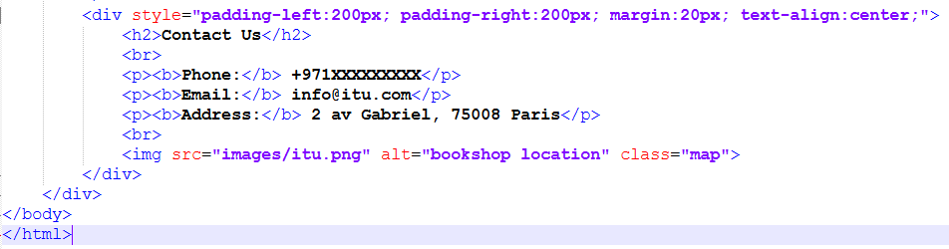

This **<div>** tag is for the last section of the home page and contains the heading Contact Us displayed using **<h2>** tag.

It has all the contact information displayed using three **paragraph (<p>) tags** and an **<img>** tag to display the location of the bookshop.

Then all the tags that are still open are closed.

**Code for “Book Details” page:**

**DOCTYPE declaration** as HTML5 document.

**<html>** opening tag.

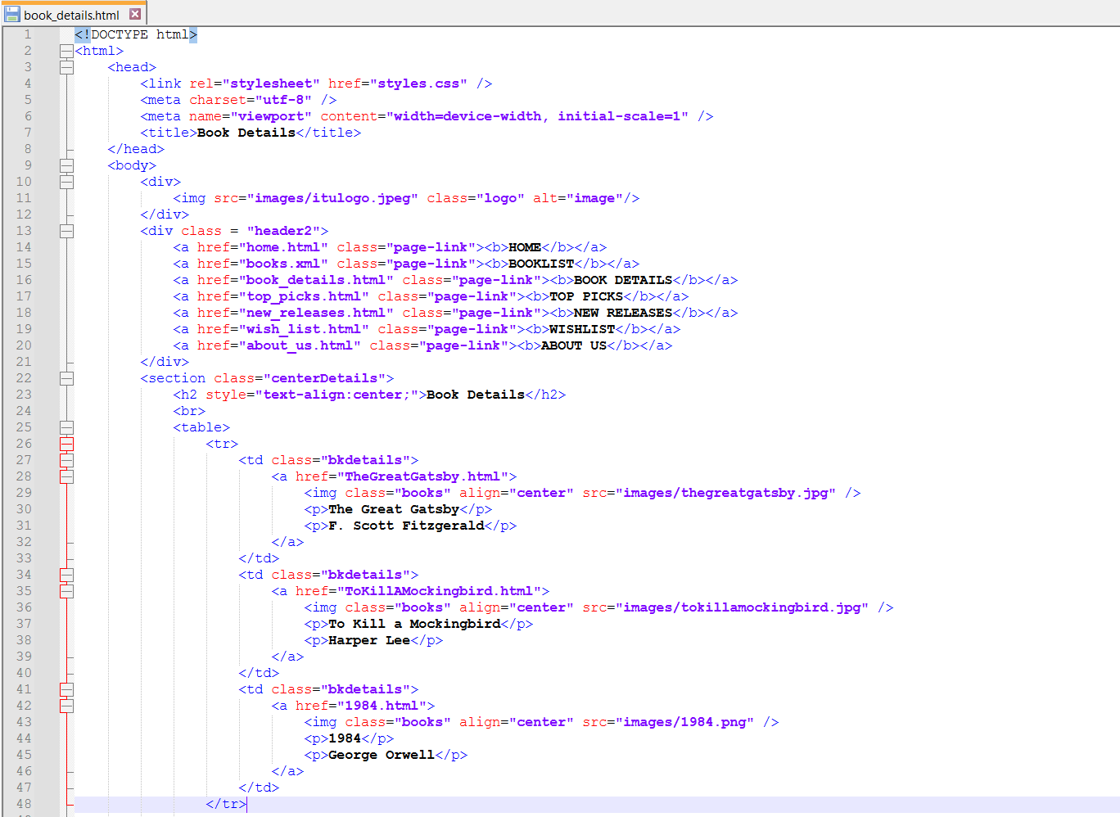

**<head>** section of HTML document.

**<link>** tag used to style website using external CSS.

**<meta>** tags to specify the document's character encoding and viewport settings.

**<title>** tag to define “Book Details” as title that appears on the tab.

**<body>** section of HTML document.

first**<div>** tag to display logo using **<img>** tag.

Second **<div>** tag to display the main navigation bar using **<a>** tag for each page and **<br>** to add a line break before the next section.

**<section>** tag starts a new section that contains a table of all the books available (a total of **50 books**; each row contains 3 books except the last row).

This was styled using the class **“centerDetails”** to align the section to the center of the page.

**<table>** tag was used to create the table, and **<tr>** tag to create the rows.

The whole table was styled using the class **“bkdetails”**.

When clicked on, **each book opens a new page** in the same tab, containing all the book’s details. This was done using **<a>** tag.

The book covers were displayed using **<img>** tags and styled using the class **“books”.**

All remaining open tags are closed.

**Code for “Top Picks” page:**

**DOCTYPE declaration** as HTML5 document.

**<html>** opening tag defining language as English.

**<body>** section of HTML document.

first**<div>** tag to display logo using **<img>** tag.

Second **<div>** tag to display the main navigation bar using **<a>** tag for each page and **<br>** to add a line break before the next section.

**<head>** section of HTML document.

**<link>** tag used to style website using external CSS.

**<meta>** tags to specify the document's character encoding and viewport settings.

**<title>** tag to define “Top Picks” as title that appears on the tab.

**<style>**  tag to define internal CSS styling.

**<section>** tag starts a new section containing a table of all the top books from 5 categories (**14 books**). This was styled using the class **“centerDetails”** to align the section to the center of the page.

**<table>** tag was used to create the table, and **<tr>** tag to create the rows.

The whole table was styled using the class **internal CSS styling.**

When clicked on, **each book opens a new page** in the same tab, containing all the book’s details. This was done using **<a>** tag.

The book covers were displayed using **<img>** tags and styled using the class **“bkimg”.**

All remaining open tags are closed.

**Code for “New Releases” page:**

**DOCTYPE declaration** as HTML5 document.

**<html>** opening tag.

**<body>** section of HTML document.

first**<div>** tag to display logo using **<img>** tag.

Second **<div>** tag to display the main navigation bar using **<a>** tag for each page and **<br>** to add a line break before the next section.

**<head>** section of HTML document.

**<link>** tag used to style website using external CSS.

**<meta>** tags to specify the document's character encoding and viewport settings.

**<title>** tag to define “New Releases” as title that appears on the tab.

**<style>**  tag to define internal CSS styling.

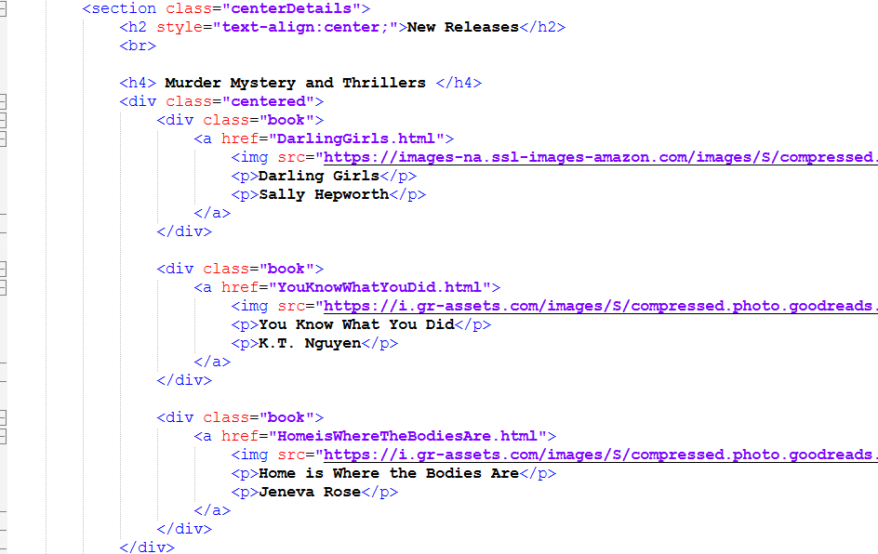

**<section>** tag starts a new section containing a list of books defined using <div> tags. This was styled using the class **“centerDetails”** to align the section to the center of the page.

**<div>** tagwas used to create containers for each book that included the book cover, title and author of book.

When clicked on, **each book opens a new page** in the same tab, containing all the book’s details. This was done using **<a>** tag.

The whole table was styled using the class **internal CSS styling.**

All remaining open tags are closed.

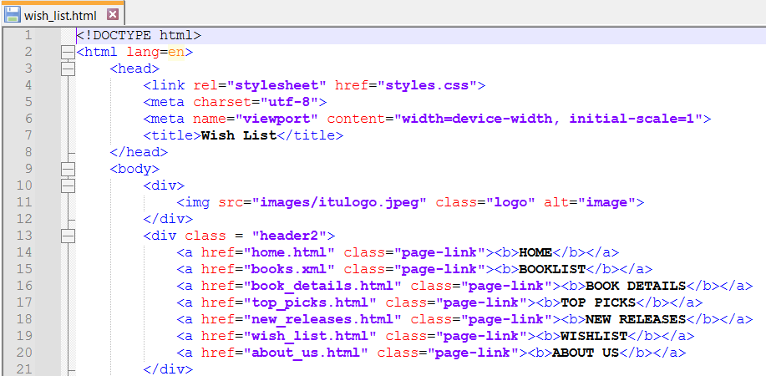**Code for “Wish List” page:**

**DOCTYPE declaration** as HTML5 document.

**<html>** opening tag.

**<head>** section of HTML document.

**<link>** tag used to style website using external CSS.

**<meta>** tags to specify the document's character encoding and viewport settings.

**<title>** tag to define “Wish List” as title that appears on the tab.

**<body>** section of HTML document.

first**<div>** tag to display logo using **<img>** tag.

Second **<div>** tag to display the main navigation bar using **<a>** tag for each page and **<br>** to add a line break before the next section.

**<section>** tag starts a new section containing a form to send book recommendations. This was styled using the class **“centerDetails”** to align the section to the center of the page.

**<form>** tag was used to create the form, and input from the user was taken using **<input>** tag.

The data from the form is sent to an email address using the **action attribute** (mailto: “email”).

The form was styled using **External CSS Styling** with the class **“form_format”.**

All remaining open tags are closed.

**Code for “About Us” page:**

**DOCTYPE declaration** as HTML5 document.

**<html>** opening tag.

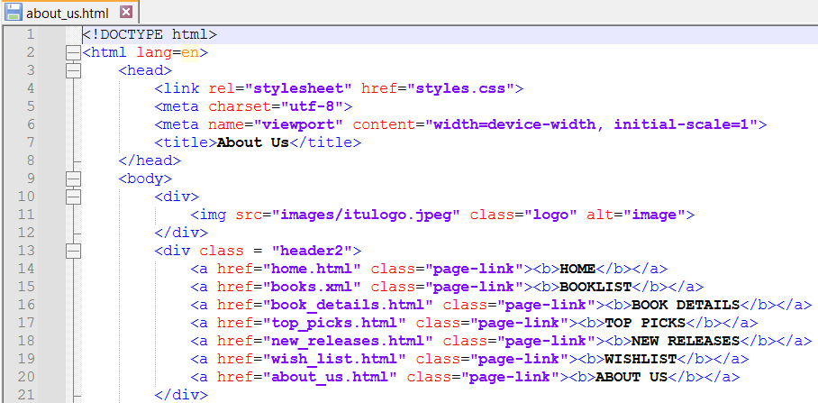

**<body>** section of HTML document.

first**<div>** tag to display logo using **<img>** tag.

Second **<div>** tag to display the main navigation bar using **<a>** tag for each page and **<br>** to add a line break before the next section.

**<head>** section of HTML document.

**<link>** tag used to style website using external CSS.

**<meta>** tags to specify the document's character encoding and viewport settings.

**<title>** tag to define “About Us” as title that appears on the tab.

**<section>** tag starts a new section containing a form to send book recommendations. This was styled using the class **“center”** to align the section to the center of the page.

The section contains information about the workshop and our mission.

The headings are displayed using **<h2>** and **<h4>** tags respectively.

The content for each heading was displayed using **paragraph<p>** tags.

**<br>** tag was used to separate the two contents by adding a line break.

A video is also displayed using the **<video>** tag with the attributes **autoplay, loop,** and **muted.** It was styled using **Inline CSS Styling.**

All remaining open tags are closed.

**Stylesheet for Website (CSS):**

It sets the background color to navy, the **text color** to white, and uses Lato as the **font.**

**Font size, text alignment, line height, margin, and padding** are set to adjust spacing and format.

**Box-sizing** ensures that padding is included within the element’s width and height.

This style is applied to the **main** **navigation bar.**

Sets **the width of logo image to 100%** to cover the width of the screen, **sets the height to 400px** and **padding to 0** to remove extra spacing.

Sets **background image** for website and ensures that it covers the entire background.

Sets **padding and margin of all elements** to zero. **Ensures consistency** in spacing.

It sets a **2-pixel solid black border** around each cell and provides **padding of 8 pixels** to add space between the content and the border.

It styles a table with a **5-pixel solid black border** and a **light blue background**. It sets the **width to 100%** and ensures that the **table borders are collapsed** for a cleaner appearance. Additionally, it centers the table by setting the left and right margins to **auto**.

It styles **navigation links when hovered over** with a **white background** and **navy blue text color**.

It styles **navigation links** with a **navy blue background** (`#030266`) and **white text color** (`#FFFFFF`).

It sets the **font size** to 20px and **line height** to 1.5 for readability.

The links are **centered** with **padding** for spacing, and a **transition duration** of 0.2 seconds to make the hover effect better.

It styles all anchor <a> elements. It sets the **text color** to black, **font size** to 1rem, **font-weight** to 400 (normal weight), **line height** to 1.5 for readability, and **removes any underline** from the links.

It sets the **font size** for paragraphs and list items and **removes the bullet points** from the list.

It **aligns the text to the center** for the heading elements **(<h2> and <h4>**) and list items **<li>.**

It sets the **font size for heading elements** - <h2> to 35px and <h4> to 30px.

This styles all headings, paragraphs and list item elements. It sets the **font family** as well as the **padding** to **adjust the spacing** of all the elements.

It sets the **margin, padding, overflow, and height** attributes for book details (title, author). It also adds **word-wrap and overflow attributes** to ensure the **content stays within the element’s boundary**.

It styles the book details part when it is hovered over, and **the cursor changes to the pointer**.

It sets the **width and height** of images (<img>, map image and images of books).

It **aligns the element to the center** by adding a margin and padding to the left and right of the element.

It **aligns the element to the center** by adding a margin and padding to the left and right of the element.

This was used to **style the form** to send book recommendations. It sets the **font family & size, font color of text**, **background color, border, width, and padding of the<form>** element. It also aligned the text to the left.

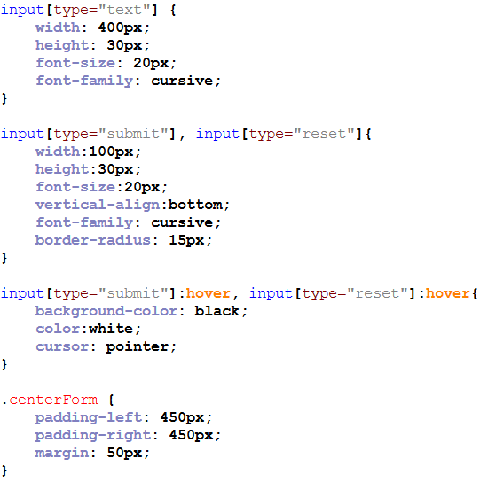

This was used to **style the form.** It **aligns the form to the center** by adding **padding** to the left and right of the form and adds **margin** to adjust the spacing.

This was used to **style the buttons** of the form when it is hovered over. The **background color of the button** changes to black, the **color of the text** to white and the **cursor** to the pointer.

This was used to **style the buttons** of the form. It sets the **size and font** of the text. It also sets the **width and height of the buttons**. It **aligns the button to the bottom** of the form and it **sets the radius of the border** so that the button’s corners become smoother.

This was used to **style the input fields** of the form. It sets the **size and font** of the text. It also sets the **width and height of the input fields**.

It sets the **maximum width and height of the images** of books. The curser is set to pointer.

The **element** that contains title and author of the book **is aligned to the center** with the style “bkdetails”.

The images of the books are **set to a height of 500px and a width of 500%**. The padding and margin of the images are set to **adjust spacing**.

This was used to **style the section**s inside the main section. It sets the **left section to the left** side of the main section and **the right section to the right** by setting the float attribute to the left and right respectively. The width was set to 100%.

This was used to **style the section** as a parent container. It **centers the section** and adds a **display and justify-content** attribute to position the sections in it. It also adds a **gap to separate the sections** inside it.

This **sets the style of the buttons** in the book details page. (download and buy)

It sets the border, background color, width and border radius, margin and padding of the buttons to **adjust the size and spacing**.

It also set the **color, size and alignment of the text**.

This styles an element and **aligns it to the center of the page** by adding margin, padding to the left and right of the element.

This **sets the style of the buttons** in the book details page. (release date).

It sets the background color, border, border-radius, width, margin and padding to **adjust size and padding** of the button.

It also **sets the color and size** of the text.

This styles the **hover effect** of the above mentioned buttons. It **switches the background color and the color of the text** with each other. It changes the **cursor to pointer**.

**Section 2 – XML**

Declaration of XML version and encoding.

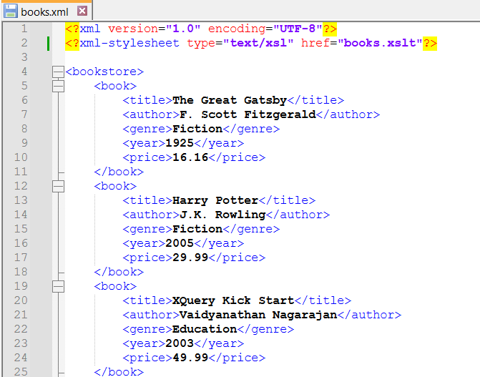

Linking to an XSL stylesheet for transforming the XML

**<bookstore>** is the Root element of the XML document.

**<book>** is a container element representing a single book and contains the following child (data) elements:

**<title>:** The title of the book.

**<author>:** The author of the book.

**<genre>:** The genre of the book.

**<year>:** The year of publication.

**<price>:** The price of the book.

<bookstore>is the Root element of the XML document.

<book>is Element representing a single book and contains the following child elements:

<title>: The title of the book.

<author>: The author of the book.

<genre>: The genre of the book.

<year>: The year of publication.

<price>: The price of the book.

**Section 3 – Validation**

**Declaring the DTD** for the XML .

**<bookstore (book+)>** implies that bookstore is the root element and book has one to many relation.

**PCDATA** implies that the specified element carries data.

**Section 4 - Transformation**

**Declaration** of XML version and encoding.

**Linking** to an XSL stylesheet for transforming the XML

This **template matches the root node** of the XML document.

**<html>** Opening HTML tag  
**<style>** CSS styles for the table and body.

**<title>** tag to define the title for the tab.

**<body>** section of xsl.

**<table>** Opening table tag with border attribute.  
  
**<tr>** Table row for column headers with background color.  
  
**<th>** Table header for book (Title, Author, Genre, Year, Price).  
  
**<xsl:for-each select="bookstore/book">**

Loop through each book element in the XML  
  
**<td><xsl:value-of select=" "/></td>**

Table data cell for book details  
(title, author, genre, year, price).

The table is styled using **Internal/Embedded CSS Styling.**

All remaining open tags are closed.

**Reflection**

This project was a valuable experience that honed our skills in HTML, CSS, XML, and XSL. We combined our knowledge and ideas to design the website, using HTML for structure, CSS for style, and XML and XSL for data organization and transformation. It taught us the patience and determination needed for web development. Additionally, it enhanced our creativity and collaboration abilities, demonstrating the importance of teamwork in successfully creating a website.