Supplementary material

Environmental microbial communities and host selection shape larval microbiomes

Stephanie F. Hendricks¹, Amy L. Tan¹, Amelia G. Williams², Mikayla M. Clark¹, Katherine M. Buckley², Marie E. Strader¹

¹Department of Biology, Texas A&M University, College Station, TX 77843, USA
²Department of Biological Sciences, Auburn University, Auburn University, Auburn, AL 36849, USA

ORCID
Hendricks: 0009-0003-1874-0947
Tan: 0000-0003-1222-3474
Williams: 0009-0009-8915-0737
Clark: 0000-0002-2862-3416
Buckley: 0000-0002-6585-8943
Strader: 0000-0002-1886-4187

Corresponding authors: Stephanie F. Hendricks and Marie E. Strader
Postal address: Texas A&M University, 3258 TAMU, BSBE Bldg 107, College Station, TX 77843
FAX: 979-845-2891
Emails: stephaniehendricks@tamu.edu and mstrader@tamu.edu
Supplemental table 1. Supplemental table 1 - sample sizes
Supplemental table 2. Supplemental table 2 - metadata
Supplemental table 3. Supplemental table 3 - taxa family
Supplemental table 4. Supplemental table 4 - taxa genus
Supplemental figure 1. Alpha diversity boxplots
Supplemental figure 2. Relative abundance stacked bar plot showing top nine families
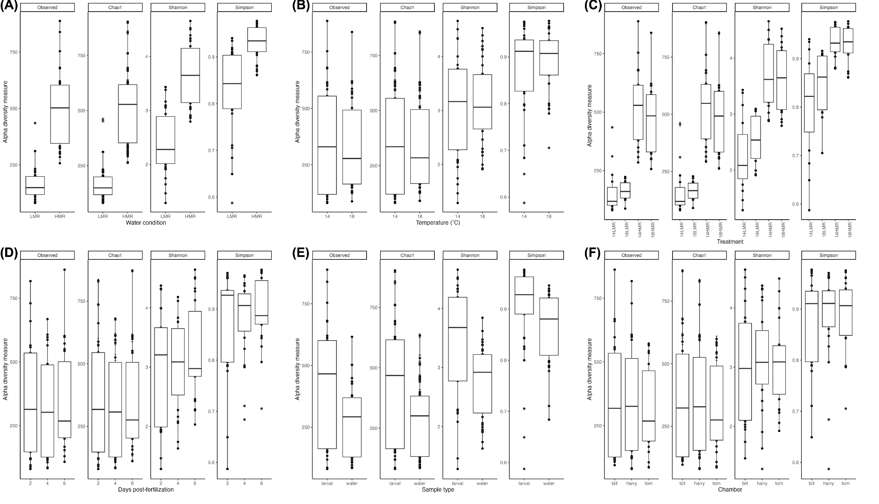
Supplemental figure 1. Alpha diversity measures of Observed, Chao1, Shannon, and Simpson by seawater condition (A), temperature (B), treatment (C), days post-fertilization (D), sample type (E), and chamber (F).

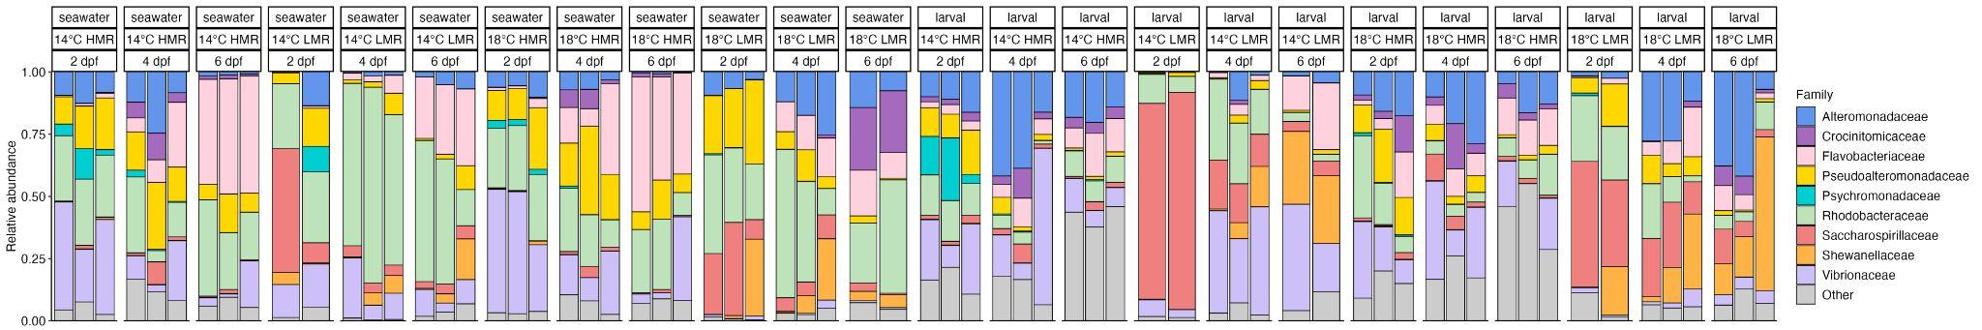
Supplemental figure 2. Stacked bar plot with relative abundance of microbial communities across four treatments at all time points in seawater and larval samples. Each bar represents a sample, with colors indicating the top nine families (≥2 5% relative abundance in any single sample). “Other” consists of the remaining families grouped as one category.

