**Drone description**

**A picture of the drone**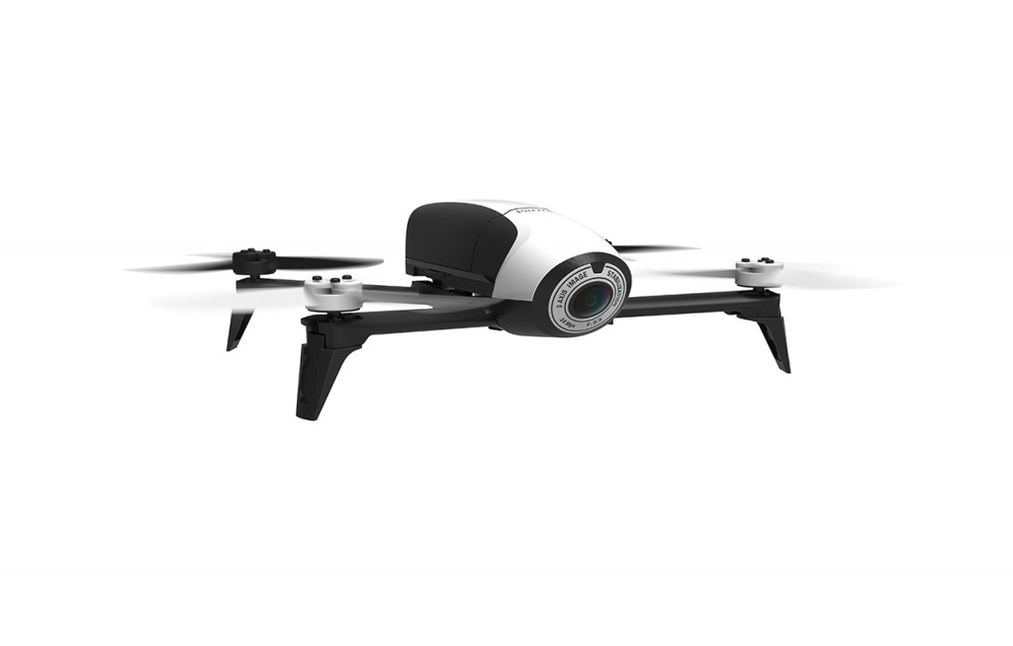

**A picture of the ground station**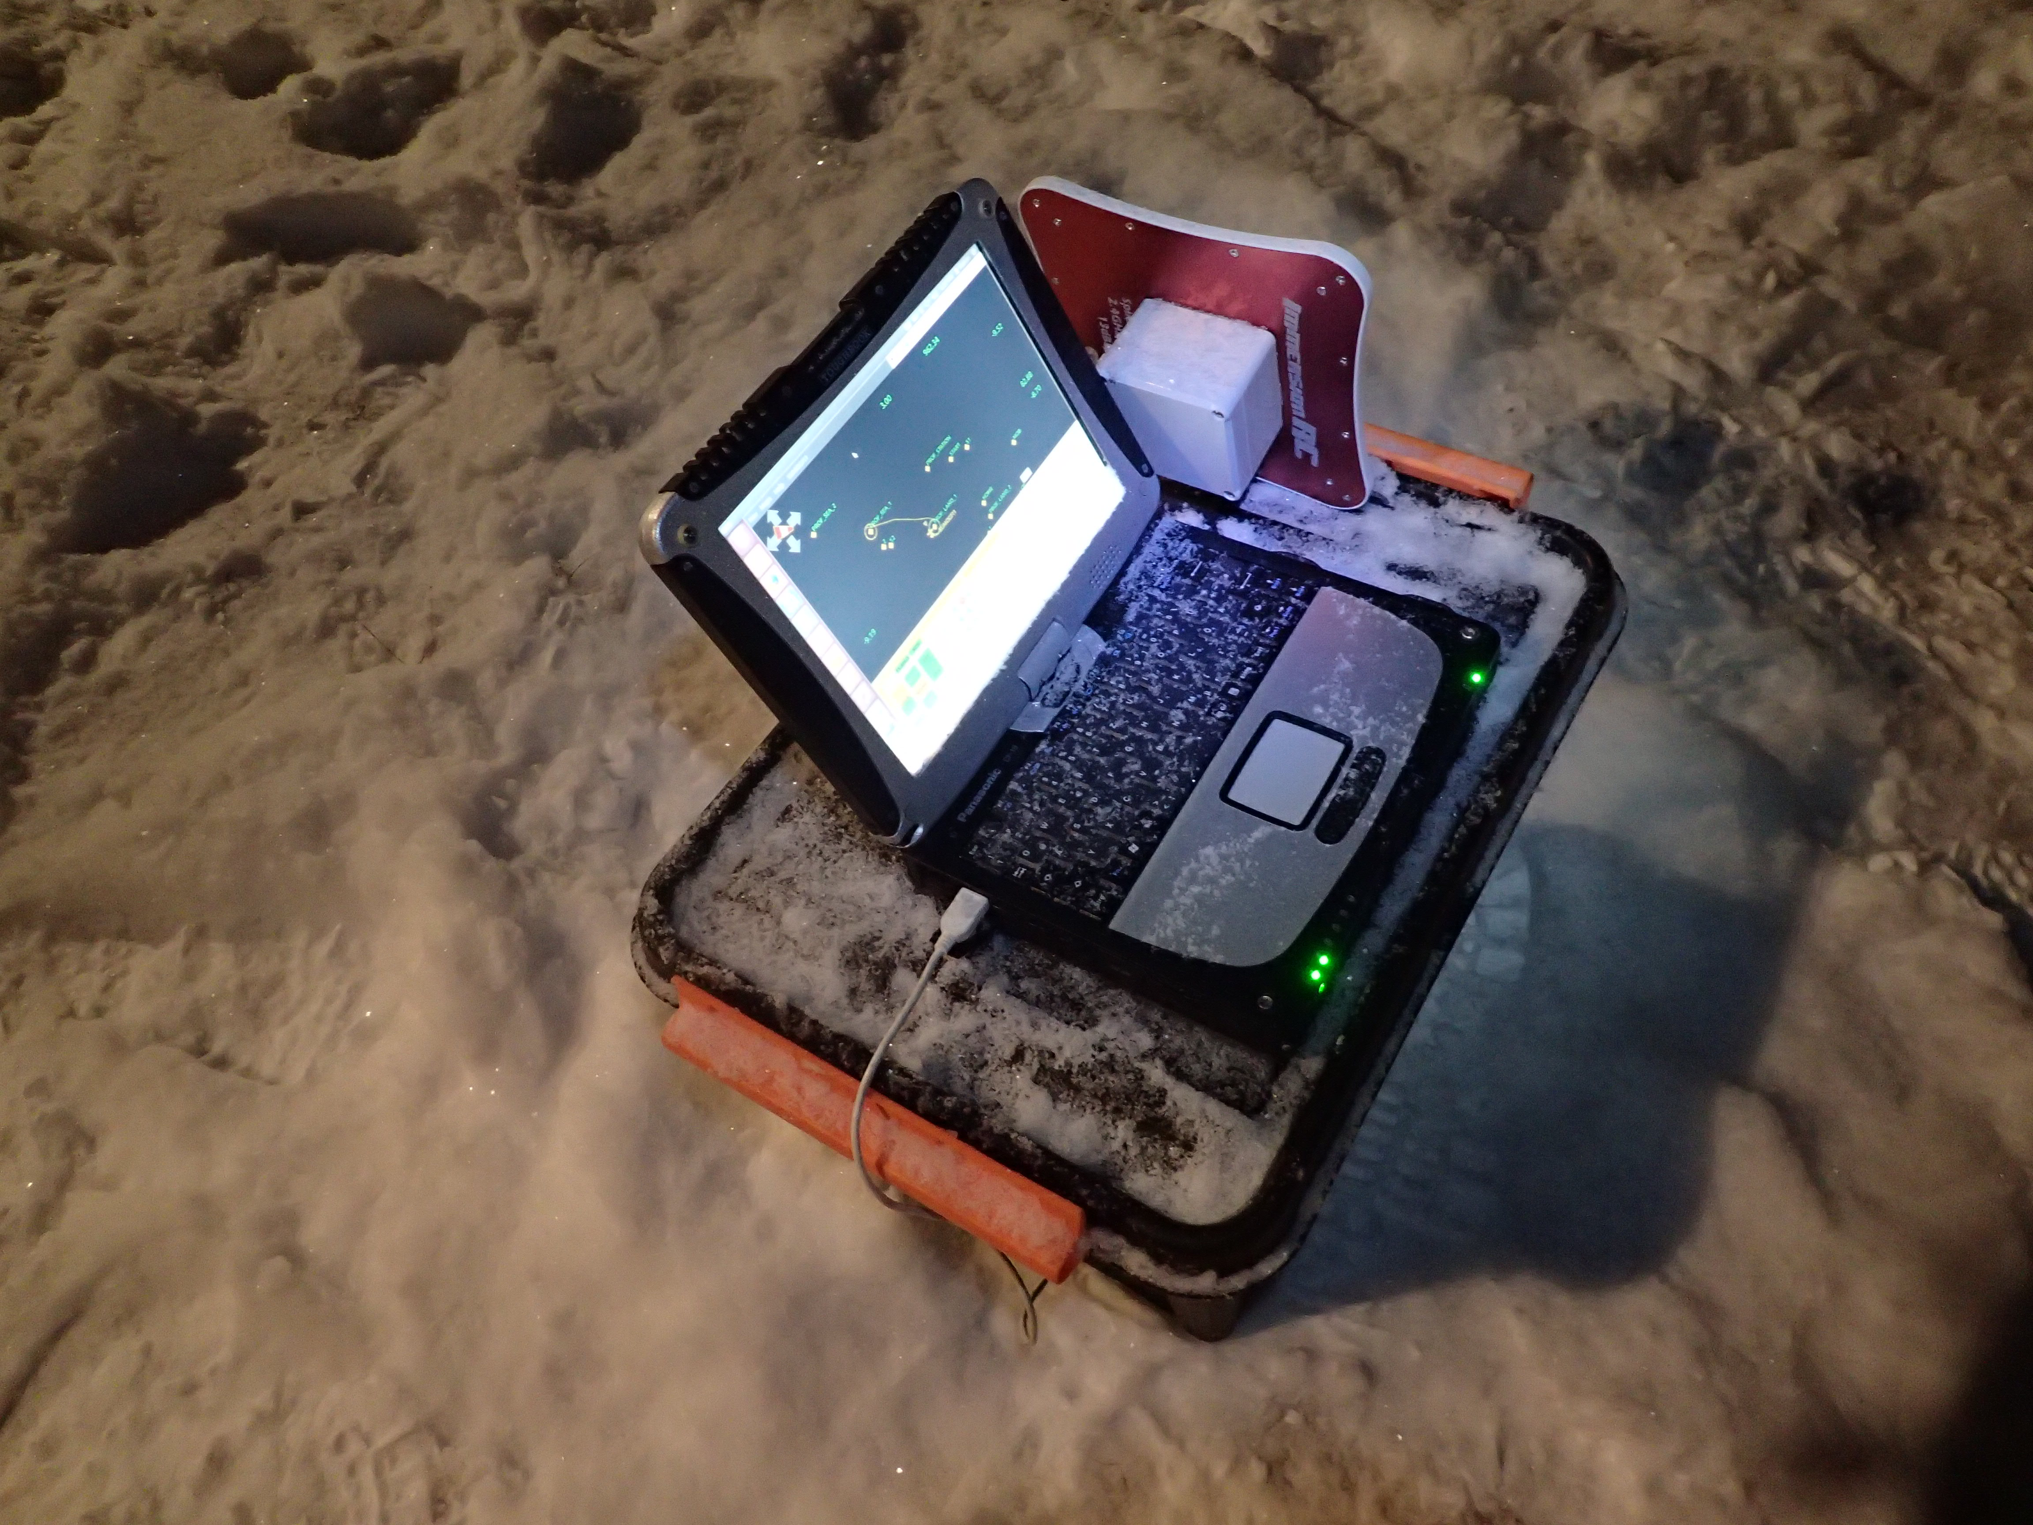

**System general information:**

The Parrot BEBOP2 is a commercially available quadcopter, made from glass fibre reinforced ABS and with a diameter of about 50 cm. The system has been modified for meteorological purposes by adding autopilot components, meteorological sensors and data acquisition systems and integrated into a 3D printed frame that is attached on top to the battery in a fixed position. This additional payload is only increasing the height of the BEBOP2 and is not significantly contributing to the weight of the RPAS, thus in case of a crash the impact force and energy will basically not be different from the original BEBOP2. The BEBOP2 has four propellers and motors and have not been modified. With its overall take-off weight of about 500 g, the system is comparable to the mass of the routinely used weather balloon (radiosonde), and less than a duck.

The modified BEBOP2 is equipped with the open source autopilot system Paparazzi, mainly developed and maintained by the École Nationale de l’Aviation Civile (ENAC), Toulouse, France. The Paparazzi autopilot uses the original BEBOP2 inertial measurement unit (IMU), gyro, magnetometer and GPS receiver to sense the aircraft’s attitude and measure the position, heading and climb rate.

The system has two different control modes. Mode 1 is STABILIZED and in this mode the aircraft can be flown like a normal RC quadcopter. In Mode 2 (AUTO) the autopilot controls the aircraft.

The Paparazzi autopilot is used by more than 50 registered educational and scientific users all over the world. The SUMO system has been operated in numerous field campaigns in different parts of the world. About 1000 scientific flights have proven the reliability of this system even under harshest conditions

**Characteristics**

A general description of the characteristics of the drone.

The basic design is symmetrical with respect to the lateral axis of the aircraft and four rotors. The flight characteristics for the BEBOP2 in a straight forward flight path are in an X configuration, where the two propellers pointing forward are coloured (red or white) whereas the rear ones are black. Front right and rear left propeller rotate clockwise, front left and rear right counter-clockwise.

**Risk analysis**

A risk analysis of the technical part of the drone.

The technical solutions and the control electronics on the BEBOP2 are among the best available on the hobby market ensuring high quality and great reliability. The autopilot system in use is Paparazzi, an open source hardware and software autopilot system, developed and maintained under the lead of the École Nationale de l’Aviation Civile, Toulouse, France. It is used by numerous research groups all over the world and has proven its reliability and robustness under most extreme conditions.

However, one must pay extra attention to it when it comes to safety. There are few redundancy systems and one must assume that a failure can be catastrophic. It is important to consider this when planning the flight and safety zones.

Strong winds may cause negative ground speed when the aircrafts maximum tilt angle (or airspeed) is not sufficient to keep its location and will lead to a to some degree uncontrolled drift of the quadcopter. This problem is prevented by paying special attention to the prevailing wind conditions and returning to a flight level with lower wind speed or land in a controlled manner as soon as a significant drift is observed. The GCS operator has to make sure that the aircraft is controlled accordingly if strong winds are experienced. Furthermore, all operations in atmospheric profiling should as far as possible take place with the aircraft to the windward side of the start point to provide an additional safety margin for strong wind speeds during ascent. To ensure that the aircraft can be returned to its start/landing point a flight level with lower wind speeds shall be chosen through either the RPC or manually by the safety pilot.

Moreover, the BEBOP2 system includes a number of important automatic safety functions, which make the system reasonably fault-tolerant and ensure safe and predictable behaviour also in “degraded” conditions:

* Manual/automatic control: The safety pilot can overrule the on-board autopilot and the remote pilot station at any time during automatic operation (when the RPA is within RC range) by switching the aircraft into manual “radio-control” mode.
* A fly-away prevention system (geo-fencing): If the aircraft for some reason leaves a predefined area (usually a circle with radius 300 m around the start point) or exceeds a predefined maximum altitude (400 ft. for VLOS), the on-board computer will terminate the current mission and guide the aircraft to a predefined holding pattern (typically a fixed position at a predefined altitude) close to its start position, from where it can be manually recovered by the RPAS pilot. If the aircraft fails to return to the start position, and leaves the specified operation area, the on-board computer will eventually initiate an automatic landing at the aircraft's current location.
* Energy management: In case the aircraft battery voltage drops below a predefined value, corresponding to ca. 10 min of remaining operation, the RPAS will return to its start position and enter a holding pattern at a predefined altitude, until it is landed manually or automatically.
* Loss of data-link procedure: The data link of the 2.4 GHz modem is usually ensured in a cylinder of 1000 m in diameter and 10000 ft. AGL. In case of complete loss of the communication link (2.4 GHz modem) between the RPAS and the GCS for more than a user predefined time interval (usually 30 s), the RPAS will return to its start position and enter a holding pattern at a predefined altitude, until it is landed manually by the safety pilot.
* Loss of GPS position procedure: If the GPS signal is lost and the autopilot does not get position information, the autopilot will use the IMU and gyro (attitude sensors) to initiate a controlled automatic landing.
* Loss of attitude procedure: If the IMU (attitude sensor) gets degraded and the autopilot cannot control its flight, the autopilot will keep all motors at a constant throttle that allows for a slow descend until the aircraft hits ground.

To reduce the risk of GPS loss the BEBOP2 should never be started without receiving signals from a sufficient number of satellites (typically 6) and the normal procedures have to be followed.

**Components**

A description of what kind of hardware the drone is built up by.

The BEBOP2 is a commercially available quadcopter produced by Parrot, which uses a 3-axes magnetometer (AKM 8963), 3-axes gyroscope and accelerometer (MPU 6050), an optical-flow sensor (vertical stabilization camera taking ground images every 16 milliseconds and comparing them to the previous one to determine the speed of the RPA), an ultrasound sensor (analyses the flight altitude up to 8 meters), a pressure sensor (MS 5607) and a GPS (u-blox Neo M8N GPS) geo-location system. The autopilot software is run directly on the internal system of the BEBOP2

The modem is 2.4GHz XBee pro and the RC receiver a Futaba FASST R617FS.

**Ground station:**

The SUMO GCS is based on a Panasonic Toughbook laptop computer running the Paparazzi GCS software on a Linux distribution. The Paparazzi software supports a range of radio modems and it also contains the possibility of simulating flight missions. The GCS software provides the operator with possibilities to alter the aircraft’s flight plan, target altitude and speed in-flight, in addition to modify control gains for tuning the flight characteristics. Relevant parameters such as battery status, ground speed and climb speed in addition to weather data, like wind speed, wind direction and temperature, are displayed in real time on the GCS screen. These parameters should be continuously monitored by the GCS operator to ensure safe flight and to keep operation within the given weather limitations.

In addition to this the Paparazzi software also provides an option for simulating flight plans under different wind conditions. Prior to any flight using a new flight plan, the flight plan should be simulated using the Paparazzi simulation software applying realistic wind conditions to ensure a proper and safe design and to thereby minimize the risk of mishaps during flight related to a poor flight plan design. The software can also replay flown flight missions and this feature may be especially useful in the event of mishaps.

**Technical Specification**

Vehicle mass: 350g  
Take-off weight (max): 500g  
Payload mass (recommended): 50g  
Payload mass (max): 150g  
Battery: 11.1 V (3S), 3.1 Ah

Climb rate: 6 m/s  
Cruise speed: 16 m/s  
Endurance: 25 min  
Flight radius: 2 km (horizontal range)

**Operational Conditions**

Temperature range: -30degC 40degC  
Humidity: 0-95% (flying in clouds under freezing temperatures is not recommended, precipitation should be avoided)  
Wind tolerance: 15 m/s (avoid flights when the wind speed close to ground is around 10 m/s)  
Minimum visibility: 150 m

**Physical dimensions and colour**

Diameter (multirotor): 50 cm  
Height: 5 cm  
Length (fixed wing): 38 cm  
Width (fixed wing): 33 cm  
Colour: Black-white or Red-white

**Payload**

Meteorological sensors, for T, RH, p, long-wave radiation sensors.

**Normal procedures**

Checklist of normal procedures:

* Pre-Flight Checks: Campaign and Mission Planning
  + Required permissions in place
  + NOTAM for UAS operation issued if applicable)
  + Temporarily restricted area (TRA) activated
  + Maps for the GCS downloaded
  + Terrain height for the GCS downloaded
  + Important POIs defined
  + Points for automatic landing defined
  + Safety zones defined
  + Fail-safe modes defined
* Pre-Flight Check List: RC
  + Battery charged
  + Antenna properly mounted
  + Throttle in ZERO POSITION
  + Mode switch in MANUAL
  + Correct pre-programmed aircraft definition active
* Pre-Flight Check List: GCS
  + Battery charged
  + Correct telemetry antenna connected to the GCS
  + Correct flight plan selected
  + Correct flight mode selected
  + Correct aircraft selected
  + Paparazzi GCS application running
* Pre-Flight Check List: BEBOP2 airframe
  + Battery charged
  + Airframe intact
  + Propeller mounting intact
  + Propellers intact
  + Propellers’ rotation direction correct
  + Motor mounts intact
  + Battery mounted and fixed in proper position
  + Centre of gravity properly placed
  + Payload frame intact and properly mounted
  + Payload frame connected
  + Sensor mounting OK and sensors properly aligned
  + Sensors clean, protection caps taking off
  + Correct flight plan uploaded
* Check List: BEBOP2 start procedure
  + Safety transmitter ON
  + GCS switched on and Paparazzi application running
  + Battery connected
  + BEBOP2 after battery connection motionless and levelled for IMU setup
  + Hold BEBOP2 levelled -> Is horizon horizontal and vertically aligned
  + Rotate BEBOP2 right -> Does horizon tilt to the left
  + Rotate BEBOP2 left -> Does horizon tilt to the right
  + Point BEBOP2 nose downward -> Does horizon move up
  + Point BEBOP2 nose upward -> Does horizon move down
  + Is GPS 3D fix available and stable
  + Is the correct aircraft active
  + Is battery level OK
  + Is the correct map displayed
  + Is the SUMO position displayed correctly
  + Is telemetry data updated several times per second
  + Do a “Walk around”
  + Switch between all flight modes
  + Verify weather conditions
  + Verify start area is clear
  + Verify that wind is opposite to start direction
  + Start motors
  + Verify timer is running

**Emergency and safety procedures**

Emergency procedure checklist.

* The following general rules apply if an emergency situation appear:
  + FLY THE AIRCRAFT
  + ANALYSE THE SITUATION AND TAKE PROPER ACTION
  + NOTIFY PEOPLE IF NECESSARY WITH THE WORD: Danger!
  + LAND THE RPA AS SOON AS POSSIBLE IN A CONTROLLED MANNER
* Critical aircraft battery level during
  + Identify landing area
  + Set altitude to 100m and wait until reached
  + Change flight mode to MANUAL
  + Pilot lands ASAP
* Telemetry link loss
  + Check that antenna cable is connected
  + If disconnected, reconnect and restart link-server
  + If directional antenna is used orient antenna towards aircraft
* RC link loss
  + RC power on
  + If RC link is not back initiate automatic landing