Objective:
This assignment aims to familiarize bootcamp students with containerization using Docker by dockerizing a three-tier application built with Node.js. Students will learn to identify and replace hard-coded values with environment variables, create Dockerfiles for the frontend and backend components, write a Docker Compose file, initialize a sample SQL dataset, and push the Docker images to DockerHub using GitHub actions CI. Additionally, assessment 3 aims to reinforce concepts such as networking and volume usage in Docker.

Codebase: Movie nodeapp
Project walkthrough video: Video explanation of the project

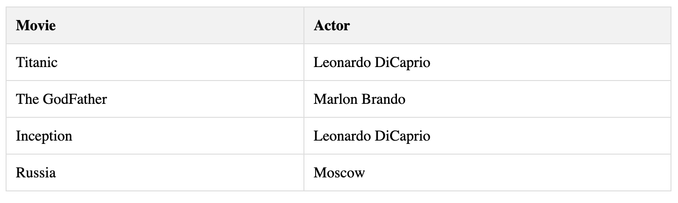

Milestones
- Code Analysis and Environment Variables:
  - Identify hardcoded values in the frontend and backend code.
  - Replace hardcoded values with environment variables.
- Dockerfile Creation:
  - Craft Dockerfiles for frontend and backend, ensuring:
    - Base image selection
    - Application code copying
    - Dependency installation
    - Port exposure
- Docker Compose Configuration:
  - Define services for frontend, backend, and database within a Docker Compose file.
  - Establish network communication between services.
  - Configure volumes for data persistence.
- Database Initialization:
  - Implement SQL script execution for dataset initialization within the database container.
- Image Building and Pushing:
  - Construct Docker images for frontend and backend using docker-compose build.
  - Push images to Docker Hub using docker-compose push.
- Docker image build and push using GitHub actions CI.

Deliverables:
- Dockerized frontend and backend code with replaced hard-coded values.
- Dockerfiles for frontend and backend.
- Docker Compose file orchestrating the entire three-tier application.
- SQL script for initializing a sample dataset.
- Evidence of proper networking and volume usage in Docker Compose.
- Screenshots/logs confirming the successful push of Docker images to DockerHub.
- GitHub actions CI yml file

Guidelines:
- Follow best practices for Dockerfile creation.
- Ensure that the application works seamlessly after Dockerization.
- Include comments in the code to explain the purpose of environment variables and Dockerfile instructions.
- If any individual student is not able to select the right base image, then hints will be given the next day.
- You have to create the GitHub repos to perform CI. Code has been given in one zip file.
- You can use this command to create sonarqube server. Local testing can be done on system but for CI ec2 is needed. (Try hacking a way out with ngrok)
sudo docker run -d --name sonarqube -p 80:9000 -v sonarqube_data:/opt/sonarqube/data -v sonarqube_extensions:/opt/sonarqube/extensions -v sonarqube_logs:/opt/sonarqube/logs sonarqube

Grading Criteria (100 Marks):
- Identification and Replacement of Hard-Coded Values (10 Marks):
  - Thoroughness of identifying hard-coded values.
  - Accuracy in replacing hard-coded values with environment variables.
- Creation of repos for frontend and backend. (10 Marks)
- Dockerfiles (20 Marks):
  - Proper structure and syntax of Dockerfiles.
  - Correct configuration of dependencies and environment variables.
- Docker Compose File (20 Marks):
  - Effective orchestration of services.
  - Proper definition of networking and volumes.
- Sample SQL Dataset Initialization (10 Marks):
  - Accuracy and completeness of the SQL script.
  - Successful initialization using Docker Compose.
- Networking and Volume Usage (10 Marks):
  - Proper demonstration of networking between frontend, backend, and the database.
  - Effective utilization of Docker volumes for persistent storage.
- Image Push to DockerHub (10 Marks):
  - Successful push of Docker images to DockerHub.
  - Proper organization and tagging of Docker images.
- GitHub actions CI (10 Marks)
- Documentation and Code Comments (10 Marks):
  - Clear and concise documentation.
  - Inclusion of comments in the code explaining key decisions and configurations.
Bonus step:
- Sonarqube-based code testing in Docker CI step.

