N01052617

1

M-179973

F-120051

2a

Shahab

2b

Make

2c

Dipankar

3

All the different last names

4a

63838.1769

4b

63769.6032

4c

63810.7448

5

34040

Male -20554

Female -13486

6a

59.9141

6b

59.92

6c

59.9181

7

Every department has more males

8a

5.8619

8b

3.9384

8c

9.8002

Bonus

Male

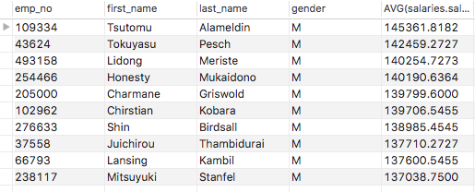

Female

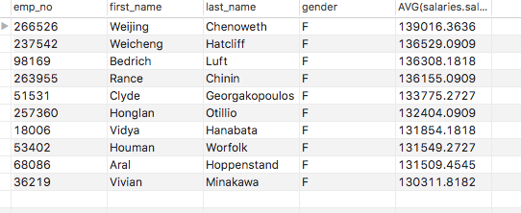

Both

