
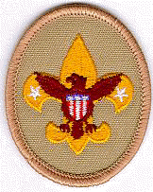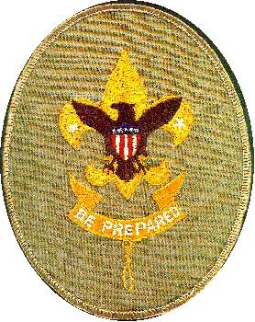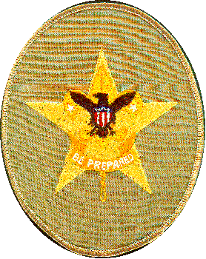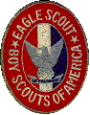
Tax ID #95-2458929

April 30, 2019

Dear St. Bonaventure Men’s Club,

Thank you for your recent donation. We appreciate it very much and are pleased to be volunteering and working for the Scouts BSA charted by the St. Bonaventure Men’s Club.

Throughout the past few years, some of our equipment has been getting worn down. This donation will help replace some 8+ year old stoves, connecting hoses, and some old tents that are beginning to tear and show their age. In addition, it will also allow some scholarship for scouts that have difficulty with some of the costs of this year’s summer camp.

We will continue to lead the scouts and abide by the Scout Law which reads as follows:

On my honor, I will do my best
To do my duty to God and my country and to obey the Scout Law;
To help other people at all times;
To keep myself physically strong, mentally awake and morally straight.

Sincerely,

Dan Minear Dan Lavallee
Committee Chair Scoutmaster

Boy Scouts of America Huntington Beach California
Sponsored by the St. Bonaventure Men's Club

