Setup & Execution Guide
1. Load HDFS Data
- Open a terminal and navigate to:
- C:\hdfs_data
- Run:
- docker-compose down
- docker-compose up -d
Access the NameNode Container
docker exec -it namenode bash
Inside the NameNode container:
ls /data # Verify your dataset is visible
hdfs dfs -mkdir /training_data
hdfs dfs -put /data/modified_fraud_dataset.csv /training_data/
Assuming the csv is in hdfs_data folder.

2. Spark Setup
Start the Spark container:
docker start spark
docker exec -it --user root spark bash
Install required Python packages:
pip install numpy
pip install kafka-python
pip install pyspark
Create the directory for Spark JARs:
mkdir -p /opt/spark/jars
Exit the container:
exit
Copy your scripts into the Spark container:
docker cp "C:\Users\17144\Desktop\logistic_regression_model.py" spark:/app/
docker cp "C:\Users\17144\Desktop\fraud_streaming.py" spark:/app/
docker cp "C:\Users\17144\Desktop\fake_kafka_producer.py" spark:/app/
Run Spark again:
docker exec -it --user root spark bash
cd /app
ls
/opt/spark/bin/spark-submit logistic_regression_model.py
exit
3. Test Kafka (Outside Spark)
Producer
Open Terminal 1:
docker exec -it kafka-broker /opt/kafka/bin/kafka-console-producer.sh --topic fraud-transactions --bootstrap-server kafka-broker:9092
Send a sample message:
{"transaction_id":1,"amount":500,"fraud":0}
Consumer
Open Terminal 2:
docker exec -it kafka-broker /opt/kafka/bin/kafka-console-consumer.sh --topic fraud-transactions --from-beginning --bootstrap-server kafka-broker:9092
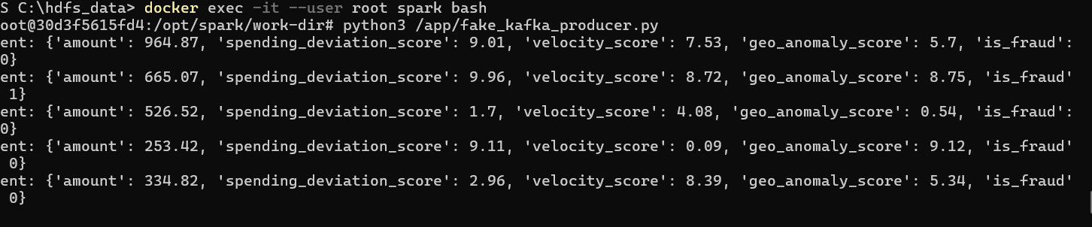

4. Test Kafka Inside Spark Container
Terminal 1 — Run Fake Producer
docker exec -it --user root spark bash
python3 /app/fake_kafka_producer.py
Terminal 2 — Run Spark Streaming
docker exec -it --user root spark bash
/opt/spark/bin/spark-submit \
--packages org.apache.spark:spark-sql-kafka-0-10_2.13:4.0.1 \
/app/fraud_streaming.py

