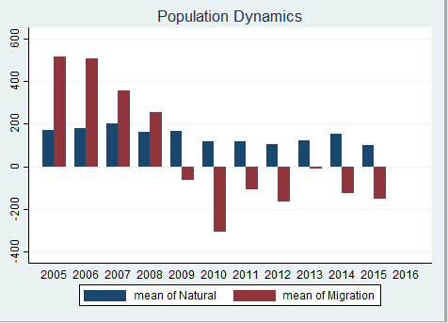

According to [census.gov](http://census.gov), approximately 80% of the population in Baker County aged 25 and up only have a high school degree or higher. Only about 11 percent of the population aged 25 and up have a bachelors degree or higher, which leads me to believe that those that are not pursuing higher education are just staying in Baker County. Also, the elderly population (65+) has gone up approximately 3 percent from 2010 to 2015, which could also lead to less migration. Also, I noticed the migration decrease started around the housing crisis, so I did some research and found out that houses in Baker County cost less than in other areas in Florida which might have incentivized residents to stay.

It seems as if those that are moving out are staying out, and those that are staying are settling in Baker County. Also, when looking at demographics, you see a lot of young people (under 18) still counted in the population, as well as older people. My thought is that when they finish high school, those that want to pursue education will want to move out of Baker county, making the mean of migration go up again. These reasons combined paint a pretty good picture as to what is happening to Baker county's mean of migration. It looks like more people are staying than they are leaving which could be due to education level, an aging population, or some other outside factor.