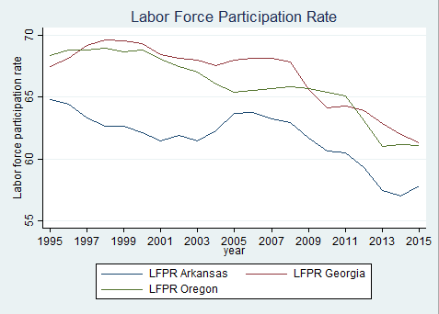Labor-force Participation Rate (with Descriptive Statistics)

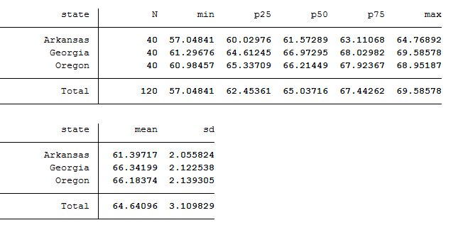

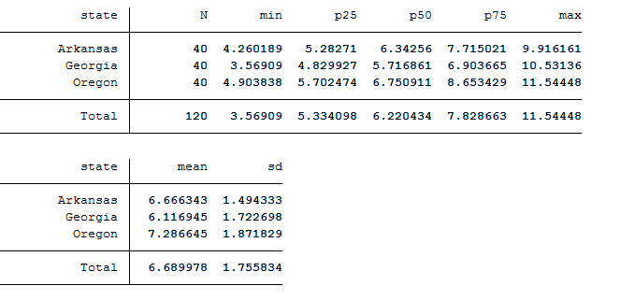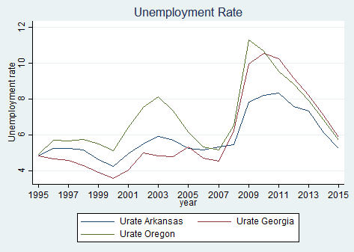Unemployment Rate (Descriptive Statistics)

Findings:

I randomly chose three states: Arkansas, Georgia, and Oregon. The first thing I saw was how the housing bubble bursting caused the unemployment rate to go up in all of these places. This led me to compare the unemployment rate with the labor-force participation rate. From what it seems, people still felt the crash years later. It seems like workers were discouraged from going out to find new jobs after possibly being let go which leads to the disinterest of finding a new job down the road. It seems like all three states have been acting the same (each going up or down at the same time), however, it may be tricky for us to see the same effects on Arkansas but that may be due to the smaller population in the state. The unemployment rate has been going down for approximately the last five years in these states and is almost at the lowest it has been since 2007. All in all, these states seem to be fluctuating at the same rate so nothing too major to note here.