**word - mot - palabra - Vort – lexis**

or simply **word**\*

* the other words are translations of “word”

**I want a web app that is easy enough for a non-native English speaker to look up the definition of a word.**

**As well, this app could be useful for native English speakers, who may want to know more details about the selected word, and what it is in different foreign languages.**

# Concept

* **The web page for the app should be pleasant looking with a modern design.**
* **A person can easily input a word and get its definition****.**
* **The word is then stored for later reference.**
* **French, Spanish, German and Greek translations of the selected word are then presented.**

# Process

# Tools: I used HTML, CSS, Bootstrap and jQuery, along with Photoshop for the graphics, and content delivery networks Googleapis for the title and Fontawesome for the new tab icon.

**Tasks:**

* **I designed the site in HTML, CSS and Bootstrap, with a collage hero image and a Bootstrap carousel on the right-side column of the page, below the collage, using the Bootstrap** **version of flex/grid. This was made responsive with Bootstrap breakpoints. For mobile phones, there is only one column with the carousel appearing at the bottom of the page.**
* **Using JavaScript fetch, I connected to two APIs: Word Dictionary API and NLP Translation API, using these to provide the definition and translations for the selected word.**
* **Then, with jQuery, I coded the event listeners and functions, with some DOM manipulation.**

**Challenges: Bootstrap and jQuery are supposed to be easy. As I’m not very familiar with either, I had to Google a lot and refactor the HTML and JavaScript a few times.**

**Successes:**

* + **Connecting with the two APIs, one of them 5 times.**
  + **Getting a nice working flow and coding flow, adding, undoing or refactoring code as I went along.**
  + **For instance, I had a function to store history as a final function in a chain. As I proceeded in development, that function became the first function to be called using event delegation.**
  + **Creating a bootstrap carousel, with annotated pages from the five countries, with an accessible link to Google for info about the active slide.**

# Demo

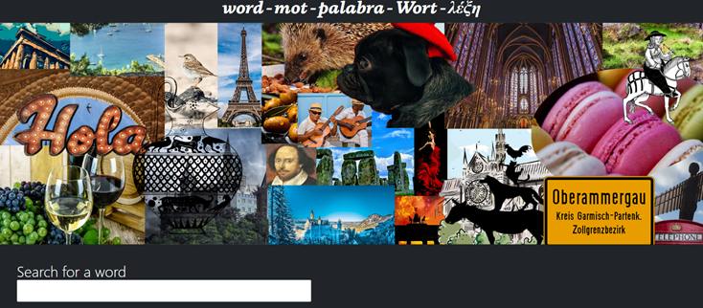

# Future Development

* **More languages to be translated?**
* **More related APIs?**
* **Look further into using Rich Internet Applications (ARIA**)

# Links

* Deployed **-** [**https://stephdavid.github.io/english-words/**](https://stephdavid.github.io/english-words/)
* GitHub -[**https://github.com/stephdavid/english-words**](https://github.com/stephdavid/english-words)
* Presentation -[**https://sway.office.com/1Yj5m4aVAdaOZmRs**](https://sway.office.com/1Yj5m4aVAdaOZmRs)