A statement declaration of what useful debugging strategy you will use the most:

* The Watch function seems really useful for looking at problematic items and very intuitive to use. I struggled to get auto/locals to populate anything with this file, but I think that could be extremely useful to have a list of all your variables (if I understand the function correctly).

A statement describing the difference of step into and step over.

* Step into will proceed to follow the code into a called method, whereas step over will proceed without invoking the method.

Breakpoints: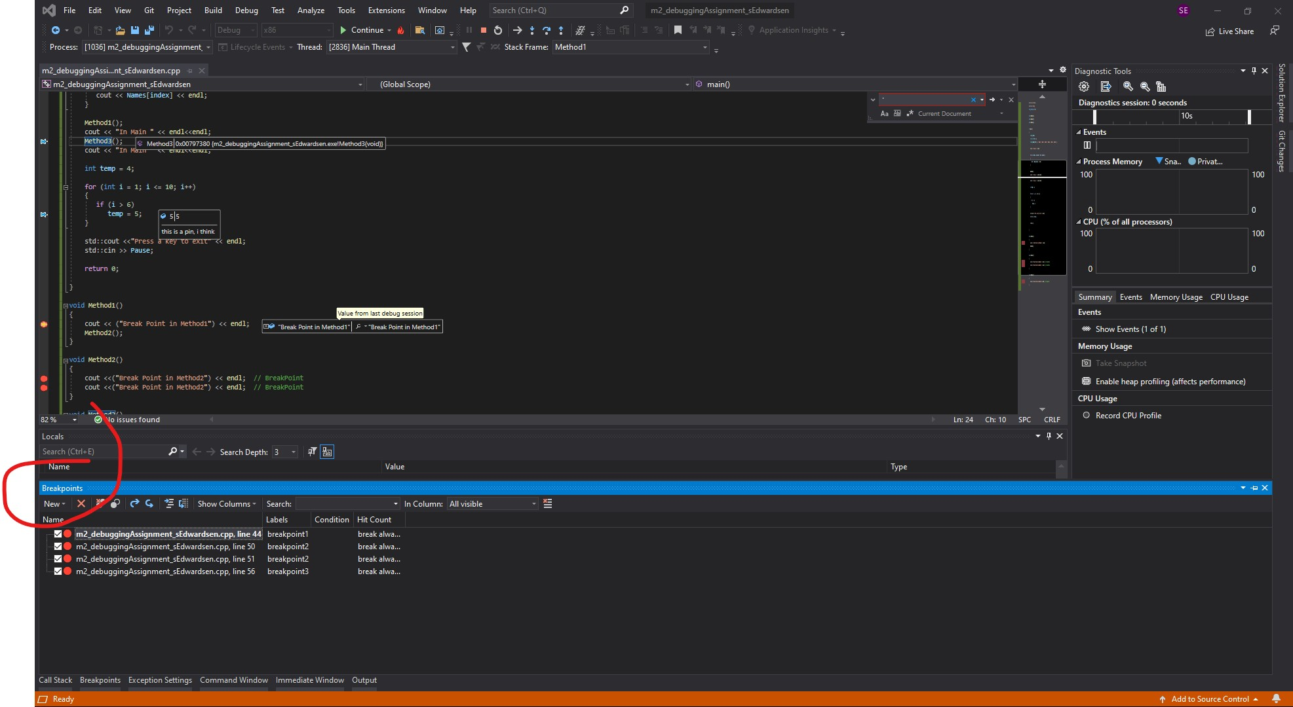

Locals and Autos windows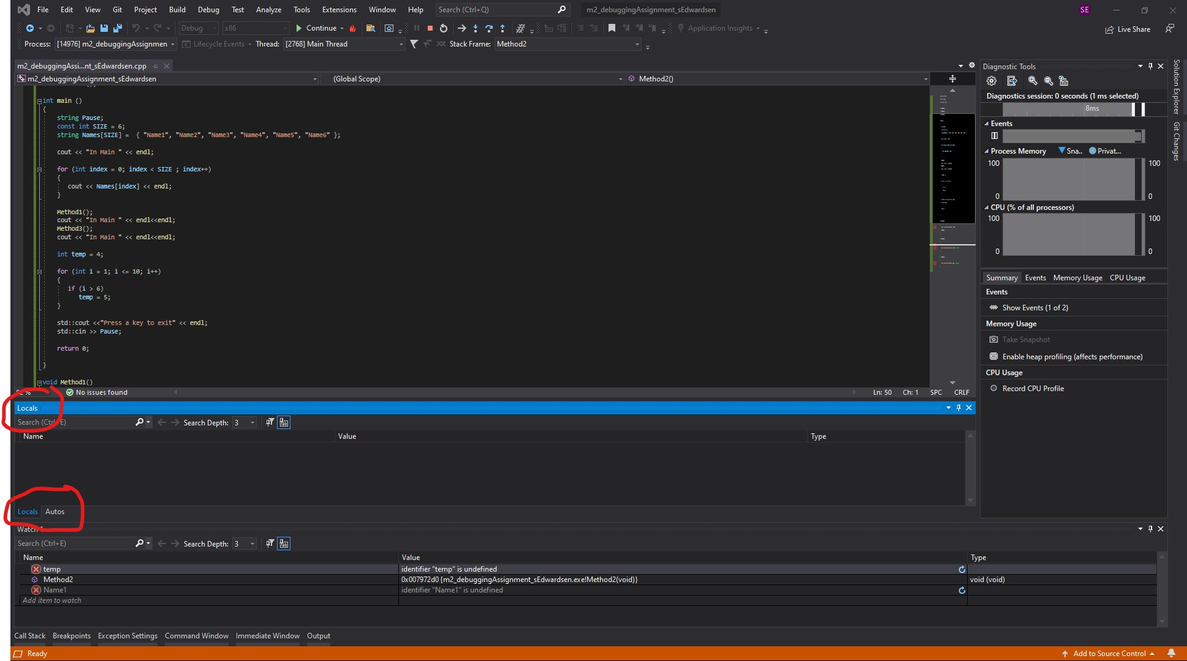Pinned items