Optimized Machine Learning Approaches for Better Sleep Disorder Diagnosis

ABSTRACT
Sleep disorders, particularly sleep apnea, are a significant health concern affecting millions of individuals globally. Timely and accurate detection of sleep apnea is essential for early intervention and effective treatment. This project presents an optimized machine learning-based approach for detecting sleep apnea using electrocardiogram (ECG) data. The system employs three powerful machine learning algorithms—Support Vector Machine (SVM), Random Forest, and XGBoost—to classify ECG signals into two categories: normal (0) and sleep apnea (1). By utilizing these models, the system aims to provide accurate, real-time detection of sleep apnea from ECG signals, which are commonly used for diagnosing this disorder. The models are trained and evaluated using Python, leveraging popular libraries such as scikit-learn for SVM, Random Forest, and XGBoost implementations. The goal is to create a robust and scalable solution that can assist healthcare professionals in diagnosing sleep apnea efficiently, ultimately improving patient outcomes. This work emphasizes the potential of machine learning in enhancing diagnostic accuracy and providing automated support for healthcare providers.
Keywords: Sleep Apnea, ECG Data, Machine Learning, Support Vector Machine (SVM), Random Forest, XGBoost, Classification, Healthcare, Diagnostic System, Real-time Detection, Python, Early Diagnosis.

OBJECTIVE OF PROJECT:
The objective of this project is to develop an optimized machine learning-based system for the accurate detection and classification of sleep apnea using electrocardiogram (ECG) data. The project employs three powerful machine learning algorithms—Support Vector Machine (SVM), Random Forest, and XGBoost—to categorize ECG signals into two classes: normal (0) and sleep apnea (1). By leveraging these models, the system aims to enhance the detection accuracy of sleep apnea, providing healthcare professionals with a reliable tool for early diagnosis. The primary goal is to create a real-time, scalable solution that can aid in sleep disorder diagnosis, improving patient care and treatment outcomes.
PROBLEM STATEMENT:
Sleep apnea, a serious medical condition characterized by interruptions in breathing during sleep, remains underdiagnosed due to its subtle symptoms and reliance on traditional diagnostic methods such as polysomnography. These methods are often expensive, time-consuming, and not widely accessible. This project seeks to address these limitations by utilizing machine learning algorithms to detect sleep apnea directly from ECG data. The challenge lies in accurately classifying the ECG signals into two categories: normal and sleep apnea, while maintaining high diagnostic accuracy. By overcoming the constraints of existing methods, this project aims to provide an efficient, cost-effective, and non-invasive alternative for diagnosing sleep apnea.
MOTIVATION:
The motivation behind this project stems from the rising prevalence of sleep apnea and the increasing need for early and accurate detection methods. Traditional diagnostic techniques for sleep apnea are costly, require specialized equipment, and involve lengthy testing processes, limiting their accessibility. By leveraging machine learning, this project aims to provide an automated, real-time solution that can be used in both clinical and home settings to detect sleep apnea more efficiently. This approach not only reduces healthcare costs but also facilitates early intervention, leading to better patient outcomes. The use of algorithms like SVM, Random Forest, and XGBoost provides a reliable and scalable solution for widespread deployment.
SCOPE:
The scope of this project includes the development of a machine learning-based sleep apnea detection system using ECG data. The project will apply three machine learning algorithms—SVM, Random Forest, and XGBoost—to classify ECG signals as either normal or indicative of sleep apnea. The system will be trained using publicly available ECG datasets, and the models will be evaluated for accuracy, precision, and recall. The project will also include the creation of a user-friendly front-end interface, where healthcare providers can input ECG data and receive real-time classification results. The back-end will be powered by Python, utilizing libraries such as scikit-learn and XGBoost. This project aims to provide a cost-effective, accurate, and accessible solution for sleep apnea diagnosis, making it applicable to both clinical environments and home monitoring systems.

PROJECT INTRODUCTION:
Sleep apnea is a common but often undiagnosed condition that can lead to serious health issues, including cardiovascular disease and stroke. Timely and accurate diagnosis is crucial for effective management and treatment. Traditional diagnostic methods, such as polysomnography, are expensive, time-consuming, and require specialized equipment. These challenges make it difficult for healthcare providers to offer widespread and accessible sleep apnea diagnosis. With the growing need for more efficient and accessible diagnostic tools, there is a pressing demand for automated, real-time systems that can detect sleep apnea reliably from simple, non-invasive data sources.
This project aims to address these challenges by leveraging machine learning techniques to detect and classify sleep apnea using electrocardiogram (ECG) data. The system will employ three powerful algorithms—Support Vector Machine (SVM), Random Forest, and XGBoost—to classify ECG signals as either normal or indicative of sleep apnea. The goal is to provide a more efficient, cost-effective, and accurate alternative to traditional diagnostic methods, enabling early detection and intervention.
ECG data offers a non-invasive and widely available means of monitoring heart activity, making it an ideal input for sleep apnea detection. However, detecting sleep apnea from ECG signals is challenging due to the subtle nature of the disorder and the variability in individual heart patterns. Machine learning models, particularly SVM, Random Forest, and XGBoost, have proven to be effective in such classification tasks, as they can learn complex patterns from data and provide highly accurate predictions.
SYSTEM ANALYSIS
Existing System
Currently, sleep apnea detection predominantly relies on traditional methods such as polysomnography (PSG), a comprehensive sleep study conducted in specialized sleep clinics. PSG involves recording multiple physiological parameters, including EEG, EOG, ECG, and airflow, to diagnose sleep apnea. However, this method is expensive, time-consuming, and requires patients to stay overnight in a clinic, making it impractical for widespread, regular monitoring. Additionally, the process is labor-intensive, requiring skilled technicians to interpret the results, which can lead to delays in diagnosis. Although home-based sleep apnea testing devices (such as portable monitors) are available, they still rely on cumbersome equipment and lack the convenience and non-invasiveness that could be achieved with an automated, real-time detection system.

Disadvantages of the Existing System
- High Cost and Inconvenience: Traditional methods such as PSG are expensive and require patients to spend the night in a clinic, which is both inconvenient and financially burdensome.
- Limited Accessibility: Access to sleep apnea diagnosis through PSG is often limited to certain medical facilities, restricting access for people in remote areas or with limited healthcare coverage.
- Manual Interpretation: PSG requires skilled technicians to analyze the data, which is time-consuming and can introduce human error or inconsistency in the diagnosis.
- Invasive and Discomforting: Methods like PSG are often invasive and uncomfortable for patients, leading to a reluctance to undergo testing, especially for frequent monitoring.
- Lack of Real-Time Monitoring: Existing systems are not capable of continuous, real-time monitoring, limiting their ability to detect sleep apnea events in a timely manner and prevent complications.

Proposed System
The proposed system aims to address these issues by leveraging machine learning algorithms, specifically Support Vector Machine (SVM), Random Forest, and XGBoost, to detect sleep apnea from electrocardiogram (ECG) data. The system will analyze real-time ECG signals to classify them as either normal or sleep apnea events, providing a cost-effective and non-invasive alternative to traditional diagnostic methods. The proposed solution will utilize a user-friendly front-end interface built with HTML, CSS, and JavaScript, allowing patients or healthcare providers to input ECG data and receive immediate predictions. The back-end will be implemented in Python, with model training, evaluation, and prediction powered by libraries like scikit-learn and XGBoost. The system will also be scalable, making it suitable for integration into wearable devices for continuous, real-time monitoring of sleep apnea.

Advantages of the Proposed System
- Cost-Effective and Non-Invasive: The system uses readily available ECG data, making it a cheaper and non-invasive alternative to traditional methods like PSG. It eliminates the need for costly clinic visits, enabling widespread access to diagnosis.
- Real-Time Detection: The machine learning models can provide real-time classification of sleep apnea events, allowing for timely intervention and reducing the risk of complications associated with undiagnosed sleep apnea.
- Ease of Use and Accessibility: The user-friendly front-end interface makes it easy for healthcare providers and patients to use the system, even in non-clinical settings, improving accessibility and convenience.
- Scalability and Flexibility: The system can be integrated into wearable devices for continuous monitoring, making it adaptable to various environments such as home care, hospitals, or sleep centers.
- Enhanced Accuracy and Automation: Machine learning algorithms, particularly SVM, Random Forest, and XGBoost, offer high accuracy in detecting sleep apnea, reducing the subjectivity of traditional methods and ensuring more reliable diagnoses.
- Improved Patient Outcomes: By providing an affordable, real-time, and non-invasive solution for diagnosing sleep apnea, the system helps in early detection, enabling timely treatment and better management of the condition.

PROJECT FLOW

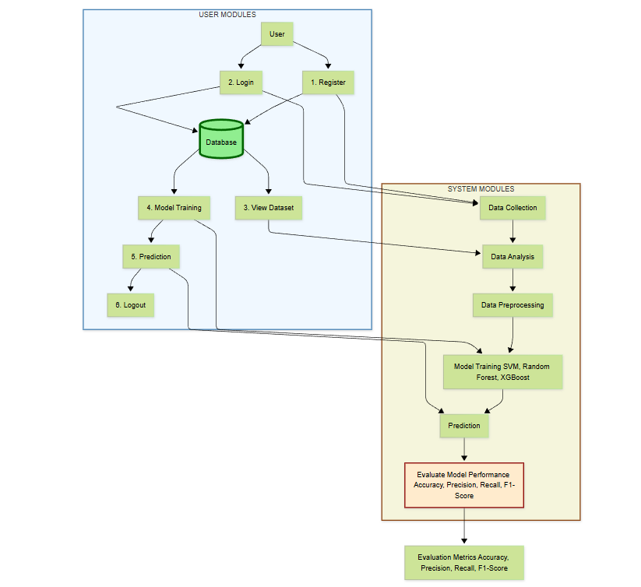

SOFTWARE REQUIREMENS
Operating System : Windows 7/8/10
Server side Script : html,css,js
Programming Language : Python
Libraries : Django, Pandas, Torch, Keras, Sklearn, Numpy , Seaborn
IDE/Workbench : VSCode
Server Deployment : Xampp Server
Database : SQLite
HARDWARE REQUIREMENTS
Processor - I3/Intel Processor
RAM - 8GB (min)
Hard Disk - 128 GB
Key Board - Standard Windows Keyboard
Mouse - Two or Three Button Mouse
Monitor - Any
ARCHITECTURE:
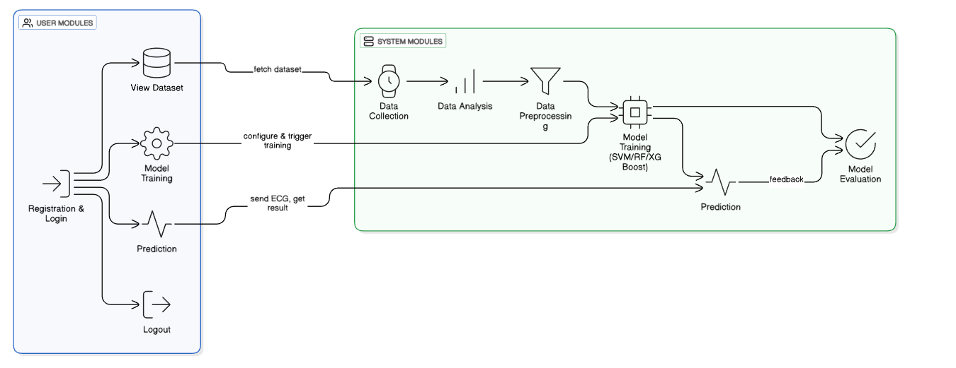

MODULES:
System:
Data Collection:
The system collects real-time electrocardiogram (ECG) signals from patients, which are used to detect sleep apnea events. These signals are captured using wearable ECG monitors, medical-grade ECG machines, or smartphones equipped with ECG sensors. Data from various patients, with different conditions and sleep patterns, are included to ensure comprehensive model training. The ECG signals serve as input data for the sleep apnea detection model. The system is designed to process both real-time ECG data and previously recorded files, allowing for continuous monitoring and efficient diagnosis.
Data Analysis:
Once the ECG data is collected, the system performs an analysis to detect sleep apnea events. The analysis includes feature extraction, where key characteristics of the ECG signals, such as heart rate variability, QRS complex duration, and R-wave amplitude, are identified. These features help distinguish normal heart activity from sleep apnea events. The system also examines correlations between the extracted features and the classification labels (normal or sleep apnea) to improve model training. The model learns to identify patterns in the ECG signals that are indicative of sleep apnea, improving the classification accuracy.
Data Preprocessing:
The collected ECG data undergoes preprocessing before being used to train the machine learning models:
- Noise Reduction: The ECG signals are cleaned by removing noise and artifacts to ensure that the data fed into the model is of high quality.
- Normalization: The ECG signals are normalized to a common scale, making the model more efficient and preventing biases that could arise from variations in signal amplitude.
- Feature Extraction: Relevant features, such as heart rate, intervals, and rhythm patterns, are extracted from the raw ECG signals. This step is essential for enhancing model performance.
- Splitting: The preprocessed data is split into training, validation, and test datasets to ensure proper model training and evaluation.
Model Training:
The system uses machine learning algorithms—Support Vector Machine (SVM), Random Forest, and XGBoost—to classify sleep apnea events. These algorithms are trained on the preprocessed ECG data, with each algorithm learning to detect the patterns associated with normal heart rhythms and sleep apnea events. During training, hyperparameters such as learning rate, batch size, and epochs are optimized using cross-validation. Once trained, the models are evaluated using performance metrics such as accuracy, precision, recall, and F1 score to assess their effectiveness in detecting sleep apnea.
Prediction:
After training, the system uses the trained models to classify new ECG signals in real-time. The system processes incoming ECG data, classifies it as normal or sleep apnea, and provides predictions to the user. The prediction results are accompanied by a confidence score, indicating the model’s certainty in its classification. These real-time predictions help healthcare providers make timely intervention decisions, such as adjusting treatment plans or recommending further tests.
User Module:
Registration:
Healthcare professionals or patients can register on the platform by providing their name, email, and password. This ensures that only authorized users can access and interact with the sleep apnea detection system.
Login:
Once registered, users can log in to the system using their credentials. The system authenticates users to ensure that only authorized individuals can access the functionalities related to sleep apnea detection and patient data management.
View Dataset:
Registered users can view the dataset used to train the sleep apnea detection models. The dataset includes ECG signals from various patients, classified into normal and sleep apnea events. This transparency helps users understand how the model was trained and the features used for classification.
Model Training:
Users can initiate the training of the sleep apnea detection model by selecting the machine learning algorithms they wish to use, such as SVM, Random Forest, or XGBoost. Users can configure training parameters such as the number of epochs, learning rate, and batch size. After the model is trained, performance metrics such as accuracy, precision, recall, and F1 score are displayed to help users assess the model's performance.
Prediction:
After the model is trained, users can use the system to make real-time predictions about the sleep apnea status of patients. The system uses the trained models to classify incoming ECG data, providing results in categories of normal or sleep apnea. These predictions allow healthcare providers to make informed decisions about patient care and treatment adjustments.
Logout:
After completing their tasks, users can log out of the system. This ensures that their session is securely closed, preventing unauthorized access after they leave the platform. The logout functionality helps protect user credentials and session data from unauthorized use.

