1.Architecture of LSTM
两层LSTM叠加

2. Architecture of stacked residual bidirectional-LSTM

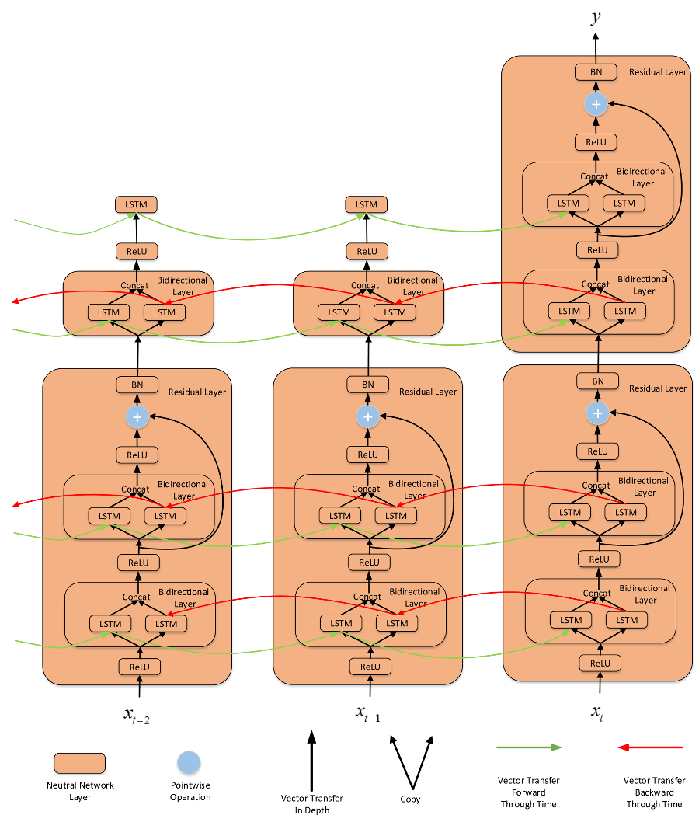

Note: 2 residual cells as a block stacked 2 times for a total of 4 bidirectional cells, which is in reality 8 unidirectional LSTM cells. We obtain best results with a 3x3 architecture, consisting of 18 LSTM cells.

