**Name Stephen McGuire**

**CSIT 2510 Advanced Database – Applied Midterm Exam (90 points)**

**Download this file to your H: drive or other available class drive. Please note that this part of the exam is open book, open notes, open browser, closed neighbor. You are not permitted to consult with any person other than the instructor during this exam.**

1. You have access to the *SaleCo* database on web-students.psctcc.edu. Here’s a partial ERD:

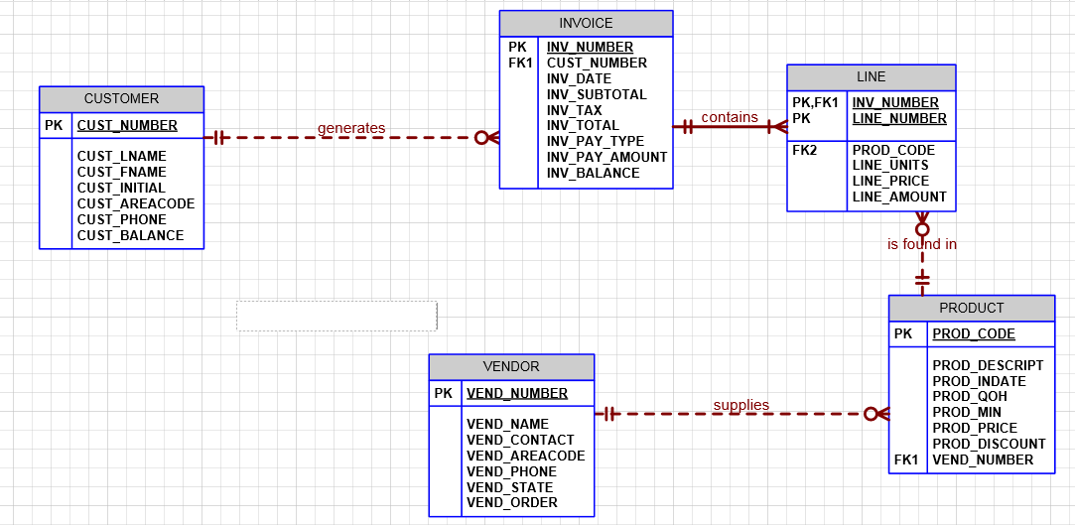

1. The ACCT_TRANSACTION table that you can see in SaleCo, which tracks payment transactions by customer, is missing from this ERD. Add it to the model, including all columns and show it’s relationship (if any) to the other tables. This should be done electronically on this doc or hand-drawn on a printed copy of this page that you will hand over when you complete the exam. (5 pts)
2. You might have noticed that the price of the ordered product appears in both the PRODUCT table and the LINE table. Is there an advantage to this redundancy or should we remove it to achieve a more normalized set of tables? Explain. (5 pts)

We would remove this to achieve a more normalized tables. It is already stated in another table. We do not need this in our design.

1. The invoice tracking coordinator needs a report that lists all invoices to include the following information: invoice number, customer number, invoice date and, for each product ordered, product code, product description, the number of units ordered, price of the product at the time of the order.

Here’s a sample of the output:

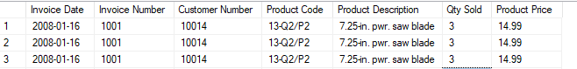

Ensure that all line items of the same invoice are displayed one immediately after the other. Write the query below, run it in Management Studio and cut-n-paste the query result below as well. (15 pts)

use SaleCo

select i.[INV_DATE] as [Invoice Date], i.[INV_NUMBER] as [Invoice Number], c.[CUST_NUMBER] as [Customer Number], /*i.[INV_DATE],*/ p.[PROD_CODE] as [Product Code], p.[PROD_DESCRIPT] as [Product Description],l.[LINE_UNITS] as [Qty Sold], p.[PROD_PRICE] as [Product Price]

from INVOICE as i

inner join CUSTOMER as c on i.[CUST_NUMBER] = c.CUST_NUMBER

inner join LINE as l on l.INV_NUMBER = i.INV_NUMBER

inner join PRODUCT as p on l.[PROD_CODE] = p.PROD_CODE

1. Indexes

The invoice tracking coordinator is complaining that the query he is given is running very slowly. To try to speed it up, you need to ensure the proper primary keys and the appropriate indexes are in place.

* 1. List the primary keys and the indexes that need to be in place (10 pts). For the primary keys, specify the table name and the column(s) name(s). For Indexes, specify an index name and the table/column(s) on which it would be created.

*PK on CUSTOMER.CUST_NUMBER && we would need an index on CUST_NUMBER such as create nonclustered index IDX_CUST_NUMBER on SaleCo.CUSTOMER (CUST_NUMBER)

PK on INVOICE.INV_NUMBER && we would need an index on INV_NUMBER such as create nonclustered index IDX_INV_NUMBER on SaleCo.INVOICE (INV_NUMBER)

*PK on LINE.LINE_NUMBER && we would need an index on LINE_NUMBER such as create nonclustered index IDX_LINE_NUMBER on SaleCo.LINE (LINE_NUMBER)

*PK on PRODUCT.PROD_NUMBER && we would need an index on PROD_NUMBER such as create nonclustered index IDX_PROD_NUMBER on SaleCo.PRODUCT (PROD_NUMBER)

* 1. Choose two of the indexes you have listed above, place an asterisk(*) next to each of your choices, then provide the DDL to create those indexes (write it below) (5 pts)

1. use SaleCo
2. create nonclustered index IDX_CUST_NUMBER on SaleCo.CUSTOMER (CUST_NUMBER)
3. create nonclustered index IDX_LINE_NUMBER on SaleCo.LINE (LINE_NUMBER)
   1. Choose one of the primary keys you specified above, place an asterisk(*) next to it, then either provide the DDL below on how to create it or describe how to create it using SQL Server Management Studio (5 pts)

create clustered index IDX_PROD_NUMBER on SaleCo.PRODUCT (PROD_NUMBER)

1. Authorization and Authentication  
     
   A corporate risk analyst named Eddy Semaan will be visiting us at the end of the week to analyze our customer’s data and their payment history and their current outstanding invoice balances. An account has already been created for him on the database: auditor_esemaan
2. List the database objects that Mr. Semaan will need privileges to access along with the type of privilege that should be granted. Keep in mind that every user should be granted the least possible privileges, i.e. needed privileges only (5 pts), List the object and the type of access required

He well need read on customer table, read on ACCT_TRANSACTION tabl, and read on invoice.

1. Provide the DDL to be used in order to provide for the privileges described above. (5 pts)
2. GRANT SELECT ON dbo.Customer TO auditor_esemaan
3. GRANT SELECT ON dbo.ACCT_TRANSACTION TO auditor_esemaan
4. GRANT SELECT ON dbo.INVOICE TO auditor_esemaan
5. Mr. Semaan needs to capture his own opinion of the customer credit rating (based on their invoice payment history) into the CustomerRatings table. What DDL statements will be required to give him that update ability? (provide the DDL below) (5 pts)
6. GRANT UPDATE ON dbo. CustomerRatings TO auditor_esemaan
7. GRANT SELECT ON dbo. CustomerRatings TO auditor_esemaan
8. Create an AuditorRatings view for Mr. Semaan that allows him to see the results of his work. View will show all customer numbers, last name, first name, and their rating (provide DDL below). (10 pts)
9. When Mr. Semaan is done with his analysis, he should no longer be authorized to access any of the database objects. Write the DDL statements below that will have to be executed to remove the Auditor’s access to all database objects. Note: He may remain with the ability to authenticate onto the server and access the database but he should not be authorized to access any of the database objects. (10 pts)
10. Export all the 6 tables (Customer, Invoice, Line, Product, Acct_Transactions, CutomerRatings), each to a separate spreadsheet. Upload the spreadsheets to D2L’s MidTerm assignment folder. (10 pts)

**Save this document using the name *MidtermExamResults_yourname.docx*. Upload this file to the Midterm Exam Applications dropbox in D2L.**