**Python project – stocks**

For the project I will try to apply analytic techniques to identify trends in stock prices. This will hopefully help me to better predict the rising and falling of stock prices. By the end of this project I hope to create code that will automate the buying and selling of the stock I choose when certain signals are found.

Part 1

Extracting the information from google finance was fairly simple with the use of ‘pandas’ in python using the following line.



Web.dataReader creates a data frame which holds stock prices at various dates. It requires 4 pieces of information. A ticker which is an abbreviation of a company to search for. The website to search for the company API. And the window of time which you would like to get the stock information from.

Part 2

Once I had the information stored in a csv file I could create a simple ggplot to show the stock price over time for Tesla

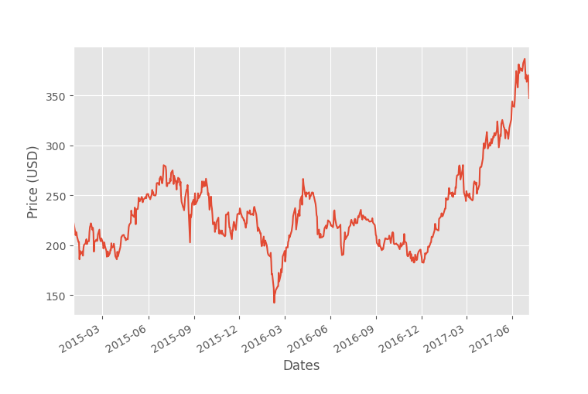

Part 3 – **Moving Averages**

A simple moving average is a good way to look at the long term trends of a data set. A 100 day moving average works by taking the mean price for days 0 – 99. This is the first plot point. The next plot point would be the mean price for days 1 – 100 and so on…

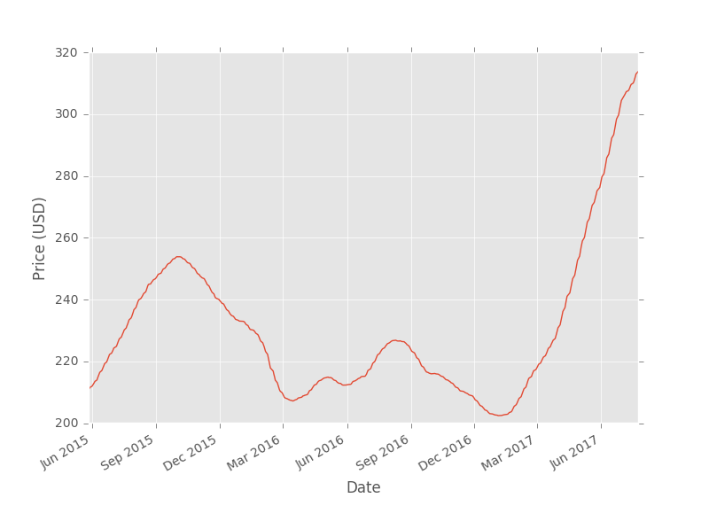**Simple moving average**

The long term trends show Tesla overall is growing rather well. Especially between march 2017 and July 2017. The chart indicates strong volatility which makes it hard to identify where the price will be in the coming months. If it follows the cyclical nature of the historical data however, it seems the price will soon fall.

An exponential weighted average uses the same principle as the simple moving average but applies more weighting to recent historical data. This is regarded as a better estimate of long term trends.

**Exponential Weighted average**

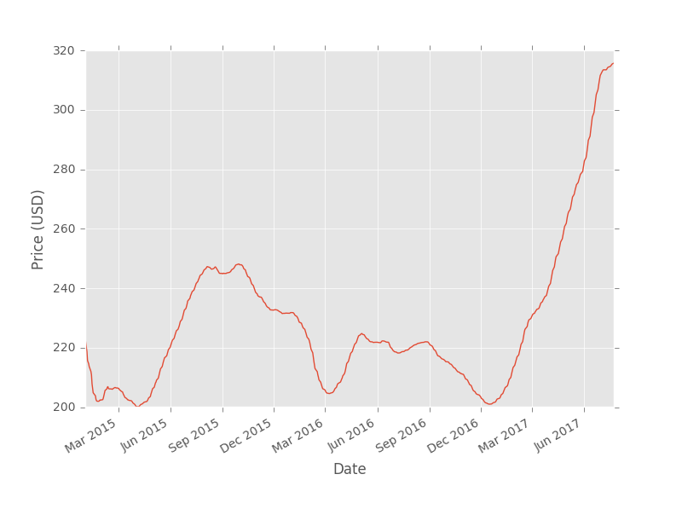

The exponential weighted average shows more volatility than the simple moving average the small troughs and peaks in the graph could give traders some good short term gains.

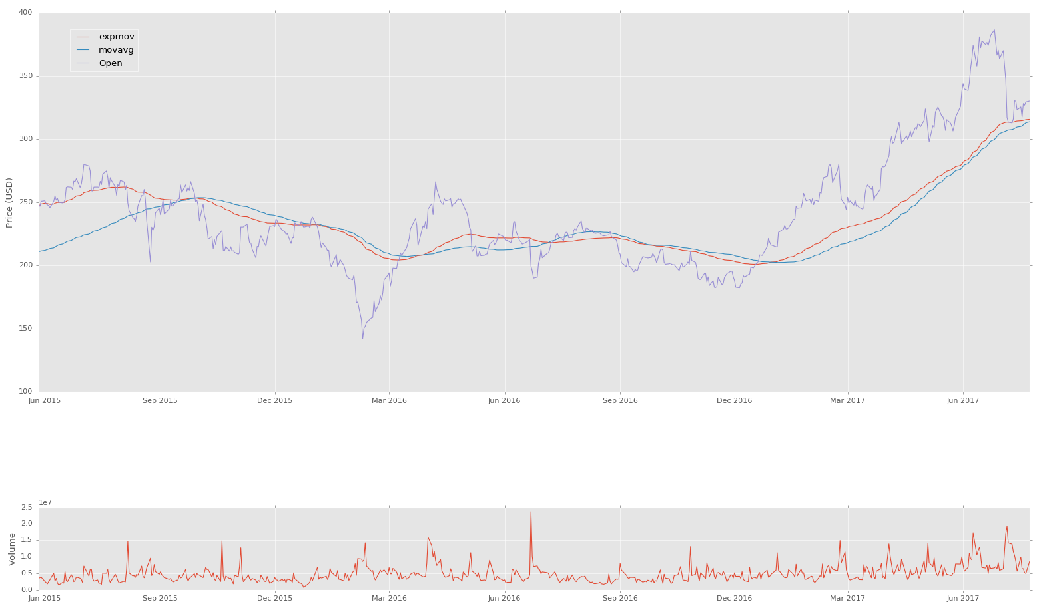**Price history of Tesla stock**

From the graph we see that the exponential moving average follows the actual price data better than the simple moving average. This is because the exponential moving average give a greater weighting to more recent prices. As a result the exponential moving average is more responsive to price trends

Part 4 – Candlestick charts

Candlestick charts are a great way to convey a large amount of information about a stock. If a stock is colored red that means the close for the day way lower than the open. The bottom of the wider body constitutes the close whilst the top of the wider body constitutes the open. If the color is green then the open and close swap positions. The sticks coming out of the main body indicate the highs and lows for the day.

Not only do candlestick charts show the long term trend of the price history but also show the volatility and public sentiment on the stock rather well.

