**Monty hall problem**

The Monty hall problem can be summarised as follows:

In a gameshow contestants want to guess which of the three closed doors contain the cash prize. The odds of choosing the correct door are 1 in 3...

Given that the host opens one door to reveal that it is a goat (not the cash prize) should the contestant stay with the door they picked or change?

**Approach**

To see which decision was better I decided to create a simulation where the contestant does one of two things:

Stay with the initial guess

Change to a different door

Each decision was simulated ten thousand times to get a percentage of the contestant winning. The results were very interesting…

**Results**

Given that the contestant **stays with the door he initially chose**, his percentage of winning is roughly 33.3%

Give that the contestant **changes the door he initially chose**, his percentage of winning is roughly 66.7%

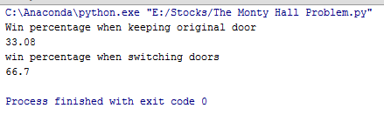

**Thoughts**

This result is quite counter intuitive as it would seem the chances of picking the correct door are 33.3% regardless of the host’s actions. Therefore the choice of a contestant changing doors or staying with the original door would yield the same probability for winning.

The best way I have thought about it is that the only way to get it wrong from switching is to have picked the correct door in the first place. The odds of pickings the correct door are 1 in 3. Therefore the odds of winning from switching are 2 in 3