**CREATE A NEW MODULE**

- Open 2 Jmeters applications.

- Open an existing project in one of the jmeter

- Copy all the threads and "user defined variables" component to the jmeter in blank.

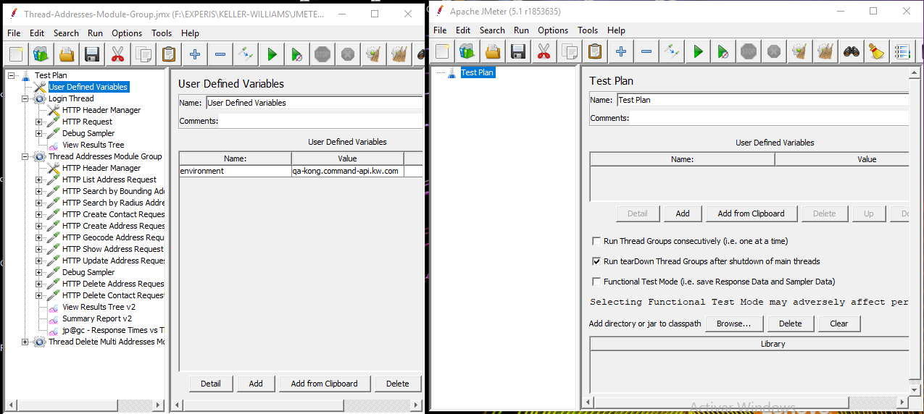

**DETAILS OF PROJECT:**

- **User defined variables:** contains the public variables that the project will use it.

- **Login Thread:** Contain the login request and get the token authorization for the header of the services.

The other thread contains all the services that should be tested.

**ADD A NEW REQUEST IN TO THE PROJECT**

Duplicate an existing http request.

Update the values in the "Path" variable

Update the assertions

Update the variables extractor

