Spoilt rice detection test, FRIDGE001 run R00062
19 to 20 October 2026, times in WAT. Experiment RICE-SPOILT-001, sample RICE-S01. Data source: Firebase project food-spoilage-7b60a, export taken at 02:10 WAT on 20 October.

1. Summary
About 0.25 kg of spoilt cooked rice was placed, uncovered, in a refrigerator with the FRIDGE001 detector at 00:04. Both MQ135 sensors responded within 2 to 3 minutes. Over the next 98 minutes, sensor resistance (Rs) on MQ1 stayed about 32 times below its clean-air baseline and Rs on MQ2 stayed about 4.3 times below its baseline. Clean-air variation during the baseline was a few percent on MQ2 and noisier on MQ1, so the rice signal is far outside the noise. Under the project’s existing scoring, the baseline scored Normal and the rice scored Critical.
The test shows that the system detects a strongly spoilt cooked meal. It does not show the meal changing from fresh to spoilt, because the rice was already spoilt when the test began.

2. Setup
- Device: ESP32 FRIDGE001 with two MQ135 sensors. MQ1 on GPIO 34 (RL 2000 ohm, NH3 datasheet curve), MQ2 on GPIO 35 (RL 1370 ohm, CO2 datasheet curve). The MQ135 is not selective; the curve names do not mean those gases were measured.
- Firmware: fridge_monitor 1.0.0, running in calibration mode. It averages 2 s samples into one record per minute and uploads every minute. Readings are marked settling for the first hour after boot.
- Run: R00062 started at 22:47 on 19 October and ran without a restart until about 02:08 on 20 October.
- Sample: cooked rice, about 0.25 kg, in an open container with no cover, in the same refrigerator compartment as the device. Cooking time unknown; the operator estimates it was at least a week old. No other food was in the refrigerator during the test.
- Reference condition: the operator judged the rice spoiled by smell and sight: a terrible smell and some grains turned yellow. No slime or mould was seen.
- Scoring method: each sensor’s Rs is compared with its own median Rs during the clean-air baseline just before the rice went in (23:49 to 00:04). This follows the recommendation in the 17 October calibration findings, since a single fixed R0 does not hold between days.

3. Timeline
Time (WAT) | Event
22:47 | Run R00062 boots and starts warming up.
23:47 | Settling period ends; readings marked valid.
23:49 to 00:04 | Clean-air baseline window used for scoring.
00:04 | Rice placed in the refrigerator, uncovered.
00:06 to 00:07 | Both sensors fall below half of their baseline Rs.
00:09 to 00:10 | Refrigerator door open for about 1 minute.
00:34 to 00:35 | MQ1 alone steps down from about 2.55 V to 1.85 V and recovers over about 8 minutes. Nothing was done to the device or the refrigerator. Cause unknown.
01:10 onward | MQ2 occasionally touches the 3.3 V ADC limit.
01:58 | MQ2 sits at the 3.3 V ADC limit on almost every sample. Readings marked fault.
About 02:09 | Rice removed (time approximate). The device restarted twice while it was being handled.

4. Results
Food window: 00:20 to 01:58, after the response settled and before MQ2 reached the ADC limit (98 one-minute records). Values are medians of the one-minute means.
Measure | MQ1 (GPIO 34) | MQ2 (GPIO 35)
Baseline Rs (23:49 to 00:04) | 72.9 kohm (0.136 V) | 6.17 kohm (0.920 V)
Rice Rs (00:20 to 01:58) | 2.30 kohm (2.33 V) | 1.44 kohm (2.46 V)
Rice Rs range | 1.88 to 3.40 kohm | 0.98 to 2.89 kohm
Rice Rs ÷ baseline Rs | 0.032 | 0.233
Fall in Rs | about 32 times | about 4.3 times
First minute below 50% of baseline | 00:06 (2 min after rice in) | 00:07 (3 min after rice in)
First minute below 10% of baseline | 00:07 (3 min after rice in) | not reached
ppm from firmware, baseline | 0.46 ppm (NH3 curve) | 25.9 ppm (CO2 curve)
ppm from firmware, rice | 2,131 ppm (NH3 curve) | 1,587 ppm (CO2 curve)

Score against the existing bands. The soup anchor of 120.68 ppm on the MQ1 NH3 curve is 100%. The baseline median of 0.46 ppm scores 0.4%, which is Normal (under 40%). The rice median of 2,131 ppm is about 18 times the anchor, so it scores above 100% and falls in Critical (80% and above).
Caution on ppm. The firmware still uses the August R0 values (MQ1 7,802 ohm, MQ2 3,463 ohm). The rice readings sit far outside the 10 to 300 ppm range of the datasheet curves, and the MQ135 cannot tell gases apart. Quote the ppm figures as indicative only and rely on the Rs ratio as the main result.
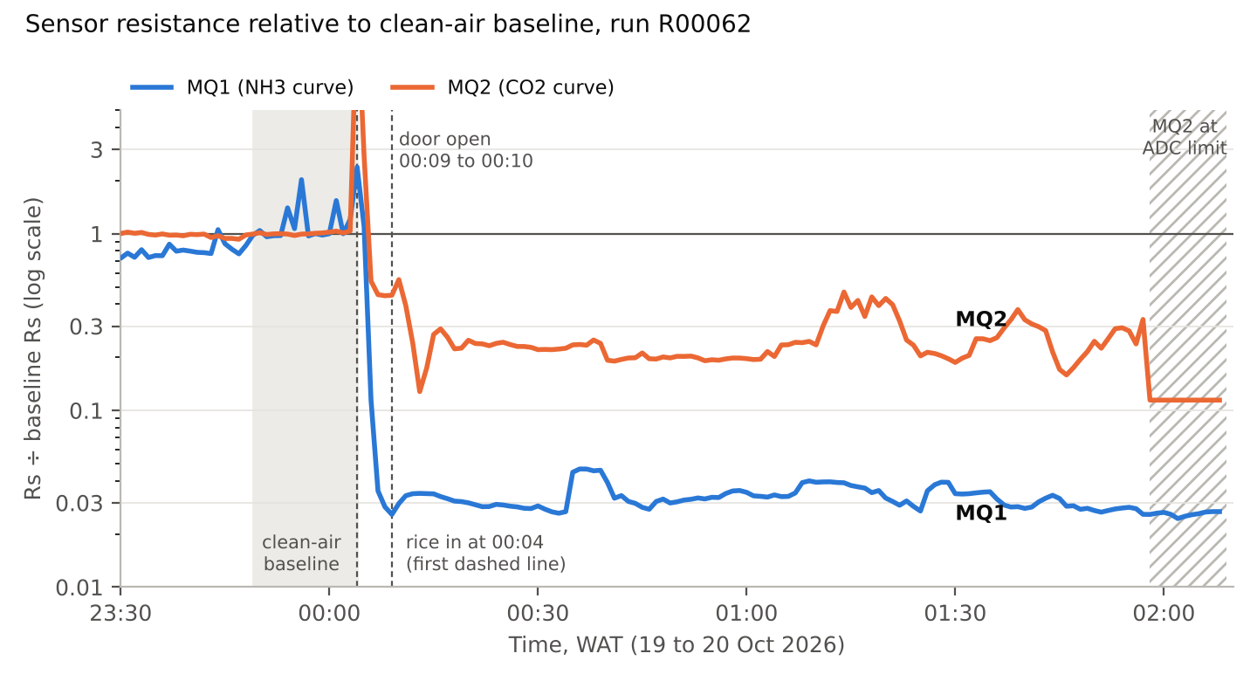
Figure 1. Rs divided by the baseline median for each sensor, on a log scale. 1 means clean-air level; 0.1 means one tenth of it. The hatched area marks MQ2 at the ADC limit, where the true value is lower than plotted.

5. Data quality notes
- Door opening at 00:09: a one-minute disturbance on both sensors that recovered within a few minutes. It falls before the food window.
- MQ1 dips: MQ1 Rs rose for a few minutes at 00:35, about 00:58 and about 01:08, each time recovering slowly while MQ2 barely moved. A slow recovery points to air movement inside the refrigerator, such as the compressor or fan cycling, rather than a wiring fault. Even at its highest, MQ1 Rs stayed about 21 times below baseline.
- MQ2 saturation: from 01:58 MQ2 was at the 3.3 V ADC limit, so its true Rs was below about 706 ohm. Those records are excluded from the food window. 22 records inside the food window carry a fault flag because one or more of the 30 samples in that minute touched the limit; their means are still below 3.3 V and are kept.
- MQ1 baseline noise: in clean air MQ1 sits near 0.13 V, so a few ADC counts make a large change in Rs. Single minutes reached 102 to 147 kohm. The median was used to limit their effect. MQ1 was also still rising slowly before 23:49.
- Labelling: the board logged the run in calibration mode with no experiment or sample ID. The rice labels were added after the test from the operator’s log (see the import file).

6. Limitations
- The rice was already spoilt, so the test shows detection, not the progression of spoilage over time.
- Recovery after removal was not measured, because the refrigerator still smelled strongly and the device restarted when handled.
- One sample and one run. The baseline window was 15 minutes.
- No temperature or humidity sensor, and MQ135 readings depend on both. The baseline was taken in the same cold compartment to limit this.
- The cooking time is unknown, and the time of removal is approximate.

7. Importing the experiment record into Firebase
The file RICE-SPOILT-001.json holds the experiment meta, the relabelled run record for R00062, seven events and one observation. It does not change any telemetry readings.
- In the Firebase console, open food-spoilage-7b60a, then Realtime Database, Data tab. Use the three-dot menu and choose Export JSON to save a backup first.
- Click the experiments node so the path at the top reads /experiments.
- Add a child with the + button: key RICE-SPOILT-001, value x (a placeholder). Click Add.
- Click RICE-SPOILT-001 so the path at the top reads /experiments/RICE-SPOILT-001. Check this carefully: importing replaces everything at the current path, and importing at the root would wipe the database.
- Open the three-dot menu, choose Import JSON, pick RICE-SPOILT-001.json, and click Import.
- Check that RICE-SPOILT-001 now contains meta, runs, events and observations, and that the placeholder x is gone.

