**US-1: Login**

As a user, I would like to login to the system so that I can begin studying.

Relation to Use Case: 2 as it allows the user to login to the program

Assigned Developers: David T, Kevin

Due Date: 2-17-16

Priority: High

Mockup:

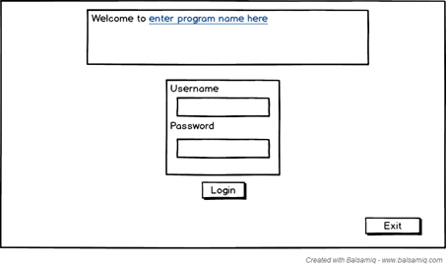

**US-2: Register Screen**

As a user, I would like to be able to make an account for the program so that I can login to begin studying.

Relation to Use Case: 1 as it allows the user to create an account login.

Assigned Developers: David L, Jonathan

Due Date: 2-17-16

Priority: High

Mockup:

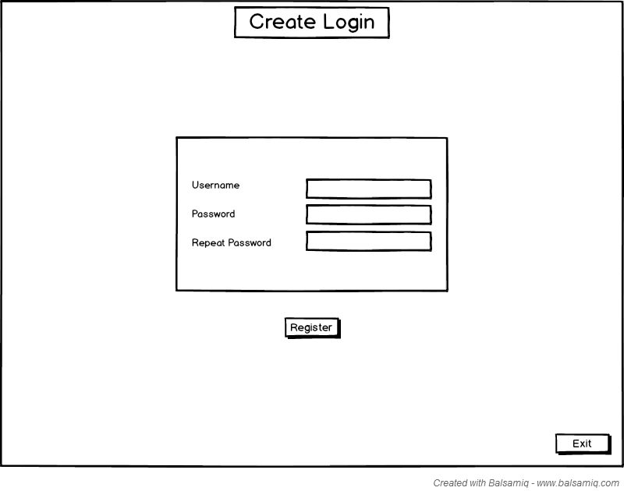

**US-3: Chapter Screen**

As a user, I would like to click on a chapter button so that I can begin being quizzed.

Relation to Use Case: 3 as it allows the user to view and select chapters.

Assigned Developers: Michael, Stephen

Due Date: 2-17-16

Priority: High

Mockup:

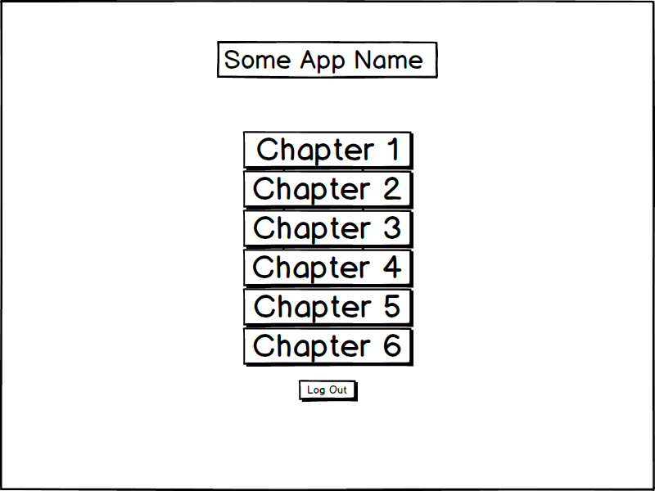

**US-4: Matching**

As a user, I would like to select my answer for matching questions in order to see if I got the correct answer.

Relation to Use Case: 7 as it allows the user to view and answer matching questions.

Assigned Developers: Michael, David T

Due Date: 2-17-16

Priority: High

Mockup:

**US-5: Fill in the Blank**

As a user, i would like to select my answer for all chapters Fill in Blank questions in order to see if I got the correct answer.

Relation to Use Case: 6 as it allows the user to view and answer fill in the blank questions.

Assigned Developers: David L, Kevin

Due Date: 2-17-16

Priority: High

Mockup:

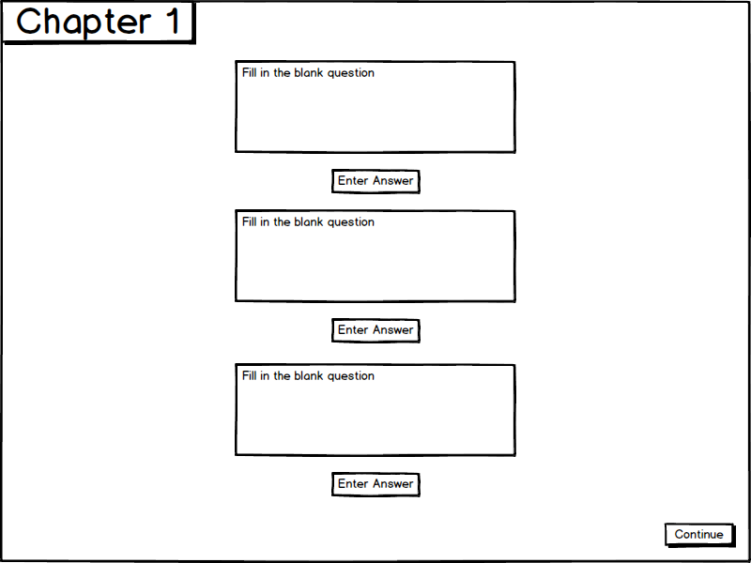

**US-6: True/False**

As a user, i would like to select my answer for all chapter true/false questions in order to see if I got the correct answer.

Relation to Use Case: 4 as it allows the user to view and answer true/false questions.

Assigned Developers: Stephen, Michael

Due Date: 2-17-16

Priority: High

Mockup:

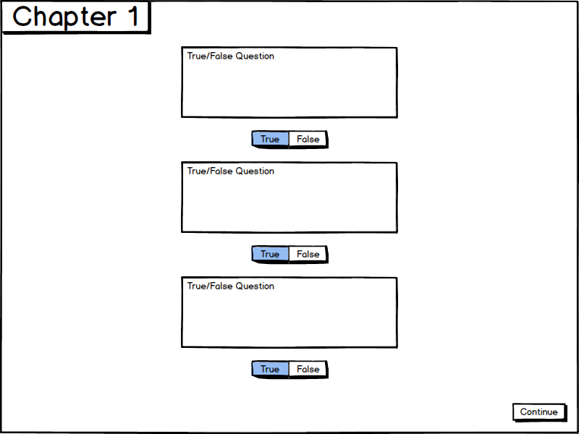

**US-7: Multiple Choice**

As a user, i would like to select my answer for all chapter's multiple choice questions in order to see if I got the correct answer

Relation to Use Case: 5 as it allows the user to login to view and answer multiple choice questions.

Assigned Developers: Jonathan, Kevin

Due Date: 2-17-16

Priority: High

Mockup:

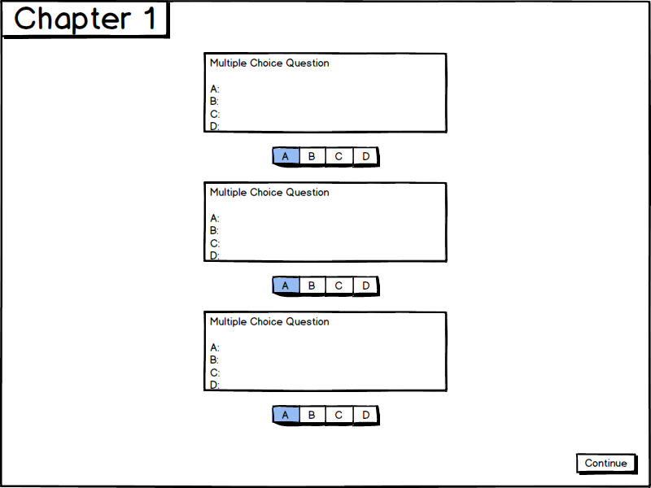

**US-8: Results Screen**

As a user, I would like to access my results screen so that I can review my answers and go back to the questions I missed.

Relation to Use Case: 8 and 9, as it allows the user to view their results and return back to questions.

Assigned Developer: Stephen, Jonathan

Due Date: 4/3/16

Priority: High

Mockup:

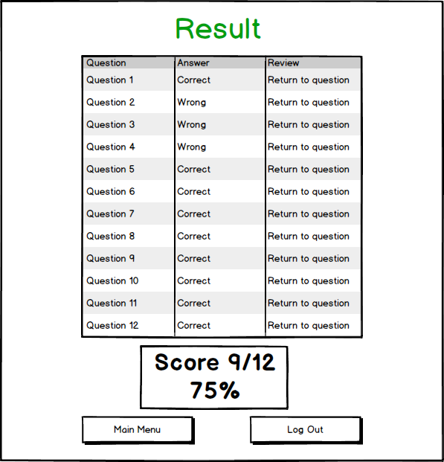

**US-9: Synchronize UI**

As a user, I would like the UI to and text to be the same across each page so that it looks efficient.

Relation to Use Case: Related to all Use cases since buttons will be same sizes and text will be aligned with correct/wrong answers.

Assigned Developer: Stephen, Jonathan

Due Date: 4/3/16

Priority: Low

MockUp:

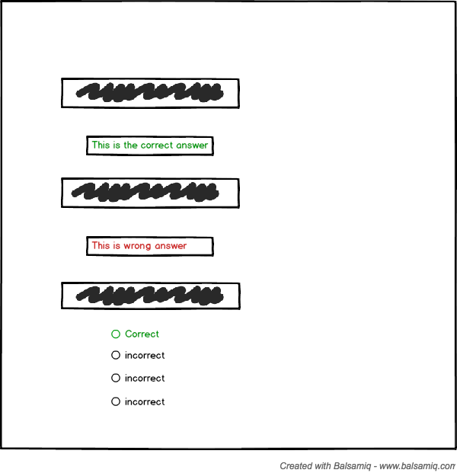

**US-10: Timer for Pages**

As a user I would like a timer to keep track of my progress during answering questions.

Relation to Use Case: Relates to question screen and result screen

Assigned Developer: Michael, Kevin

Due Date: 4/1/16

Priority: Low

MockUp:

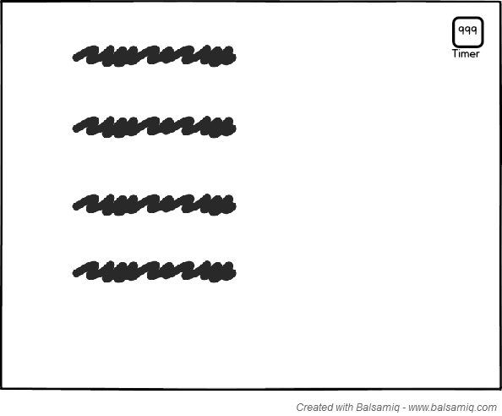

**US-11: Pages Numbers for Results Screen**

As a user, I would like to see the page numbers on the results screen for each question I got correct/incorrect.

Relation to Use Case: Relates to results screen and answers.

Assigned Developer: David Luong, David Tran

Due Date: 4/1/16

Priority: Low

MockUp:

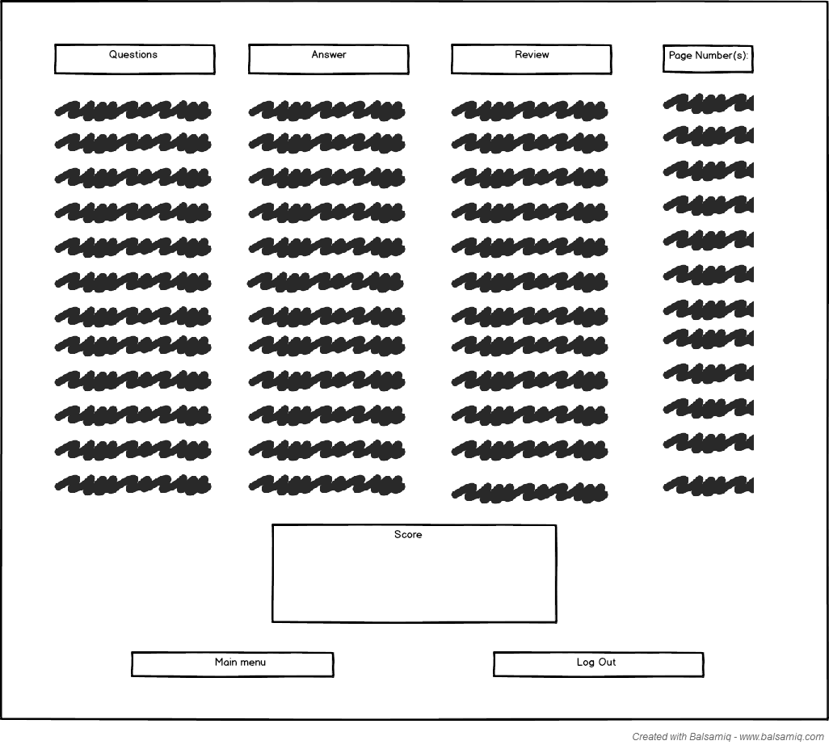

**US-12: Save User’s chapter scores**

As a user, I would like my chapter score saved in order to compare it to my other quizzes from the other chapters.

Relation to Use Case: Relates to chapter select screen as well as results screen.

Assigned Developer: Kevin Le, David Tran, Jonathan Peng

Due Date: 4/25/16

Priority: High

MockUp:

