Raspberry Pi 2 & 3 Pin Mappings
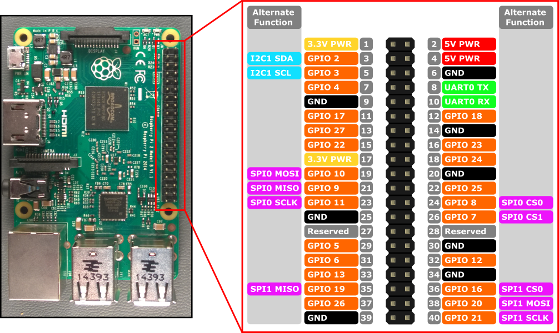
Hardware interfaces for the Raspberry Pi 2 and Raspberry Pi 3 are exposed through the 40-pin header J8 on the board. Functionality includes:
- 24x - GPIO pins
- 1x - Serial UARTs (RPi3 only includes mini UART)
- 2x - SPI bus
- 1x - I2C bus
- 2x - 5V power pins
- 2x - 3.3V power pins
- 8x - Ground pins

GPIO Pin Overview
The following GPIO pins are accessible through APIs:
GPIO# | Power-on Pull | Alternate Functions | Header Pin
2 | PullUp | I2C1 SDA | 3
3 | PullUp | I2C1 SCL | 5
4 | PullUp |  | 7
5 | PullUp |  | 29
6 | PullUp |  | 31
7 | PullUp | SPI0 CS1 | 26
8 | PullUp | SPI0 CS0 | 24
9 | PullDown | SPI0 MISO | 21
10 | PullDown | SPI0 MOSI | 19
11 | PullDown | SPI0 SCLK | 23
12 | PullDown |  | 32
13 | PullDown |  | 33
16 | PullDown | SPI1 CS0 | 36
17 | PullDown |  | 11
18 | PullDown |  | 12
19 | PullDown | SPI1 MISO | 35
20 | PullDown | SPI1 MOSI | 38
21 | PullDown | SPI1 SCLK | 40
22 | PullDown |  | 15
23 | PullDown |  | 16
24 | PullDown |  | 18
25 | PullDown |  | 22
26 | PullDown |  | 37
27 | PullDown |  | 13

Reference
https://developer.microsoft.com/en-us/windows/iot/docs/pinmappingsrpi

https://pinout.xyz/

Step 1: Install Python development tools
Open a terminal on the Raspberry Pi either via the desktop or by SSH'ing in (default credentials are pi/raspberry).

Run the following commands to install some basic Python development tools:

sudo apt-get update
sudo apt-get install python-dev python-pip
sudo pip install --upgrade distribute
sudo pip install ipython

http://raspberry.io/projects/view/reading-and-writing-from-gpio-ports-from-python/

host: hs.diy
password: specialforce

