EVO PROTOCOL
Assets That Don't Stay the Same
How programmable assets with a guaranteed floor value
change everything we know about digital ownership

Solana Mainnet | Anchor 0.31 | 17 Instructions | 5 Lifecycle Types

The Problem: Everything Can Go to Zero
Every digital asset you've ever held has the same fatal flaw. The floor is zero.
NFTs? Beautiful art, strong communities, deep marketplaces. But the floor price? Whatever someone is willing to pay. When hype dies, the floor goes to zero. You're left holding a JPEG worth nothing.
Meme tokens? Instant liquidity, viral reach, fun as hell. But the LP can be pulled. The devs can rug. The chart can bleed to zero while you sleep. Your tokens are only worth what the pool says they are.
Gambling? You bet, you watch, you lose. The house always wins. When you lose, you walk away with nothing. There's no asset, no ownership, no exit except winning.

Every single one of these has the same problem: your money disappears and you have nothing to show for it.
What is EVO?
EVO is a new on-chain asset primitive on Solana. It's not quite an NFT. It's not quite a token. It's something new.
Every EVO locks real SOL inside a program-derived address (PDA). That locked SOL gives each asset a provable floor value that cannot go to zero. The SOL belongs to whoever holds the EVO. Not the creator. Not the protocol. The holder.
Unlike a static NFT — a frozen image with a market price — an EVO is alive. It has lifecycle states. It can reveal, evolve, and change over time based on on-chain triggers. The protocol itself is the source of truth for what the asset looks like at any given moment.
You can trade EVOs on the built-in marketplace. You can shatter them to reclaim the locked SOL. You can feed them to advance their state. The exit is always built in.

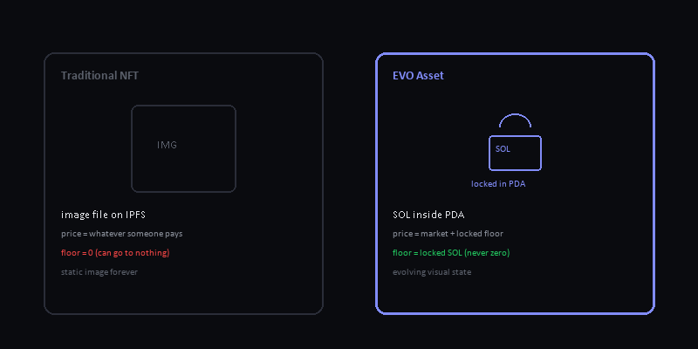
The Floor That Can't Zero
This is the core insight. Everything else flows from this.
When you forge an EVO, SOL gets locked inside a PDA on Solana. That PDA is controlled by the EVO program, not by any human. The program's rules say: whoever holds the EVO can shatter it and reclaim the SOL.

This means:
- The floor is real SOL, not a promise.
- The floor can't be rugged — the SOL is in the PDA, not the creator's wallet.
- The exit is always one transaction away — shatter and you get your SOL back.
- The market price can go ABOVE the floor (hype, rarity, evolution) but never BELOW it.
- You can lose the premium. You can never lose the floor.

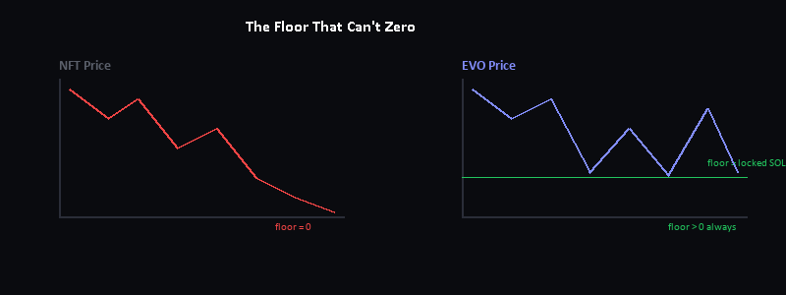
How It Works: From Zero to Living Asset
1. Create a Collection
A creator calls create_collection, paying a small protocol fee (0.0459 SOL). This defines the lifecycle type, randomness policy, metadata, supply ceiling, and fee structure. One-time setup.

2. Forge an EVO
Users forge (mint) EVOs from the collection. Each forge locks SOL inside a PDA. That SOL is the floor value — it belongs to whoever holds the EVO. The creator sets the lock amount per collection.

3. It Evolves
Depending on the lifecycle type, the EVO can reveal, evolve through stages, or change visually. Triggers are on-chain and permissionless where possible. The asset doesn't stay the same — it has a life.

4. Trade It
List on the built-in marketplace. Buyers pay the listing price. The protocol handles escrow, fees, and ownership transfer atomically. No middleman, no escrow service, no trust needed.

5. Shatter for Value
Don't want to sell? Shatter the EVO. It gets burned and the locked SOL is returned to you minus a max 20% fee. The exit is always one transaction away. You're never trapped.

6. Verify Everything
Manifests are Merkle-verified on-chain. Metadata and images are stored on Arweave/Irys. The protocol is the source of truth — not a centralized server, not a dev's database.

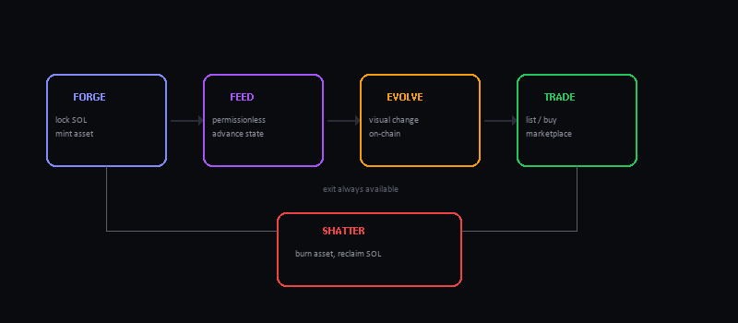

Lifecycles: Not All EVOs Are the Same
EVO supports five lifecycle types. Creators pick one when deploying a collection. This determines how the asset changes over time.
Static: Asset stays the same forever. Classic NFT behavior. Boring but safe.
Reveal: Hidden at mint, revealed later by creator or community. Build hype, then drop the reveal.
Commit-Reveal: Creator commits a hash before mint, reveals after. Proves fairness — no last-second manipulation. Trustless reveals.
Reveal & Evolve: Reveals on trigger, then continues evolving through stages. The asset keeps changing after reveal. Living art.
Custom: Authority-driven visual stages. Full manual control. The creator decides when the asset changes and what it changes to.

Three randomness policies control how reveals work: None (deterministic), Predetermined (creator sets the order), and BatchReveal (on-chain batch randomness for fair distribution).
The Comparison: NFT vs Meme Token vs EVO
Property | NFT | Meme Token | EVO
Backed by | JPEG on IPFS (no SOL) | Liquidity pool (can drain) | SOL locked in PDA
Floor price | Can go to zero | Can go to zero | Locked SOL (never zero)
Fungibility | Non-fungible (1 of 1) | Fully fungible | Non-fungible, shatters to SOL
State | Static (never changes) | Static (no visual) | Evolving (on-chain state)
Exit | Sell on marketplace | Sell into LP | Shatter (always works)
Rug risk | Creator can abandon | Devs can pull LP | No rug — SOL in PDA
Speculation | Hype + scarcity | Viral + LP depth | Premium + locked floor
Strength | Deep marketplaces | Instant liquidity | Guaranteed floor
Weakness | Floor = 0 | LP can be pulled | Max 20% shatter fee, new

NFTs built culture and community on art and scarcity. Meme tokens proved liquidity and virality can move real money fast. Both have real value and real risks. EVO takes the non-fungible ownership of NFTs, the liquidity option of tokens, and adds a guaranteed floor backed by locked SOL.
Gambling vs EVO: Same Risk, Different Exit
Both involve risk and SOL. The difference is what you walk away with.
Aspect | Gambling | EVO
Your SOL | Gone the moment you bet | Locked in PDA you control
Floor value | Zero — lose everything | Locked SOL minus max 20%
Exit | Only if you win | Always available via shatter
House edge | Built into the odds | No house — fee is protocol surcharge
Ownership | Nothing — bet and leave | Tradeable evolving asset
Upside | Fixed payout if you win | Market premium + locked floor

The key insight: gambling is a binary bet with a house that always wins. EVO is an asset you own with a guaranteed exit. The locked SOL is your money, not a wager. The market premium is upside, not a jackpot. You can lose the premium, but you never lose the floor.

The Thesis: Why This Changes Everything
EVO sits at the intersection of three things that have never been combined before:
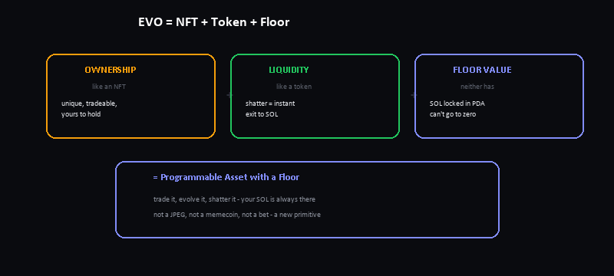

NFTs gave us digital ownership. Meme tokens gave us instant liquidity. Neither gave us a floor. EVO gives us all three.

Why this matters for degens:
- You're never trapped. Hold for the premium, shatter for the floor. The choice is yours, on-chain, permissionless, 24/7.
- No rug possible. The SOL is in a PDA controlled by the program. The creator can't touch it. The protocol enforces the rules. Code is law.
- Evolution = engagement. Assets that change keep people watching. Reveal hype, evolution arcs, stage unlocks — it's not a static JPEG that gets boring after a week.
- Built-in marketplace. No need for Magic Eden integration or third-party escrow. List, buy, settle — all on-chain, all atomic.
- Fair reveals. Commit-reveal with on-chain hashing means creators can't peek and front-run. BatchReveal uses on-chain randomness for trustless distribution.
- Merkle-verified supply. The entire collection manifest is committed as a Merkle root on-chain. Anyone can verify that what you see is what was deployed. No hidden mints, no supply manipulation.
Under the Hood: Architecture
How the pieces fit together — from your browser to Solana.
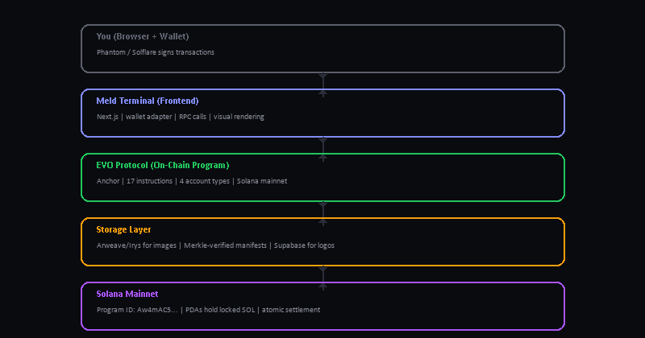

Tech Specs
Network: Solana mainnet
Program ID: Aw4mAC5oUfQCP65a8a6mTwkrL2CoUMsBa45KvWPY3CN2
Framework: Anchor 0.31.0
Instructions: 17
Account types: 4 (Protocol, Collection, EVO, Listing)
Lifecycle types: 5 (Static, Reveal, CommitReveal, RevealAndEvolve, Custom)
Randomness policies: 3 (None, Predetermined, BatchReveal)
Max supply per collection: 20,000
Collection creation fee: 0.0459 SOL
Transfer fee: 0.009 SOL (flat, to treasury)
Max shatter fee: 20% (2000 bps)
Max royalty: 25% (2500 bps)
Storage: Arweave/Irys for images, Supabase for logos
Frontend: Next.js 16, deployed on Vercel
Source code: github.com/stephenclawdbot-png/EVO
The 17 Instructions
Everything EVO does is one of these 17 on-chain instructions:
initialize_protocol — One-time setup. Sets treasury, authority, and creation fee.
create_collection — Deploys a new EVO collection with config + metadata.
forge — Mints a new EVO inside a collection. Locks SOL.
feed — Permissionless trigger that advances an EVO's lifecycle state.
evolve — Advances visual state when lifecycle conditions are met.
reveal_collection — Reveals hidden assets using committed secret.
commit_reveal — Creator commits hash before mint to prove fairness.
list — Lists an EVO on the built-in marketplace.
delist — Removes a listing.
buy — Purchases a listed EVO. SOL flows to seller, fee to treasury.
shatter — Burns the EVO and reclaims locked SOL. Exit is always available.
transfer — Sends an EVO to another wallet. Flat fee to treasury.
set_visual_stage — Authority-only override for Custom lifecycle.
update_metadata — Updates off-chain metadata URI.
update_treasury — Rotates treasury address or authority.
close_collection — Permanently closes a collection.
verify_merkle_proof — Permissionless on-chain manifest verification.

The Bottom Line
EVO is a new primitive. Not a better NFT. Not a better token. A new category.

It takes the best parts of what already works — ownership from NFTs, liquidity from tokens — and fixes the fatal flaw both share: the floor can go to zero.

By locking real SOL inside each asset, EVO guarantees that every holder has an exit. You're not betting. You're not hoping someone buys your JPEG. You're holding an asset with a provable floor, a market premium on top, and a one-click exit back to SOL.

Assets that don't stay the same. That's not a tagline. That's the mechanism.

EVO Protocol + Meld Terminal
EVO is the protocol — the on-chain rules that define what an asset is.
Meld is the terminal — where you create, forge, trade, and shatter.

Live on Solana mainnet.
meldterminal.io

