

Mace Style Validator
Architecture, Security, Deployment & Governance

Document | Architecture, Security & Governance
Version | 1.0
Owner | Stephen Cummins · stephen.cummins@macegroup.com
Date | June 2026

1. Executive summary
The Mace Style Validator enforces the Mace Way Control Centre Writing Style Guide automatically, at the point documents are authored. It is integrated into SharePoint and orchestrated by Power Automate, with a lightweight, stateless validation engine running as an Azure Function. This document sets out the architecture, the security and data-residency model, the deployment approach, and the governance recommendations for taking the capability to production.
Key message on security: although the validation engine currently runs in a separate Azure subscription, all data and all access controls remain within the Mace tenant. The engine stores nothing, sees only one SharePoint site, and can be revoked by Mace at any time.

2. Architecture
The solution has four components:
- Mace SharePoint (Mace Way Control Centre) — holds the documents, the style rules, the validation results and the generated reports. This is the system of record and never leaves the Mace tenant.
- Power Automate flow — triggered when a document is flagged for validation. It runs inside Mace, as a Mace user, and performs all writes back to SharePoint.
- Azure Function (validation engine) — receives a document, validates it against the rules, returns the result and a report. It is stateless and holds no data.
- Microsoft Entra app registration — the identity the engine uses to read style rules, scoped to a single site via Sites.Selected.
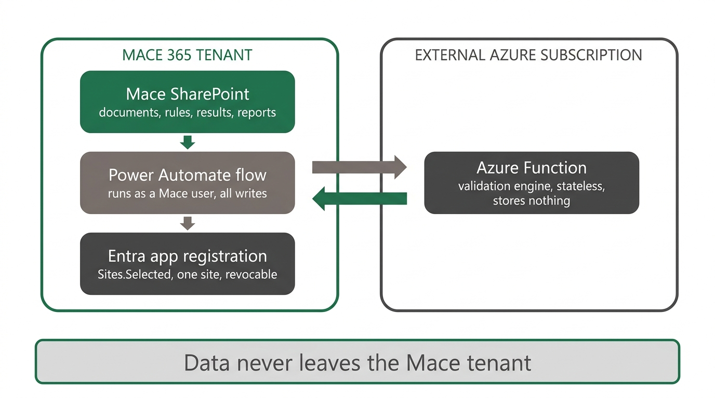
Figure 1 — Architecture and trust boundary: the engine is separate, but data stays in Mace

Flow of a validation: the flow sends the document content and reads the rules; the engine validates in memory and returns the outcome plus a report; the flow writes the results, uploads the report, and updates the document — all within SharePoint.
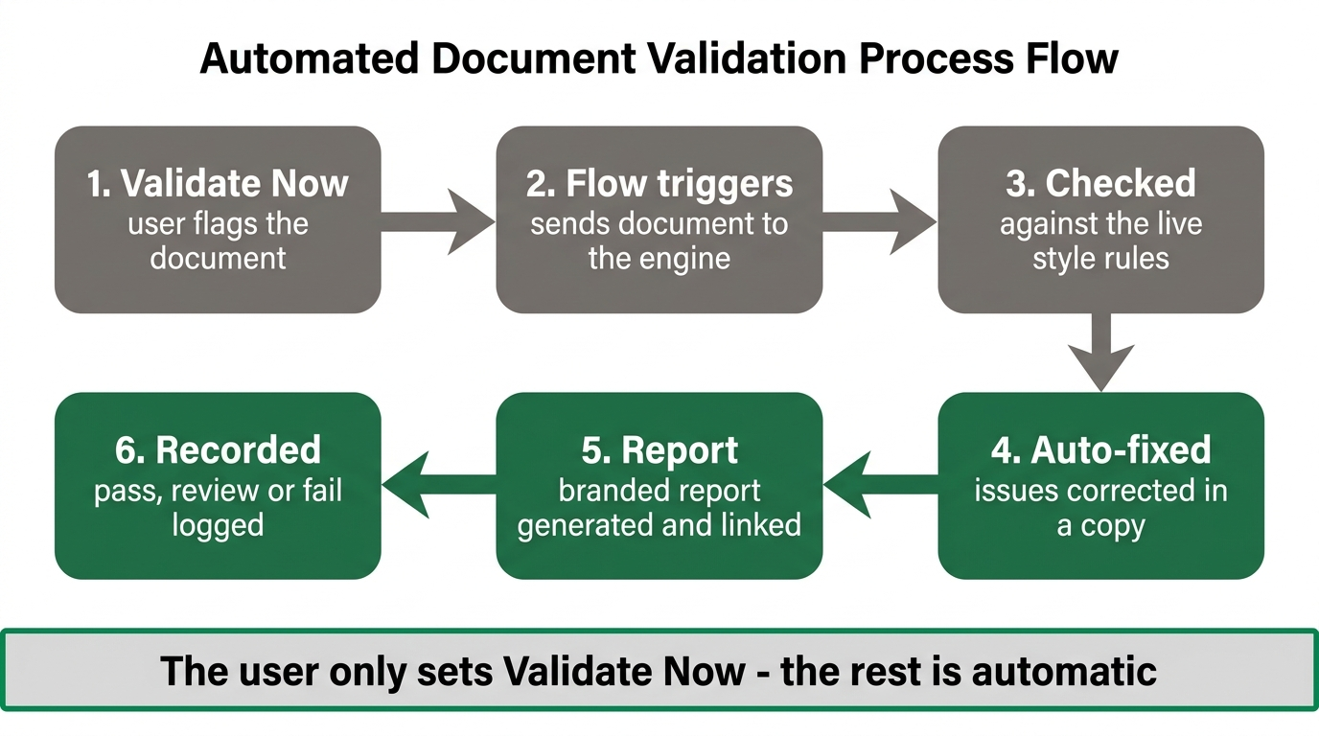
Figure 2 — End-to-end validation process

3. Security & data residency

3.1 Your data stays in your tenant
- All documents, rules, results and reports live in Mace SharePoint. The engine never persists them elsewhere.
- The engine is stateless — content is processed in memory and discarded. There is no database and no retention in the external subscription.
- All traffic is encrypted in transit (TLS / HTTPS).
- External AI is currently disabled; no document content is sent to any third-party AI service. If enabled in future, a data-classification check warns before any external processing.

3.2 Identity & access
- Access is via an Entra app registration on the Mace tenant, admin-consented by Mace IT.
- It uses Sites.Selected — scoped to the Mace Way Control Centre site only, not tenant-wide. It cannot reach any other Mace data.
- The engine's HTTP endpoints require a function key; only the Mace flow can invoke them.
- Mace can revoke access instantly — withdraw the site grant, disable the app registration, or rotate the key.

3.3 Auditing
- Every request is assigned a request identifier and emits an audit event.
- Access-control checks are enforced on each call.
- Controls are aligned to recognised SOC 2 control families (access control, monitoring).

4. Why the engine runs where it does
The engine currently runs in a personal Azure subscription. This was a deliberate pilot decision: it enabled rapid iteration with no dependency on Mace infrastructure or change-control while the concept was proven. The security model described above does not depend on where the engine runs, because the data and the controls live in Mace. The engine is tenant-agnostic: moving it to a Mace-owned subscription is a redeployment of the same code, with no change to the data model or security posture.
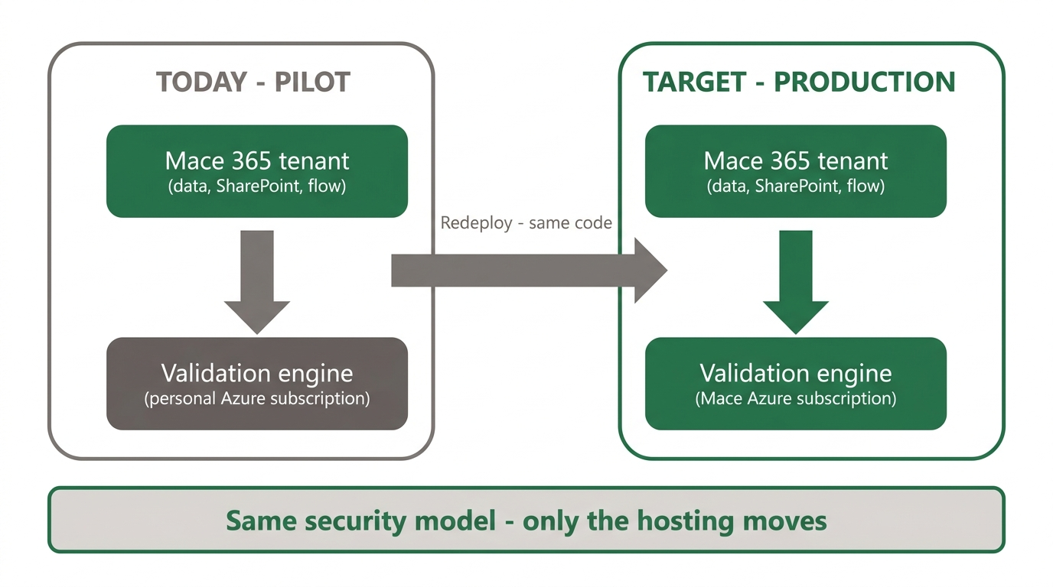
Figure 3 — From pilot to production: same code, same security model

5. Deployment & operations
Aspect | Detail
Validation engine | Azure Function, Python, serverless (Flex Consumption).
Orchestration | Power Automate flow (Mace Document Style Validator).
Storage | SharePoint lists (Style Rules, Validation Results) and libraries (documents, Validation Reports).
Infrastructure-as-code | ARM template defines the Azure resources.
CI/CD | Azure DevOps pipeline for build and deploy.
Configuration | Style rules and results are managed in SharePoint — no release needed to change a rule.
Current state | Piloted on Mace Way Control Centre; validated end-to-end on production documents.

Operational changes fall into two categories: rule changes (made by the business in SharePoint, no deployment) and engine changes (deployed via the pipeline). Access can be revoked by Mace IT independently of either.

6. Governance & recommendations
- Adopt the engine into a Mace-owned Azure subscription under CDIO governance, with a nominated DTS owner for the app registration and hosting.
- Tighten the site grant to least-privilege: the engine only needs read access to the style rules, so the grant can be reduced from its current level to read-only.
- Maintain the app registration, function key and site grant under standard Mace identity and secrets management.
- Keep style-rule ownership with the business; keep engine changes under change control.

7. Risks & mitigations
Risk | Mitigation
Engine hosted outside Mace (pilot) | Mitigated: no data stored outside; least-privilege, revocable access. Resolved by migrating to Mace Azure.
Over-privileged site grant | Reduce to read-only; tracked as a recommendation.
Credential management | Standard secret rotation; no secrets in code or documents.
Service availability | Serverless platform with retry in the flow; non-critical, asynchronous workload.

8. Configuration summary
Item | Value
App registration | MaceStyleValidator-App (Mace tenant).
Permission model | Sites.Selected — single site (Mace Way Control Centre).
SharePoint site | mace365.sharepoint.com/sites/MaceWayControlCentre.
Validation engine | Azure Function (Python, Flex Consumption), UK South.
External AI | Disabled.

Note: this document contains no secrets. Client secrets and keys are held in Azure / Mace secret management and are never recorded here.

