

Mace Style Validator
User Guide & Frequently Asked Questions

Document | User Guide & FAQ
Version | 1.0
Owner | Stephen Cummins · stephen.cummins@macegroup.com
Date | June 2026

1. Overview
The Mace Style Validator automatically checks documents in the Mace Way Control Centre against the Control Centre Writing Style Guide, fixes common issues, and produces a branded validation report — all from within SharePoint. It works across Word, Excel, PowerPoint and Visio.

2. Running a validation
Validation is triggered from the document library — there is no separate application to open.
- Open the Document Technical Review library and locate your document.
- Set the document's ValidationStatus column to "Validate Now".
- The validator runs automatically: it checks the document against the live style rules, auto-fixes common issues, generates a report, and records the outcome.
- Within a short time the document's status updates (Passed, Review Required or Failed) and a "View Report" link appears.
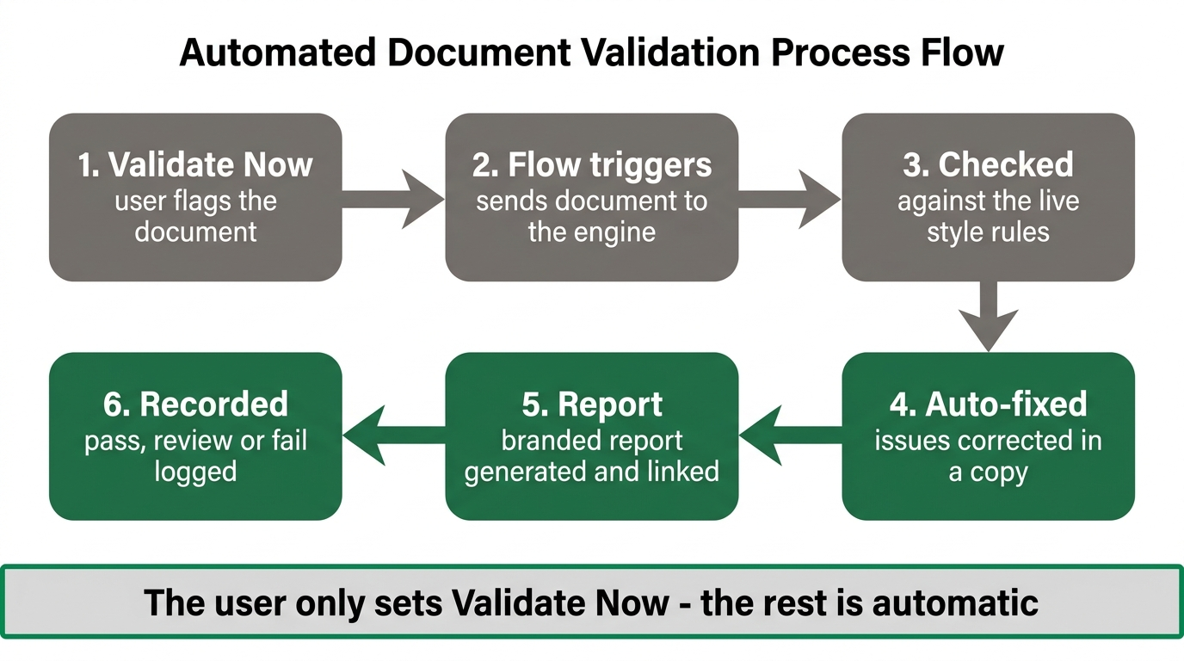
The end-to-end validation process

3. Understanding the report
Each validation produces a Mace-branded HTML report containing:
- A status banner — Passed, Review Required or Failed.
- A summary — issues found, auto-fixed, and remaining.
- Changes Made — each rule applied, what was found and what it was changed to, and where.
- Remaining Issues — anything needing manual attention.
- Links back to the source document and its library.
Tip: open report links with a normal click — they navigate in the same tab. Use your browser's Back button to return to the report.

4. Where results are recorded
Where | What it shows
ValidationStatus | Passed / Review Required / Failed, shown on the document.
LastValidated | Date and time of the most recent run.
ValidationReport | "View Report" — opens the HTML report for the document.
ValidationResultLink | "View Result" — opens the matching record in the Validation Results list.
Validation Results list | One record per run: file name, date, status, issues found and fixed.
Validation Reports library | Holds the generated HTML reports.

5. What it checks
- British English spelling (e.g. colour, analyse, centre).
- Contraction expansion and symbol replacement (& → and, % → percent).
- Number formatting and font standardisation (Arial).
- Document structure and headings.
Supported formats: Word (.docx), Excel (.xlsx), PowerPoint (.pptx) and Visio (.vsdx).

6. Managing the style rules
The rules are not hard-coded — they live in the Style Rules list in SharePoint and are owned by the business. To change what the validator enforces, edit that list; no software release is required. Add a new item to introduce a rule, or amend an existing one to change its behaviour.

7. Frequently asked questions
Q. Does the validator send my documents outside Mace?
A. No. All documents, rules, results and reports stay within the Mace tenant. The validation engine processes content in memory and stores nothing. External AI is currently disabled, so no document content is sent to any third-party AI service.
Q. Will it change my original document?
A. It corrects common, auto-fixable issues and records exactly what changed in the report. Anything that needs judgement is listed under Remaining Issues for you to address manually.
Q. What do the statuses mean?
A. Passed — compliant (any issues were auto-fixed). Review Required — some issues were fixed but others need manual attention. Failed — issues were found that could not be auto-fixed.
Q. Why does the report sometimes show a status of 'Validating…'?
A. That is a transient state while a run is in progress; it updates to the final status when the run completes.
Q. Who can see the reports and results?
A. Anyone with access to the Mace Way Control Centre library and lists — the same permissions as the documents themselves. Access is governed entirely by Mace.
Q. How do I add or change a style rule?
A. Edit the Style Rules list in SharePoint. Changes take effect on the next validation — no deployment needed.
Q. The logo doesn't appear if I download the report. Is that expected?
A. Yes. Reports are designed to be viewed from SharePoint, where the Mace logo loads from the site. A downloaded copy may not show it.
Q. Who do I contact for help?
A. Stephen Cummins — stephen.cummins@macegroup.com.

