Homework 28

The Rabbit Hunt
Due by noon on November 17 (Monday)
This is a second "loops and decisions" capstone project. The scoring is a little different though, and you actually do have a chance to get some extra credit. When you complete the program, your grade will be double the percent of times that the rabbit escapes from the fox. That means you'll get 100% on the assignment if your rabbit escapes 50% of the time. In past semesters, the best students have managed about a 95% survival rate. There is one additional caveat: you can only modify the code in the Rabbit class; you can't shoot, drug or otherwise make the Fox stupid.
Here's the story:
A fox is hunting a rabbit in a field. The field contains a number of bushes which obstruct both the fox's view and the rabbit's view, so each may or may not be able to see the other. The fox tries to catch the rabbit; the rabbit tries to get away from the fox. If the fox can catch the rabbit, he eats it (and wins). If the rabbit can keep away from the fox for 100 turns, the rabbit wins.
You are the rabbit.
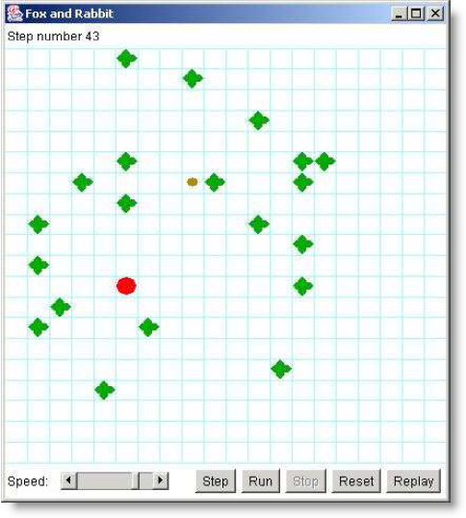
Getting started:
Download the RabbitHunt.jar file from the exercise page and then import it as a project into Eclipse. (Actually, it's both an Eclipse and a BlueJ project, so if you want to open it in BlueJ, you can do that as well.) When you run the program, you'll see something like this:
The big red dot represents the fox, the small brown dot is the rabbit, and the green blobs are bushes.
Run the RabbitHunt program a few times and see what happens. Notice that you can step through the hunt, or just let it run. You can adjust the speed at which the animation proceeds (this does not affect what happens, only how quickly it happens). Notice that the rabbit almost always meets an untimely end. However, occasionally the rabbit will evade the fox for 100 turns, and the rabbit wins--this doesn't happen very often.
Now look at the Rabbit class. It has a constructor Rabbit(model, row, column), and it has a method decideMove(), which decides how the rabbit is going to move at each turn. The rabbit I've given you is a really stupid rabbit--it just moves randomly.
Your job is to improve the Rabbit class so that the rabbit escapes more often. This is your class; you can do (almost) anything you want with it. You can look at all the other classes, but the Rabbit class is the only one you are allowed to change. It is probably impossible to find a strategy for the rabbit that ensures a 100% survival rate.
Structure of the program
This program uses the Model-View-Controller design pattern. That is, there are separate classes that do the following: The Model represents the "rules of the game." The View displays what is going on. The Controller is the part of the program that displays the controls (the four buttons and the speed controls at the bottom of the window).
The Controller and View classes are almost entirely independent of the Model class. The Rabbit class is part of the Model. This means that you do not have to understand anything about either the Controller or the View in order to complete your assignment.
In addition to the Model class, there are Animal, Rabbit, Fox, and Bush classes. Rabbit and Fox are subclasses of Animal (as you can see from the solid arrows in the BlueJ diagram); all other classes just extend Object. This is the part of the program that you will work with. I'll describe these classes briefly, just to get you started; but you should examine the code to find out how it all really works and fits together.
The Model class places the fox, rabbit, and bushes in the field and then:
- gives the rabbit and the fox each a chance to move (one moves, then the other--they don't both move at the same time)
- tells the View to display the result of these two moves, and determines which animal won
In addition, Model provides several constants that you can use:
Model.N | indicates "north" (straight up)
Model.NE | indicates "northeast" (up and to the right)
Model.E | indicates "east" (to the right)
Model.SE | indicates "southeast" (to the right and down)
Model.S | indicates "south" (straight down)
Model.SW | indicates "southwest" (to the left and down)
Model.W | indicates "west" (to the left)
Model.NW | indicates "northwest" (up and to the left)
Model.STAY | indicates "no move"
Model.MIN_DIRECTION | the numerically smallest direction (not including STAY)
Model.MAX_DIRECTION | the numerically largest direction (not including STAY)
Model.BUSH | indicates a bush
Model.FOX | indicates a fox
Model.RABBIT | indicates a rabbit
Model.EDGE | indicates the edge of the board
Finally, Model provides the following method: static int turn(int direction, int amount)
Given a starting direction and the number of 1/8 turns to make clockwise, this method returns the resultant direction.
Other classes that you'll work with are:
- Bush: which doesn’t doesn't do anything; the bushes just sit there and get in the way.
- Animal: provides methods that are the same for both the rabbit and the fox: looking in a particular direction, measuring the distance to an object, and moving.
- Fox: tries to catch and eat the rabbit.
- Rabbit: is an animal that tries not to get caught and eaten.
The Animal class provides the following methods that are inherited by Fox and Rabbit.
int look(int direction)
Return one of the constants Model.BUSH, Model.FOX, Model.RABBIT, or Model.EDGE, depending on what the animal sees in that direction.
int distance(int direction)
Returns the number of steps the animal would have to make in order to land on top of the nearest object (or go off the edge of the playing area).
boolean canMove(int direction)
Tells whether the animal can move in the given direction without being stopped by a bush or the edge of the board. Doesn't say whether it's a good idea to move that direction.
The part you have to write:
When it is the rabbit's turn to move, the model sends the message decideMove() to the rabbit. The rabbit must return a direction in which to move. I have written a Rabbit class, but my rabbit makes really stupid moves. Your job is to fix the Rabbit class by replacing my decideMove() method with a better one.
Note that the rabbit does not actually move itself. Instead, it responds to the decideMove() message by returning the direction in which it wants to move. The model will then move the rabbit in that direction, if the move is possible and legal. If the move cannot be made (because of a bush or the edge of the board), the rabbit will not move.
Run the Grader class to quickly execute the program a few hundred times and to get an overall percentage. When you’re done, package your program (including the source code) in a single executable jar file named LastFirst_hw28.jar. When you make your jar file, please make Grader the main class. Email your assignment to cs170f08@gmail.com. Use only the exact phrase: LastFirst hw28 as the subject line on your email. Replace LastFirst with your actual last and first name.

