Executable Jars

Executable Jars with Eclipse
An executable jar (Java Archive) is simply a zip file that contains all of the classes and resources for an application, along with a manifest file that tells the Java interpreter where to find the main() method to start the program running. An executable jar allows you to package all of the various pieces of your program into an easy to distribute format.
If you have a GUI program packaged as an executable jar, you can usually just double-click it, like you would any executable, to start it running. For console-mode programs, like Nim, you’ll run it by using the Java interpreter from the command line, along with the –jar switch, like this:
java –jar Nim.jar
Creating the jar with Eclipse
To create a jar file, you first choose Export from the File menu, after you’ve completed and debugged your application. On the Select dialog, expand the Java folder and select JAR File as shown here (not the Runnable JAR File):
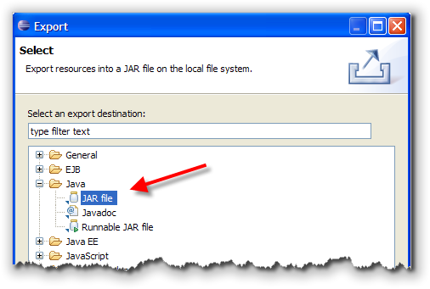
Click the Next button at the bottom of the dialog and you’ll be taken to the JAR Export screen.

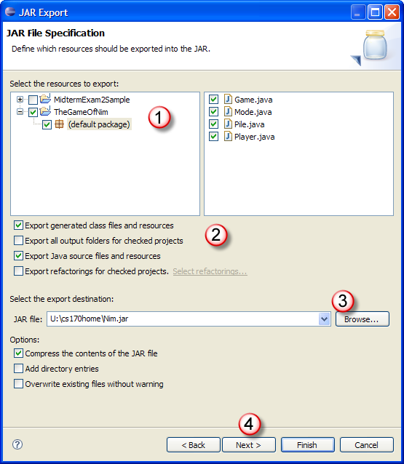
On the JAR Export screen you need to first select the project that you want to export. Then, make sure that the Export generated class files and resources checkbox is selected (2). To include the Java source code as well, select Export Java source files and resources also.
To select the export destination, either type a name into the JAR file: text box or click the Browse button appearing to its right and navigate to the directory where you want to store your file. Finally, click the Next button to go on to the next screen: JAR Packaging Options. There is nothing you need to change on this screen, so just click Next once again to go to the JAR Manifest Generation screen which I’ve reproduced on the next page.
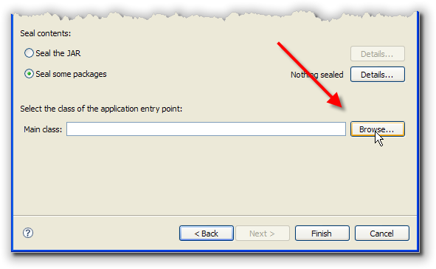
When the JAR Manifest Generation screen appears, locate the Main class text box and click the Browse button that appears at its right as shown here:
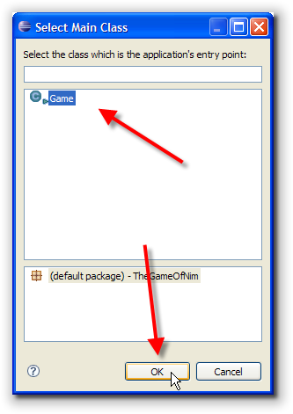
When the Select Main Class dialog appears (on the right), select the class containing your main() method and click the OK button.
Click the Finish button on the JAR Manifest Generation screen to finish the process.

