Extra-Credit #3

The Game of Nim
The game of Nim is a well-known game with a number of variants. For this project, you'll build the following variant, which has an interesting winning strategy. Two players alternately take marbles from a pile. In each move, a player chooses how many marbles to take. The player must take at least one, but at most half of the marbles. Then, the other player takes a turn. The player who takes the last marble loses.
Here’s one sample run to give you an example of how the program should act:
Welcome to the game of Nim. Pile Size: 67 marbles

Your move. How many would you like to take? 5

Current pile size: 62 marbles. I'll take: 21
Current pile size: 41 marbles. How many would you like to take? 11
Current pile size: 30 marbles. I'll take: 2
Current pile size: 28 marbles. How many would you like to take? 8
Current pile size: 20 marbles. I'll take: 9
Current pile size: 11 marbles. How many would you like to take? 8
Illegal Move. Maximum you may take is 5 marbles. Try Again. 3
Current pile size: 8 marbles. I'll take: 4
Current pile size: 4 marbles. How many would you like to take? 1
Current pile size: 3 marbles. I'll take: 1
Current pile size: 2 marbles. How many would you like to take? 1

Current pile size: 1 marbles. I'll take: 1

Current pile size: 0 marbles
YOU BEAT ME!!

Thank you for playing
Write an ACM console-mode program, (so you don't need to get bogged down with graphics or the user interface; instead, you'll concentrate on designing the classes and the logic), in which the computer plays against a human opponent. Generate a random integer between 10 and 100 to denote the initial size of the pile. Generate a random integer between 0 and 1 to decide whether the human or the computer takes the first turn. Generate a random number between 0 and 1 to decide whether the computer plays smart or stupid.
In stupid mode, the computer simply takes a random legal value (between 1 and n/2) from the pile whenever it has a turn. In smart mode the computer takes off enough marbles to make the size of the pile a power of two minus 1 (that is, 3, 7, 15, 31, or 63). That is always a legal move, except if the size of the pile is currently one less than a power of 2. In that case, the computer makes a random legal move.
Note that the computer cannot be beaten in smart mode when it has the first move, unless the pile size happens to be 15, 31, or 63. Of course, a human player who has the first turn and knows the winning strategy can win against the computer.
When you implement your game, use the classes Nim, Pile, Player and Game. The Nim class should contain a run() method that looks exactly like this, except that you must add a line before the loop, that prints your name in the form: Author: Last, First::
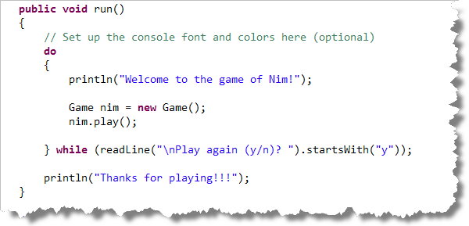
Notice that the run() method simply creates a Game object. The Game object will create the two Player objects as well as a Pile object. A player can be either: a)stupid, b) smart or c) human. Human Player objects will prompt for input, while stupid and smart players will simply play according the appropriate strategy.
Package your program into an executable JAR file, so that I can just double-click it to run. You'll learn how to do that in class this week.

