CS 170 Java Tools Spring 2013
This semester in CS 170 we'll be using the DrJava Integrated Development Environment. You're free to use other tools but this is what you'll use on your programming exams, so you'll need to be familiar with it. You also must use DrJava to submit your homework assignments. The version of DrJava we'll be using has been customized for CS 170 to include built-in style checking and providing feedback and submission of your programming assignments. This short document will show you how to download and configure it on your own personal computer.

Step 1: Got Java?
Before you can run DrJava, you first need to have (at least) the Java runtime (JRE)on your computer. If you have a Mac (and you run Software Update regularly), Java should be installed and correctly configured. (On new Macs you'll be asked if you want to install a Java Runtime the first time you start a Java application.) With Windows and Linux just visit http://java.com
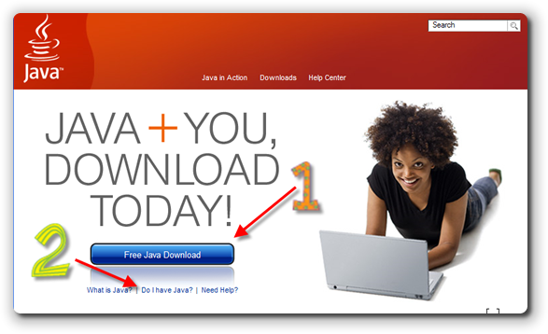
Click the link that says Free Java Download (1) and follow the instructions to install the program. If you want to see if you already have Java installed before you start, just click the hyperlink that says "Do I have Java installed" (2). If you have 64-bit Windows 7, use IE-64-bit to install the JRE. You can have both the 64 and 32 bit versions, but you'll need the 64-bit version on Windows 7-64 to use DrJava.
For most of the class, you can use just the JRE (Java Runtime Environment) because DrJava contains its own copy of the Eclipse compiler, already built-in. If you want to use the DrJava debugger or the Javadoc documentation tool, though, you'll need to install the Java Development Kit (or JDK) which doesn't take that long.

Step 1-Alternative: Install the JDK
The Java Development Kit (or JDK) is a free set of command-line tools available from Oracle. If you download and install the JDK, it will also install the JRE, so you don't have to do both. Note that the JDK is a larger download than the JRE, however.
Here's how to install the JDK:
- If you have a Mac (and you run Software Update regularly), the JDK should be installed and correctly configured. Starting with Java 7, you can follow these instructions for Mac as well.
- If you are using Ubuntu Linux you should be able to install and configure Java using the shell command sudo apt-get install sun-java6-jdk
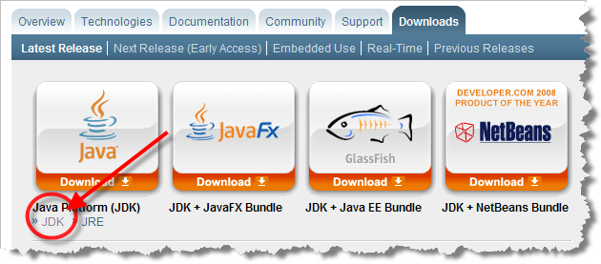
- If you are using Windows or another version of Linux, download the JDK (not the JRE) for your particular platform at: http://java.sun.com/javase/downloads/index.jsp
- Then, follow the installation instructions at::
http://java.sun.com/javase/6/webnotes/install/index.html
Note: you'll find the Java 6 version of the JDK at the bottom of the page shown here. The current version is JDK 7. DrJava will work with JDK 7, but, we are using JDK 6 in the labs. That means that if you bring a compiled program to school, you'll need to recompile it to run on the OCC lab computers. Either Java 6 or Java 7 should work just fine for class, though.
Note: if you download the Java 7 JDK for the Mac, it does not include the browser plug-in, so you won't be able to see Java applets in your Web browser. For this class, that really won't be a problem. If you want to run applets in your browser, then stick with JDK 6, delivered from Apple. Here's the tech-note from Apple: http://support.apple.com/kb/DL1550
Note: if you are using Linux, you can't use the GNU version of Java, gcj. One way to check is to type java –version in a shell window. Even though gcj doesn't work, if you have OpenJDK already installed, it may work fine. If you are using Windows-7-64-bit, then download the 64-bit version of the JDK. That's what we have in the labs.
Note: if you are using Windows-7-64-bit, then download the 64-bit version of the JDK. That's what we have in the labs.

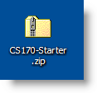
Step 2: Call the Doctor
Copy the folder Q:\faculty5\sgilbert\cs170\tools\cs170home-S13 to your U:\drive or USB thumb drive (if working in the Computing Center), or download the CS170-Starter Zip File from Blackboard. (The name will actually be slightly different, depending on the semester.) You can put in on your desktop or in your documents folder. Once you've downloaded it, unzip it on your local machine. (Make sure that you actually unzip the file. Don't use the Windows feature that lets you treat the file as a compressed folder. If the zipped file looks like the picture here—with a zipper up the middle—then right-click it and choose Extract All from the context menu.)
Once you've unzipped CS170-Starter Zip File you will find a folder named cs170home-S13. This is the folder that contains DrJava and all of the starter files and some of the testing code that accompanies the online textbook. Go ahead and drag it wherever you want to keep it. In the picture shown below, you can see that I've dragged the cs170home-S13 folder to a USB drive:
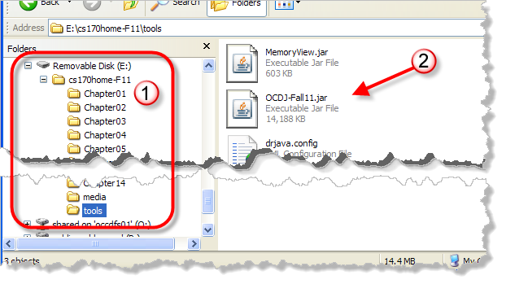
As you can see, the cs170home-S13 folder has a subfolder named tools, as well as folders for each chapter in the textbook. Open the tools folder and double-click our customized version of DrJava, OCDJ-S13.jar.
Of course the picture shown here shows the Fall-11 version instead of Spring 2013. I didn't want to re-shoot.

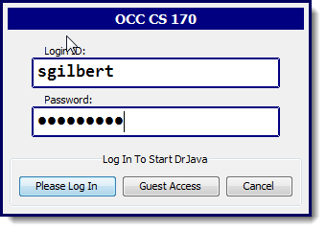
Logging In
When you first double-click OCDJ-S13.jar, you should be taken to a login dialog that looks like this:
- Use your OCC student email name, (not the entire email address) as your login ID
- Use your OCC student ID (including the capital C) as your password.

If all goes well, you'll see the DrJava "splash screen" appear as DrJava loads for the first time. If you can't login for some reason, you can still use DrJava by clicking on Guest Access, but you won't be able to submit your homework assignments unless you are able to log in.
When the semester is over, you will still be able to use guest
access, but won’t be able to connect the server.

Troubleshooting Your Installation
DrJava doesn't start. If you have an "unarchiver" program like WinZip installed, it's possible for that program to "grab" the JAR (Java Archive) file extension, so that when you double-click the file it gets unzipped instead. (This may happen in different version of Linux as well.) If that occurs, open a command shell window, switch to the folder containing the Jar file, and type the command:
java –jar OCDJ-S13.jar.
Moving the JAR: You can move the OCDJ-S13.jar file, but it must be started from a folder named tools that also contains the drjava.config file from the original download. I have had some problems with Windows 7 erasing the drjava.config file when it can't save correctly, so you may want to keep another copy of that file available.
No compiler available. If you've tried the JRE only installation, when you start up DrJava on a machine without a JDK, you may see the message shown here when your program starts up. This should only occur on a machine that has an older version of Java installed.
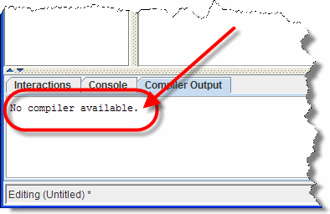
The easiest fix is to make sure that you have a current version of Java installed by following the instructions in Step 1: Got Java?

Step 3: Have It Your Way
I'll leave it to you to explore and to customize DrJava to your taste. Use the Edit->Preferences menu (on the Mac, you'll find it at OCDrJava->Preferences from the Mac menu at the top of the screen), make your changes. I've modified the CS 170 custom version of DrJava so that it uses the native look-and-feel of the Window system. You can switch to a different look and feel if you like:
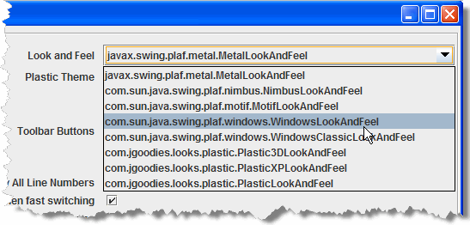
I also find that the default fonts are really too small for me to see. These are the settings I use on Windows. Unfortunately, when I take my USB drive over to my Mac, I then have to change the fonts to something else, like Monaco. If you leave the fonts at Monospace, then they'll work correctly, if unattractively, on either system:
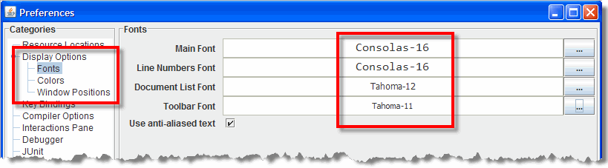
Feel free to explore and change the other options like Colors, Window Positions and Key Bindings (hot-keys), to make DrJava work the way that you want it to work. You can't really hurt the program. If something goes horribly wrong, just replace the .config file with the original.

Step 4: Where to Go Now?
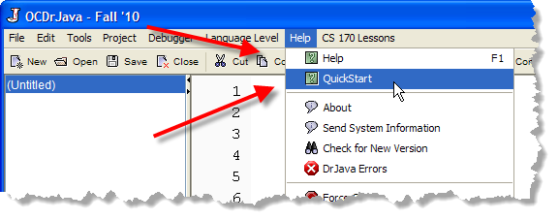
Browse the DrJava Quick Start from the Help menu to get a quick overview of using DrJava. Use F1 or Help->Help to read the DrJava reference manual.

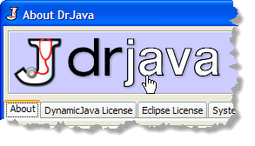
Clicking About on the Help menu, and then clicking the DrJava logo will take you to the DrJava Web site where you can find other information. You can find a concise, one-page DrJava Primer at the University of Pennsylvania:
http://www.seas.upenn.edu/~cis1xx/resources/drjava/primer/

