Homework 11

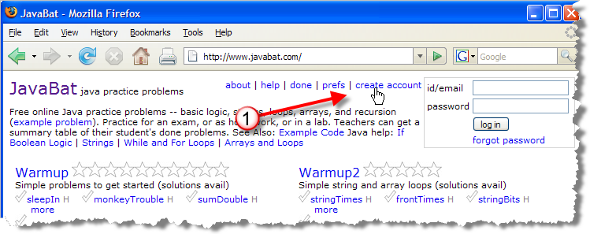
JavaBat: Configuring your account
Head over to http://www.javabat.com and click the create account link as shown here:
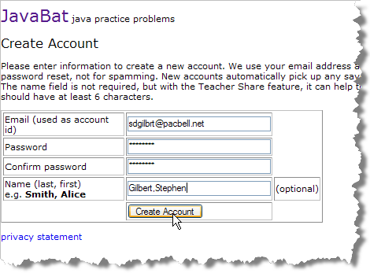
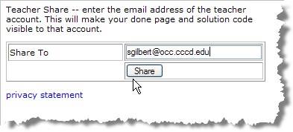
You can use your OCC email address (which will probably make it easier to remember for this class), but that's not important. It is important that you use your last and first name as it appears on my class roster (or as you may have changed it for grading). It has to be the same last and first name you use for the in-class exercise file names.
Once you have created your account, click the prefs link on the JavaBat home page and fill in the Teacher Share option with my email address: sgilbert@occ.cccd.edu. This is the only way I'll be able to see that you've completed your assignments.

