Executable Jars

Executable Jars with Eclipse
An executable jar (Java Archive) is simply a zip file that contains all of the classes and resources for an application, along with a manifest file that tells the Java interpreter where to find the main() method to start the program running. An executable jar allows you to package all of the various pieces of your program into an easy to distribute format.
If you have a GUI program (or an ACM ConsleProgram) packaged as an executable jar, you can usually just double-click it, like you would any executable, to start it running. For regular console-mode programs, you can run an executable Jar file it by using the Java interpreter from the command line, along with the –jar switch, like this:
java –jar MyExecutableJar.jar
Creating the jar with Eclipse
First, make sure that you have already run the program from inside of Eclipse to create a run configuration. Then, to create a jar file, choose Export from the File menu. On the Select dialog, expand the Java folder and select Runnable JAR File as shown here :
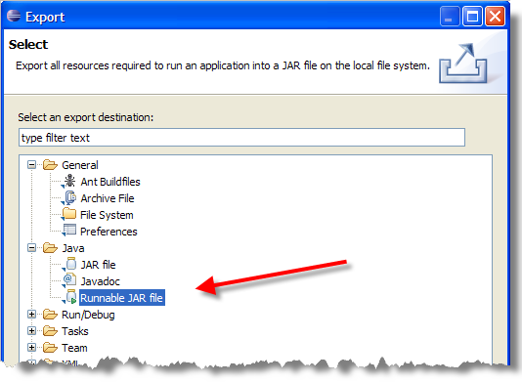
Click the Next button at the bottom of the dialog and you’ll be taken to the JAR Export screen.
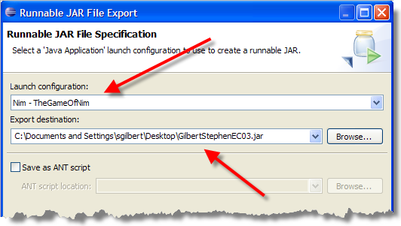
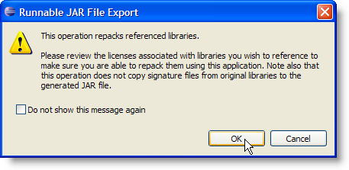
On the Runnable JAR File Export screen you need to first select the Launch configuration. This will be automatically created when you run your program. Use the drop-down list to select a configuration that is already defined. Once that's set up, enter an Export Destination. It doesn't have to be the same name as the program you are running. In my case here, I've named it GilbertStephenEC03.jar so I can turn it in as an assignment. I'm placing it on my desktop.
Click the Finish button to generate the Runnable JAR File. If your program uses any external JAR files (like acm.jar), you'll also see a dialog like this letting you know that those JAR files will be repackaged along with your executable. That's what we want to happen, so just click OK. When you're done, you should be able to double-click the JAR file and it should automatically launch your application, like this:
