Sample Final Exams
Welcome to the CS 170 Sample Final Exams. The Final Exam is comprehensive; it will over material from the entire semester, with an emphasis on new material. The sample exams are the same kinds of questions and the same format as the actual final exam.
The Final exam has two parts. Part 1 is a 100-question multiple-choice exam. You’ll use the Blackboard system to take both the Sample Final and the actual exam. After you've completed the Sample Final exam, you can check your score and compare your answers as an aid in preparation for the actual exam. Remember, though, that the actual exam is closed-book, but you may use two, 8.5 x 11 pages of personal notes. The second part of the exam is an open-notes, open-book programming exam. You’ll use Eclipse to complete this portion of the exam, which will be graded using Web-Cat. There will be no style points for the Web-Cat scoring. The multiple-choice portion will be worth 100 points and the programming 75 points.

Part I: The Multiple-Choice Exam
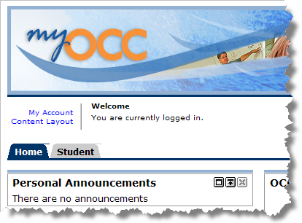
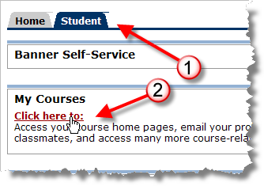
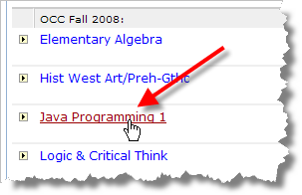
Step 1: Use your MyOCC password to log into the Blackboard Vista CS 170 online classroom.
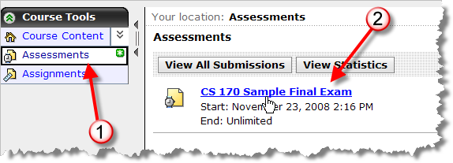
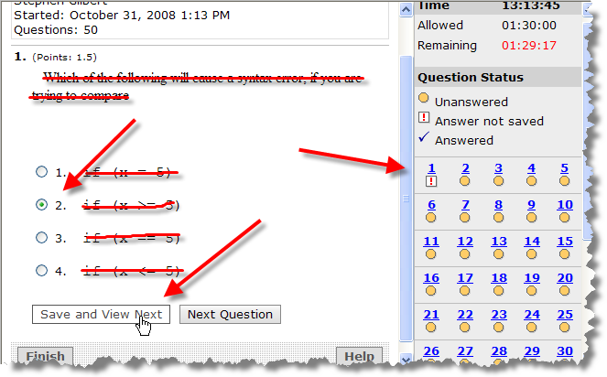
Step 2: Start the exam by clicking Assessments in the menu on the left. As you answer each question, make sure you click the “Save and View Next” button so that your answers are recorded. Only click the Finish button when you have completely answered all questions. You may revisit any question just by clicking its link in the table on the right. You have 90 minutes to answer all 75 questions. When you are finished, you can see your results by visiting the Assessments page again.

Part II: The Programming Proficiency Exam
To start the sample programming exam, download the SampleFinalProgrammingZip file from the class Web page and store it on your local machine. Unzip the file and then Start Eclipse. From the File menu, select Switch Workspace and change to the SampleFinalExam workspace. Open the FinalExam project and complete the problems you find there. There you will find some sample problems with instructions written as comments at the beginning of the problem.
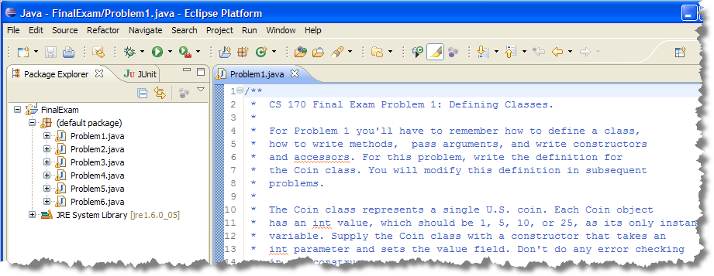
Rather than having a single large program, with lots of parts, I've divided the Final Programming problem into smaller problems that are a little more manageable.
Problem 1 - Simple Classes, Constructors and Accessors (20 Points): Define the Coin class, which represents a single U.S. coin. Each Coin object has a value, which must be 1, 5, 10, or 25, as its only instance variable.
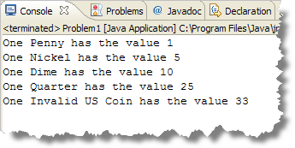
Create the Coin class using Eclipse. Add a constructor that takes a single int parameter, and two methods: getValue() which returns the Coin's int value, and toString(), which returns the name of the particular Coin object in this exact form: "Penny", "Nickel", "Dime", or "Quarter". Make sure that the Problem1 run method works correctly (producing the output shown here) before going on. (Grading is 50% structure, 50% correct behavior)

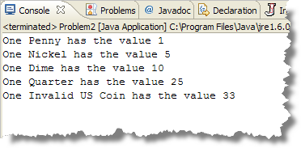
Problem 2 – Overloaded Methods or Constructors (10 points) : Add a second constructor to the Coin class that takes a double parameter. Use the parameter you receive to initialize the value field. You'll have to convert the parameter to an appropriate integer. For instance, the actual parameter .25 should be stored as 25 in the value instance variable. Do not add any additional instance variables. Make sure that the Problem 2 run method works correctly.
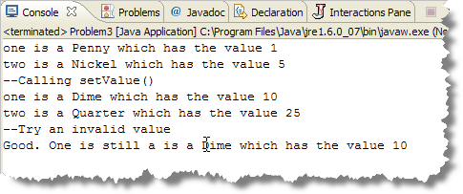
Problem 3 – Mutator Methods and Exceptions (10 points) : Add a setValue() method to the Coin class. Your setValue() method should take a single int parameter and should use exception handling so that only valid Coin values can be used. You should throw an IllegalArgumentException when someone attempts to set an invalid Coin value.
Do not modify the Coin constructors, so that Problem 1 and Problem 2 still work correctly, even though each of them constructs an invalid Coin object. Make sure that the Problem 3 run method works correctly as shown here.

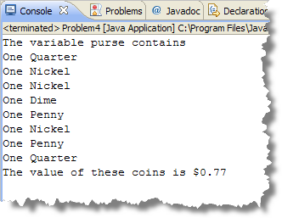
Problem 4 – Object Arrays and Standard Array Algorithms (10 points) : Write the sum() method (inside Problem4.java) that takes an array of Coin objects as a parameter, and returns the sum of the values that the array contains as a dollar amount. (That means if the array contains a single quarter, the method would return .25). Make sure that the Problem 4 run method works correctly as shown here.
For the actual exam, you should be sure you can write methods that that average (using different kinds of averaging algorithms including weighted averages, centered average, median and mode) and that make use of the algorithms for finding extreme values. I will normally give you the algorithm to use if it is anything other than a straightforward sum, average or count.

Problem 5 – Implementing the Comparable Interface (10 points) : Problem 5 first shuffles an ArrayList of Coin objects by using the Collections.shuffle() method and then sorts them. The shuffle() method works correctly, but sort() does not. For the sort method to work correctly, you need to modify the Coin class so that it implements the Comparable<Coin> interface. Make sure that the Problem 5 run method works correctly as shown here.
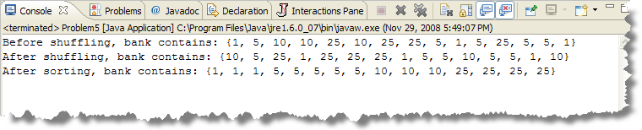

Problem 6 – Array Programming with Loops (15 points) : Write the tenRun() method (inside Problem6.java) that takes an array of int values as a parameter, and returns a new array. For each multiple of 10 in the array parameter, change all of the values following it to be that multiple of 10, until encountering another multiple of 10. So {2, 10, 3, 4, 20, 5} will return a new array with the value {2, 10, 10, 10, 20, 20}. Make sure that the Problem6 run method works correctly as shown here. (This problem will be one of the JavaBat Array2 exercises.)
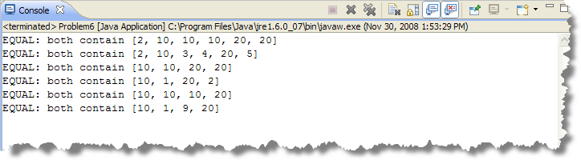

Submitting the Programming Exam
Save your work and submit the assignment. Choose Project Submit Project and select the appropriate exam. Fill in your Web-Cat user ID and password. This will be different than your MyOCC user ID and password used to log into BBVista. If you have problems submitting your exam, tell me as soon as possible.

Do the easy problems first; submit often.

