BusinessOS
Complete Screen Reference
23 March 2026
Tenant Admin screens • Superuser Tenant Management screens

Screen Index
Authentication
1. [ADMIN] Login Page
Core Views
2. [ADMIN] Master Catalogue
3. [ADMIN] Master Map
4. [ADMIN] Process Catalogue
5. [ADMIN] Process Map
Strategy
6. [ADMIN] Mission & Vision
7. [ADMIN] Strategic Planning
8. [ADMIN] Initiatives
Governance
9. [ADMIN] Governance
Productivity
10. [ADMIN] Workflows
11. [ADMIN] Documents
12. [ADMIN] Meetings
13. [ADMIN] Calendar
14. [ADMIN] Activities
15. [ADMIN] Tasks
16. [ADMIN] Queues
AI
17. [ADMIN] AI Agents
Integrations
18. [ADMIN] Connectors
System
19. [ADMIN] Dashboards
20. [ADMIN] Reports
21. [ADMIN] Audit & Logs
22. [ADMIN] Settings
Admin
23. [ADMIN] Users
24. [ADMIN] Configuration
Tenant Management
25. [SUPERUSER] Tenant Management

Authentication

1. Login Page
AUTHENTICATION — Public, no login required
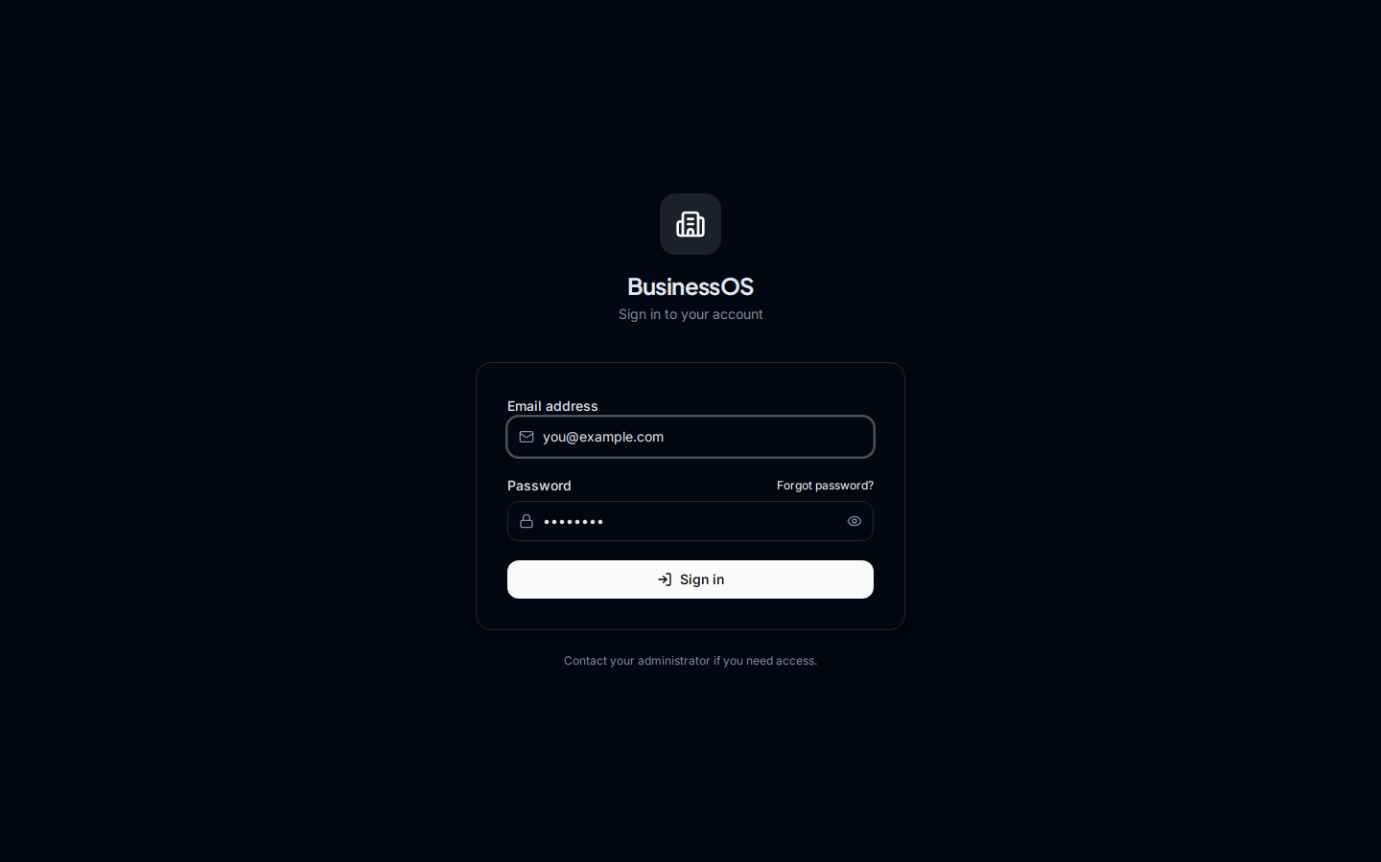

Core Views

2. Master Catalogue
TENANT ADMIN SCREEN — Requires login as tenant admin or standard user
Section: Core Views | Credentials: stephen.raj@coryphaeus.ai / admin123
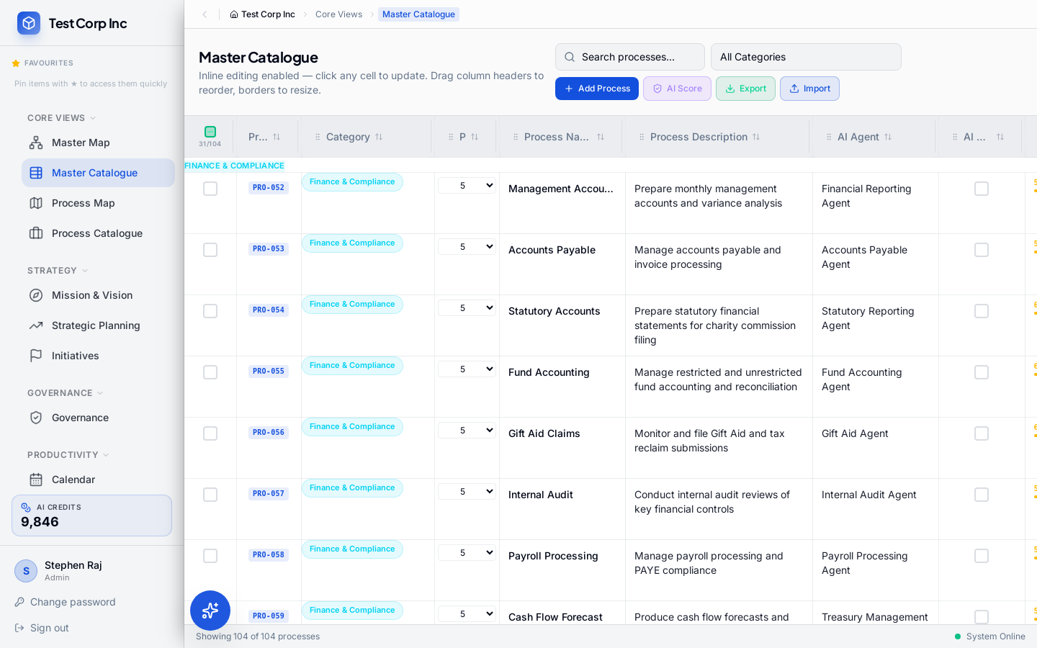

3. Master Map
TENANT ADMIN SCREEN — Requires login as tenant admin or standard user
Section: Core Views | Credentials: stephen.raj@coryphaeus.ai / admin123
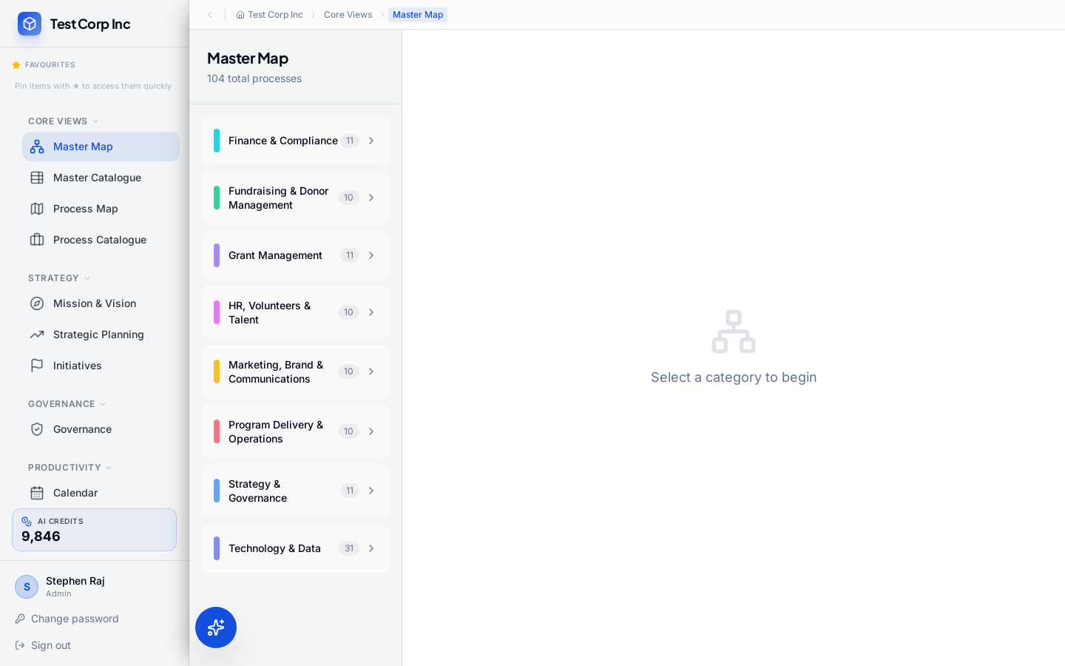

4. Process Catalogue
TENANT ADMIN SCREEN — Requires login as tenant admin or standard user
Section: Core Views | Credentials: stephen.raj@coryphaeus.ai / admin123
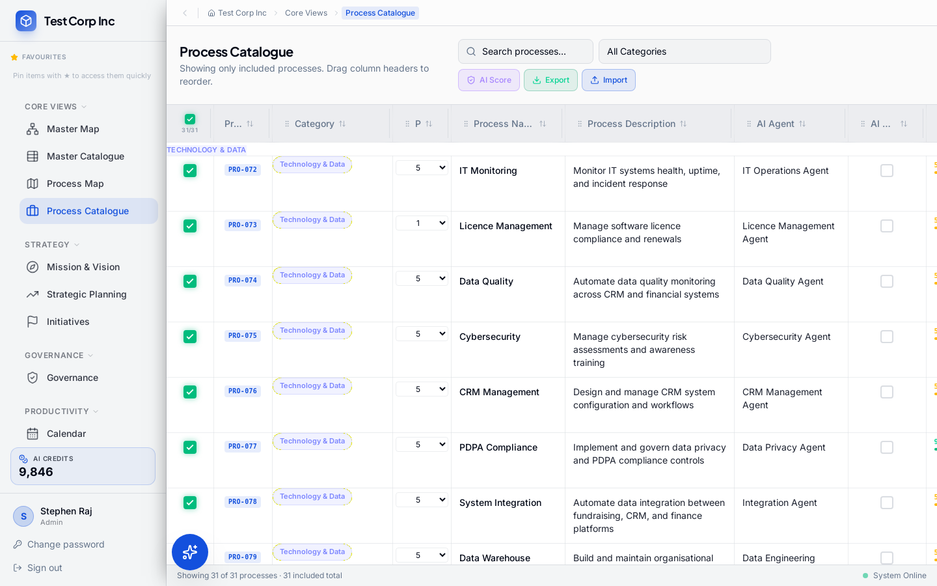

5. Process Map
TENANT ADMIN SCREEN — Requires login as tenant admin or standard user
Section: Core Views | Credentials: stephen.raj@coryphaeus.ai / admin123
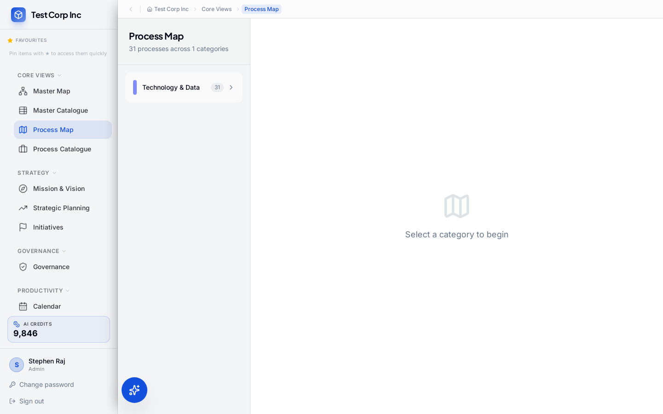

Strategy

6. Mission & Vision
TENANT ADMIN SCREEN — Requires login as tenant admin or standard user
Section: Strategy | Credentials: stephen.raj@coryphaeus.ai / admin123
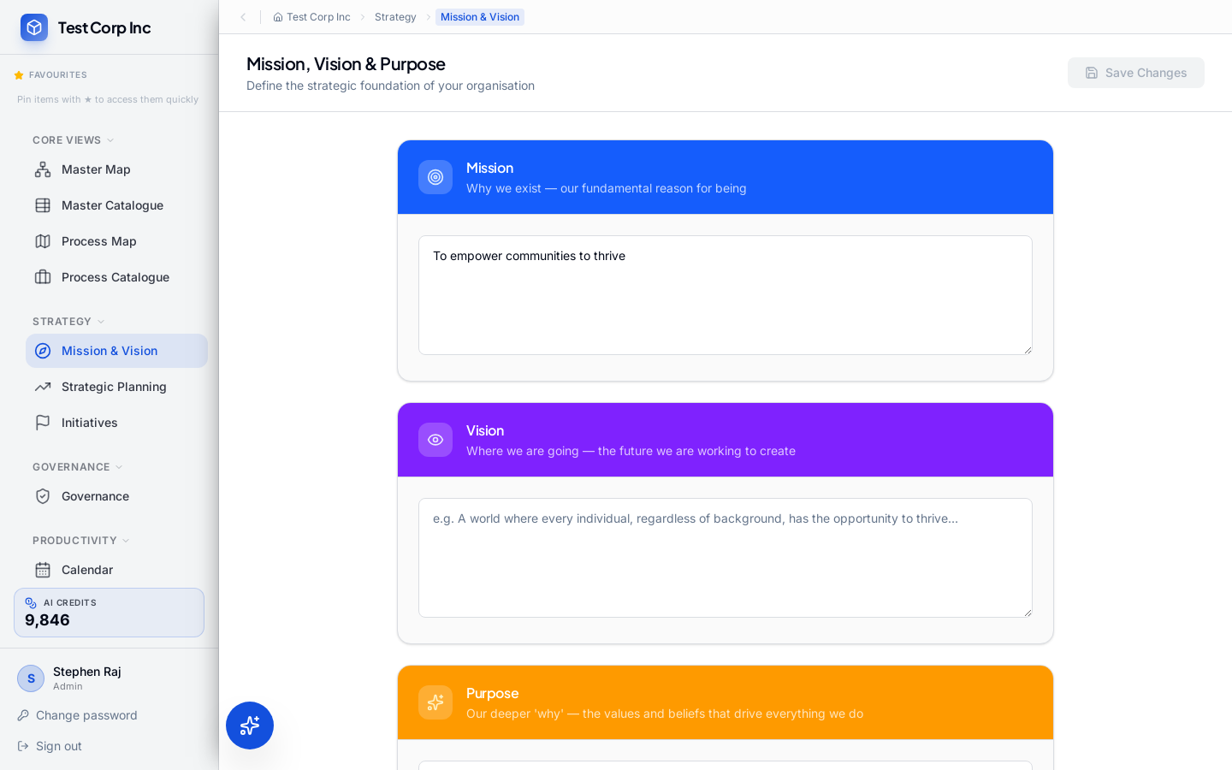

7. Strategic Planning
TENANT ADMIN SCREEN — Requires login as tenant admin or standard user
Section: Strategy | Credentials: stephen.raj@coryphaeus.ai / admin123
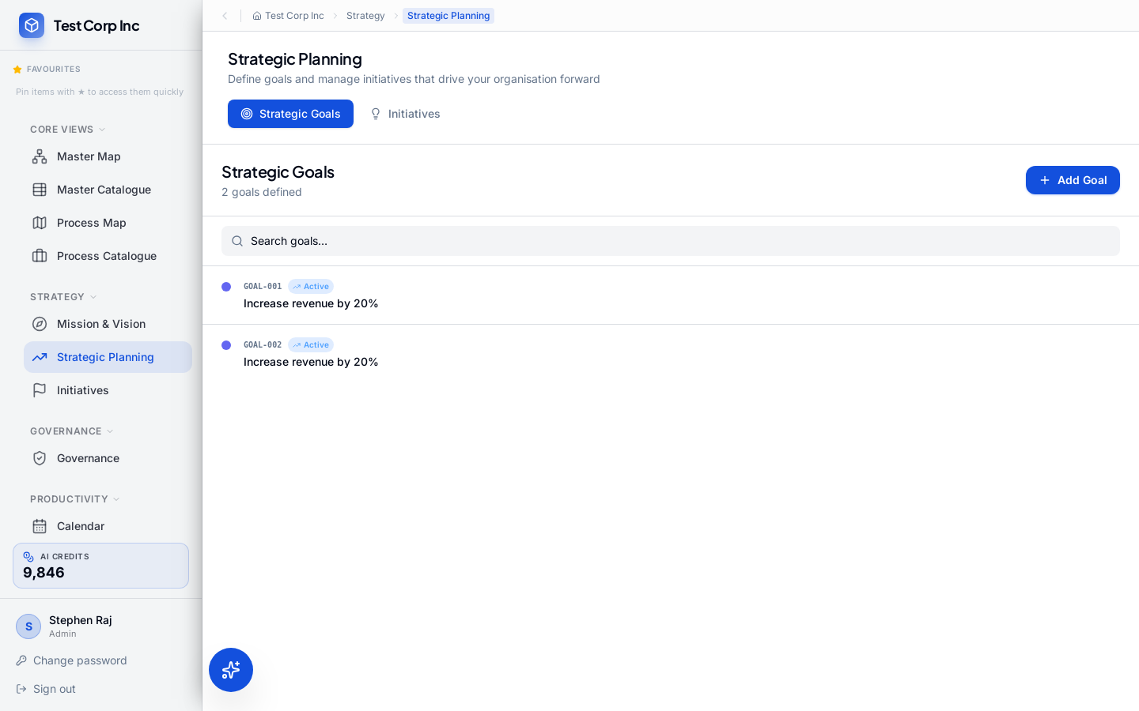

8. Initiatives
TENANT ADMIN SCREEN — Requires login as tenant admin or standard user
Section: Strategy | Credentials: stephen.raj@coryphaeus.ai / admin123
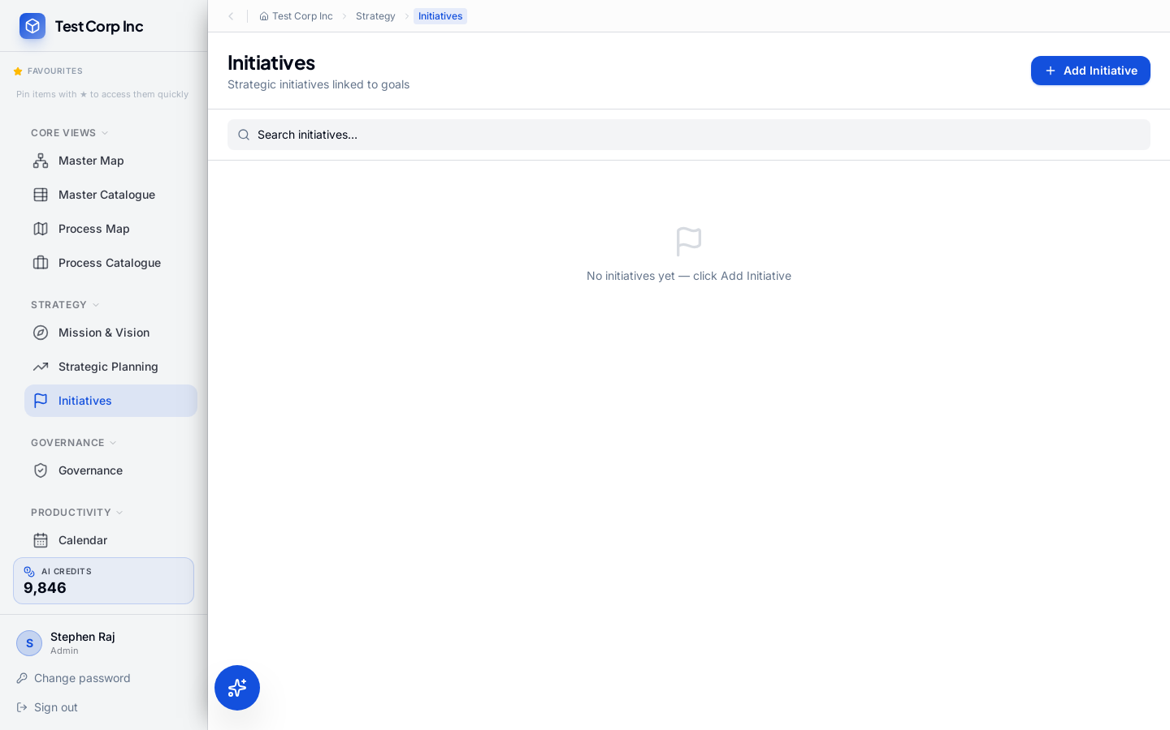

Governance

9. Governance
TENANT ADMIN SCREEN — Requires login as tenant admin or standard user
Section: Governance | Credentials: stephen.raj@coryphaeus.ai / admin123
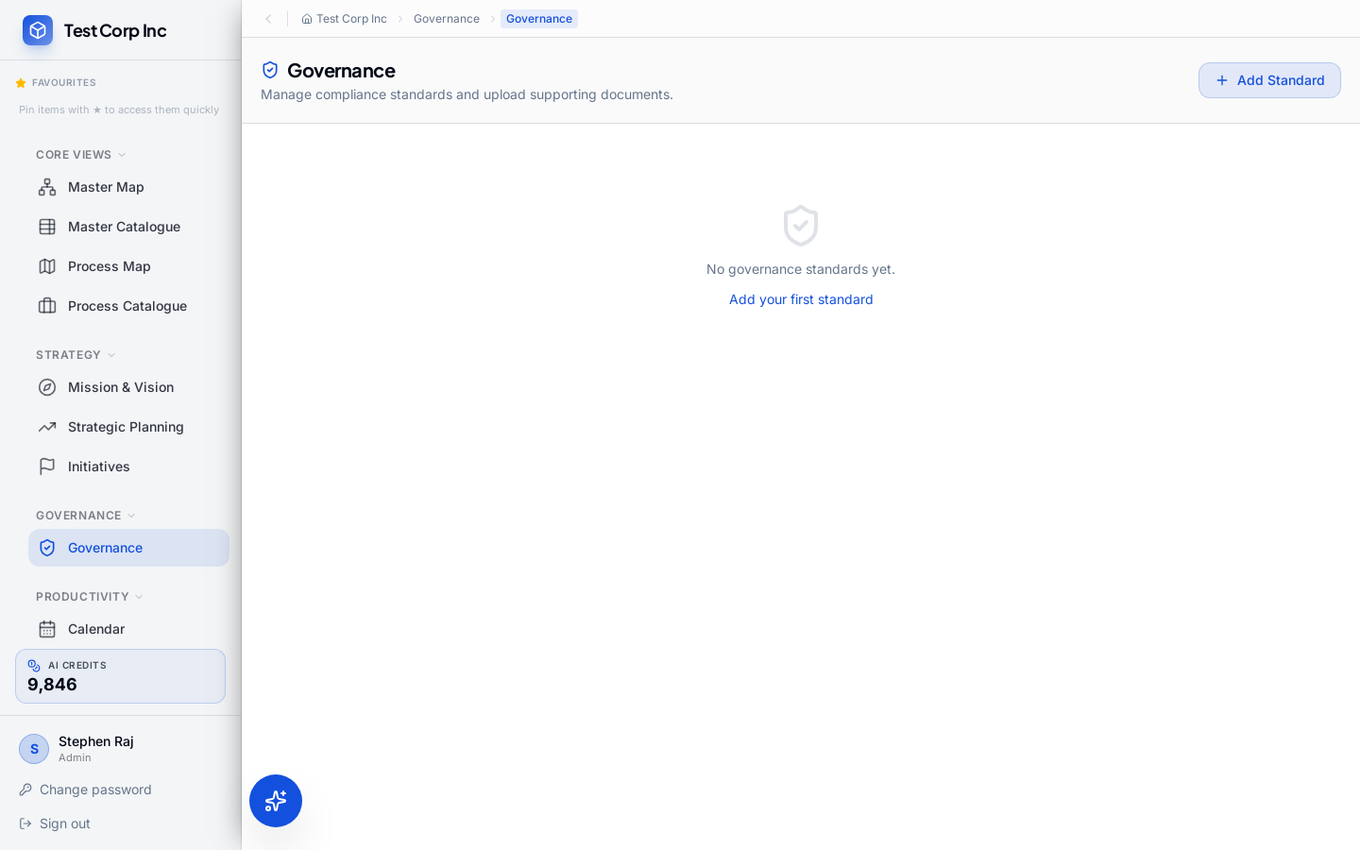

Productivity

10. Workflows
TENANT ADMIN SCREEN — Requires login as tenant admin or standard user
Section: Productivity | Credentials: stephen.raj@coryphaeus.ai / admin123
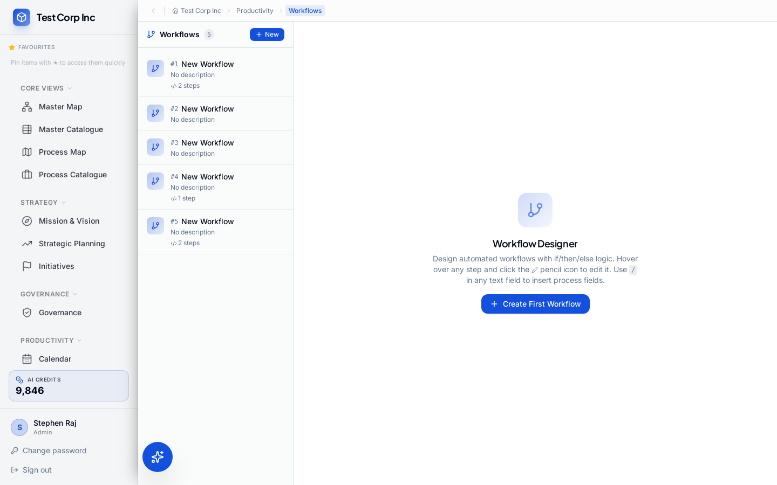

11. Documents
TENANT ADMIN SCREEN — Requires login as tenant admin or standard user
Section: Productivity | Credentials: stephen.raj@coryphaeus.ai / admin123
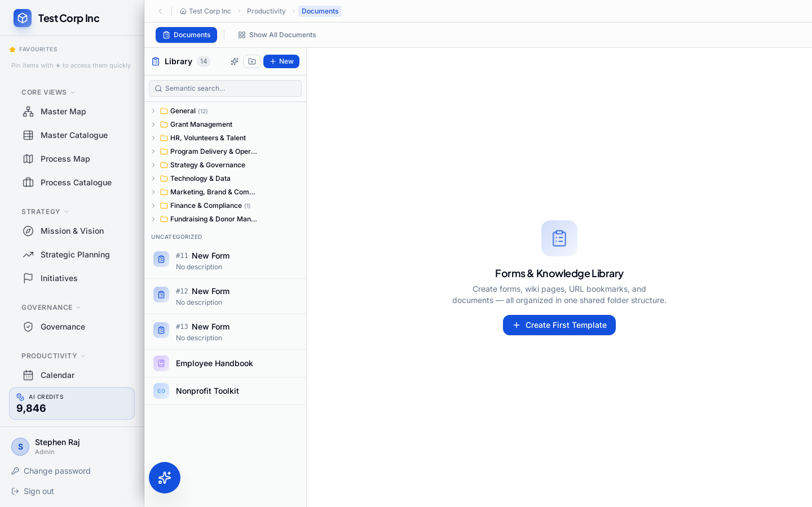

12. Meetings
TENANT ADMIN SCREEN — Requires login as tenant admin or standard user
Section: Productivity | Credentials: stephen.raj@coryphaeus.ai / admin123
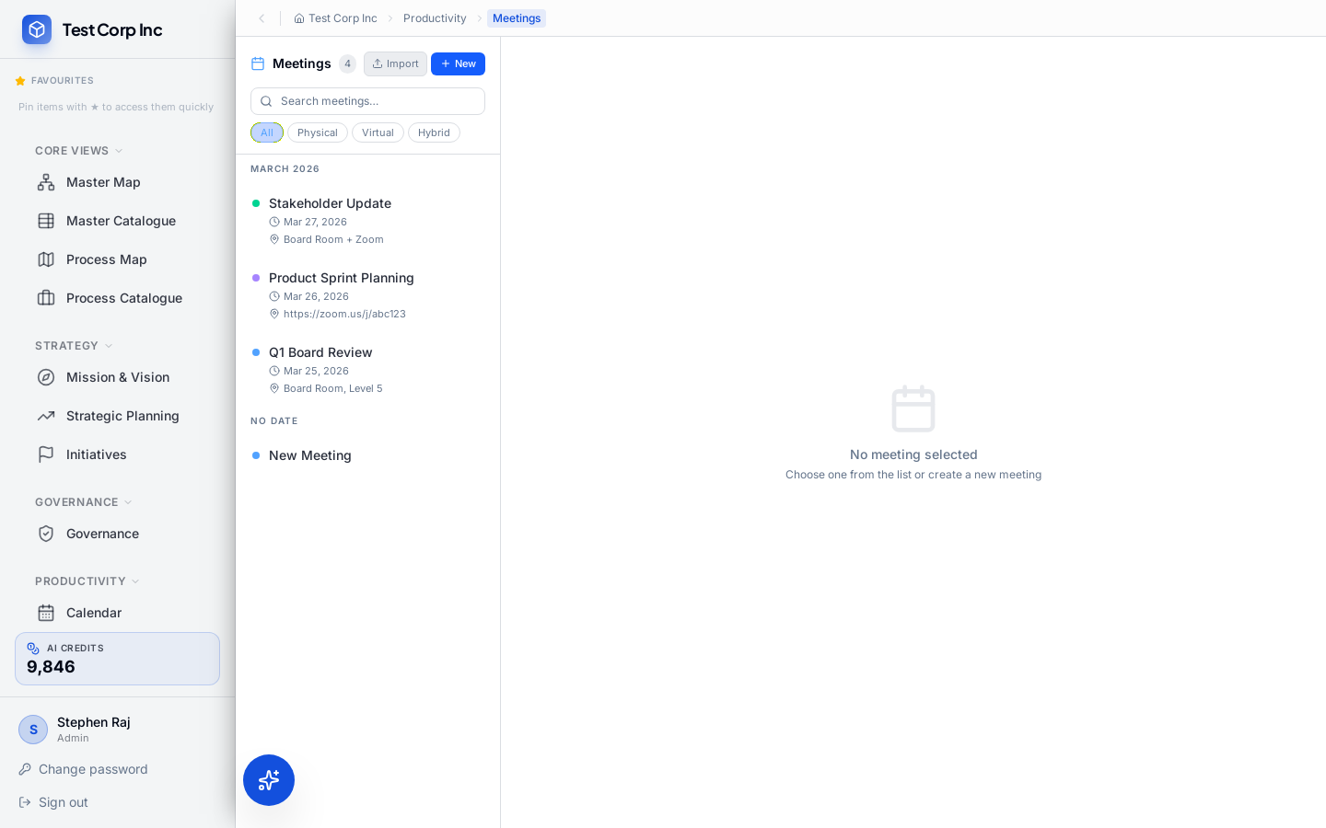

13. Calendar
TENANT ADMIN SCREEN — Requires login as tenant admin or standard user
Section: Productivity | Credentials: stephen.raj@coryphaeus.ai / admin123
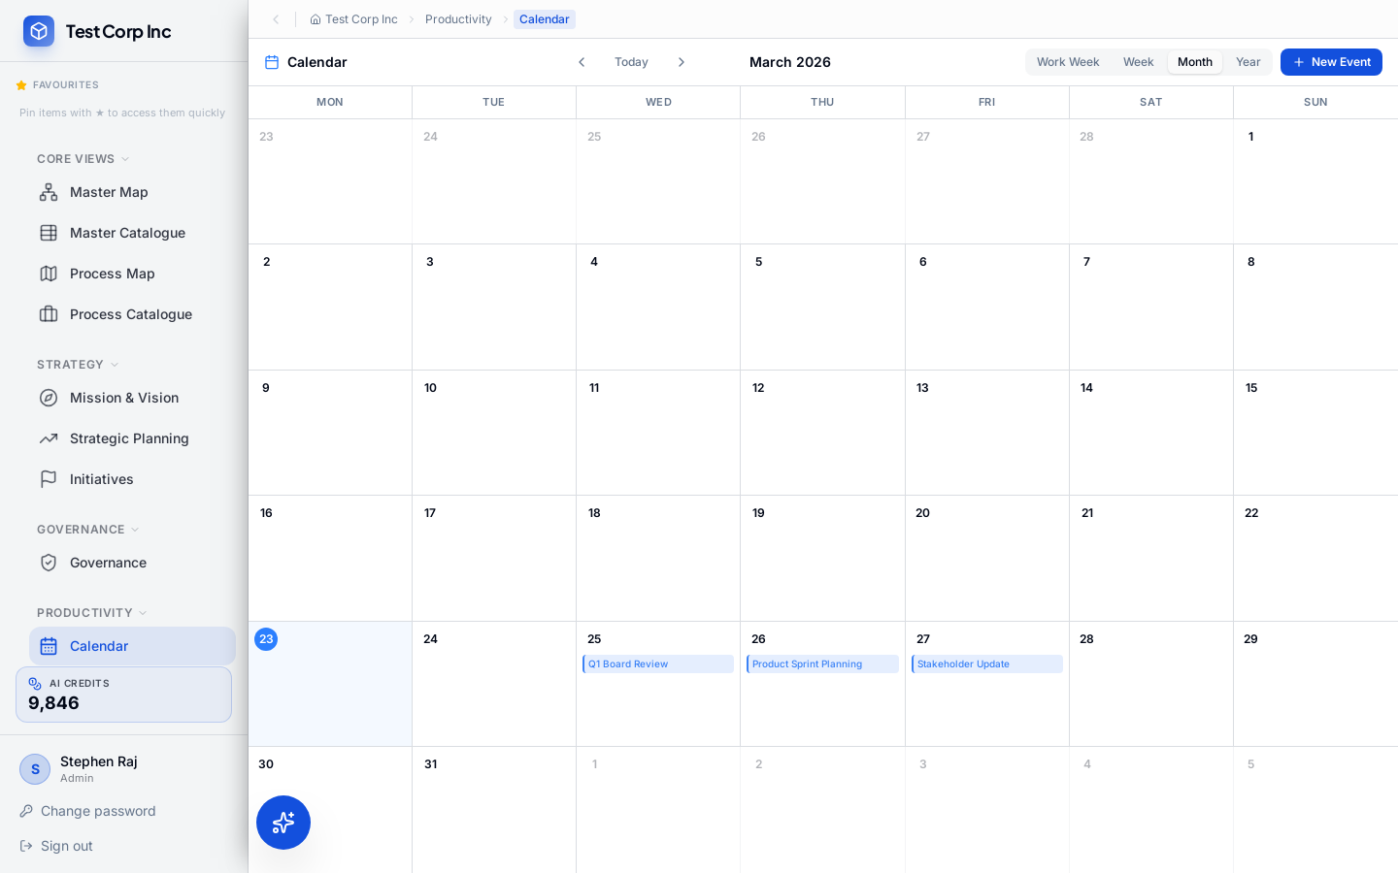

14. Activities
TENANT ADMIN SCREEN — Requires login as tenant admin or standard user
Section: Productivity | Credentials: stephen.raj@coryphaeus.ai / admin123
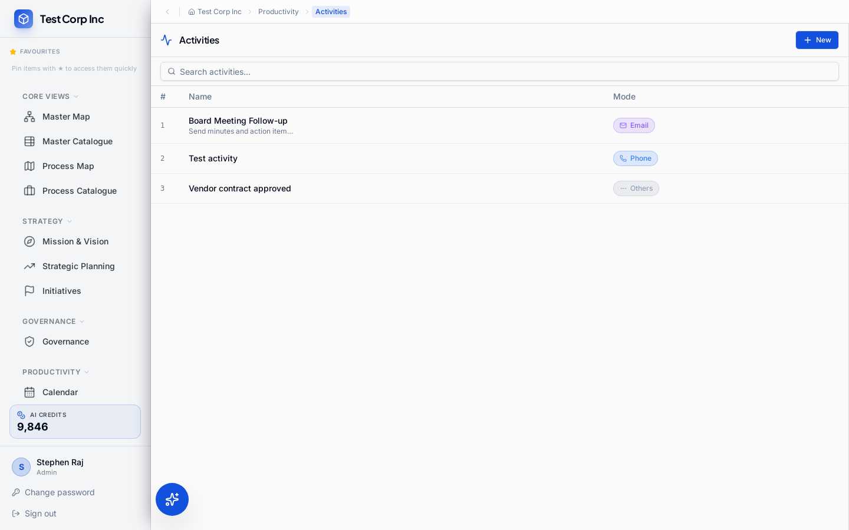

15. Tasks
TENANT ADMIN SCREEN — Requires login as tenant admin or standard user
Section: Productivity | Credentials: stephen.raj@coryphaeus.ai / admin123
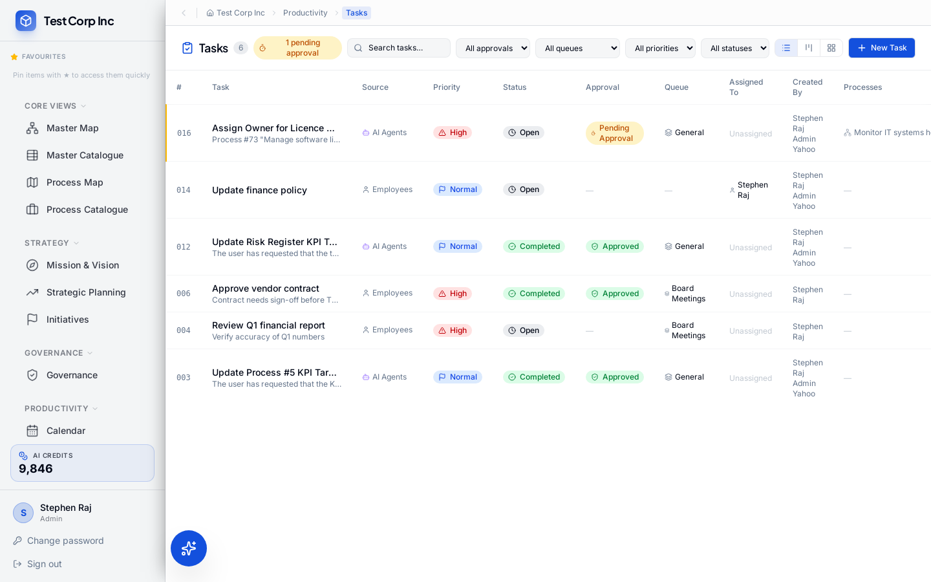

16. Queues
TENANT ADMIN SCREEN — Requires login as tenant admin or standard user
Section: Productivity | Credentials: stephen.raj@coryphaeus.ai / admin123
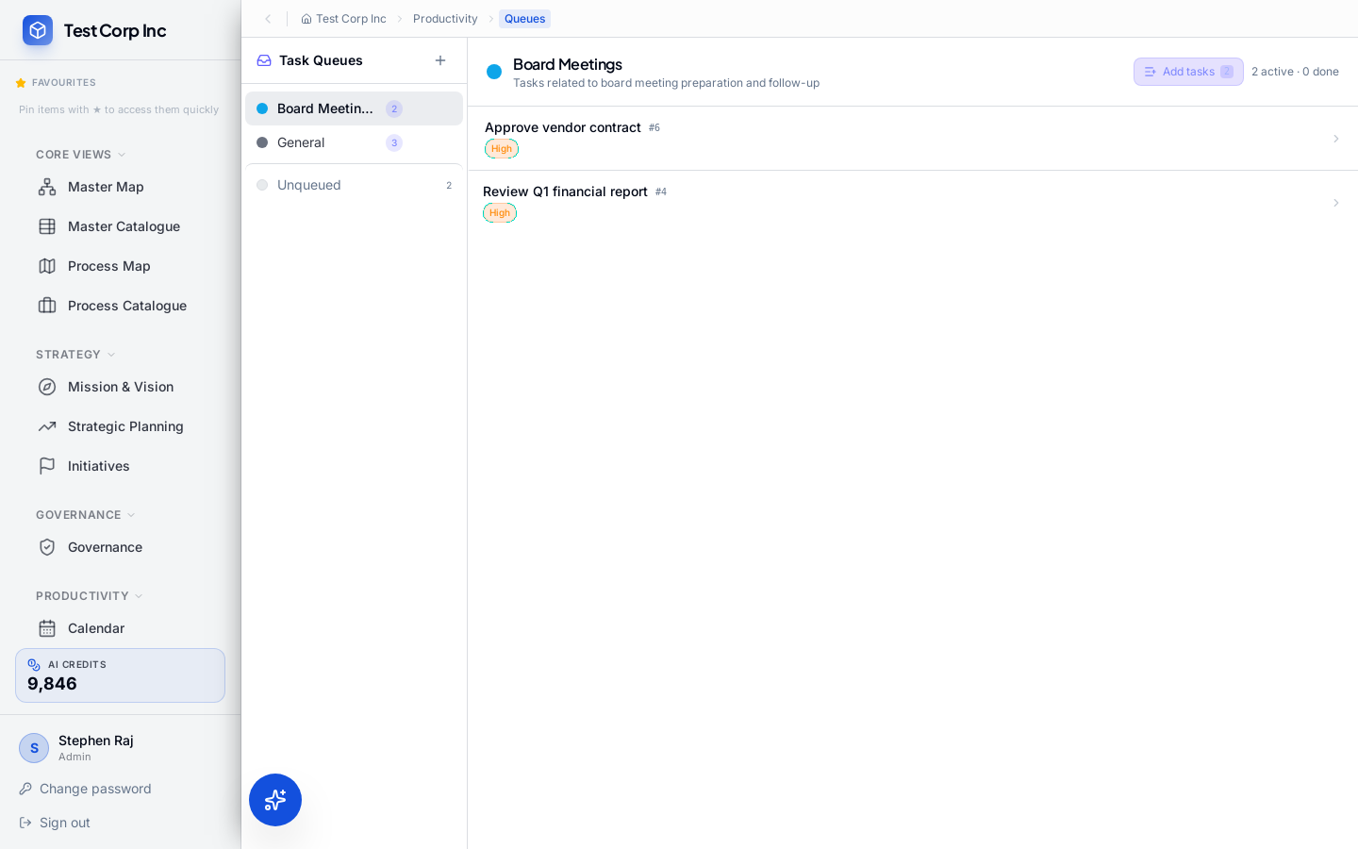

AI

17. AI Agents
TENANT ADMIN SCREEN — Requires login as tenant admin or standard user
Section: AI | Credentials: stephen.raj@coryphaeus.ai / admin123
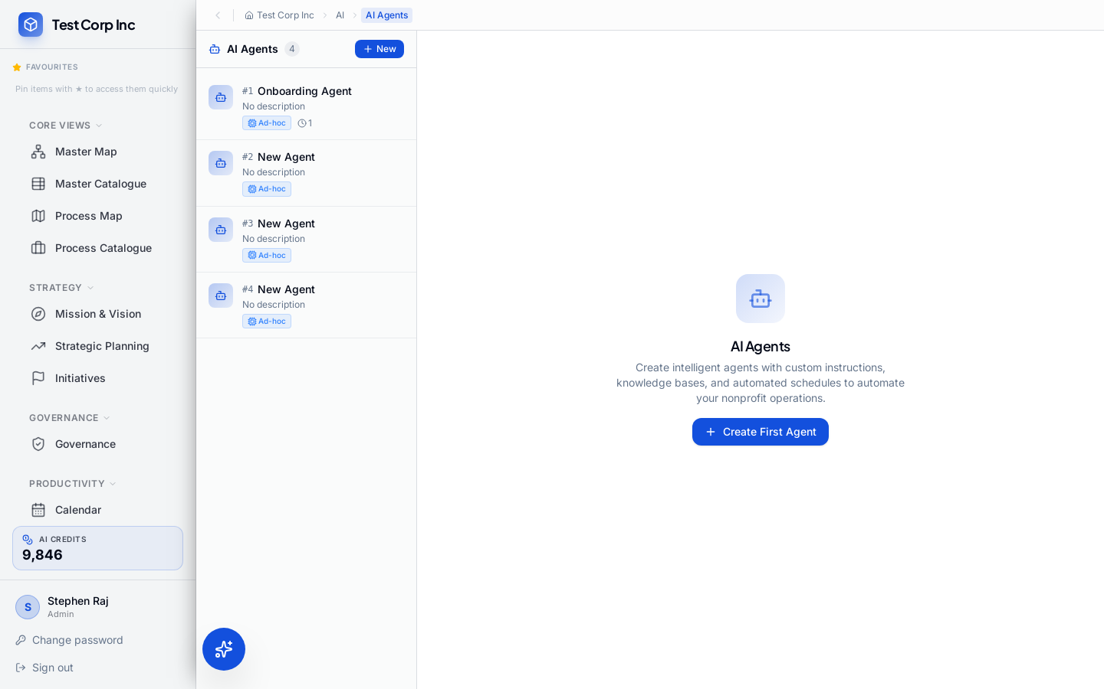

Integrations

18. Connectors
TENANT ADMIN SCREEN — Requires login as tenant admin or standard user
Section: Integrations | Credentials: stephen.raj@coryphaeus.ai / admin123
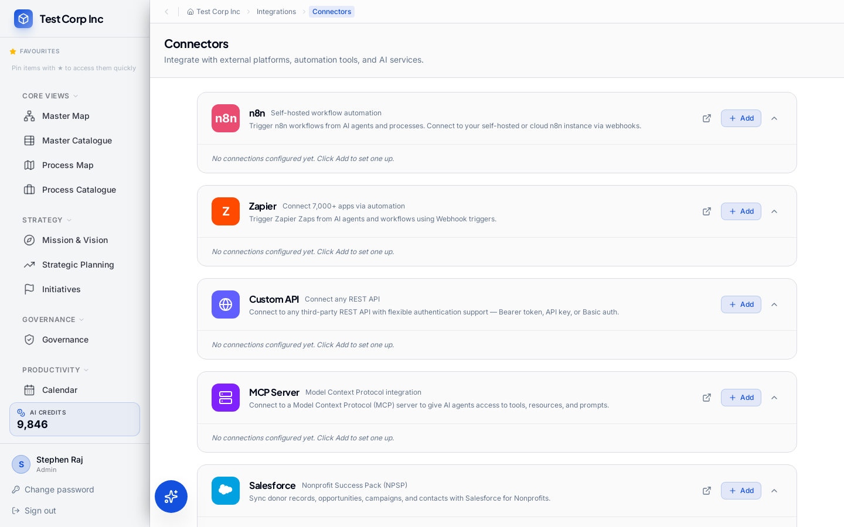

System

19. Dashboards
TENANT ADMIN SCREEN — Requires login as tenant admin or standard user
Section: System | Credentials: stephen.raj@coryphaeus.ai / admin123
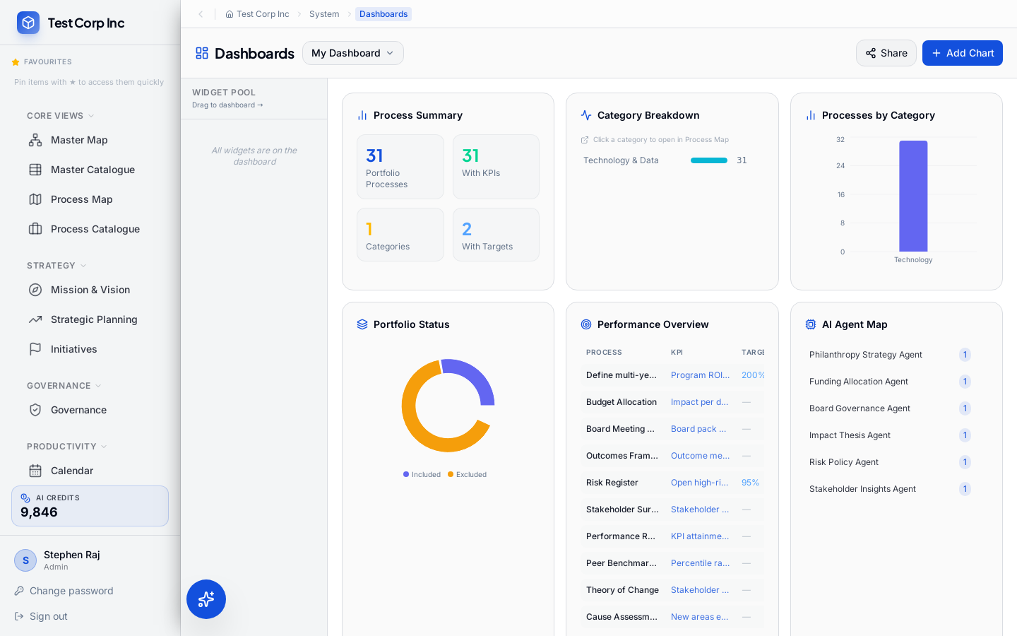

20. Reports
TENANT ADMIN SCREEN — Requires login as tenant admin or standard user
Section: System | Credentials: stephen.raj@coryphaeus.ai / admin123
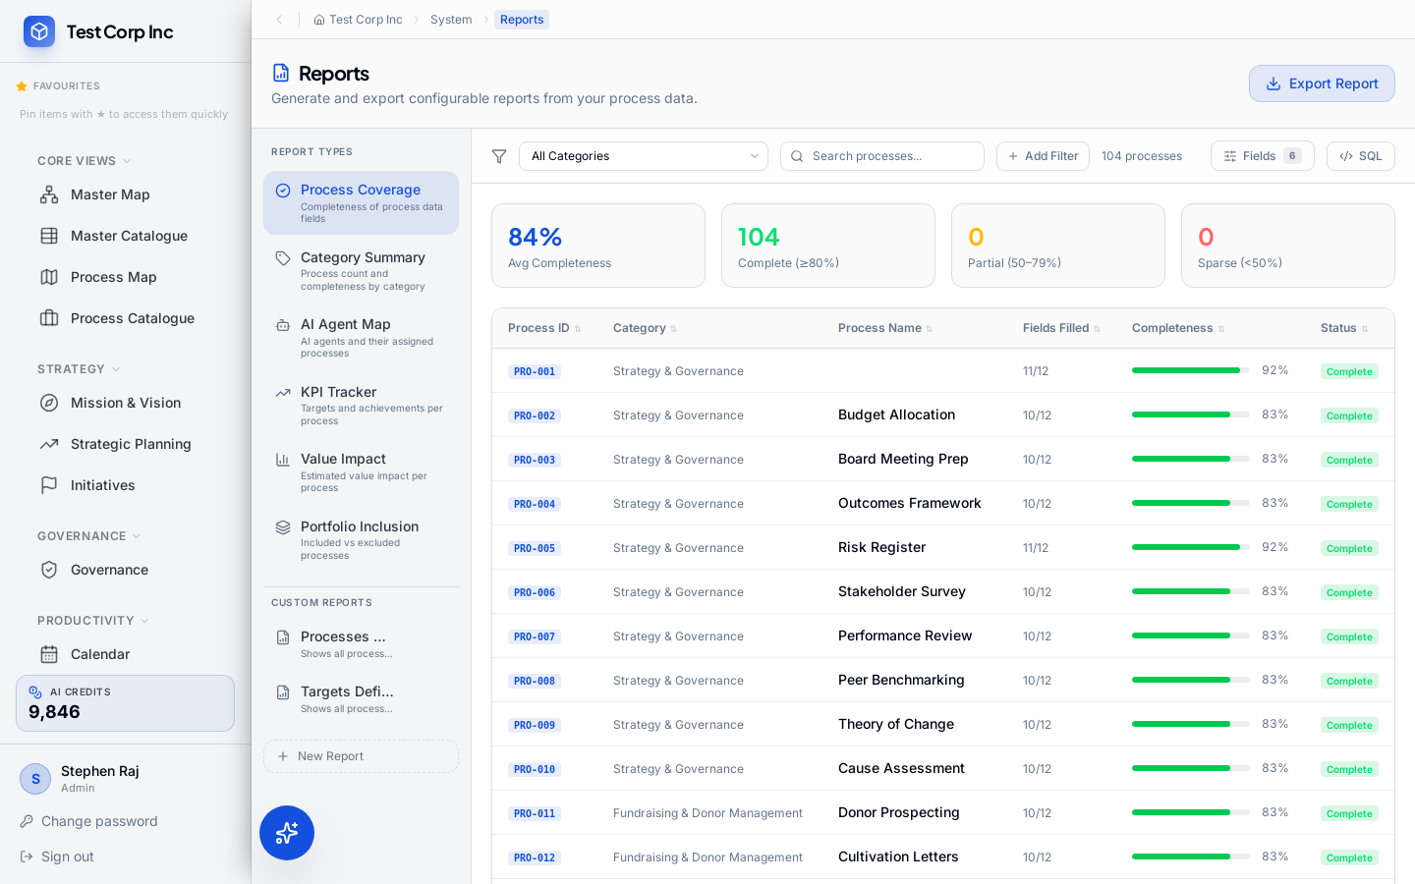

21. Audit & Logs
TENANT ADMIN SCREEN — Requires login as tenant admin or standard user
Section: System | Credentials: stephen.raj@coryphaeus.ai / admin123
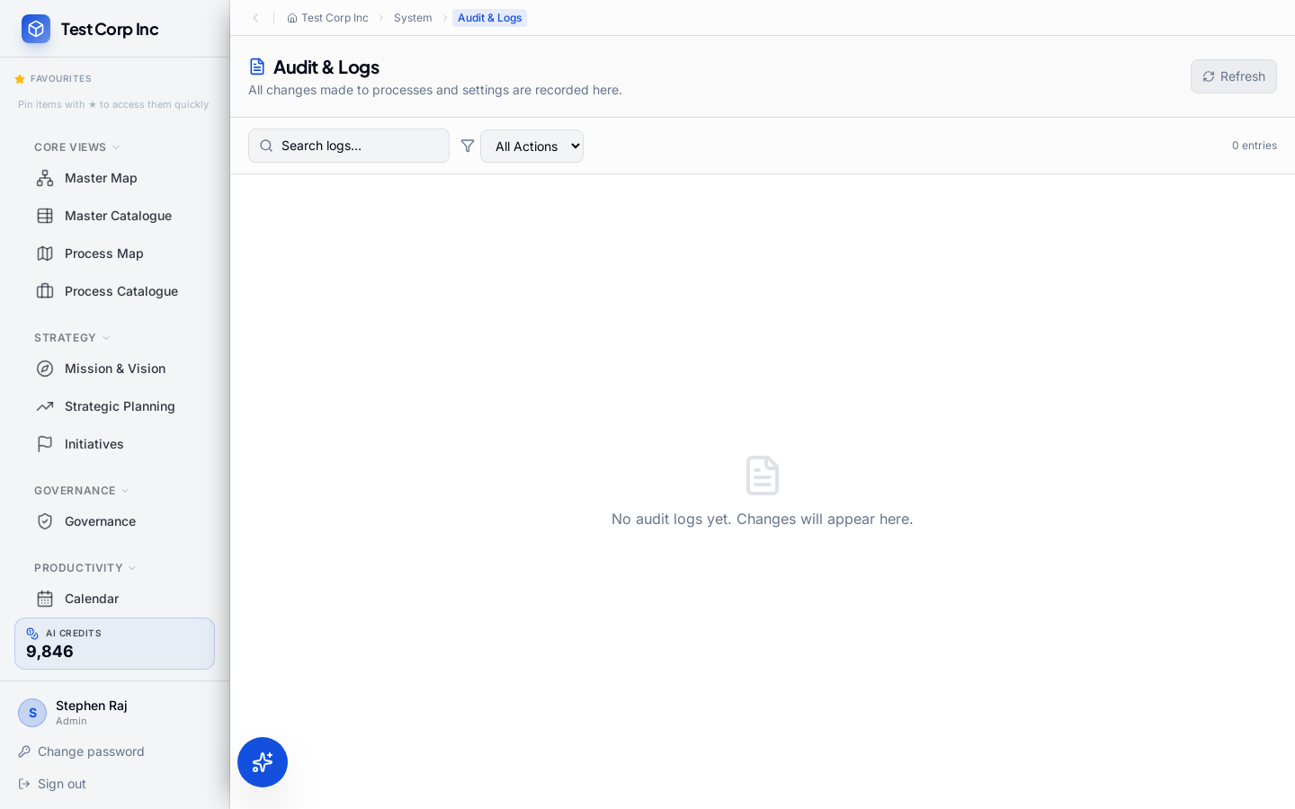

22. Settings
TENANT ADMIN SCREEN — Requires login as tenant admin or standard user
Section: System | Credentials: stephen.raj@coryphaeus.ai / admin123
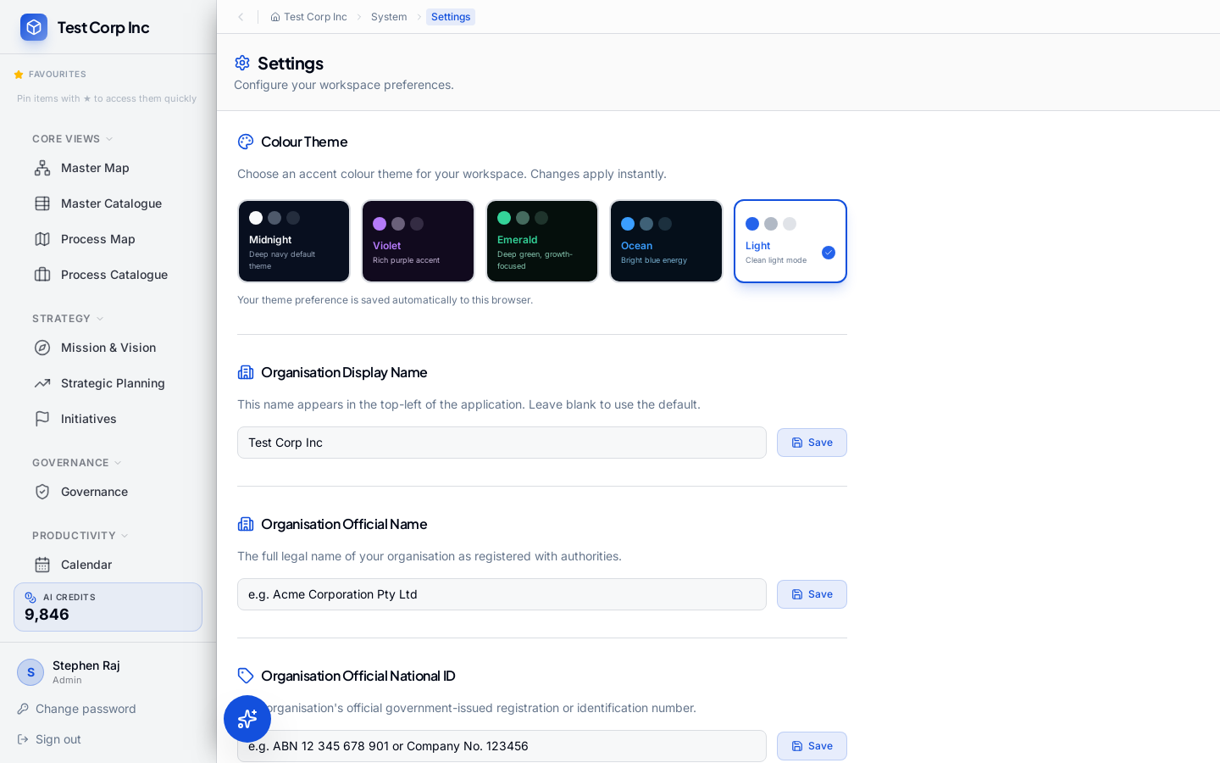

Admin

23. Users
TENANT ADMIN SCREEN — Requires login as tenant admin or standard user
Section: Admin | Credentials: stephen.raj@coryphaeus.ai / admin123
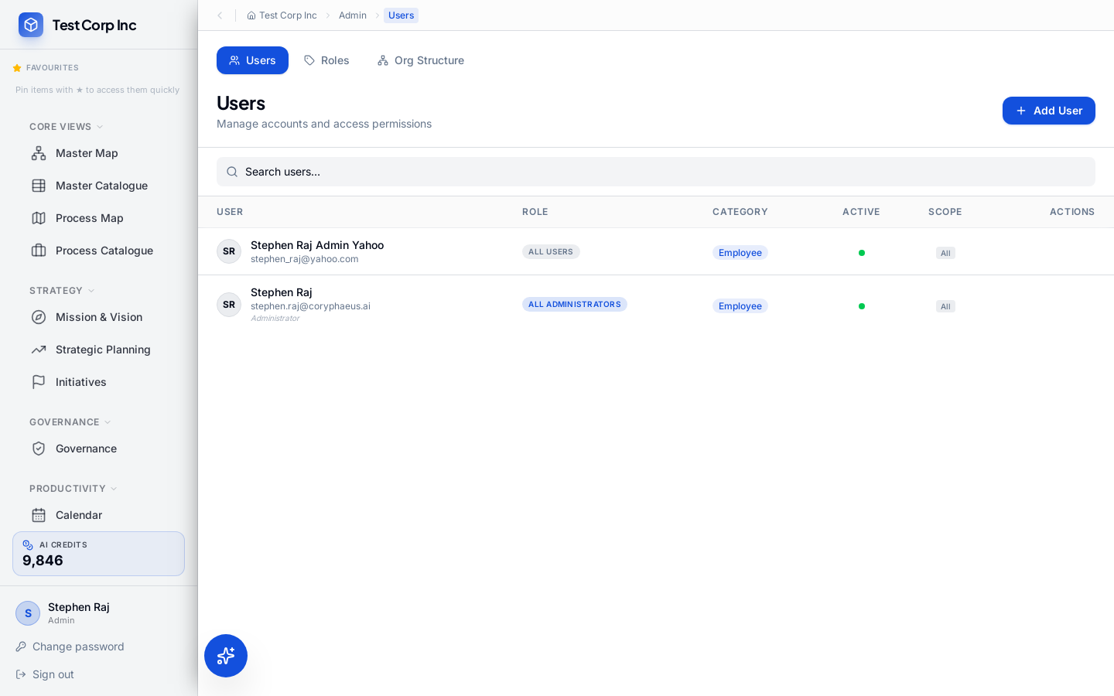

24. Configuration
TENANT ADMIN SCREEN — Requires login as tenant admin or standard user
Section: Admin | Credentials: stephen.raj@coryphaeus.ai / admin123
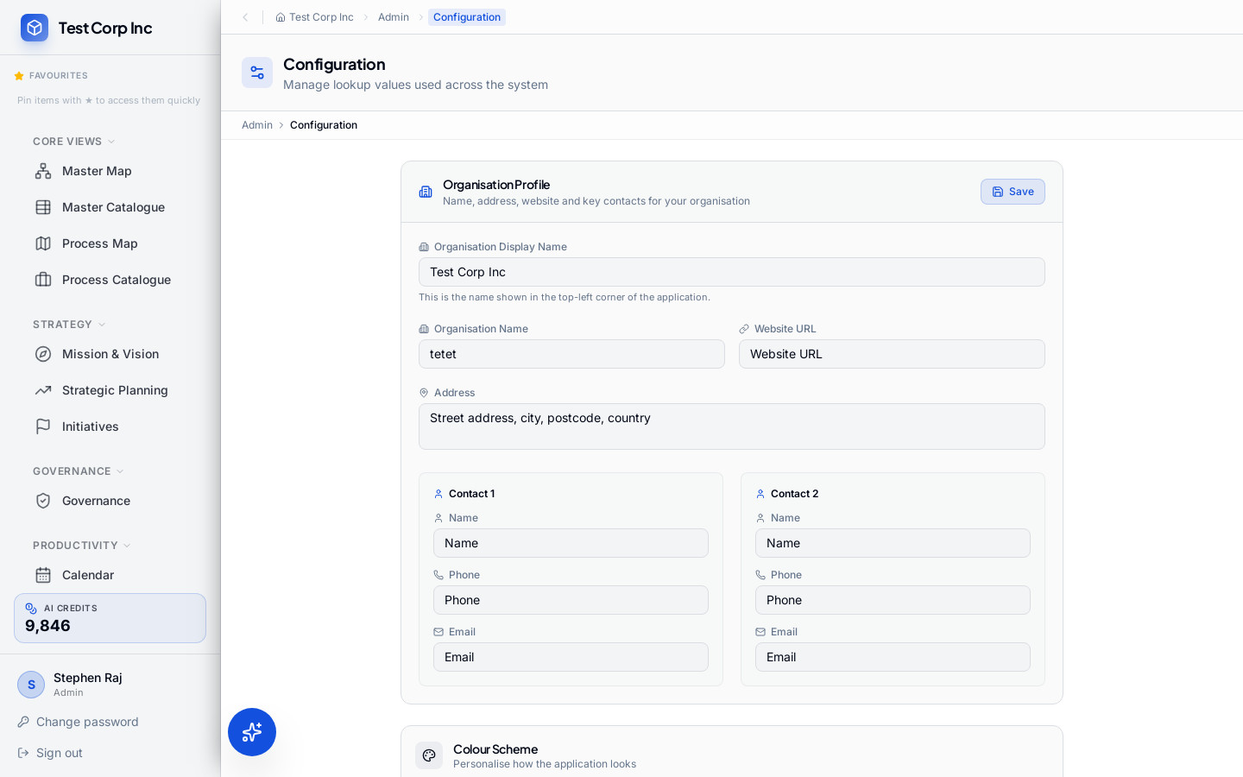

Tenant Management

25. Tenant Management
SUPERUSER SCREEN — Accessible only to the platform superuser (tenantId = null)
Used to create, view, and manage tenant organisations. Credentials: stephen.raj@insead.edu / stryker
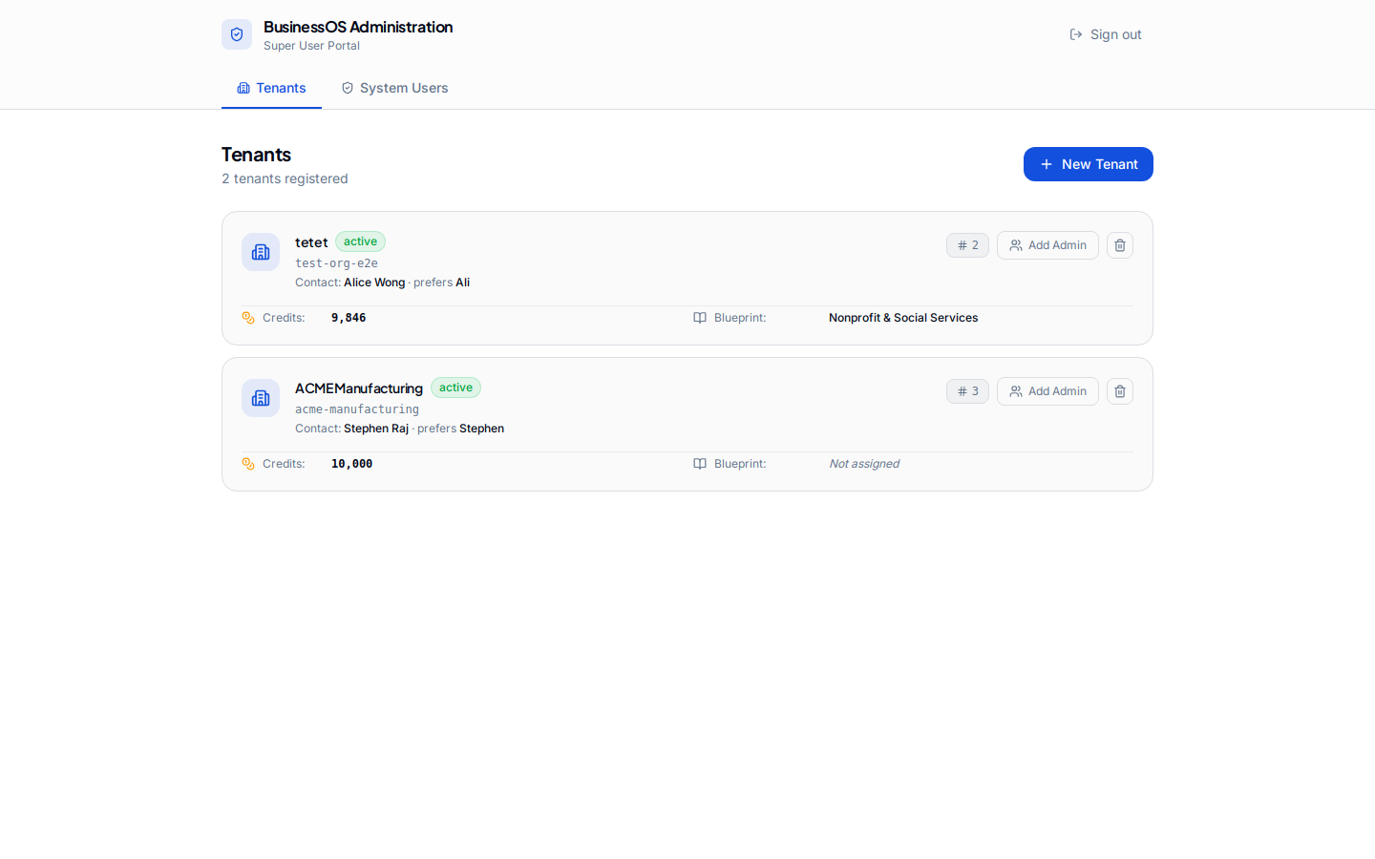

Legend
[ADMIN] Tenant Admin Screen
Accessible after logging in as a tenant admin or standard user.
Email: stephen.raj@coryphaeus.ai | Password: admin123

[SUPERUSER] Tenant Management Screen
Accessible only after logging in as the platform superuser (tenantId = null).
Email: stephen.raj@insead.edu | Password: stryker

Total screens captured: 25

