Lesson 7 Demo 2: Docker Compose with Centos

This section will show you how to use Docker Compose to manage a container.

This lab has 2 sub-sections:

* Set up docker-compose
* Create docker-compose file

**Step 1:** Set up docker-compose:

* Install docker-compose using the command given below:

**mkdir compose-test**

**cd compose-test**

**sudo apt-get install python-pip**

**sudo pip install docker-compose**

* Alternatively you can use the following command:

**sudo curl -L https://github.com/docker/compose/releases/\**

**download/1.7.1/docker-compose-`uname -s`-`uname -m` &gt;\**

**/usr/local/bin/docker-compose**

**sudo chmod +x /usr/local/bin/docker-compose**

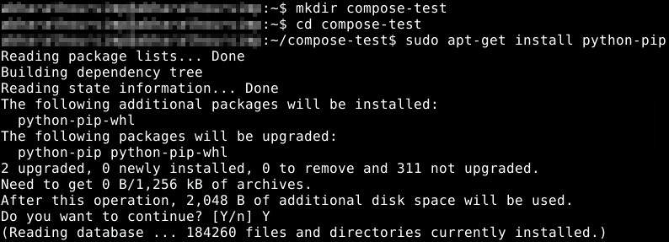

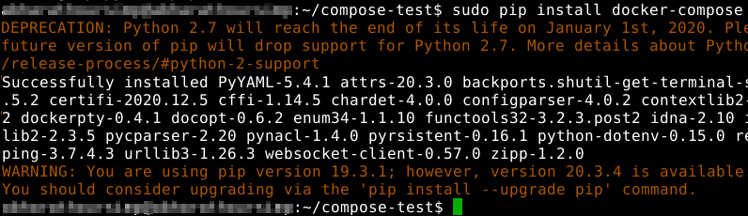

**Step 2:** Create docker-compose file

* Inside **compose-test** folder, create **docker-compose.yml** file, and add the following code in it:

**vi docker-compose.yml**

* Add the following code in the file:

**version: '2'**

**services:**

**compose-test:**

**image: centos**

**links:**

**- compose-db**

**command: /usr/bin/curl compose-db:6379**

**compose-db:**

**image: redis**

**expose:**

**- "6379"**

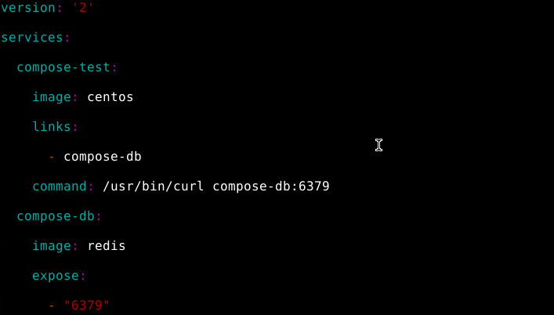

**Note:** Press **Esc** and enter **:wq** to save the file.

* Run the following command to execute the yaml file:

**sudo docker-compose up**

