Q&A

**Sujee : What time is lunch break? :-)**

11am PT

**Are we supposed to do both projects or just one?**

One

**Can you do some example about Jenkins pipeline , use dockerfile to build an image and push them to DockerHub?**

* Install docker-pipeline plugin on jenkins
* You need credentials to publish to dockerhub

**Do we need to reinstall Jenkins to capture the screen shots or can we use our existing installation of jenkins?**

No need…. Just take screenshot of dashboard

If you can, just put a few commands or point to url to install jenkins

**Screen shot / annotation utilities**

ON mac

Skitch

ON Windows

-Snag it

- Or Snip and Sketch (which is replacing “Snag It”)

**Can you show us how to add our ssh key to a running docker container?**

* When you build the docker you add ssh… here is a dockerfile directive

## password less login to localhost (needed by spark)

RUN /bin/bash -c "ssh-keygen -q -t rsa -N '' -f ${HOME_DIR}/.ssh/id_rsa 2>/dev/null <<< y >/dev/null"

RUN cat ${HOME_DIR}/.ssh/id_rsa.pub > ${HOME_DIR}/.ssh/authorized_keys

* To running instance
  + Changes are ephemeral
  + If you want to change to last, take a snapshot of running container

**There are three tests under the two projects. Do we need to complete any or all of those?**

No. Self-assessment only.

**At the start of a Jenkinsfile, how do we stop any running Docker containers using the Docker plugin?**

Run a shell command : docker stop $(docker ps)

$ docker container stop $(docker ps -a -q)

$ docker rm -f $(docker ps -a -q)

To stop a particular container, specify a name during startup, and then stop that container

**Does our solution need to have jenkins automatically build if we commit a new code to Git or can we still manually start a build from jenkins?**

* Manual trigger or polling is fine for now

**What are we supposed to be tracking on Git, the dockerfile?**

* Jenkinsfile
* Dockerfile
* Application files

**Running Ubuntu on laptop (optional)**

* Parallels
* Vmware
* Hyper v
* Virtual box

**How do you restart Jenkins? It was running after the initial install, but now localhost:8080 is unable to connect.**

$ sudo /etc/init.d/jenkins restart

Or you can find and kill jenkins process

$ ps -ef | grep jenkins

$ sudo kill pid1 pid2

You can try rebooting

$ sudo reboot

**Local vs public network interface**



**Terraform vs Ansible :**

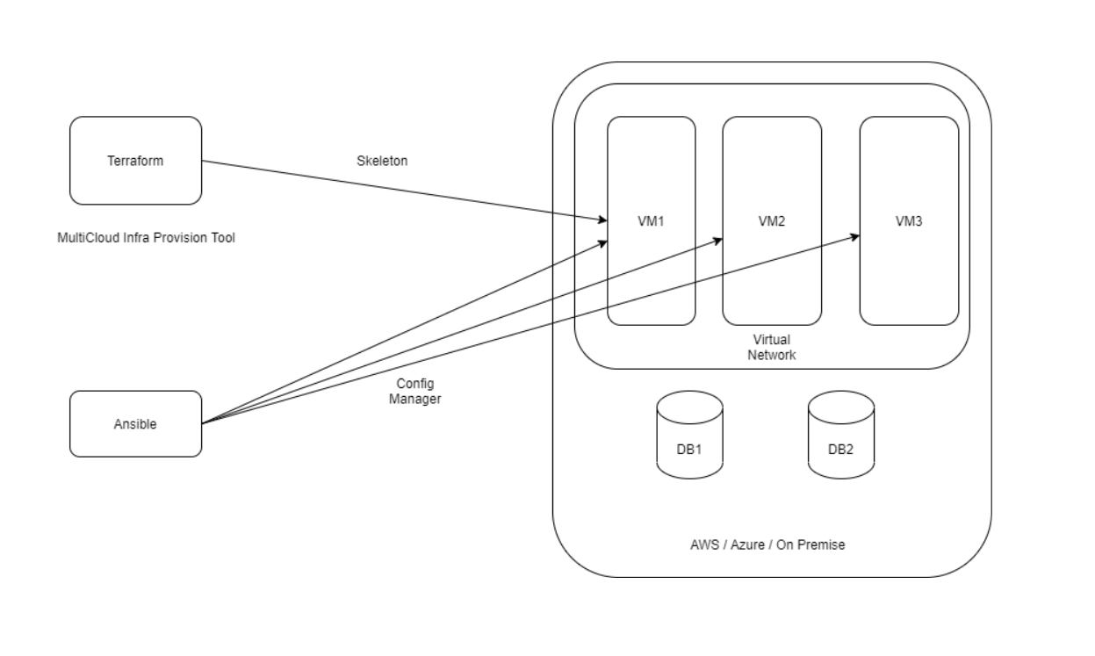

**Question: In order to test that the Docker Hub image is correct, do you need to make sure any related image is removed from your terminal, pull the image from Docker Hub, and then run it in your terminal? I was initially expecting that I could go to DockerHub and click on something there to see it run.**

I not aware of any method to run a dockerhub image on dockerhub.

You need to pull the image first , and then run it locally

$ docker pull your_img:v2

$ docker run your_img:v2

**Error invoking docker from Jenkins**

This is a permission issue. Try this

$ sudo chmod 777 /var/run/docker.sock

And then kick off another jenkins build

**Sample Jenkins file**

Please try this Jenkins file : Replace git url

pipeline {

agent any

stages {

stage('Cloning Git') {

steps {

git([url: 'https://github.com/ismailyenigul/hacicenkins.git', branch: 'master', credentialsId: 'ismailyenigul-github-user-token'])

}

}

stage('Building image') {

steps{

script {

dockerImage = docker.build imagename

}

}

}

stage('Deploy Image') {

steps{

script {

docker.withRegistry( '', registryCredential ) {

dockerImage.push("$BUILD_NUMBER")

dockerImage.push('latest')

}

}

}

}

stage('Remove Unused docker image') {

steps{

sh "docker rmi $imagename:$BUILD_NUMBER"

sh "docker rmi $imagename:latest"

}

}

}

}

## **Pushing to Dockerhub from jenkins**

Since you have already created a Docker Hub account, login and click on “**Create** **Repository**”.

Go to Jenkins page and click on  **Credentials** → **Global** → **Add Credentials**

Add your Docker Hub credentials and save it. ID and Description should be “**dockerhub”.**

Also, a Git repository should be cloned in order to use a Node.js application as an example.

Add the image in Docker registry to pull in other machines.

Now change the script in the Jenkins Pipeline as given below. Replace **docker_hub_account** with your Docker Hub account name and **repository_name** with the repository you have created. The final script code will be:

Here is the Jenkins build file

pipeline {

environment {

registry = “docker_hub_account/repository_name”

registryCredential = ‘dockerhub’

dockerImage = ‘’

}

agent any

stages {

stage(‘Cloning Git’) {

steps {

git ‘https://github.com/SimplilearnDevOpsOfficial/DockerizeJenkins.git '

}

}

stage(‘Building image’) {

steps{

script {

dockerImage = docker.build registry + “:$BUILD_NUMBER”

}

}

}

stage(‘Deploy Image’) {

steps{

script {

docker.withRegistry( ‘’, registryCredential ) {

dockerImage.push()

}

}

}

}

}

}

---

## Docker vs Docker Compose



## Docker Layers



Docker + jenkins